LC-Relay-ESP12-2R-D8
5V/8-80V power supply ESP8266 WIFI dual relay module ESP-12F development board secondary development
Overview:

Airsay ESP8266 dual relay development board is equipped with ESP-12F WiFi module, all I/O ports are led out, and it supports DC5V/8-80V power supply. Provide Arduino development environment reference code, suitable for ESP8266 secondary development learning, smart home wireless control and other occasions.

Features:

1. On-board mature and stable ESP-12F WiFi module, large capacity 4M Byte Flash;
2. The I/O port and UART program download port of the WiFi module are all led out to facilitate secondary development;
3. The onboard WiFi module RST reset button;
4. ESP-12F supports development tools such as Eclipse/Arduino IDE, and provides reference programs under the Arduino development environment;
5. Onboard 2 5V relays, output switch signals, suitable for controlling loads whose working voltage is AC 250V/DC30V;
6. Onboard power indicator, 1 programmable LED and relay indicator.

Hardware introduction and description:
1. Board size: 78*47mm
2. Weight: 38g

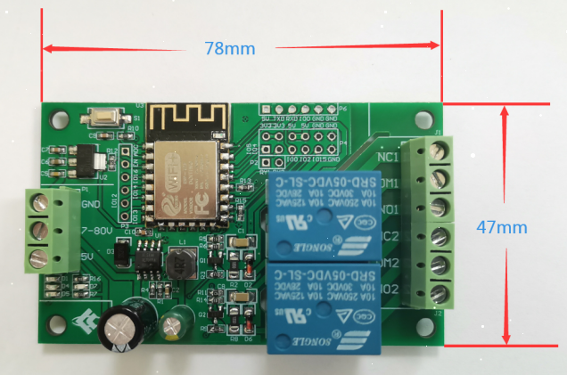
- Interface introduction:
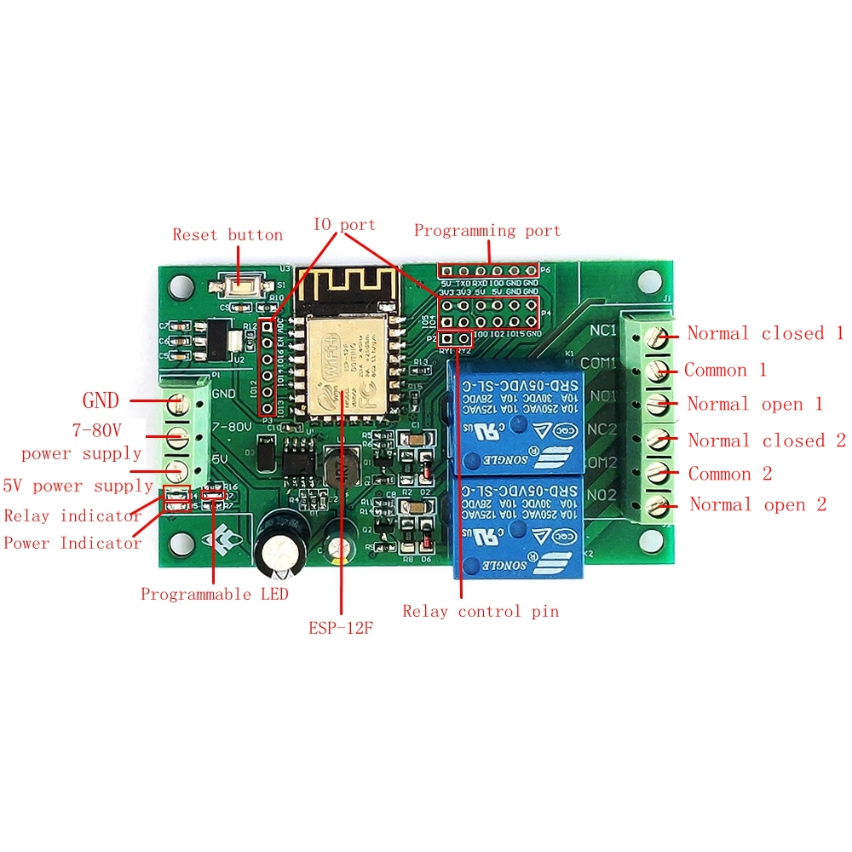
Programming port: ESP8266's GND, RX, TX, 5V are respectively connected to the GND, TX, RX, 5V of the external TTL serial port module. IO0 needs to be connected to GND when downloading, and then disconnect the connection between IO0 and GND after the download is complete;

Relay output:
NC: Normally closed, the relay is short-connected with COM before it is closed, and it is suspended after being closed;
COM: public end;
NO: Normally open end, the relay is suspended before closing, and shorted to COM after closing.

- GPIO lead port introduction:

Num. | Name | Function description | Num. | Name | Function description
1 | ADC | A/D conversion result. Input voltage range 0～1V, value range: 0～1024 | 10 | IO2 | GPIO2; UART1_TXD
2 | EN | Enable pin, pull up by default | 11 | IO15 | GPIO15; MTDO; HSPI_CS; UART0_RTS
3 | IO16 | GPIO16 | 12 | TXD | UART0_TXD; GPIO1
4 | IO14 | GPIO14; HSPI_CLK | 13 | RXD | UART0_RXD; GPIO3
5 | IO12 | GPIO12; HSPI_MISO | 14 | GND | Power ground
6 | IO13 | GPIO13; HSPI_MOSI; UART0_CTS | 15 | 5V | 5V power supply
7 | IO5 | GPIO5 | 16 | 3.3V | 3.3V power supply
8 | IO4 | GPIO4 | 17 | RY1 | One relay drive port, you can use a shorting cap and IO5 to short; if you want to use other I/O drive relays, you can use DuPont wire jumpers
9 | IO0 | GPIO0 | 18 | RY2 | One relay drive port, you can use shorting cap and IO4 to short circuit; if you want to use other I/O drive relay, you can use DuPont wire jumper

5. Arduino development environment setup
ESP8266 supports development tools such as Eclipse/Arduino IDE. It is relatively simple to use Arduino. Here is how to build Arduino development environment:
1. Install Arduino IDE 1.8.9 or the latest ve rsion;
2. Open the Arduino IDE, click File-Preferences in the menu bar, and click Add URL in "Additional Development Board Manager URL" after entering the preferences: http://arduino.esp8266.com/stable/package_esp8266com_index.json
3. Click Tools-Development Board-Development Board Manager in the menu bar, then search for "ESP8266" to install the Arduino support package 2.5.2 or the latest version of ESP8266
6. Program download
1, Use a jumper cap to connect the IO0 and GND pins, prepare a TTL serial port module (for example: FT232) to plug into the computer USB, the serial port module and the development board are connected as follows:
TTL serial port module | ESP8266 Development Board
GND | GND
TX | RX
RX | TX
5V | 5V
2. Click Tools-Development Board in the menu bar, select the development board as ESPino (ESP-12 module)
3. Open the program you want to download, click on Tools-Port in the menu bar to select the correct port number
4. After clicking "Upload", the program will be automatically compiled and downloaded to the development board, as follows:
5. Finally, disconnect IO0 and GND, power on the development board again or press the reset button to run the program.

