Function diagram / LED display
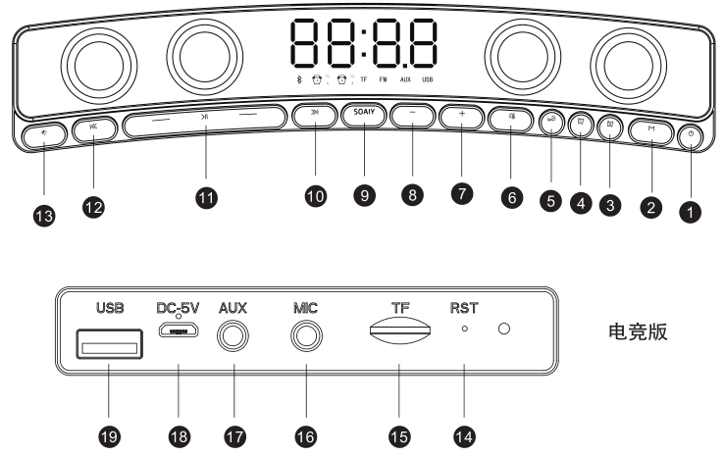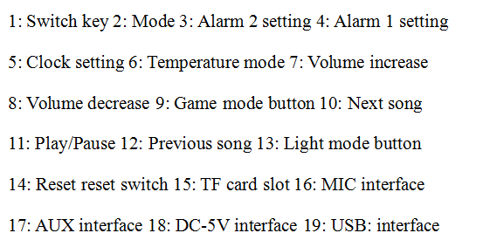
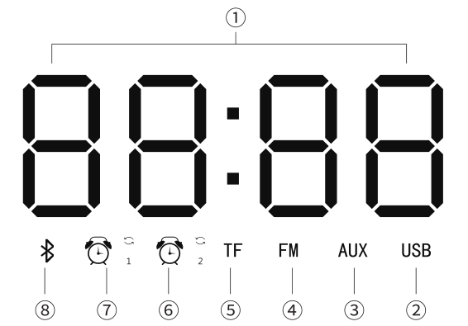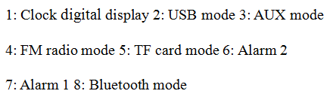
Instructions:
1. Power on/off button: long press for 3 seconds to turn on/off the machine
2. Mode key: Short press the mode switch,
3. Alarm clock setting key:
When entering the alarm setting mode, the corresponding alarm icon lights up, and the clock, minute, alarm on/off (ON/OFF), alarm once/cycle switch (ONE/ALL) flash in sequence. Short press + or-to set the alarm value, alarm switch, Alarm cycle and alarm ringtone selection. The alarm ringtones are selected in sequence from six ringtones such as 01, 02, 03, 04, 05, TFAL, among which 01-05 is the built-in ringtone, and TFAL is the TF card ringtone selection. After the audio is inserted into the TF card, the internal music of the TF card can be used as the alarm clock Ringtone; if you need to customize the alarm ringtone, please create a new alarm clock folder (named: TFAL) in the TF card, put your favorite ringtones or music in this folder, the alarm clock will select the ringtone or music in this folder as the alarm bell. Long press the alarm 2
Press to save and exit.
Alarm reminder:
a. In the alarm setting mode, if it is not adjusted within 15 seconds, it will automatically save and exit
b. The alarm clock is set to ring once (ONE): the cycle icon does not light up
c. Alarm setting ring cycle (ALL): the cycle icon is on
d. The alarm bell rings for 1 minute. When the alarm bell rings, press any key to turn it off
4. Clock setting key:
a. Short press the display time for 10 seconds, it will return to the previous mode
b. Long press to enter the time setting mode, set the clock and the minute flashing in sequence; short press + or-to set the clock or minute value. Long press the time setting button again to exit the clock setting
c. In the clock setting mode, if it is not adjusted within 15 seconds, it will automatically save and exit the time setting state
d. Switch to clock mode by short pressing the M key when powering on
5. Temperature mode key: Short press the display temperature for 10 seconds and then return to the previous interface, the temperature control changes with the sound.
6. Volume increase button: increase the audio volume 7. Volume down key: reduce the audio volume
8. Game mode button: Short press to enter the game sound effect mode and turn on the PC mode. Note: After turning on the PC mode,
The USB port cannot be used when charging and connecting to a computer
9. Next song button: short press to execute the next song for U disk, TF card, Bluetooth, play, and execute the next station in FM
10. Play/pause key: short press for play/pause/phone answering and hanging up;
11. Long press for 3 seconds in Bluetooth mode to disconnect the Bluetooth connection of the speaker
12. Last song button: Short press to execute the previous song in U disk, TF card, Bluetooth, play, and execute the previous station in FM mode
13. Light mode button: Short press to switch the light mode of the button, long press to switch the speaker light mode. The clock version switches the display brightness.
14. RESET reset switch, when the machine has abnormal operation, press the reset button on the hole with a needle-shaped object, and the machine will reset.
15. Bluetooth mode:
Turn on the Bluetooth mode or press the M key to switch to the Bluetooth mode according to the prompt sound. The icon on the LED screen flashes, turn on the mobile phone Bluetooth scan, search for "HD Soaiy" and click on pairing. After the connection is successful, there will be a prompt sound and the icon will be on.
16.USB/TF card mode
Insert the U disk or TF card when the machine is turned on, and the prompt sound U disk or TF card will automatically recognize the corresponding mode to play; when the U disk and TF card are inserted at the same time, you can switch the play mode by short pressing the M key.Support MP3, WMA, WAV, APE, FLAC and other audio format decoding and playback
17.AUX (external audio input) mode
Plug in AUX external audio when booting up, prompt sound AUX mode, the machine automatically recognizes the corresponding mode to play;When AUX, U disk, and TF card are inserted at the same time, you can switch the playback mode by short pressing the M key.
- FM mode
Press the mode button to switch to FM mode, long press the play/pause button to automatically search for radio stations. After searching, short press the previous or next song to select your favorite radio station to listen to.
Charging instructions
1. When the voltage is too low, there will be a low battery warning tone, and the product will automatically shut down.
2. Connect one end of the USB charging cable to the DC-5V charging input interface, and the other end to the USB port of the power adapter, please turn off and charge.
3. The red light is on when charging, indicating that it is charging, and the red light is off when fully charged;
4. The charging current selects DC5V/1A-2A power adapter to charge the machine.
5. If consumers use a USB power adapter to supply power, they should purchase a power adapter that has been CCC certified and meets the standard requirements.

