Desktop Wall mounted 8 Channel Phone WIFI GPS signal jammer

It only shields the downlink signal of mobile phone, without any influence to the base station. It can effectively shield 2G 3G 4G WIFI GPSL1 in the range of 2-20 meter.
All phone in the shielding area are completely diconnected from the outside world.
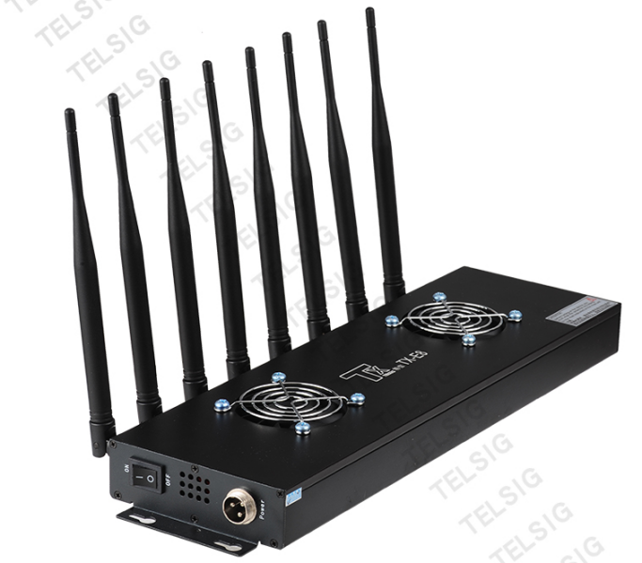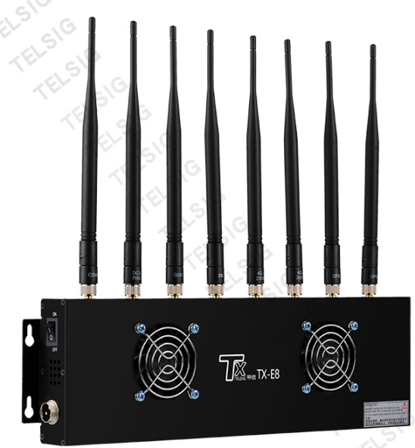
Application
This phone signal jammer is widely used in many field such as:
- Justice Administration: prison, detention house, reeducation center, public security, court, Procuratorate.
- Education: examination room, teaching classroom, dormitory, social examination sites, education training institution
3 .Conference room of Party and government offices and administrative unit
- Storehouse of Factory, Workshop, Mines, Assembly
- Military Place or Important Confidentiality Place
- Cinema, Theater, Concert hall, Memorial Hall, Auditorium, etc.

Feature
- Effective jamming required signal by high output power each band 2W~3W total 16~24W
2. Smooth working on large voltage fluctuation by 12V DC regulated power supply
3. Efficient heat dissipation helps a long stable working by professional cooling structure;
(Alluminum alloy strip outshell to avoid heat accumulation; two side ventilation hole; two quiet large fan)
4. Non-stop working with stable effect and long life span
5. ISO9001:2008 qualified through complete inspections and tests
6. Reconginzed by police department
7. No harm to human body

Specification
Jamming Radius : 2-20 meter（-75dBm, no barriers, distance from base station）
Output Power: 8 channel, each 2-3W, total 16-24W
Jamming Type: CDMA/GSM/DCS/WIFI/GPSL1/GPSL2/4G LTE
Customized frequency: added or modified.
Output Interface | Shield band of frequency |  | RF output power | Output power/channel
1 | 870-960 MHz |  | 35dBm | 8dBm/30KHz(min)
2 | 1805-1920MHz |  | 35dBm | 5dBm/30KHz(min)
3 | 2010-2170MHz |  | 33dBm | 2dBm/30KHz(min)
4 | 2300-2500MHz |  | 33dBm | 2dBm/30KHz(min)
5 | 2500-2700MHz |  | 30dBm | 2dBm/30KHz(min)
6 | 3400-3600MHz |  | 33dBm | 2dBm/30KHz(min)
7 | 4800-4900MHz |  | 35dBm | 2dBm/30KHz(min)
8 | 5725-5850MHz |  | 35dBm | 2dBm/30KHz(min)
Power: supply AC110~220-DC5V/8A |  |  | Shielding area: 2-20 meter @ according to signal density mobile network
Power consumption: 60W |  | Weight: 2.3Kg | Length × width × height:  370×110×33mm

Installation
- Choose installation place
- For temporary use, please put the jammer on desktop
- For fixed use, please hang it on wall with the provided mounting bar
- The optium installation height is 1.8-2.5meter from the ground.
- Please ensure each antenna is connected with the phone jammer by the identification code on antenna
- Please do not turn on the power until antenna is connected well with the phone jammer

Attention
1. The distance from signal base station will influence the shielding range.
The farther the jammer is from the base station, the larger the shileding range is. When the jammer is installed in a place where the signal is -75dBmv, the maxium shielding range can be 40 meter; When over -35dBmv, the maxium range is only 1-2 meter.
2. The shielding range refers to a circular area centered on the jammer. It transmit the shielding signal out from strong to weak. A large area should choose a proper quantity and location of jammer and adopt cellular installation to make the shielding signal evenly distributed.
- The normal temperature is 40～50℃ after long time working; but when the temperature is too high than that, please turn off power and contact the local distributor or agent for help
- Please ensure there is no barrier between the jammer and intended jamming area
- Please keep the antenna vertically upward when wall mounted
- Please twist the antenna 90 degree down and vertically upward when desktop use
- Please ensure there is no AC power line or other audio video line in 0.2 meter
- To avoid the possible interference to some electronic devices, please keep the jammer 1-2 meter away from the sound system, wireless microphone, radios, computer, TV, Wifi router, etc

Product Advantage
- Ultra thick 5.5mm alluminum alloy
High heat transmission efficiency
Heat of power amplifier can be transferred to outshell super quick
Strip line and chip design helps avoid heat accumulation on outshell and blow heat away very fast
- Ventilation holes at two side helps convection
1)Draw in the indoor temperature air in and blow heat away quickly
2)Two 60*60mm no noise large fans

Long life span adapter
- RF channel modulization with single adapter main board
- SMT mounting technique
- All original packing of electronic parts

Package Details
1pcs*Desktop Jammer
8pcs*Antenna
1pcs*AC adapter

