Dear users of CUT-APP
The old version of the mobile APP will be deactivated on January 5, 2021. After deactivation, the APP will not be available. The following problems may occur during the update:
1. There may be situations in which the account previously used cannot be logged in. At this time, we can use the machine serial number to register again, and the cutting points can also be recharged again. If you don't have points to recharge, you can contact customer service staff for back-end replenishment.
2. The cutting points are not synchronized, and the previously recharged points are missing. You can recharge the points first. For missing points, please contact our customer service staff to add points.
Please update the new version of the APP, the following is the new version of the APP login interface
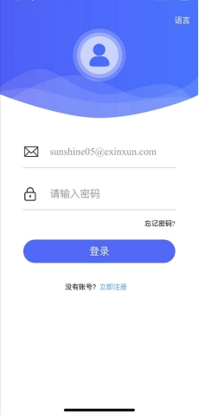
1. Apple IOS users can search and download directly in the App Store of the system:
2. Android users can directly scan and download the latest APP:
3. After the upgrade, there may be a small number of customers with different usage times, please contact us
4.After the upgrade, there may be a small number of customers who cannot log in, please re-register
5. After the upgrade, the new version of the background login address: http://cloud.purcellcut.com/v2/agent/mobile/#/login
6. There may be some bugs after the upgrade. You can give feedback in time. Our engineers are all on standby to make timely revisions.

