Digital push-pull force meter

Ⅰ、Use

Digital push-pull meter is a small and convenient tension and pressure testing instrument, which has the advantages of convenient reading, high precision, easy operation and easy to carry. Newton, kg and pound units can be switched at any time, display numbers can be flipped up and down, and have load peak (PEAK) function. It is widely used in electronics, high and low voltage electrical appliances, hardware locks, auto parts, adhesive chemical industry, lighter and ignition device, pen making, light industry, construction, textile, machinery and other industries and scientific research institutions to do tension and compression load, insertion force, destructive test and so on. Please read this manual carefully before using this instrument, so as to make full use of this instrument. The function of the test makes it possible to get accurate values when testing.

Ⅱ、 functional characteristics

◆Small volume, simple operation, handheld can also be installed all kinds of test bench use, combined with a variety of fixture testing convenience;

◆The digital display direction can be flipped up and down, large font display, convenient reading, high test accuracy;

◆Continuous load indication and peak holding function switch function freely;

◆Newton, kilos and pounds can be switched at any time.

◆The keystroke sensitivity of this instrument is set to 1 second, and there may be no reaction phenomenon if the keystroke is pressed quickly.

◆Please pause a little while pressing the button to ensure that the keystroke function works properly.

Ⅲ、Outline structure name and display, key function.

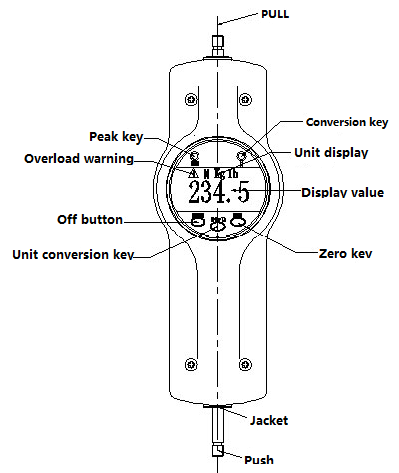

1. Peak key: control the conversion between the real-time load and the peak load.

2. Conversion key: control the upper and lower direction of the display number. It is convenient for customers to read numerical values intuitively.

3. On/ off key: control the on/ off of the instrument. This instrument is set to be automatically shut down for 5 minutes after it is not in use.

4. Unit conversion key: press this key to perform the switching of measuring units, can cycle display N (Newton), kg (kg), lb (pounds) three units. In the state of test data display, the unit conversion of the same value can also be completed.

5. Overload warning:beyond the measuring range of the instrument, triangle symbol will appear at the upper left corner of the display. Care must be taken to avoid damage.

Ⅳ、Shape and installation dimensions

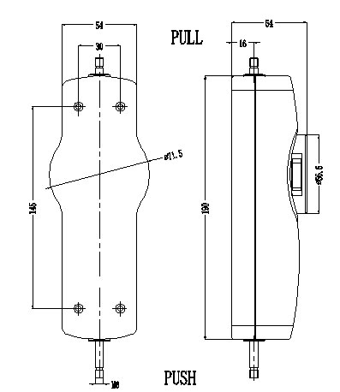

Ⅴ、Specification parameters

|  |  |  |  |  |  |  |  |  |
| --- | --- | --- | --- | --- | --- | --- | --- | --- |
| ts(typespecification) | -10 | -20 | -30 | -50 | -100 | -200 | -300 | -500 |
| Maximum load value | 10N | 20N | 30N | 50N | 100N | 200N | 300N | 500N |
| 1Kg | 2Kg | 3Kg | 5Kg | 10Kg | 20Kg | 30Kg | 50Kg |
| 2.2Ib | 4.5Ib | 6.5Ib | 11Ib | 22Ib | 45Ib | 65Ib | 110Ib |
| load index | the load index value is 0.01 when the indicating value is lower than 100 (the integer bit is 2 bits and less); The indication value is higher than 100 (integer number 3 digits) load index value is 0.1. | | | | | | | |
| precision | 1% | | | | | | | |
| push-pull rod travel | 10mm | | | | | | | |
| source | 3V button type battery | | | | | | | |
| battery life | Six months | | | | | | | |
| working temperature | 5℃～35℃ | | | | | | | |
| Transport temperature | -10℃～60℃ | | | | | | | |
| relative humidity | 15%～80%RH | | | | | | | |
| weight | 0.68Kg | | | | | | | |

Ⅵ、Prepare for the test:

1. Select the appropriate joint fixture for testing and install it on the push-pull meter.

(1) during tensile testing: install the drawing fixture on the push-pull rod and mark one end of the pull (PULL) (there is a retractor fixture in the package).

(2) as a compression test: install the fixture used for push or pressing on the push rod to mark one end of the pressure (PUSH) (such as flat fixture, pointed fixture, concave fixture, convex fixture in the package).

(3)Application of extension rod:use the extension rod to install the fixture when the clamping fixture cannot reach the object under test by pulling.

Note: When testing, the push-pull rod of the tested force and the push-pull force shall be on the same straight line, or the accurate load value cannot be measured.

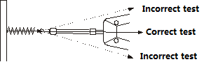

1. if the impact load is tested, the maximum load is twice as large as the impact load to be tested.

2. Warning:

(1) in destructive testing, wear protective masks and gloves to prevent spatter damage during testing.

(2) Do not use a clamp that is damaged or badly bent. The self-made clamp can be found in the relevant parameters in this specification (the company is also equipped with various kinds of clamps, and the customer can select separately as required).

3. Peak usage method

The instrument is turned on in a real-time load state. If you need to use the peak test, press the peak key, and PEAK appears in the upper left corner of the display screen.

alphascope :The letters show that the instrument enters peak test mode. Press the peak key to convert the instrument in peak and real time.

Peak state:When the test force reaches the maximum load, the value will stop at the maximum load until it is manually cleared

Real-time status:The display value changes as the load changes.

1. Scope of use:The digital explicit push-pull force meter has many specifications for the user to choose from, and the user can select the corresponding specification instrument according to the force value of the required test product. The scientific use test range is 10% ≤ 100% of the full range. The metering department recommends not using less than 1% of the full range. Therefore, this instrument has shielded less than 1% of the full range and is no longer used by users. At the same time, before the instrument and the tested object are in place, press the "zero" key to clear zero to eliminate the weight of the fixture and so on.

VII. Self-made fixture

In order for the push-pull gauge to measure accurate and stable test values, it is important to make full use of the attached fixture. When the user is to make a jig suitable for the test, please refer to the push-rod connection size shown in the right figure.

NK NLB ALB  指针式推拉力计 说明书 艾力 定型

VIII. Maintenance and maintenance

(1) do not impose a load exceeding the maximum load of the push-pull meter so as not to damage the instrument.

(2) If the digital flashing occurs, the battery is generally undercurrent. Please replace the battery in time.

(3) Please keep and store it properly according to the regulations, so as to avoid the place where the push-pull force meter is stored or used in dusty, low-humidity, low-humidity or high-humidity, high-humidity and corrosive-medium, and where there is a source of seismic source to avoid damaging the instrument.

(4) Clean the machine with a soft cloth. The cloth is immersed in the water of the detergent, and the dust and dirt are removed after being wrung. Note: Do not use volatile chemicals to clean the machine (e. g., volatile, diluent, alcohol, etc.)

(5) Please use and store within the specified temperature and humidity range, otherwise it may cause instrument failure.

(6) Do not disassemble or modify the machine itself, which may cause a permanent failure of the instrument.

|  |  |  |
| --- | --- | --- |
| Packing List | | |
| Serial number | Name | Quantity |
| 1 | Mounting screws | M3*14 4PCS  M3*16 4PCS |
| 2 | Flat head clamp | 1PCS |
| 3 | Conical tip clamp | 1PCS |
| 4 | Concave fixture | 1PCS |
| 5 | Convex fixture | 1PCS |
| 6 | Hook fixture | 1PCS |
| 7 | Extension rod | 1PCS |
| 8 | user's manual | 1PCS |
| 9 | Inspection certificate | 1PCS |
| 10 | Desiccant | 1PCS |
| 11 | Button Battery | 1PCS |