**ATU-100 Installation Description**

Technical characteristics

(basic model)

Allowable supply voltage range: 10-15VDC

Maximum current consumption: 400 mA

Maximum working power: 100W

Maximum possible measurement power: 150W

Minimum power required to start tuning: 5W

The smallest possible measurement power: 0.1W

Measurement resolution for power up to 10 Wh: 0.1W

Measurement resolution for power greater than 10 watts: 1W

Power measurement accuracy error: ±10%

Maximum installation inductance: 8.53μH

Minimum installation step of inductance: 0.05μH

Maximum installed capacity: 1869 pF

Minimum capacitance installation steps: 10 pF

Typical consumption 100-200 mA

This finished kit is purely hand-soldered, provides 3.1 program support with SSD1306 controller, the resolution is 128x32 pixels, and the diagonal is 0.91 inch mono-color OLED display.

This circuit contains a set of 7 inductors and 7 capacitors, which allows it to work in a wider frequency range, which can effectively cover the amateur radio range from 1.8MHz to 50MHz.

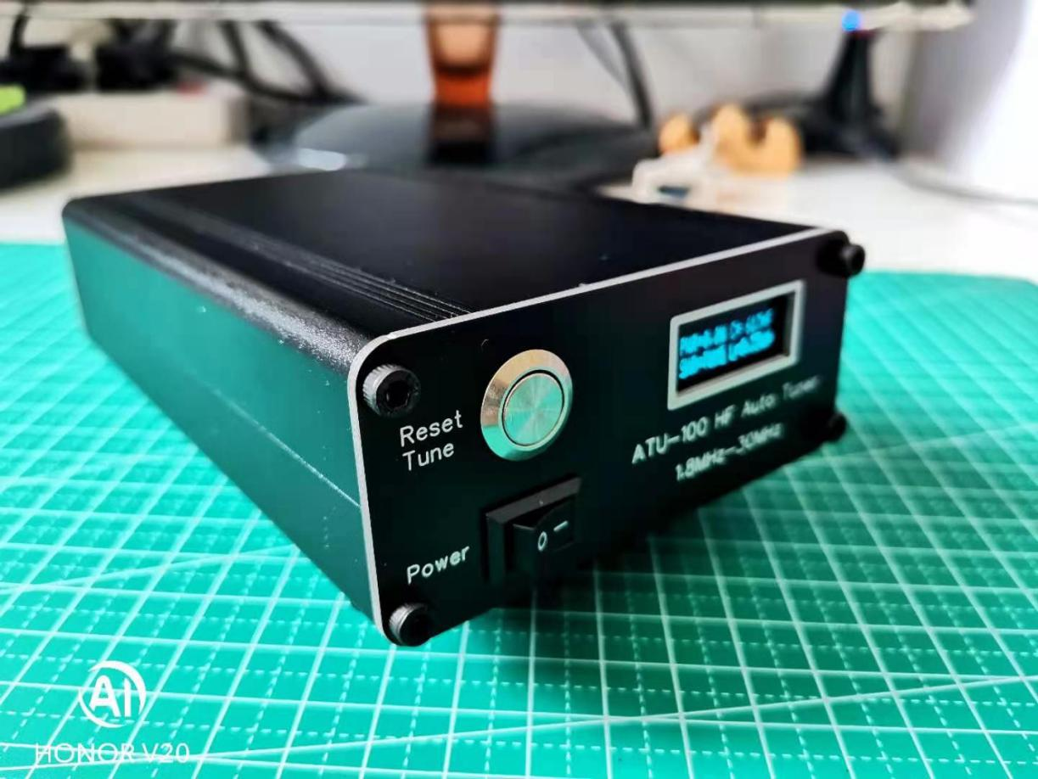

Note: The white object is 704 silica gel, which is a fixed air core inductor and magnetic loop inductor.

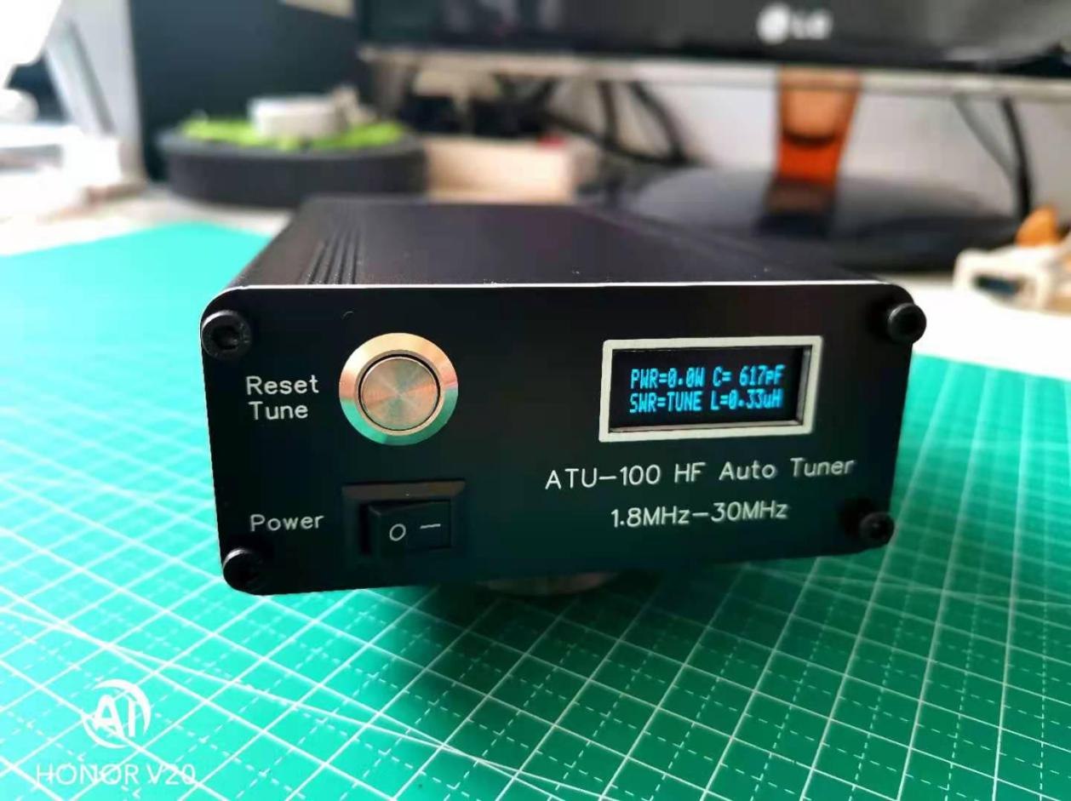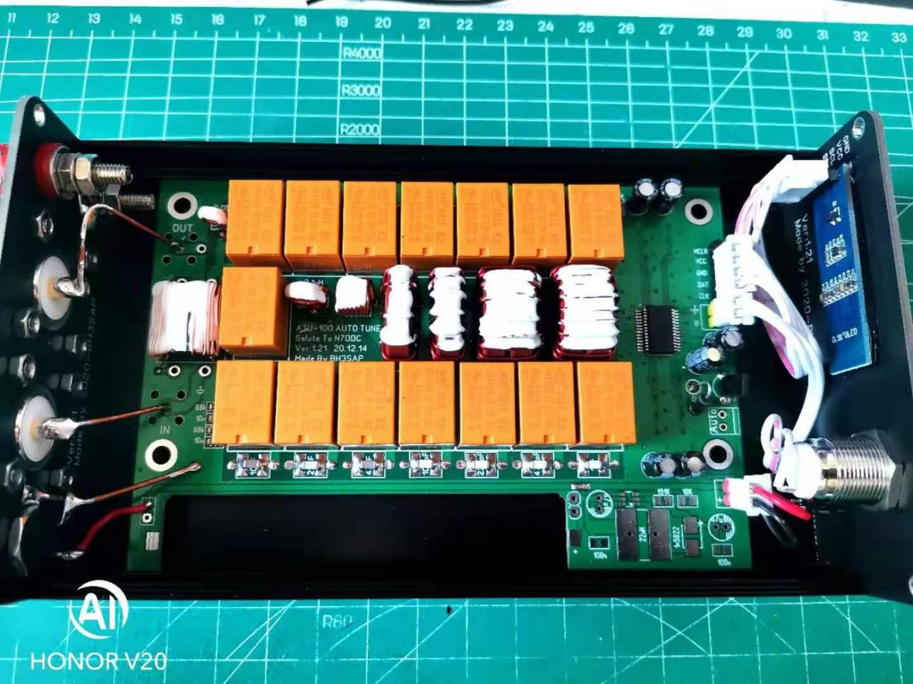

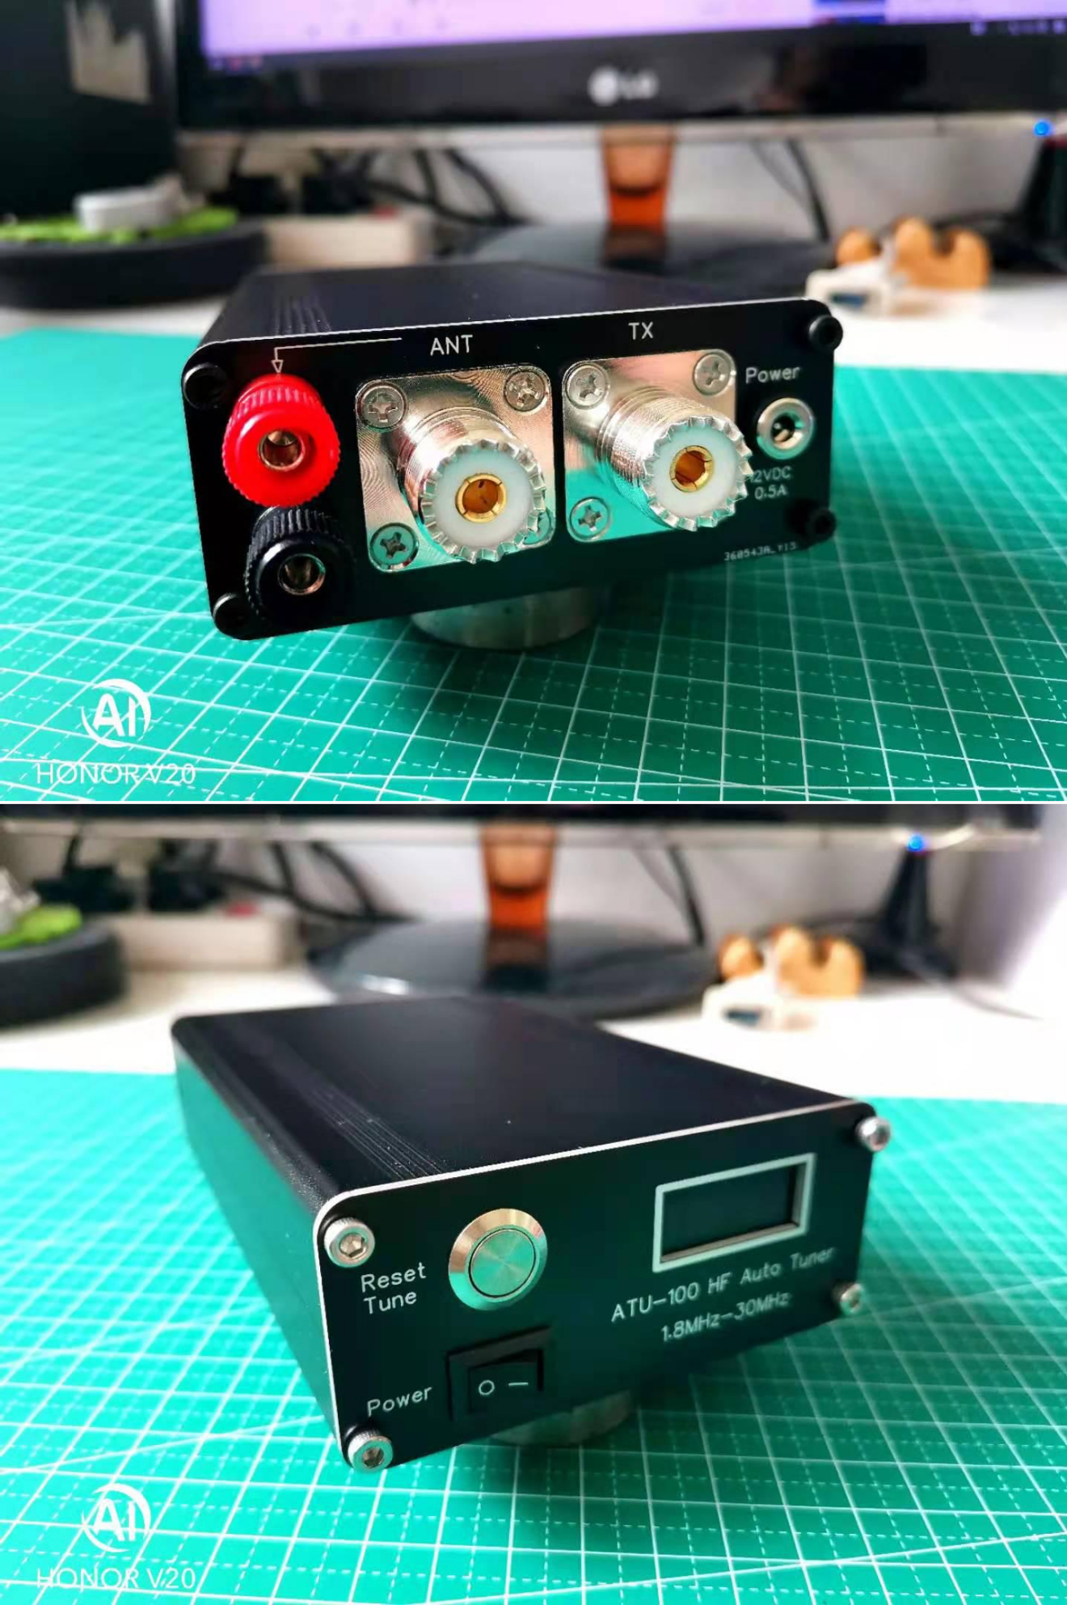

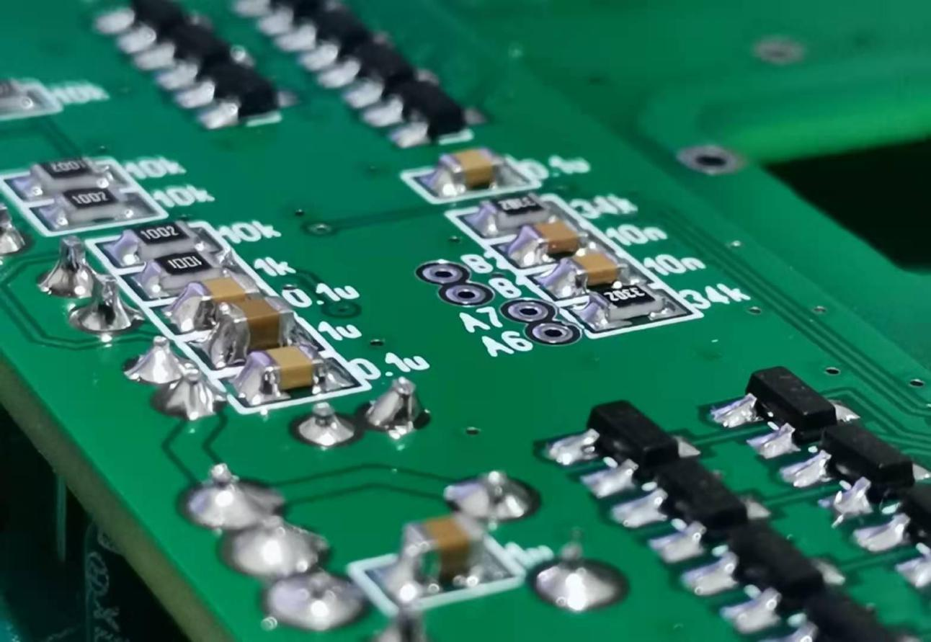

Instructions

The DC socket is connected to the power supply. The power supply is 10-15V, and the power switch is in the open position. Set the radio power to 5W-10W. Press and hold the RESET/TUNE button. The tune screen will display the word TUNE. Continuous power adjustment can automatically adjust. Short press the RESET/TUNE button, the tuning will release the previously adjusted LC relay, in the through position.

At present, the tuning is in manual mode, that is, the relay will adjust after long pressing the RESET/TUNE button.

The black and red binding posts are experimentally used for the adjustment of long wire antennas.

The Ver1.21 version adds the SX1308 booster circuit in the spare position of the motherboard (this part of the component needs to be purchased by the user), and the power supply mode can be switched through the reserved SMT pad. And add the Auto fully automatic mode interface on the motherboard to facilitate DIY grinding machine.

Note: The noise interference that may be generated after adding this DC-DC boost circuit is not used as a basis for product quality problems.

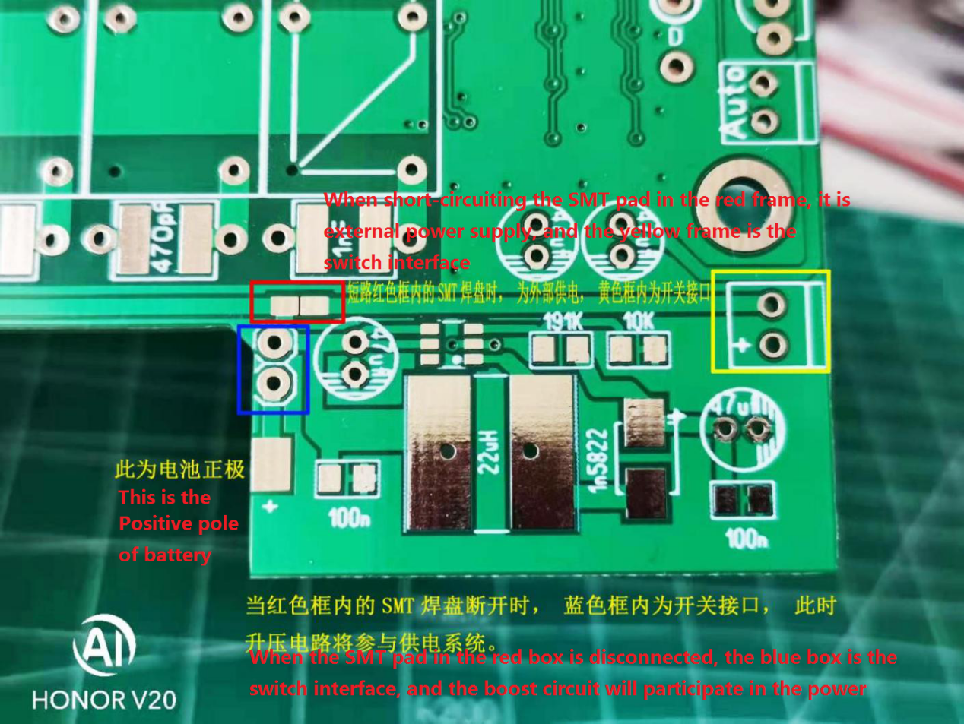

SX1308 is a fixed frequency, SOT23-6 enclosed current mode boost converter. The operating frequency of up to 1.2MHz allows the peripheral inductors and capacitors to choose smaller specifications. The built-in soft-start function reduces the starting inrush current. Built-in 80 milliohm power MOSFET, the highest boost efficiency can reach 97%

