All you need for this guide is a microcontroller, it can be Arduino or RaspberryPi or ESP8266. Here uses NodeMCU based on ESP8266. If you are using Arduino, you will need ESPWiFi module.
Hardware components:-NodeMCU
LCD display x1
Breadboard x1
Momentary switch x1
220 ohm resistor x1
10k ohm potentiometer x1
Software:-
ArdunioIDE. RemoteMe.org (register)

Step 2: Set variables on RemoteMe:-

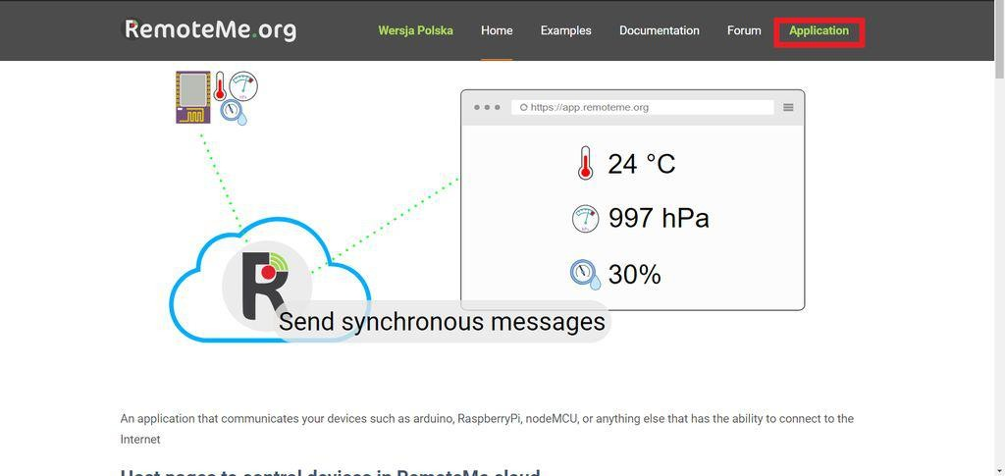

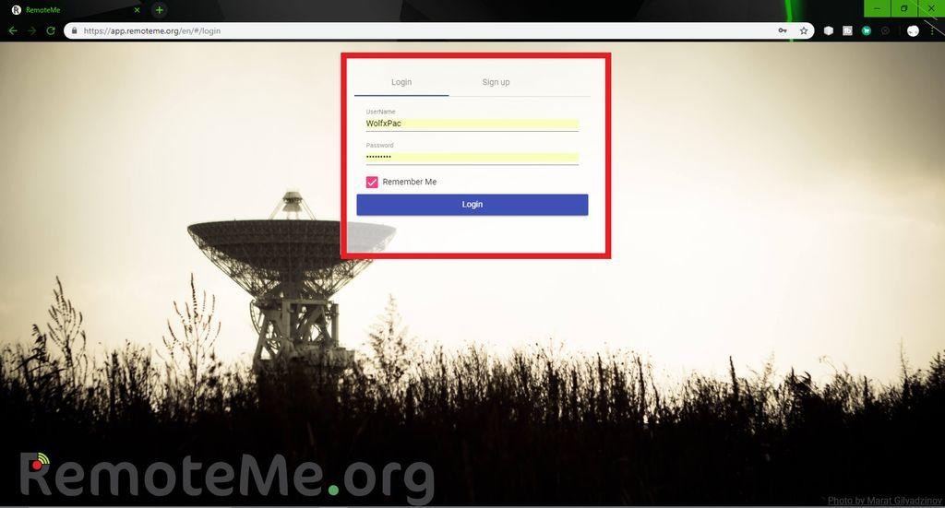
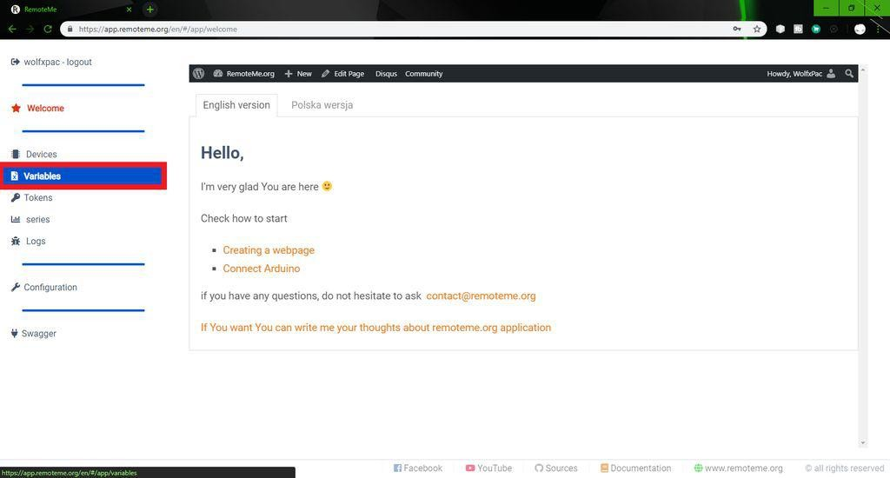

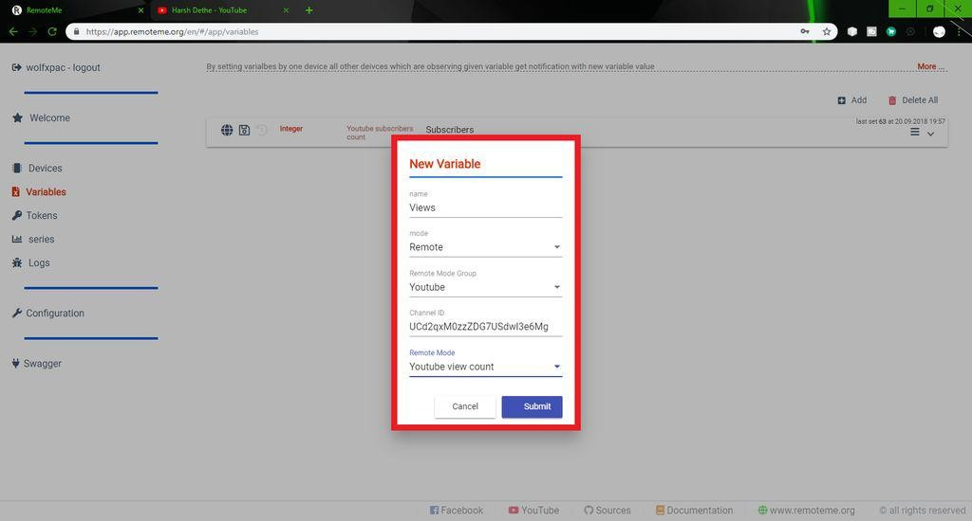

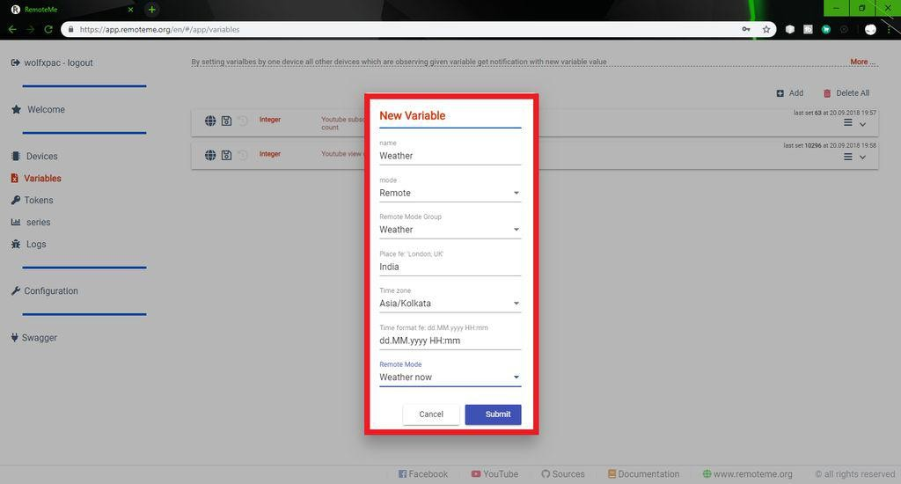
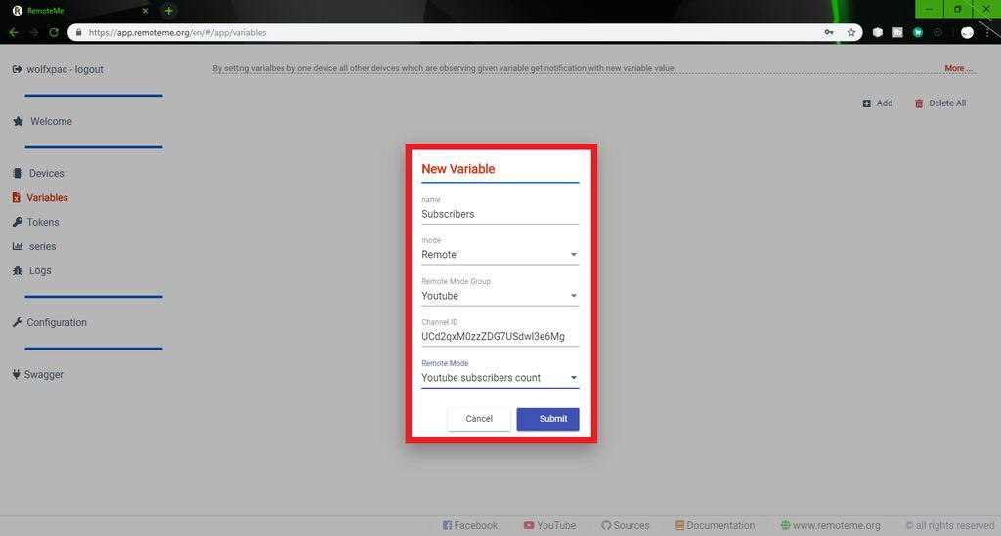

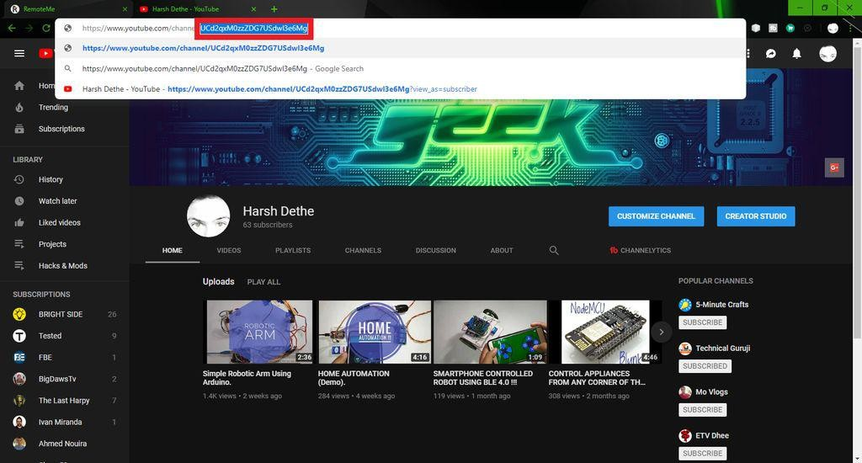

In this step we will set up variables and send data to our microcontroller. First visit RemoteMe.org and follow the steps below:- (Please refer to the picture above for better understanding.)
On the website, enter "Applications" and create an account if you don't have an account. Next, go to "Variables" (it's on the left side of the menu).
In the "Variable" option, there will be a blank page with the "Add" option in the upper right corner. click it. A pop-up window will appear.
Fill in the name of the variable in the pop-up window. It depends on what you want (subscriber count, view count or weather information).
Now select the server type "Remote", this group depends on the YouTube or weather data you want.
If you choose "YouTube", you need to know the channel ID, go to YouTube and search for the channel you want, open it and copy the code in the URL. (View image for reference.)
Now, in the "Remote Mode" option, select what you want (subscriber count or view count). And submit the data. It will create a variable. Also create more variables for other data you want.
Check the picture for more details.

Step 3: Set up the device on RemoteMe：-

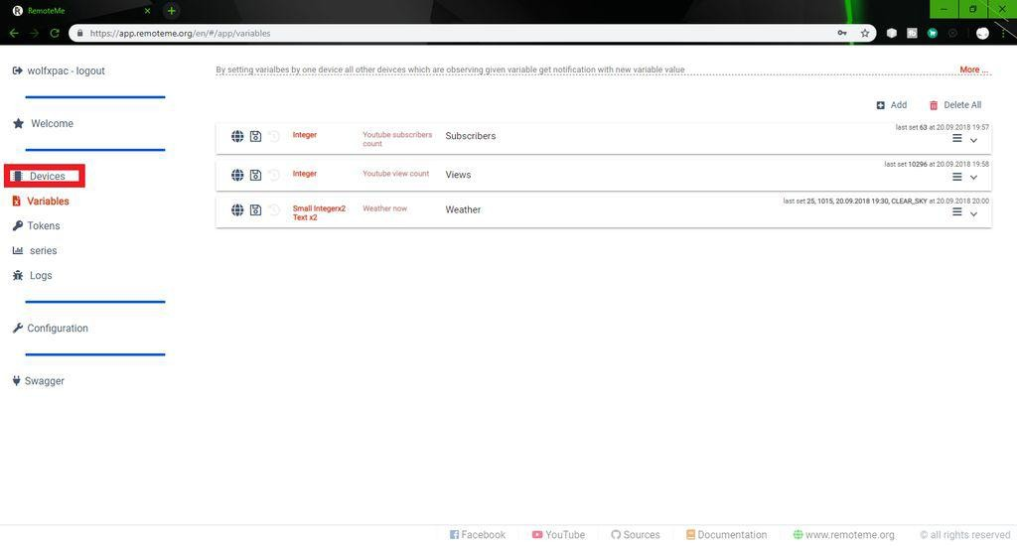

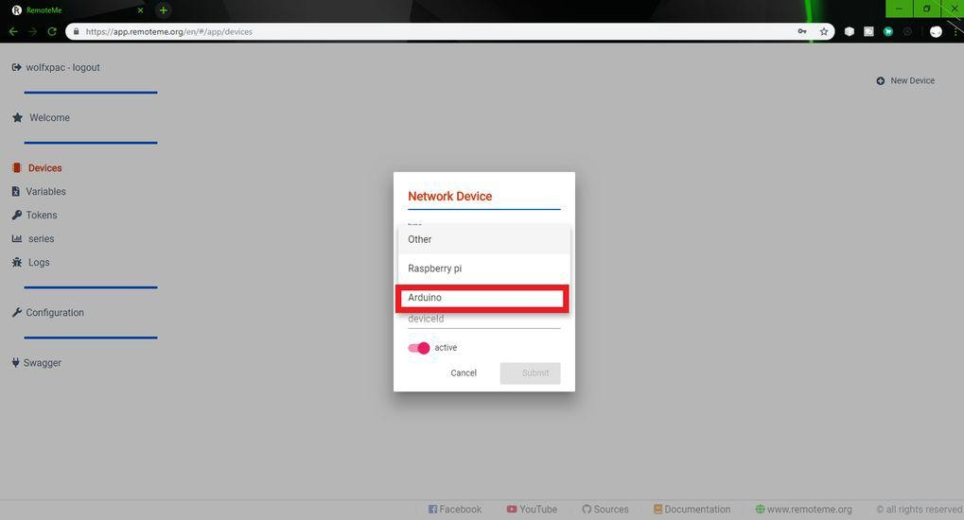

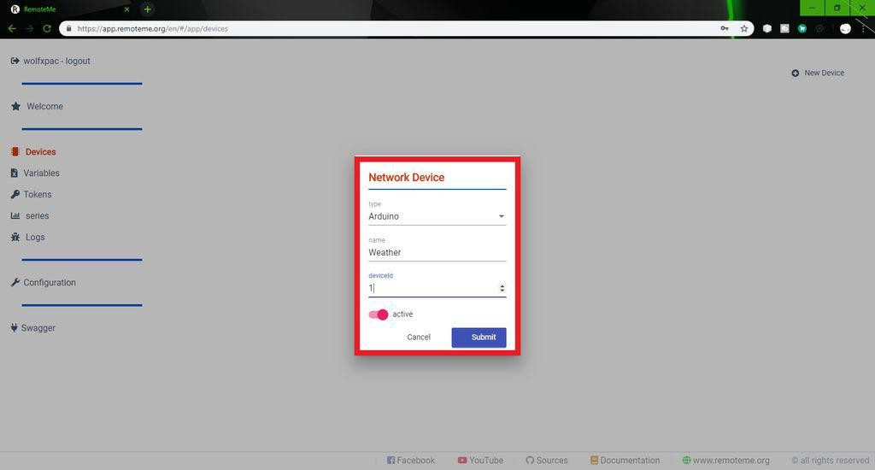

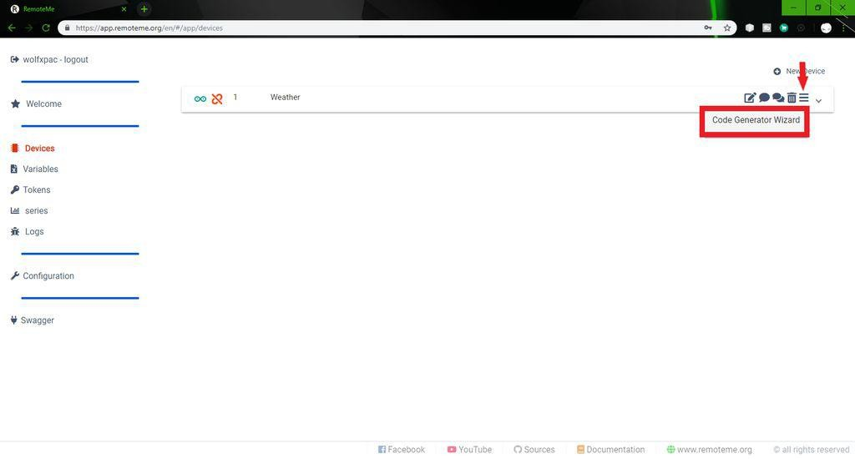
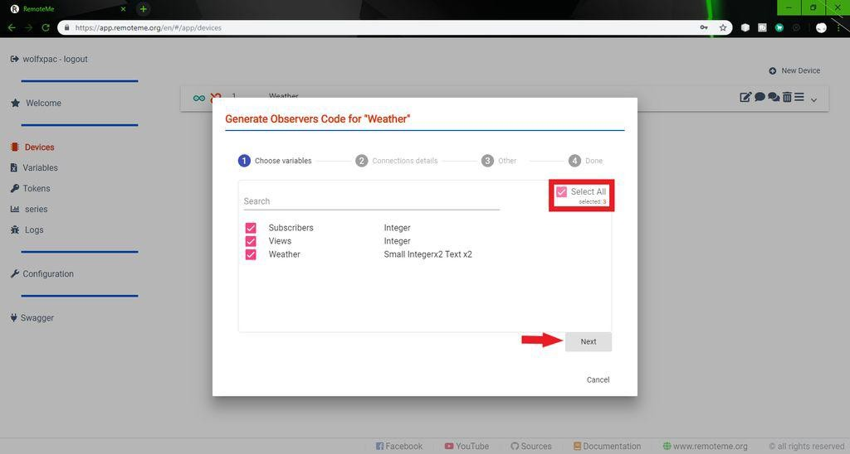

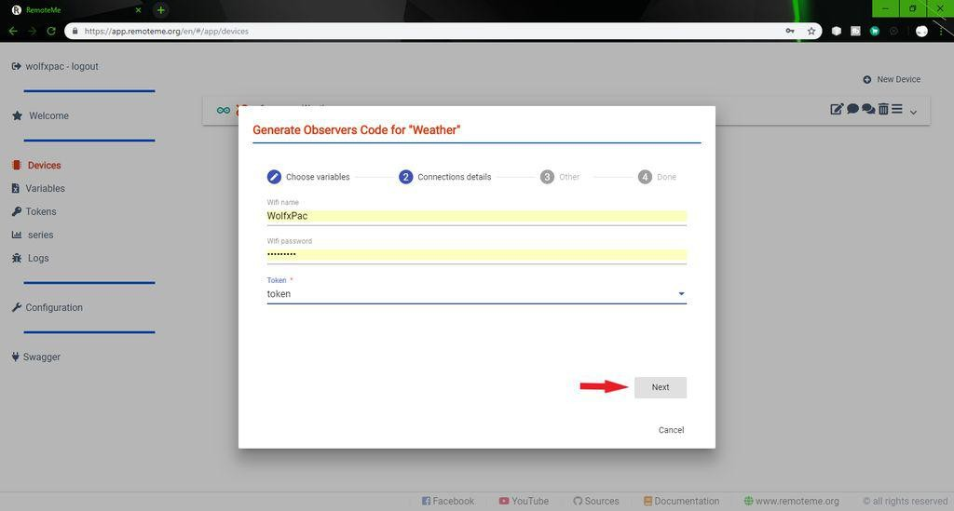
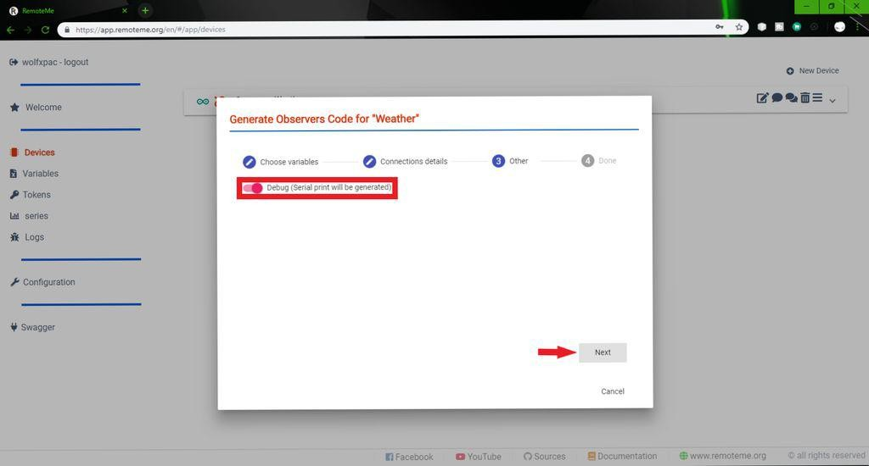

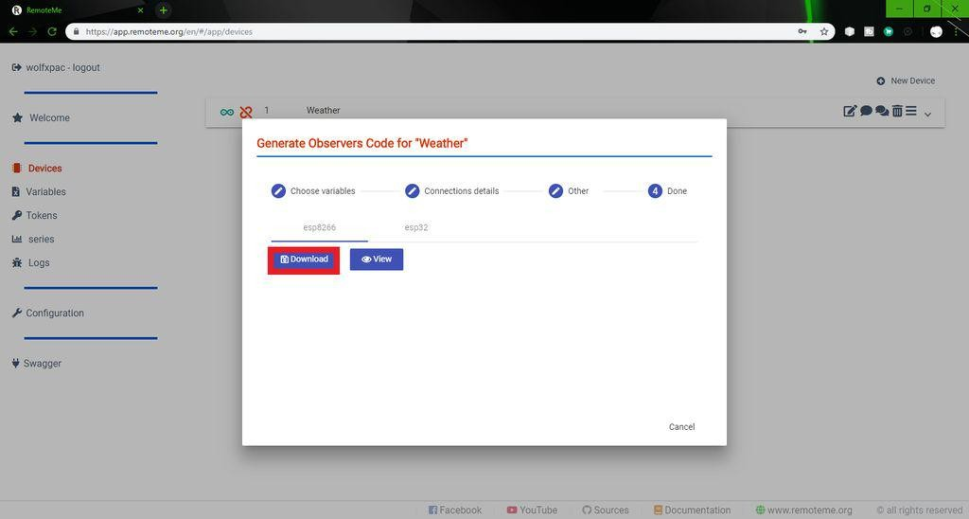
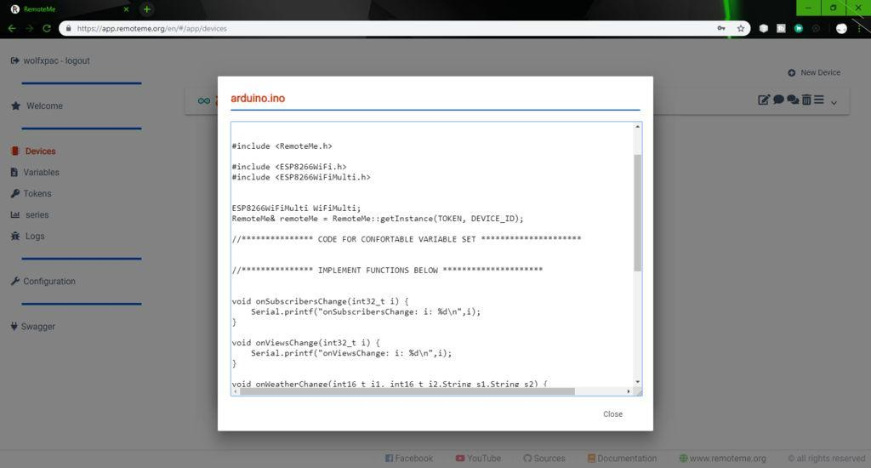

After finishing the variables, select the "Devices" option. It is located above "Variables". Here you must create a new device.
To create a new device, select the option in the upper right corner.
Select the "New Network Device" menu from the drop-down list. A pop-up window will appear. First select the type of device you are using. (For Arduino and NodeMCU, please select Arduino).
Name the device YouTube/Weather, whatever you want.
Provide a device ID, it can be anything, but give “1” for the first device. Submit now, a new device will appear.
Click the hamburger menu on the device. (Represented by 3 horizontal lines) and select "Code Generator Wizard".
Now select Variables, Select all and click Next.
Enter your WiFi name and password. Select the token in the token menu. Click Next. Open the debugging options and click Next.
Step 4: Coding:-
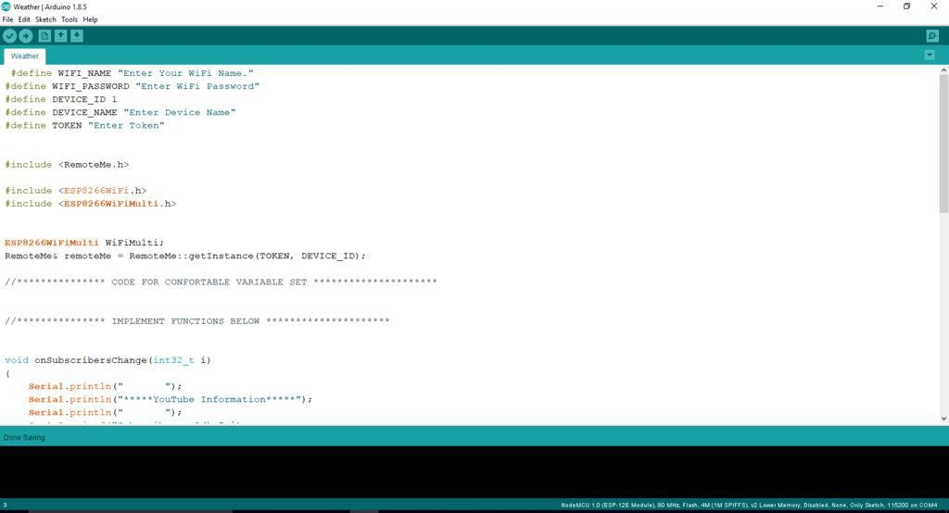

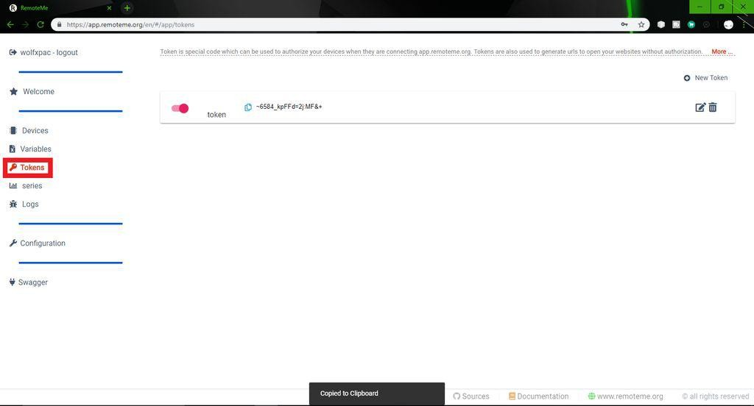

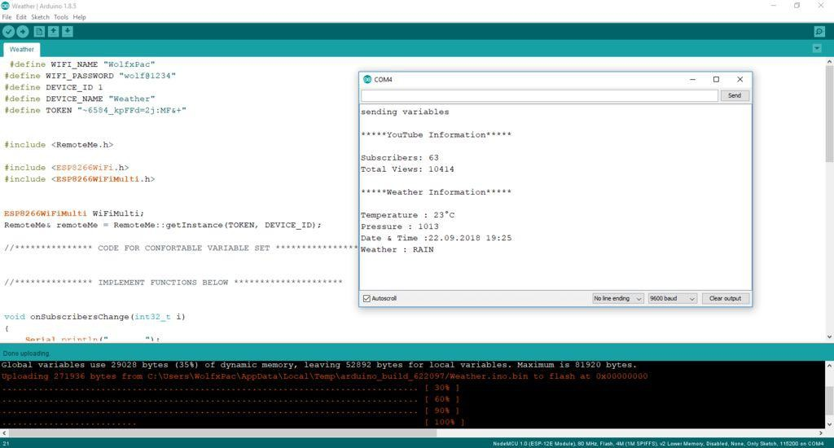

The downloaded code can now be uploaded to the microcontroller. To make the code effective, you need some libraries that can be installed from the library manager.
Install library:-
Go to "Sketch">"Include Library">"Manage Library.
Enter the name of the library in the search bar. (ESP8266WiFi, ESP8266WiFiMulti & amp;RemoteMe)

Now you can upload the code and open the serial monitor to watch the data.
Below some codes are provided, with a little editing to make the result more specific. You can download the code, add your WiFi name and password in the required fields. Also add the device ID used in the previous step ("1").
To manually add a token, go to RemoteMe >"Applications" >"Token". Copy the token and paste it on the code. Upload and check the results of the serial monitor.
Note:-To use arduinoIDE to program the ESP board, you must set up the IDE. If you don't know, you can refer to this tutorial.
Step 5: Display data on LCD：-
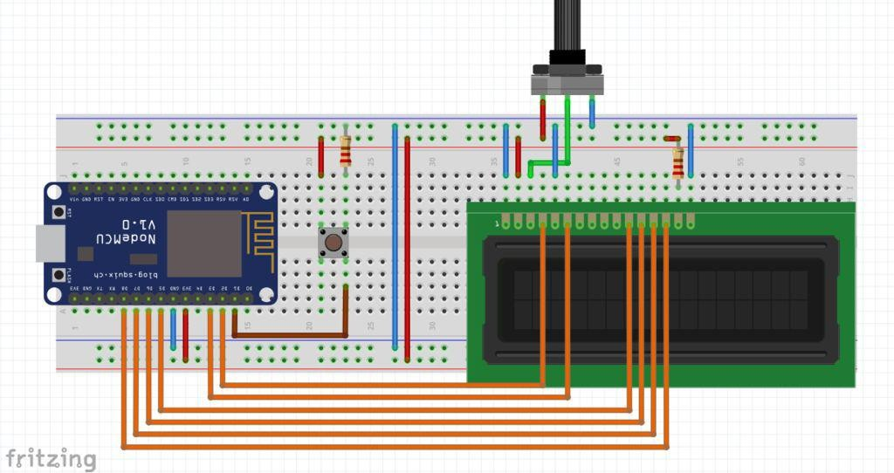

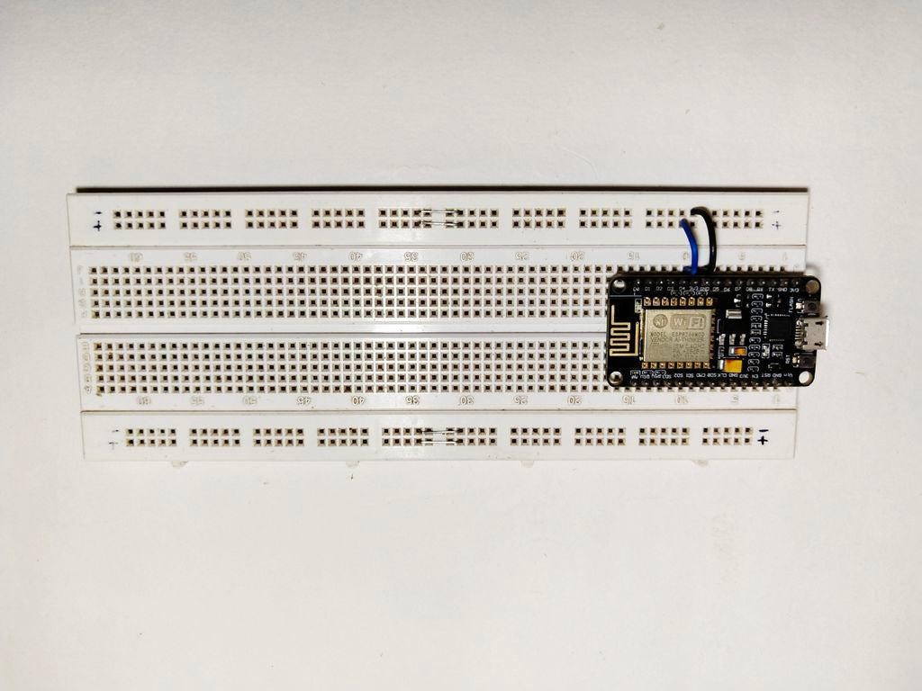

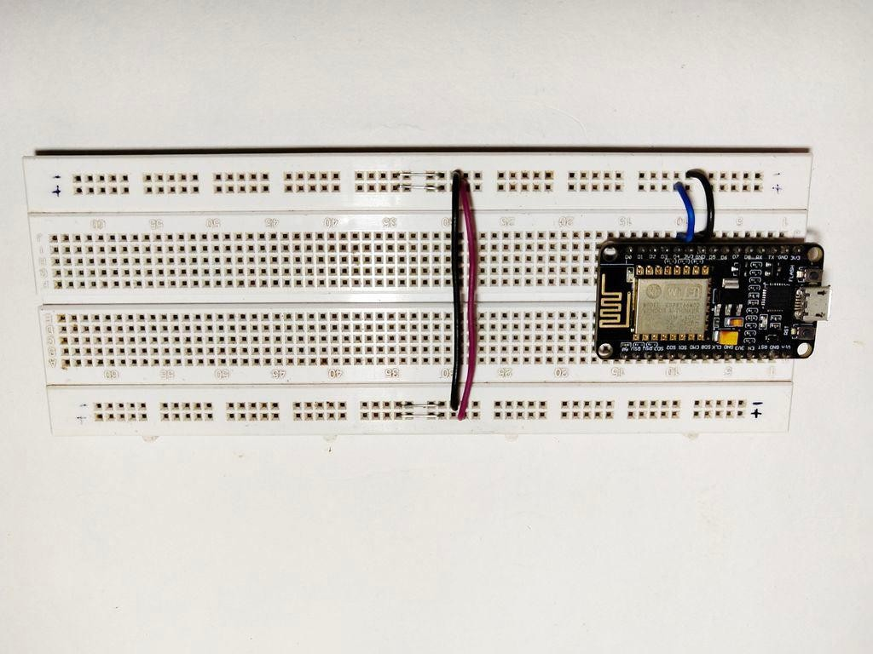

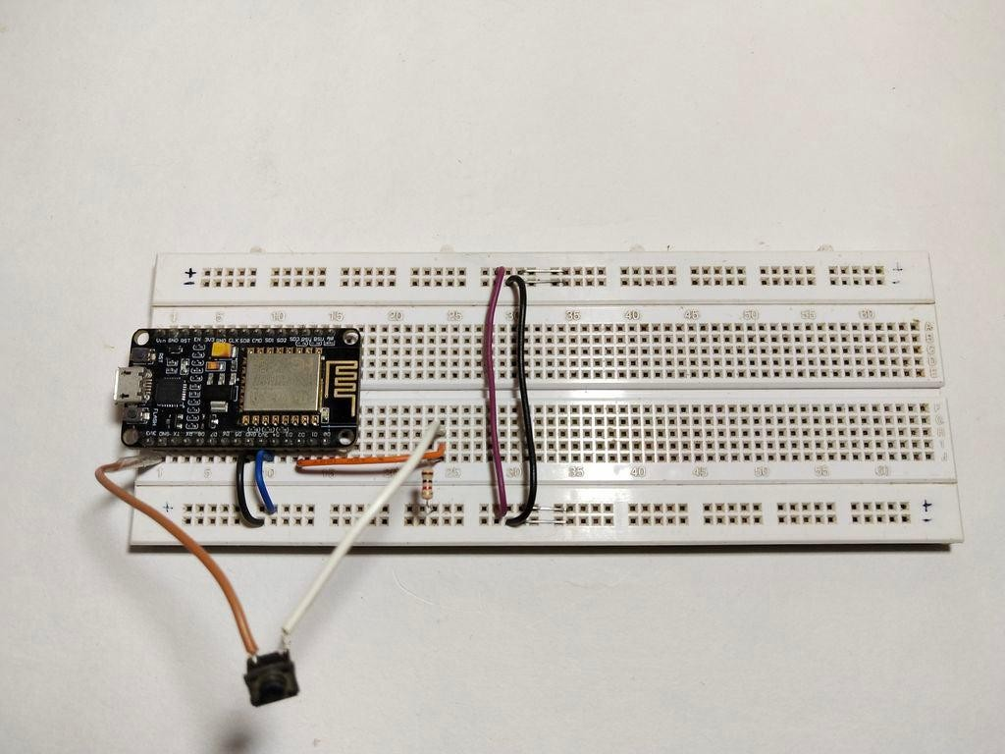

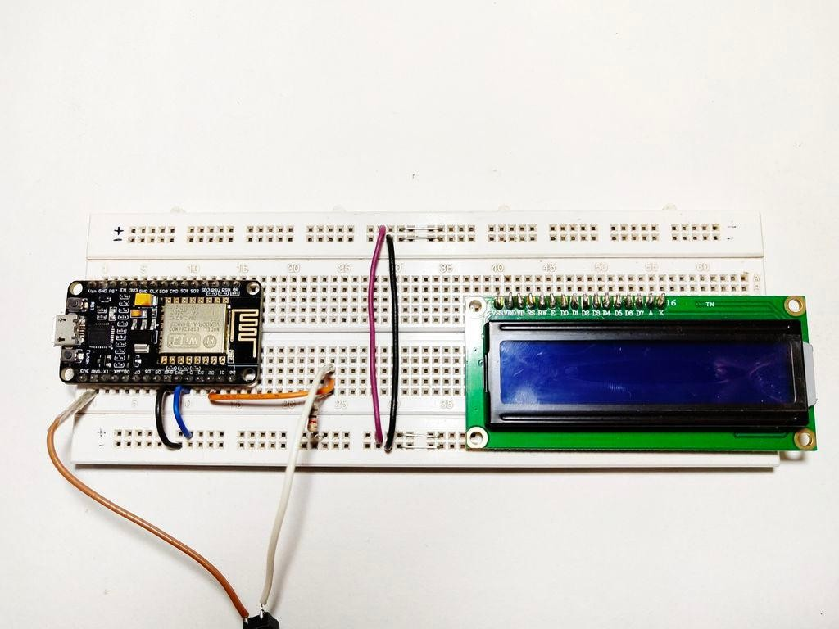

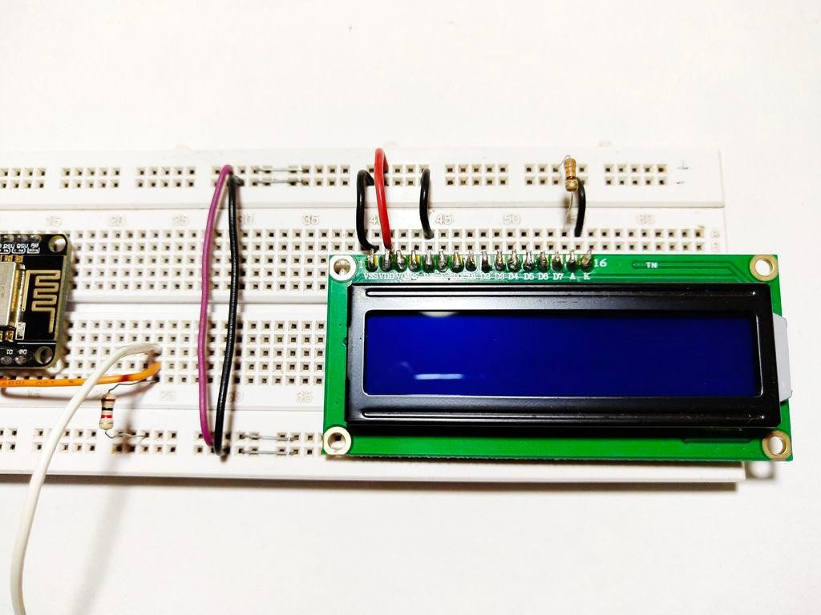
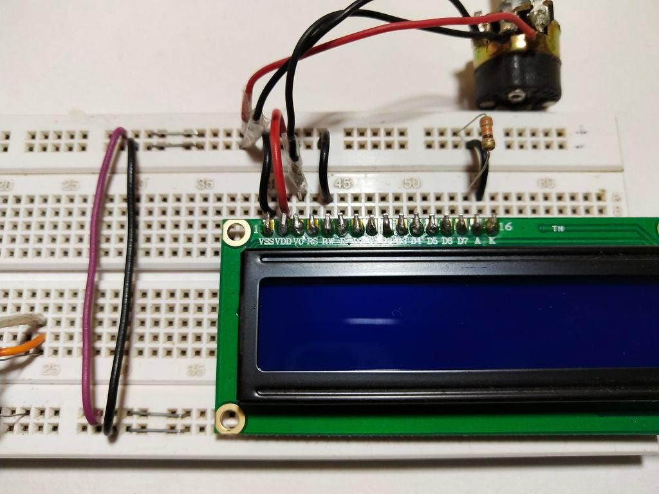

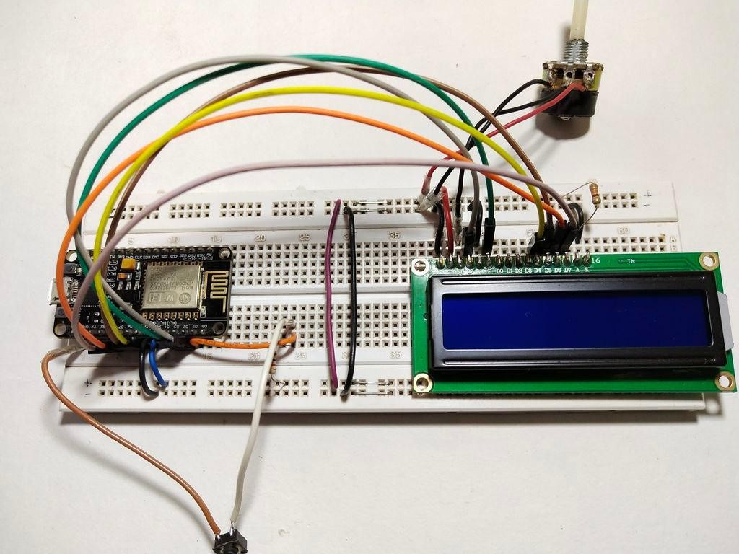

Now that the data has been successfully displayed on the "Serial Monitor", then can continue to be displayed the data on the LCD screen to make the project more portable.
Please follow the steps below carefully:-
First put the NodeMCU board (ESP8266) on the breadboard, and connect its "3.3v" to the "+ve" track of the breadboard and the "Gnd" to the "-ve" track.
Connect the button next to the MCU and connect one of its pins to the "-ve" track of the breadboard via a "220ohm" resistor. And connect the same pin to the "D2" pin of the MCU. Connect the other pin of the button to the "+ve" track of the breadboard.
Now connect the LCD on the breadboard and follow the connection carefully. VSS >> -verail of the breadboard.
VDD >> +verail.
V0 >> The middle terminal of the potentiometer. (Connect the other two terminals to -ve and +ve)
RS >> D2
RW >> -verail.
E >> D3 MCU

D4>>D5
D5>>D6
D6>>D7
D7>>D8
A >> +ve rail board via a 220 ohm resistor. K >> -verail
I know this is a bit confusing, but please refer to the picture for a better understanding. When it's done, the connection is ready, now just upload the code.
You need to edit the code to use the LCD. Let us edit the previous code:
#defineWIFI_NAME“WiFiName”
#defineWIFI_PASSWORD“WiFiPassword” #defineDEVICE_ID1 #defineDEVICE_NAME“DeviceName” #defineTOKEN“AddToken” #definebtnD1//Declareabuttonvariableforpushbutton #include
#include #include #include
#include//includinglibrarytouseLCD
LiquidCrystallcd（D2，D3，D5，D6，D7， D8）;//mappingLCDpinstoESP‘spins
/*VariablestostoredatafromRemoteMe*/ int16_ti，i1，i2，temp，pres; int32_tsubs，views; Stringhr;//Onlyneededifyouwanttodisplaytime. longlastDebounceTime=0，
debounceDelay=50;//Toeliminatebuttonbouncing.

ESP8266WiFiMultiWiFiMulti; RemoteMe&remoteMe=RemoteMe：：getInstance（TOKEN，DEVICE_ID）; voidonSubscribersChange（int32_ti）
{
subs=i;//Storingsubscriberdatainvariable’subs‘
}
voidonViewsChange（int32_ti）
{
views=i;//Storingviewsinvariable’views‘
}
voidonWeatherChange（int16_ti1，int16_ti2，Strings1，Strings2）
{
temp=i1;//storingtemperature pres=i2;//StoringPressure
}
/*Newfunctionstodisplaythestoreddata*/ voidyoutube（）
{
//DisplayYouTubeinfo. Serial.printf（“Subscribers：%d”，subs）; Serial.printf（“Views：%d”，views）; lcd.clear（）; lcd.printf（“Subscribers：%d”，subs）; lcd.setCursor（0，1）; lcd.printf（“Views：%d”，views）; lcd.setCursor（0，0）;
}
voidweather（）

{
//Displayweatherinfo. Serial.printf（“Temparature：%d°C”，temp）; Serial.printf（“Pressure：%dPa”，pres）; lcd.clear（）; lcd.printf（“Temperature：%d”，temp）; lcd.setCursor（0，1）; lcd.printf（“Pressure：%d”，pres）; lcd.setCursor（0，0）;
}
voidsetup（）
{
Serial.begin（9600）; lcd.begin（16，2）; pinMode（btn，INPUT）;
WiFiMulti.addAP（WIFI_NAME，WIFI_PASSWORD）; while（WiFiMulti.run（）！=WL_CONNECTED）
{
delay（100）;
}
remoteMe.getVariables（）-》observeInteger（“Subscribers”， onSubscribersChange）;
remoteMe.getVariables（）-》observeInteger（“Views”， onViewsChange）;
remoteMe.getVariables（）-》observeSmallInteger2Text2
（“Weather”，onWeatherChange）; remoteMe.sendRegisterDeviceMessage（DEVICE_NAME）; Serial.print（“Connected. 。 .”）; lcd.print（“Connected.。.”）;

}
voidloop（）
{
intbtn_state=LOW;//buttonstateisinitiallysetLOW staticintflag=0;//flagisset0 btn_state=digitalRead（btn）;//buttoninputisread. if（（millis（）-lastDebounceTime）》debounceDelay）
{
if（（btn_state==HIGH）&&（flag==0））//ifbuttonispressed&flagis0
{
weather（）;//showweatherdata flag=1;//setflagto1
}
elseif（（btn_state==HIGH）&&（flag==1））
//ifbuttonispressed&flagis1
{
youtube（）;//showYouTubeinfo flag=0;//setflagto0
}
lastDebounceTime=millis（）;
}
remoteMe.loop（）;
}
Therefore, after making changes, you can upload the code to the board and you should see "Connected..." on the LCD and the serial monitor.
Download the code from below:-

Step 6: Test:-
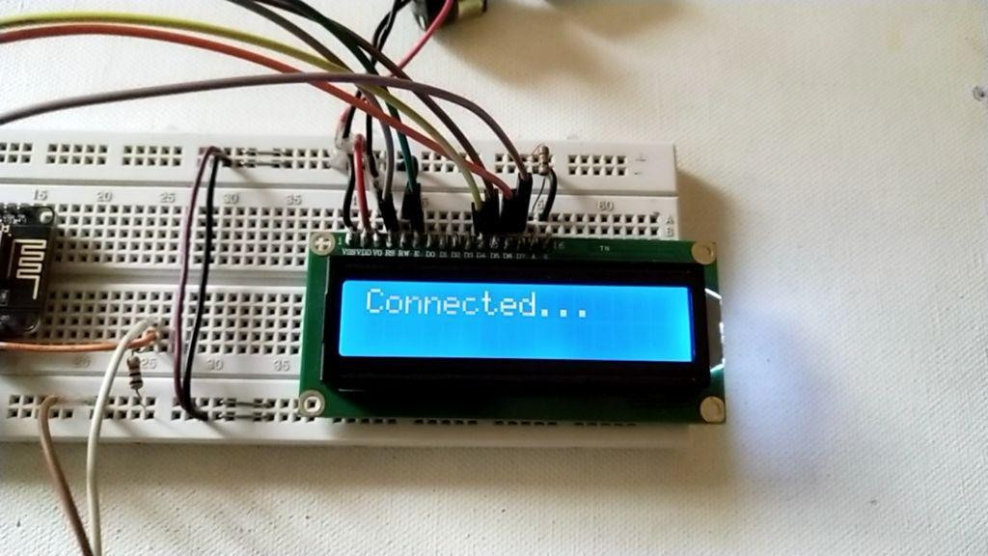
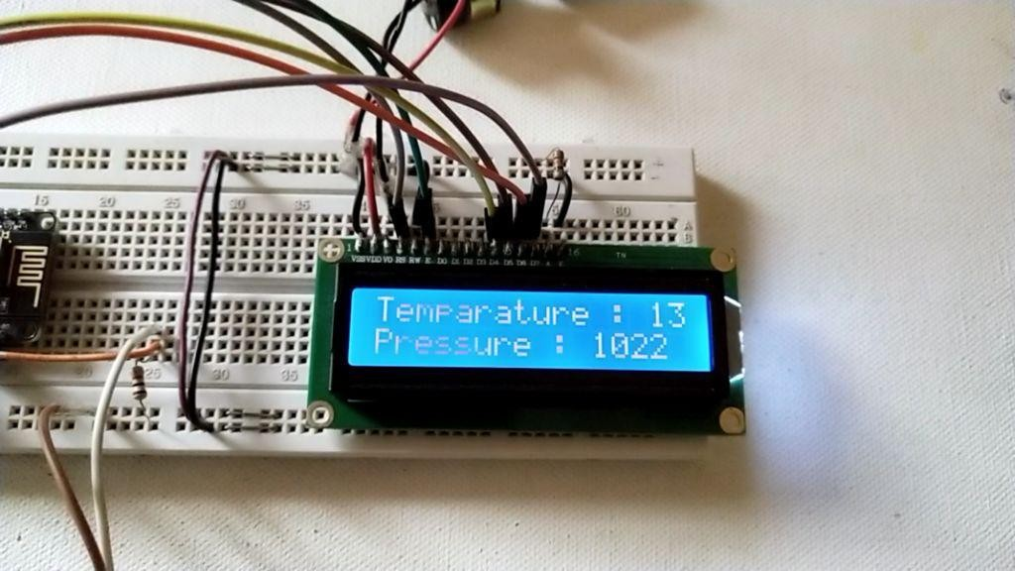

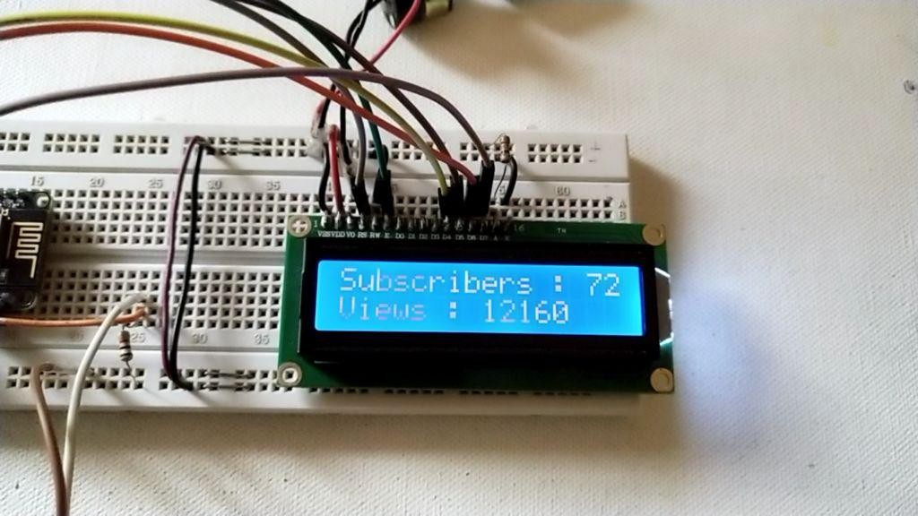

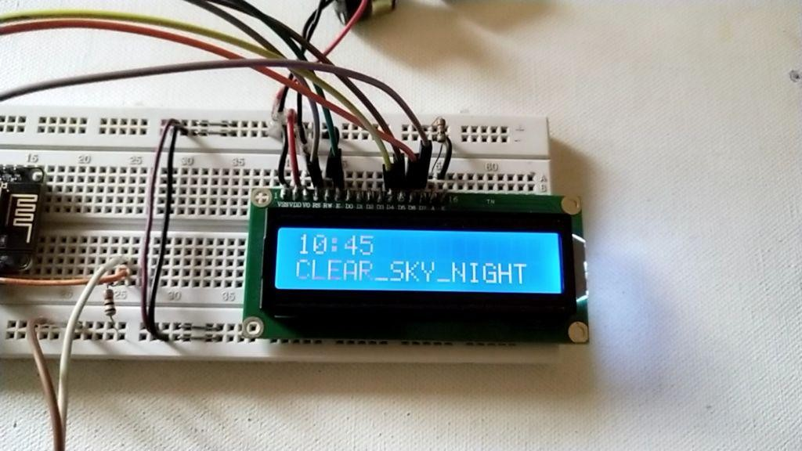

After the code is up and running, you can test whether everything is normal.
When the ESP board is connected to the network, the LCD will display "Connected..."
Press this button, it will display the weather (temperature and pressure information), and press it again, it will display the YouTube user and aggregate views.
You can edit the code to display other information such as time, weather conditions, etc.

