**用户手册**

User Manual

V1.0

**一、按键介绍**

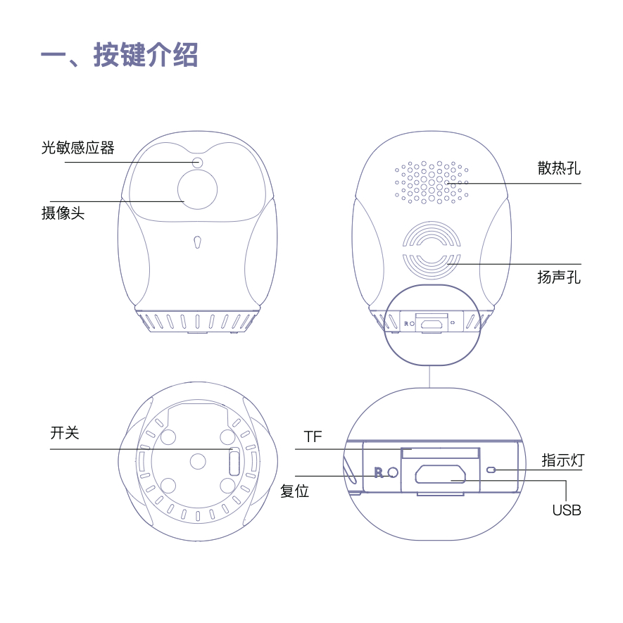

**二、APP下载**

如图所示， 用手机扫描下面的二维码下载 V380Pro APP，安装并注 册登陆。

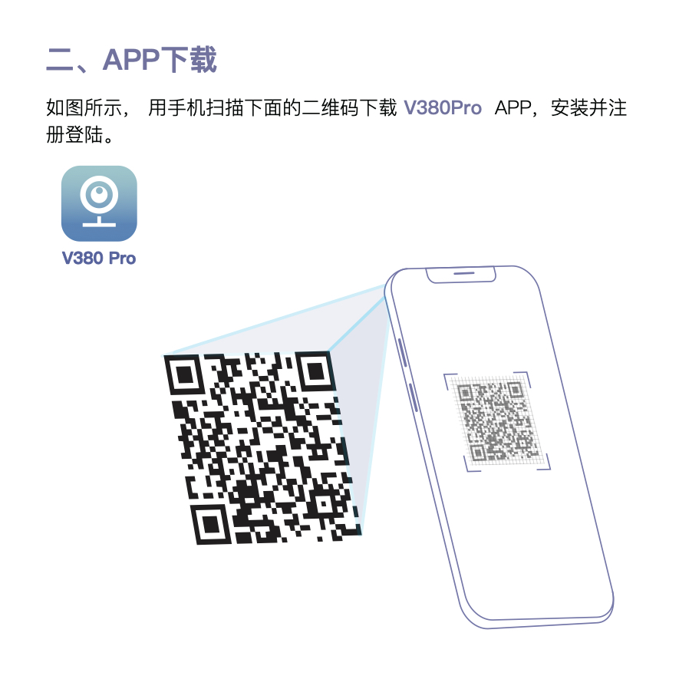

**三、配置网络**

**AP 快速配置**

1、当听到设备语音提示 “热点建立完毕”;  
2、打开 APP，点击界面右上角 ，然后点击 “添加设备”，点击 “无线智能摄像机”， 按提示接入电源后点击 “下一步”;  
3、点击 “热点建立完毕”，按提示，手机连接 MV******** 开头的 Wi-Fi，返回 APP 界面，点击 “下一步”，选择一个摄像机需要连接的 Wi-Fi 网络，然后输入 Wi-Fi 密码确认，会听到设备提示 Wi-Fi 连接中，稍等片刻，APP 提示添加完成， 设备提示音 Wi-Fi 连接完成，设置设备名字确认即可。

**注意:**

设备不支持连接 5G 信号 Wi-Fi。 连

接失败请检查手机以及 Wi-Fi 网络是否顺畅。

连接失败请尝试长按摄像机复位孔设备后再次尝试联网。

长按复位孔5秒进行复位，且会有语音提示。

**四、操作界面介绍**

**布撤防:**

一键布防开启后，设备自动推送报警消息至手机。

**云储存商城:**

云储存套餐购买和选择(云储存要在设备已设置远程监控后才能使用)。

**分享设备:**

设备已设置远程监控后给好友发送共享摄像机邀请，对方可一同观看监控画面(对 方需注册V380账号)。

**删除设备:**

删除该摄像机，不再监控。

**设置:**

设备的具体设置比如修改密码、录像、报警、语言、IP等等。

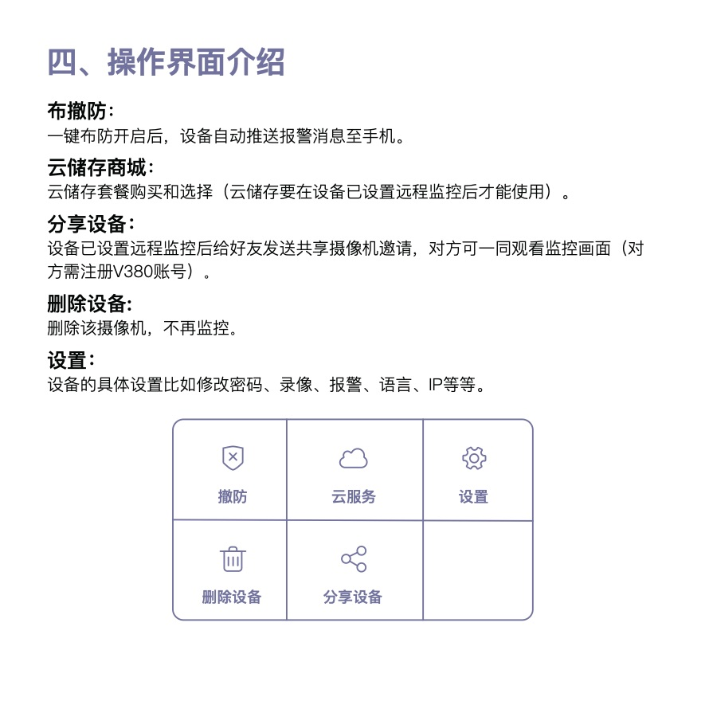

**五、设备录像设置**

**自动录像:**

全天 24 小时录像，录像时长为 10 分钟一段视频，默认循环录像(该功能需要插入 内存卡)

**报警录像:**

在开启布防后，移动侦测报警会自动拍摄一段 20 秒到 2 分钟的视频保存在内存卡或 者云服务器上。(需购买云储存套餐，视频才能保存在云服务器上)

**录像音频:**

开启该功能后，TF 卡录像才能实现音频同步。录像分辨率:可以选择 “高清”、“普清”

**六、设备功能简介**

**实时预览:**

登陆手机客户端，查看实时监控录像

**录像回放:**

通过手机客户端对存储卡或者云储存的录像进行回放

**云储存:**

录像云端高效、安全存储，多种套餐

**AI人脸识别:**

检测人员入侵，极大减少非人员走动产生的误报报警推送:设备检测异常情况，发 送报警图片至手机客户端(该功能需要在APP购买，具体以APP服务为准)

**七、提醒事项**

**视频卡顿:**

远程监控不流畅。检查当前网络状态，请根据当时的网络环境选择适合的清晰度。

**内存卡:**

内存卡不保存视频，第一次使用内存卡必须要格式化一次。注意使用正品品牌的内 存卡。

**联网失败:**

连接不上网络，请根据自己的网络性质，选择连接方式，检查当前网络状态。

**云储存绑定:**

一份云储存只能绑定一台摄像机设备。

**忘记密码:**

密码不小心忘记，请直接按设备复位键5秒，恢复出厂设置。

**AI人形侦测:**

AI人形侦测报警是云储存的一个套餐，购买云储存套餐后会优先人形侦测报警。 (具体以APP上服务为准)

**内存卡录像:**

内存卡录像是10分钟一段，循环录像的，不能改的。

**八、注意事项**

**安全信息**

·使用和操作设备前，请阅读并遵守下面的注意事项，以确保设备性能最佳，并避免出现危险或非法情况

**电子设备**

有明文规定禁止使用无线设备的场所，请勿使用本设备，否则会干扰其它电子设备或导致其他危险。

**对医疗设备对影响**

·在明文规定禁止使用无线设备的医疗和保健场所，请遵守该场所的规定，并关闭设备。

·设备产生的无线电波可能会影响植入式医疗设备或个人医用设备的正常工作，如起搏器、植入耳蜗、助 听器等。若你使用了这些医疗设备，请向其制造商咨询使用本设备等限制条件。

·在使用本设备时，请与植入等医疗设备(如起搏器、植入耳蜗等)保持至少15厘米等距离。

**易燃易爆区域**

·在加油站(维修站)或靠近易燃物品、化学制剂等任何易燃区域，请勿使用本设备，并遵守所有图形或文字的指示。在燃油或化学制剂存放和运输区或易爆场所或周围设备可能引起爆炸或起火。

**交通安全**

·遵守所在地区或国家的相关规定，驾车时请勿使用本设备。

·谨记安全驾驶是您的首要职责，请勿从事会分散注意力的活动。

·汽车的电子设备可能会因设备的无线电干扰而出现故障，请联系制造商咨询详情信息。

·请勿将设备放在汽车安全气囊上方或安全气囊展开后能够触及的区域。否则当安全气囊膨胀时，设备就 会受到很强的外力推动而对车内人员造成严重对伤害。

**操作环境**

·请勿在多灰、潮湿、肮脏或靠近磁场的地方使用设备，以免引起设备内部电路故障。

·请勿在雷雨天气使用本设备。雷雨天气可能会导致设备故障或电击危险。  
·请在温度0°C~35°C 范围内使用本设备，并在温度-40°C~70°C 范围内存放设备及其配件。当环境温度 过高或过低时，可能会引起设备故障。

·请勿将设备放置在阳光直射的地方，如窗台处。

·请避免设备及其配件雨淋或受潮，否则可能导致火灾或触电危险。

·请勿将设备靠近热源或裸露的火源，如电暖器、微波炉、烤箱、热水器、火炉、蜡烛或其他可能产生高 温的地方。

·请勿将大头针等尖锐金属物品放置在设备听筒或扬声器附近，以免金属物品附着，对您造成伤害。

·设备在运行一段时间后，设备温度会升高。如果设备温度过高，请勿长时间接触，否则可能导致烫伤， 引起皮肤红肿或色素沉淀。

·请勿让儿童或宠物吞咬设备或其配件，以免对其造成伤害或导致设备故障或爆炸。

**儿童健康**

·本设备及其配件可能包含一些小零件，请将设备及其配件放置在儿童接触不到的地方。儿童可能在无意 之中损坏本本设备及其配件，或吞下小零件导致窒息或其他危险。

·本设备并非玩具，儿童应在成人监护下使用设备。

**充电器安全**

·设备使用是需要连接充电器，电源插座应安装在设备附近并应易于触及。

·当不使用设备充电时，请断开充电器与设备的连接并从电源插座上拔掉充电器。

·请勿摔落或碰撞充电器。充电器外壳受损时请联系客服中心进行更换。

·若充电器插头或电源线已损坏，请勿继续使用，以免发生触电或火灾。

·请勿用湿手触碰设备或充电器，以免发生设备短路、故障或触电。

·充电器被雨淋、液体浸湿或严重受潮时，请停止使用，并联系客户服务中心进行更换。

·充电器必须满足标准《GB4943.1信息技术设备的安全》中“2.5受限制电源”的要求。

·若设备需要连接USB端口，请确认USB端口具备USB-IF标识且其性能符合USB-IF的相关规范。

**电池安全**

·请勿将金属物导体与电池两极对接，或接触电池的端点，以免导致电池短路，以及因电池过热而引起的 烧伤等身体伤害。

·请勿将电池暴露在高温处或发热设备等周围，如日照、取暖器、微波炉、烤箱或热水器等。电池过热可 能引起爆炸。

·请勿拆解或改装电池、插入异物、或浸入水中或其他液体中，以免引起电池漏液、过热、引起、起火或 爆炸。

·如果电池漏液，请勿使皮肤或眼睛接触到漏出的液体，若接触到皮肤或眼睛上，请立即用清水冲洗，并 到医院进行医疗处理。

·如果电池在使用、充电或保存过程中有变色、变形、异常现象，请停止使用并联系客户服务中心更换新 电池。

·请勿把电池扔到火里，否则会导致电池起火和爆炸。

·请按当地规定处理电池，不可将电池作为生活垃圾处理。若电池处置不当可能会导致电池爆炸。

·请勿让儿童或宠物咬电池，以免对其造成伤害或导致电池爆炸。

·请勿跌落、挤压或穿刺电池。避免让电池遭受外部大的压力，从而导致电池内部短路和过热。

·请勿使用以及损坏的电池。

·本设备配有不可拆卸的内置电池。请勿自行更换电池，以免损坏电池或设备。电池只能由客户服务中心 更换。

**九、法律声明**

**免责条款和责任限制:  
本质量保证覆盖本产品的正常指定途径。本质量保证不适用于:  
A. 因意外、滥用、不合理使用、搬运不当及保管不善或其他非材质或做工缺陷引起的外因而造成的损害;  
B. 由我司授权代表以外的人进行检修所造成的损坏;  
C. 最终用户安装的任何硬件、软件或其他附加组件造成的损坏;  
D. 如果通过任何方式拆卸或改装了本产品;  
E. 外表损坏、包括但不限于刮痕、凹痕或产品外壳碎裂，或正常磨损和撕裂。我司对产品缺陷的责任限于换 货、维修或者本产品的购买价格退款。所有明确和暗示的质量保证的时限遵循本质量保证条款的规定，包括 但不限任何暗示的质量保证以及适销性和针对特定用途的适用性的条件。如果本质量保证的任何条款违法 或不能执行，其余条款的合法性或者执行性不受影响或不受损。除非本质量保证有所规定并且符合法律法 规，否则我司不对因违反质量保证或条件任何其他法律理论导致的任何方式引起的对直接、特殊、附带或从 属损害负责。上述限制不适用于死亡或人身伤害索赔，或任何针对故意和重大过失行为和 / 或疏忽的法定责 任。**

**I、Button introduction**

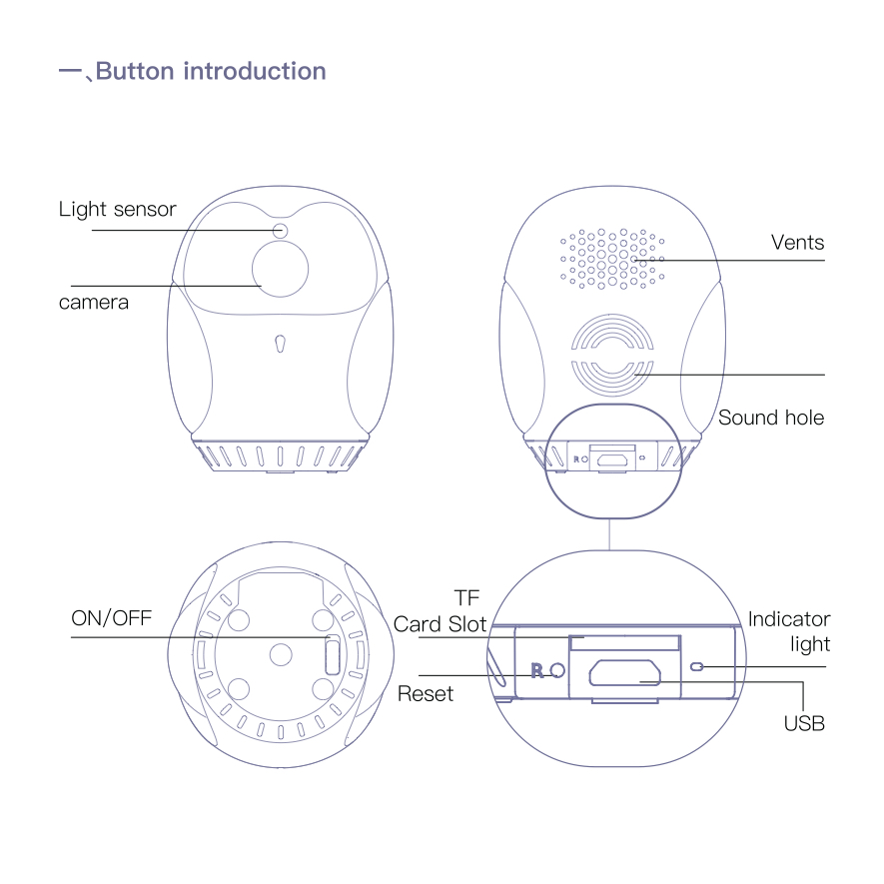

**II、APP Download**

Scan the QR code to download the “V380 Pro” app or get in your phone application market such as App Store to search the “V380 Pro” App.



**III、Network Configuration**

**AP Quick Configuration**  
1. When the device voice prompts "Hot spot is established"  
2. get in APP,click the “ ” which in the upper right corner - “add camera” - “wifi smart camera” please make sure the device has been power on. “Next” ; 3.click “Access-Point established” let your phone connect with the WIFI begin with MV********,

Back to APP “Next” choose your wifi (not suport 5G)and enter your password,the camera will prompts wifi connecting,wait a moment, the APP show have added,the camera prompts wifi connected, name your camera.

**Remote Control Setting**

Not Support 5G wi-fi

Connection failed,please check your phone and your wifi status.

Connection failed,please reset it and try again.

Press the reset hole 5 seconds to reset the device and will have voice prompt also.

**Ⅳ .Interface Introduction**

**Arming/Disarming:**

After the one-key arming is on, the device automatically sends an alarm message to the mobile phone.

**Cloud Storage Mall:**  
Cloud storage package purchase and selection (cloud storage can only be used after the device has been set up for remote monitoring).

**Device share:**

After the device has set up remote mode, it can share camera ID to the friend and family and monitor the camera together.

**Delete:**  
Delete the device, no more monitor any more

**Setting:**

The device is setting such as network, video record, alarm and so on.

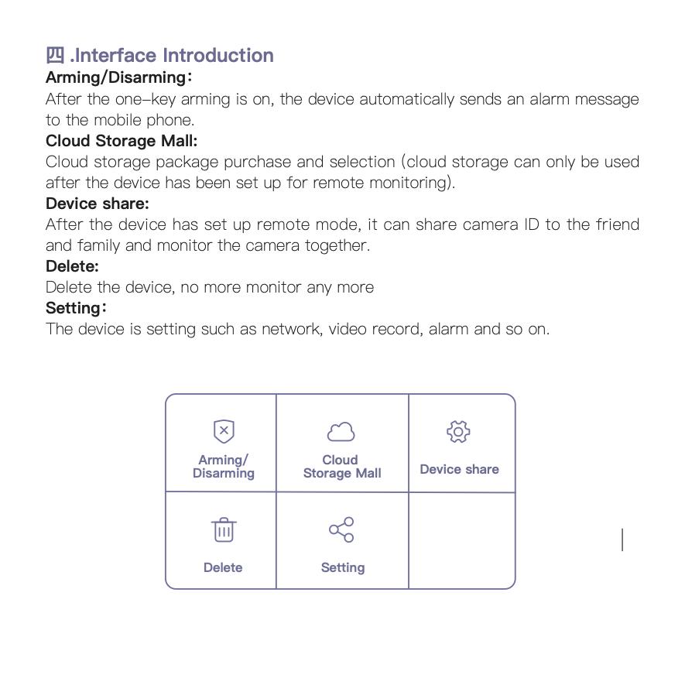

**Ⅴ、Video Record**

**Continuous Recording:**

Recording 24 hours a day; each video will be 10 minutes. The default mode is loop recording(The memory card is inserted to enable this feature.)

**Event Recording:**  
After the arming is turned on, the motion detection alarm automatically captures a video of 20 seconds to 2 minutes on the SD card or cloud server. (You need to buy a cloud storage package, the video can be saved on the cloud server)

**Record Audio、audio synchronization:**

After this function is enabled, SD card recording can achieve audio synchroni- zation. You can choose “HD”or“SD”

**Ⅵ . Function Introduction**

**Real-time preview:**

log in to the mobile client to view real-time surveillance video

**Video playback:**

Play back the video stored on the memory card or cloud through the mobile client

**Cloud storage:**  
efficient and secure storage of video clouds, multiple packages

AI face recognition: detection of personnel invasion, greatly reducing false positives caused by non-personnel movement

**Alarm Push:**  
The device detects abnormal conditions and sends an alarm picture to the mobile client.

**Ⅶ、Warm prompt**

**Video freeze:**

Check the network status, please select the clarity according to the network environment.

**The video can’t be saved in memory card:**

The memory card must be formatted in the first time and choose credibly memory cards.

**Network connection failure:**  
Please select the connection method according to your own network and check the current network status.

**Cloud storage binding:**

One cloud storage account just can be bound to one camera device.

**Forget the password:**

Please press the device reset button for 5 seconds to reset it.

**AI humanoid detection:**

AI human detection alarm is a package of cloud storage. purchased cloud storage, human detection alarm will be given priority. (The specific service on the APP shall prevail)

**Video recording:**

The memory card recording is 10 minutes, loop recording.

**Ⅷ、Attention**

**Security Information**

Before using and operating the equipment, please read and observe the follow- ing words to ensure the best performance of the equipment and to avoid dangerous or illegal situations  
**Electronic equipment**

Where there are express provisions prohibiting the use of wireless devices, do not use this device, otherwise it will interfere with other electronic devices or cause other dangers.  
**Flammable and explosive areas**

Do not use this equipment at gas stations or near any flammable materials and follow all graphics or text instructions.  
Explosion or fire may be caused in fuel or chemical storage and transportation areas or in explosive locations or surrounding equipment.

**Traffic safety**

· Observe the relevant regulations of the region or country, and do not use this device while driving.  
· Remember that safe driving is your primary responsibility, and do not engage in activities that distract you.

· The electronic equipment of the car may malfunction due to the radio interference of the equipment. Please contact the manufacturer for details.  
· Do not place the device above the airbag of a car or an area that can be reached after the airbag is deployed. Otherwise, when the airbag inflates, the strong external force will cause serious damage to the people in the car.

**Operating environment**

· Do not use the device in dusty, humid, dirty, or near magnetic fields, as this may cause internal circuit failures.  
· Do not use the device in thunderstorms. Thunderstorm weather may cause

equipment failure or electric shock hazard.  
· Please use the device within the temperature range of 0°C~ 35°C, and store the device and its accessories within the temperature range of -40°C~ 70°C. Temperature is too high or too low, it may cause equipment failure.  
· Do not place the device in direct sunlight.  
· Please avoid rain or moisture on the device and its accessories, otherwise it may cause fire or electric shock.  
· Do not place the device near heat sources or exposed fire sources, that may generate high temperatures.  
· Do not place sharp metal objects such as pins in the vicinity of the device's earpiece or speaker, otherwise the metal may be attracted and cause injury to you.  
· After the device has been running for a period of time, the temperature of the device will rise. If the device temperature is too high, do not touch it for a long time, otherwise it may cause scald.  
· Far away children and pets to avoid swallow the device or its accessories.

**Charger safety**  
· When don't need charge, please cut off the charger from the device and unplug the charger from the power outlet.  
· Do not drop or hit the charger. If the charger shell is damaged, please contact the customer service center.  
· If the charger plug or power cord is damaged, do not continue to use it to avoid electric shock or fire.  
· Do not touch the device or charger with wet hands to avoid short circuit, malfunction or electric shock.  
· The charger must meet the requirements of "2.5 Restricted Power Supply" in the standard "Safety of Information Technology Equipment GB4943.1".  
· If the device needs to be connected to a USB port, make sure that the USB

port has the USB-IF logo and it meets the standards of USB-IF specifications.  
· If the device needs to be connected to a USB port, make sure that the USB port has the USB-IF logo and it meets the standards of USB-IF specifications.

**Battery safety**  
· Do not connect the metal conductor with the two poles of the battery or touch the terminals of the battery to avoid short circuit of the battery and burns caused by the battery overheating.  
· Do not expose the battery to high temperature or heat generating equip- ment,Overheating of the battery may cause an explosion.  
· Do not disassemble or modify the battery, insert foreign objects, or immerse in water or other liquids, so as to avoid battery leakage, overheating, causing, fire or explosion.  
· If the battery leaks, do not let the skin or eyes contact with the leaked liquid. If contacted , immediately rinse with water and go to the hospital.  
· If the battery is discolored, deformed, or abnormal during use, stop using and contact the customer service center to replace it with a new battery.  
· Do not throw the battery into the fire, otherwise it may cause explode.  
· Please dispose of batteries in accordance with local regulations. Do not dispose of batteries as household waste.  
· Let children or pets far away the battery  
· This device is equipped with a non-removable built-in battery. Do not replace the battery by yourself.

**VIII、Legal Notices**

**Disclaimer and limitation of liability:  
This quality assurance covers the normal designation of this product. This quality guarantee does not apply to:  
A. Damage caused by accident, abuse, unreasonable use, improper handling and improper storage, or other non-material or workmanship defects;  
B. Damage caused by overhaul by someone other than our authorized repre- sentative;  
C. Damage caused by any hardware, software or other additional compo- nents installed by the end user;  
D. If the product has been disassembled or modified by any means;  
E. Appearance damage, including but not limited to scratches, dents or cracked product shell, or normal wear and tear.  
Our liability for product defects is limited to replacement and repair  
All clear and implied quality assurance time limits follow the provisions of this quality assurance clause, including but not limited to any  
The quality assurance and the conditions of marketability and suitability for specific purposes are shown. If any clause of this quality assurance is illegal or unenforceable, the remaining clauses**

**Unless this quality assurance stipulates and complies with laws and regula- tions, our company will not guarantee or condition is responsible for direct, special, incidental or subordinate damage caused by any other method . The above restrictions do not apply to death Claims for death or personal injury, or any legal liability for intentional and gross negligence and/or negligence.**