Instructions

一、Wiring diagram
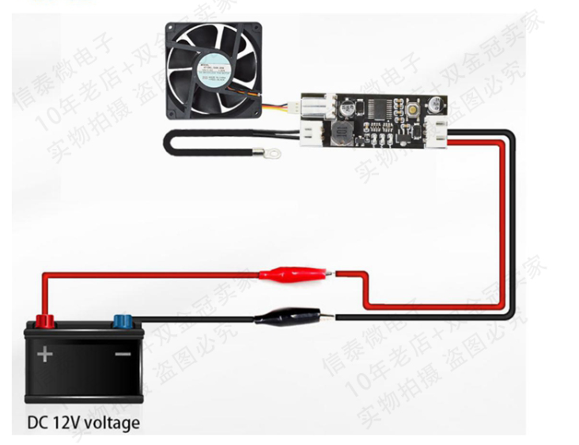

二、This controller is designed as a model that combines manual control and automatic temperature control.

1. The temperature probe is not installed:

The control mode is manual, click/double-click (do not double-click too fast) button, up/down gear position.
Each time you change the gear position and continue to run for 20 seconds, the gear position will be automatically stored. Within 20 seconds, the No. 2 indicator light will flash rapidly (the temperature control is invalid at this time). When the flashing stops, it means that the gear position has been stored. When it is in a position where it cannot continue to increase/cannot continue to decrease, the No. 3 / No. 1 indicator light will always be on.

2. Install the temperature probe:

Take the speed manually adjusted as the initial low speed (bottom line speed), when the temperature exceeds
When the acceleration temperature is over, the fan speed will smoothly accelerate with the increase in temperature. When the temperature reaches or exceeds the sum of the acceleration temperature and the acceleration width (that is, the full speed temperature), the fan is at full speed.

The setting acceleration temperature and acceleration width parameters are shown in the following setting diagram. The numbers 1, 2, and 3 in the figure represent the on (red) and off (white) states of the indicators on the board, which are displayed in binary order:

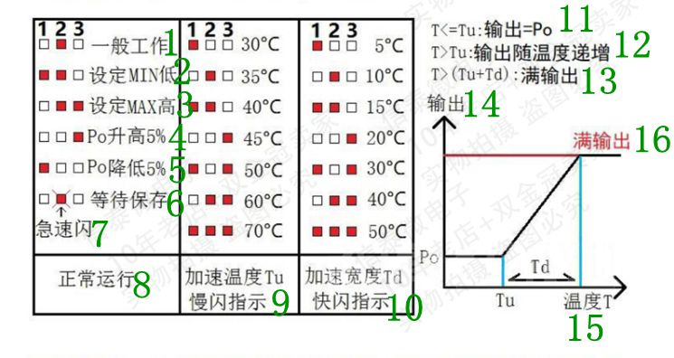
Note:(Translate into English according to the numerical order）

1. General work
2. Set Min low
3. Set Max high
4.Po increased by 5%
5.Po reduced by 5%
6. Wait to save
7. Rapid flash
8. Normal operation
9. Speed up temperature Tu slow flashing indicator
10. Accelerated payment Td flashing indicator
11.T<=Tu:Output=Po
12.T>Tu: The output increases with temperature
13.T>(Tu+Td): full output
14. Output
15. Temperature T
16.Full output

During normal operation:

The bottom line output of the click button increases by 5%, and the bottom line output of the double-break button decreases by 5%.
Run for 20 seconds after changing the value, and brake to save the parameters after the middle indicator light stops flashing rapidly. through
Long press the button to enter the temperature control setting.

Temperature control setting status:

Accelerated temperature setting: (slow flashing) by single-clicking and double-clicking to increase and decrease the value respectively, long press to enter the accelerating width
Degree setting.
Acceleration width setting: (fast flashing) also double-click to change the value and long press to save and exit the temperature setting
Set.

Note: In the setting state, if there is no operation for 20 seconds, it will automatically exit the setting without saving the parameters.

三、Fan shutdown strategy setting:

First, turn off the power and remove the fan, press and hold the setting button to power on the controller, keep the setting button always pressed (about 3 seconds) until the three lights become double flashing at the same time, then release the button, the indicator light becomes a single When the light flashes double, it means entering the mode setting state. The controller is divided into three working modes, corresponding to the double flashing of No. 1, 2 and 3 indicator lights, which can be switched by short pressing the button. After setting, long press the button to save and exit the setting mode and automatically return to the normal working state.

The three working modes are:

1. Does not shut down the output.
2. When the acceleration temperature is lower than 2℃, the output will be shut down.
3. When the accelerating temperature is lower than 5℃, the output will be shut down.

for example:

Set the acceleration temperature to 35°C, the acceleration width to 10°C, and the shutdown strategy mode 3 (shut down at 5°C below the acceleration temperature).
After this setting, the fan will not rotate when the temperature is lower than 35°C when power is on. When the temperature rises to 35°C, the fan starts according to the manual setting. The temperature continues to rise, the speed slowly accelerates, and the fan is at full speed when it reaches or exceeds 45°C. When the temperature drops to between 35-30°C, the fan always runs at the manually set speed, and the fan stops rotating below 30°C.

Note: The fan shutdown strategy is controlled in a hysteresis mode, which can effectively prevent the fan from repeatedly switching on and off near the critical point. For example, after the above setting, the temperature rises to 35°C to start the fan, and the temperature drops below 30°C to turn off the fan.

Precautions for use:

Since most fans can run but cannot start at low output, when setting the minimum speed of the temperature control, you should first adjust to the lowest speed and stop the fan by hand, and then increase the output step by step until the fan starts normally. Don't go below this position after the actual setting, otherwise the fan may not start when the speed is low.

