Smart Bracelet User Manual

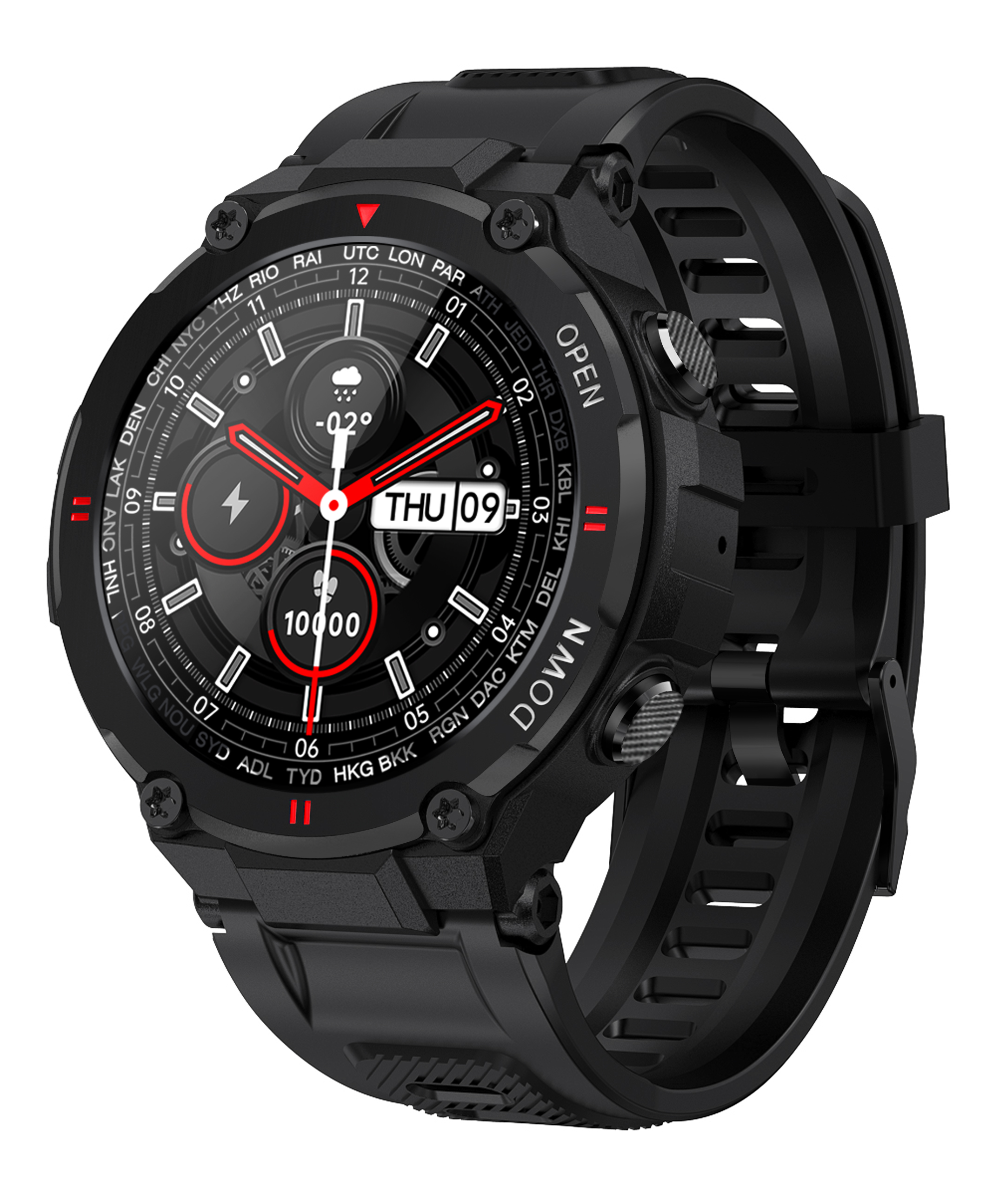

Please make a full charge before use it.
APP: Dafit

Download APP

1.1 Long press side button “OPEN” to turn on.
1.2 Scan below QR code to install Dafit APP,Or download“Dafit”from App Store, Google Player then install it.

Compatible System: Android4.4 and above， iOS 8.0 and above

BT Calling Version connecting
Step1：Turn on mobile phone Bluetooth Step2：Open“Dafit”APP，Tap“Add a device”to connect .
Step3 : Turn on phone menu on the watch.
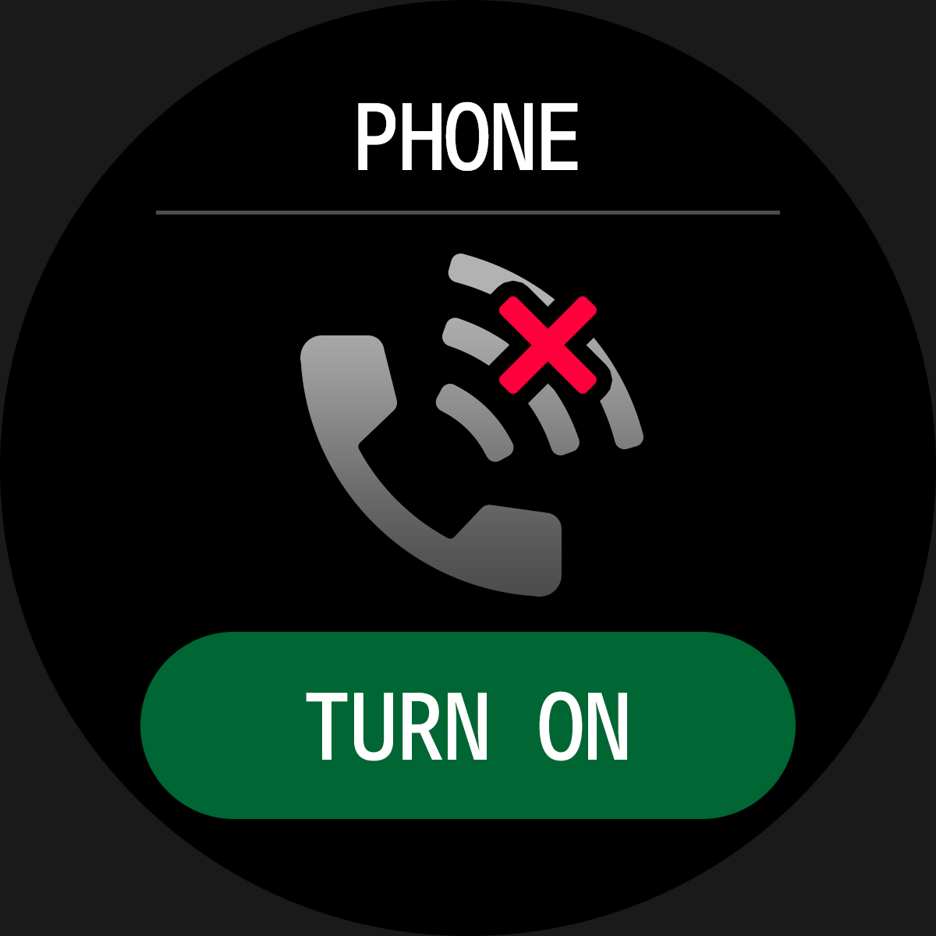
Step4: Check watch menu“about”MAC address last four number like “A9C7”, then go mobile phone “setting-bluetooth” to search the same bluetooth name with last 4 numbers “A9C7”to finish BT connection as below operation.
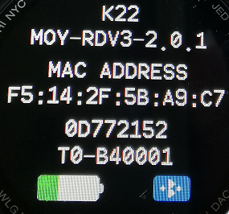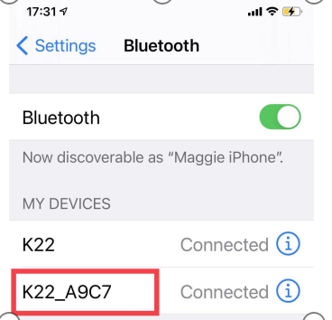

Non-BT Calling connecting
1.3 Enter the APP to bind the searched device.
Step1：Turn on mobile phone Bluetooth Step2：Open“Dafit”APP，Tap“Add a device”to connect .

2.Smart bracelet Functions
2.1.Time Interface
2.1.1 Power on：Long press side button“OPEN”for 3 seconds.
2.2.2 Power off：On the time interface，press “OPEN”side button for 3 seconds, then click”√“ icon to turn off
2.2.3 Switch watch face：Long press the screen based on main watch face,4 interface options,and the 4th dial can manually replace user-defined pictures or photos on the APP
2.2.Functions menu
2.2.1.Activity records（Step records)
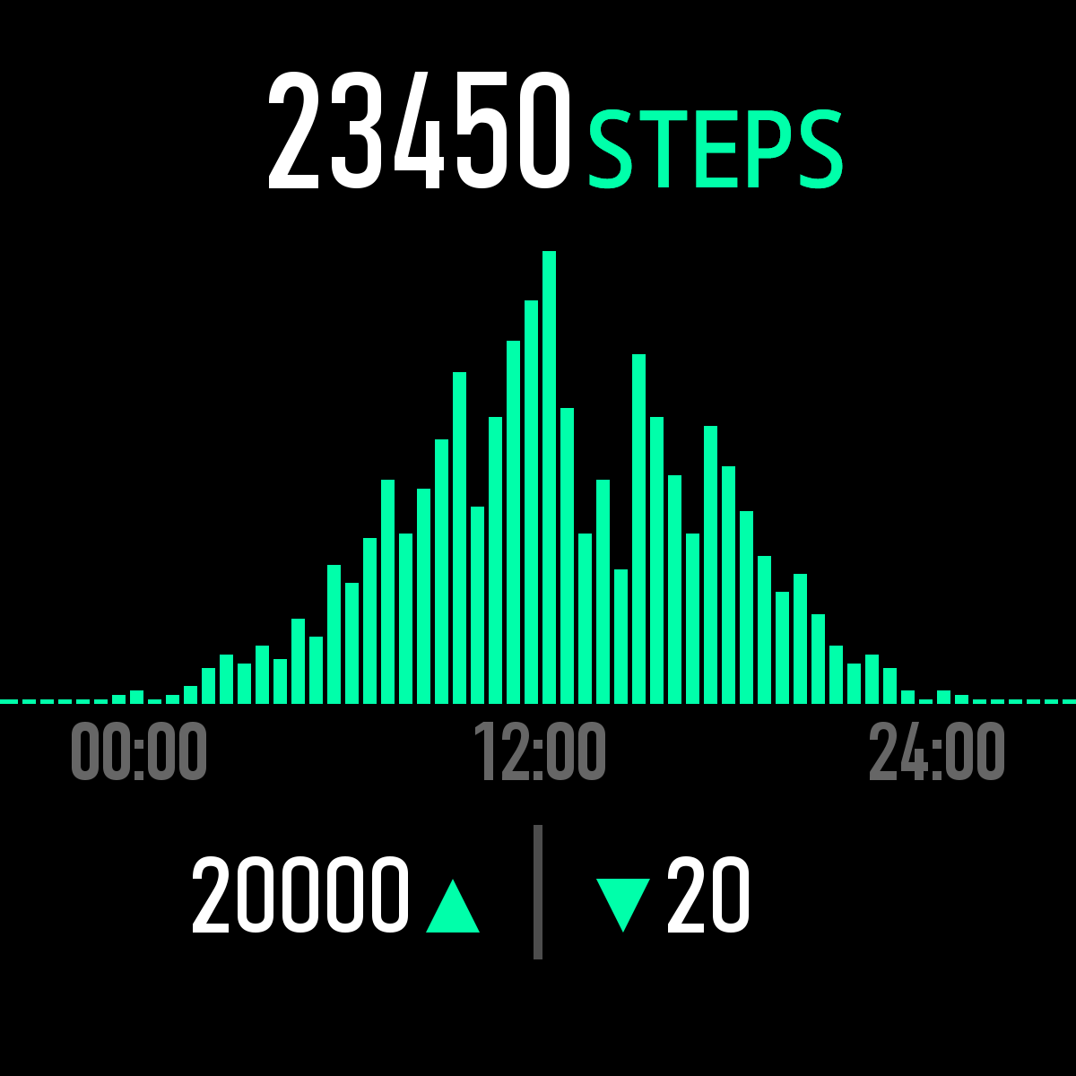
2.2.2.Sleep monitor
Sleep monitor period: 20:00PM to 10:00AM
Pls make sure weared the bracelet device
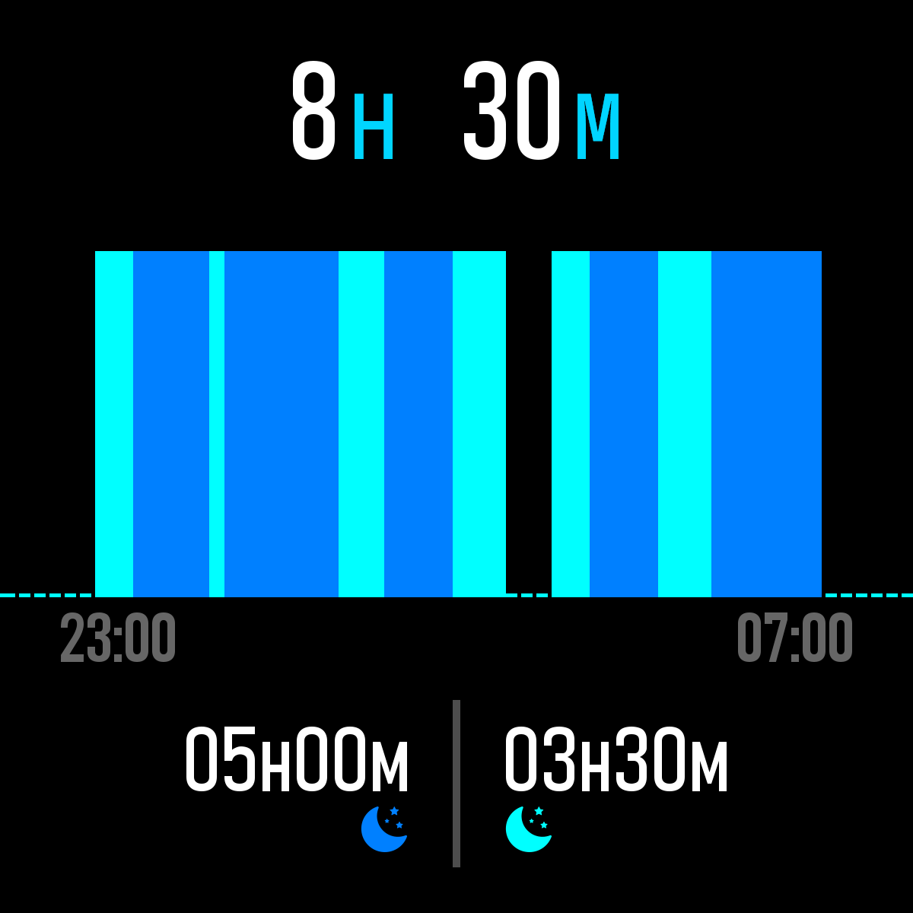
2.2.3.Heart Rate monitor(If need 24-hour monitor pls turn on”Full-day Heart rate”on Dafit app under “Other”menu)
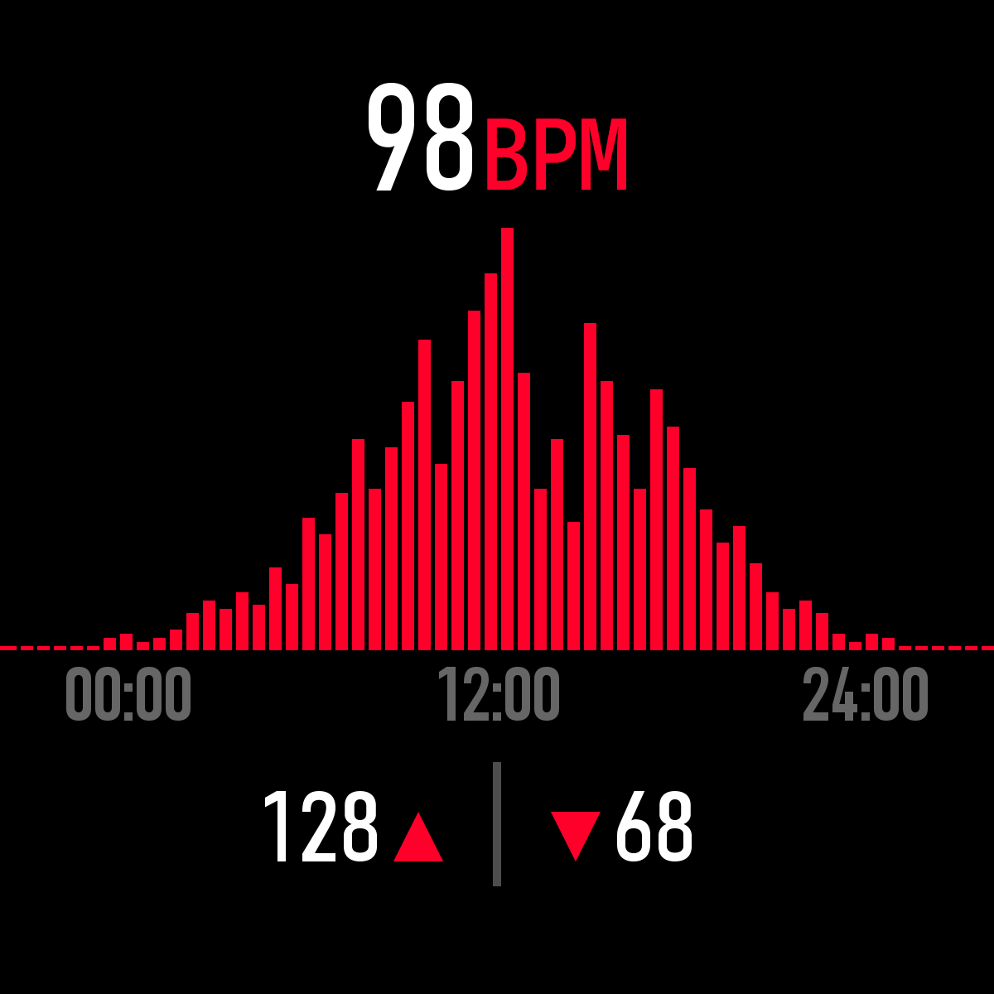
2.2.4.Exercise( Multiple sport modes: Walking, Running，Cycling，Skipping，
Badminton，Basketball，Football,Swimming, all exercise datas will be sync to mobile phone Dafit App )

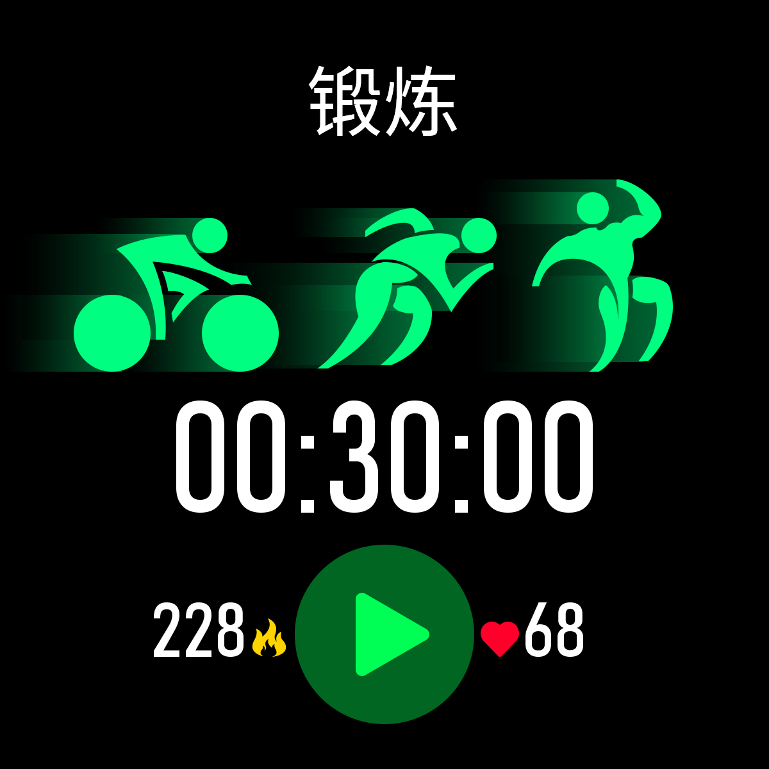
Select the sport mode you want, start to test and show all exercise data:mileage, calorie, heart-rate as below picture; Slide screen on left can exit or pause the sport testing.
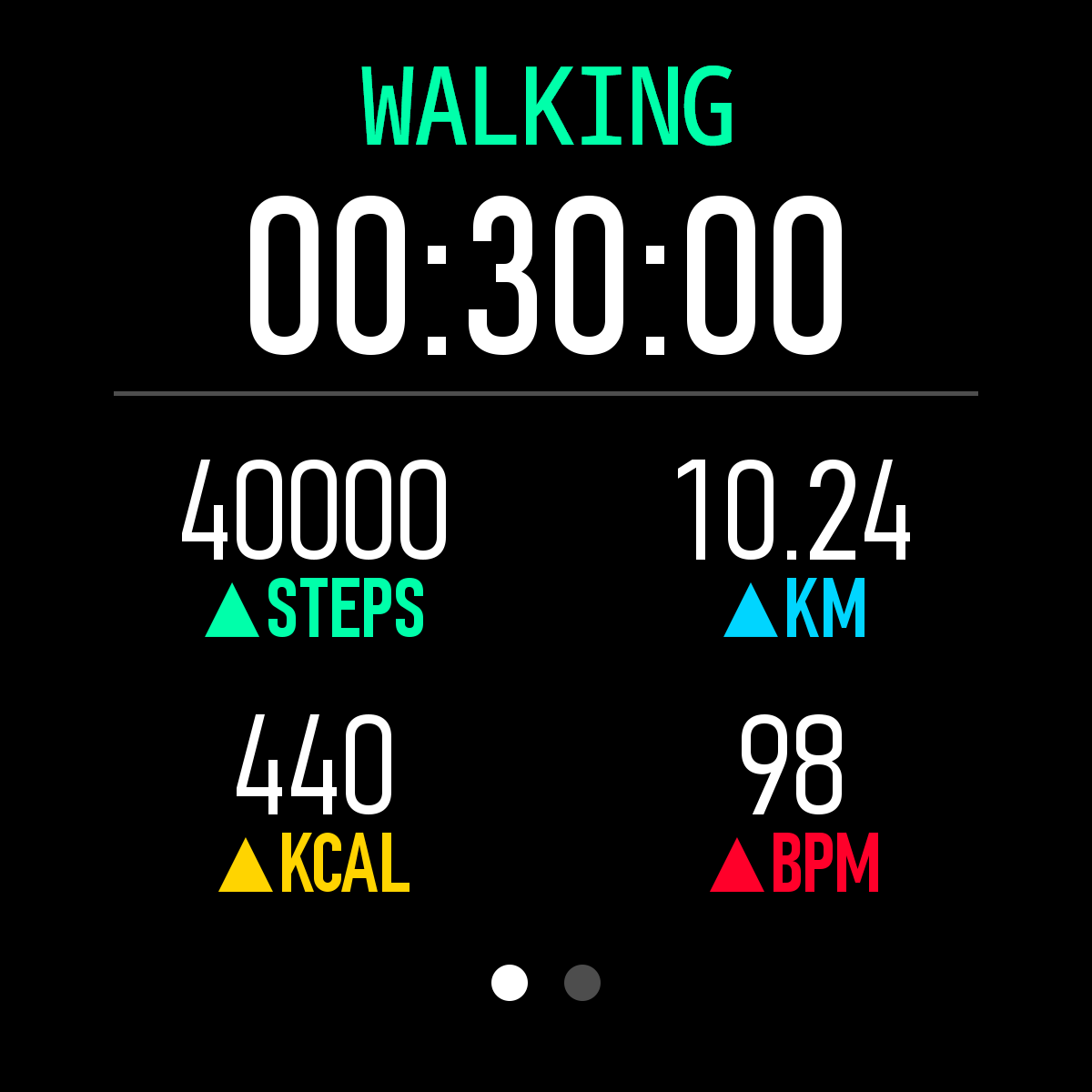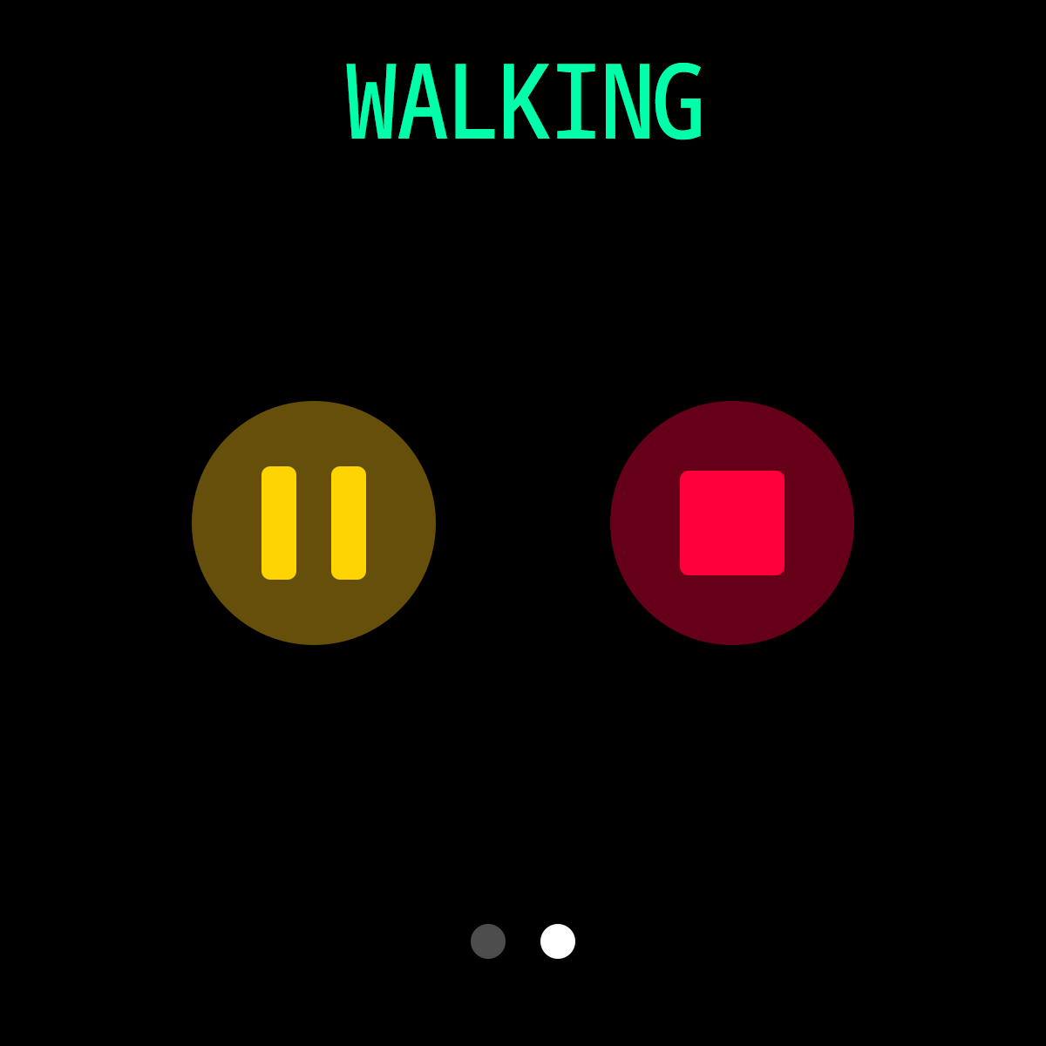
2.2.5.Bluetooth call(K27 without this BT call function)
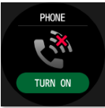
2.2.6.Blood Pressure Detection(click screen to monitor)
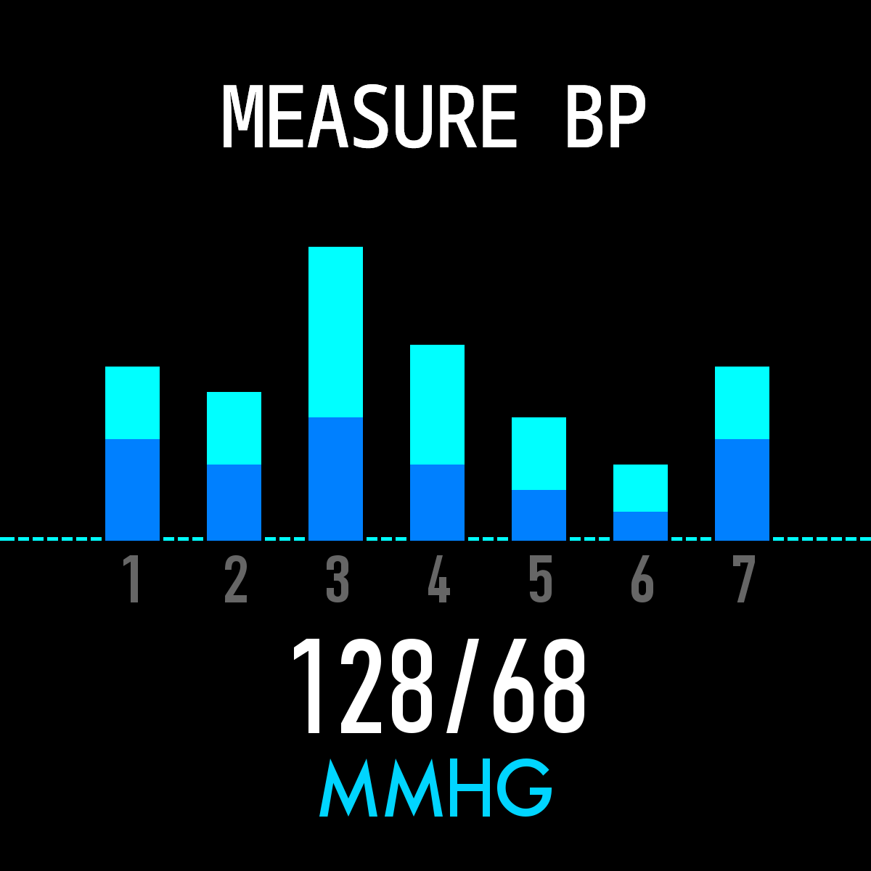
2.2.7.Blood Pressure Detection(click screen to monitor)
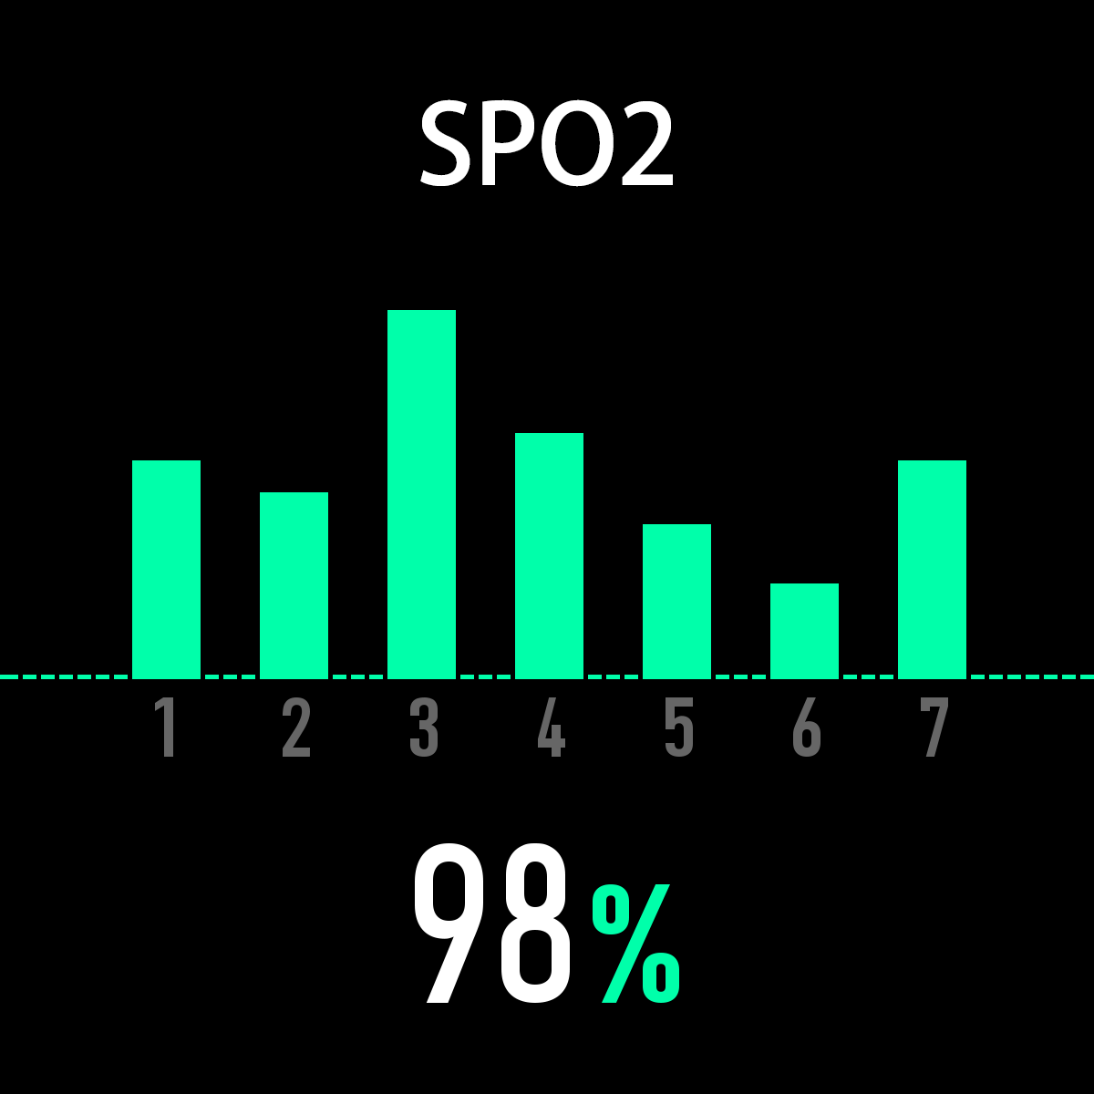
2.2.8.Weather（Slide up screen can check this week weather information)
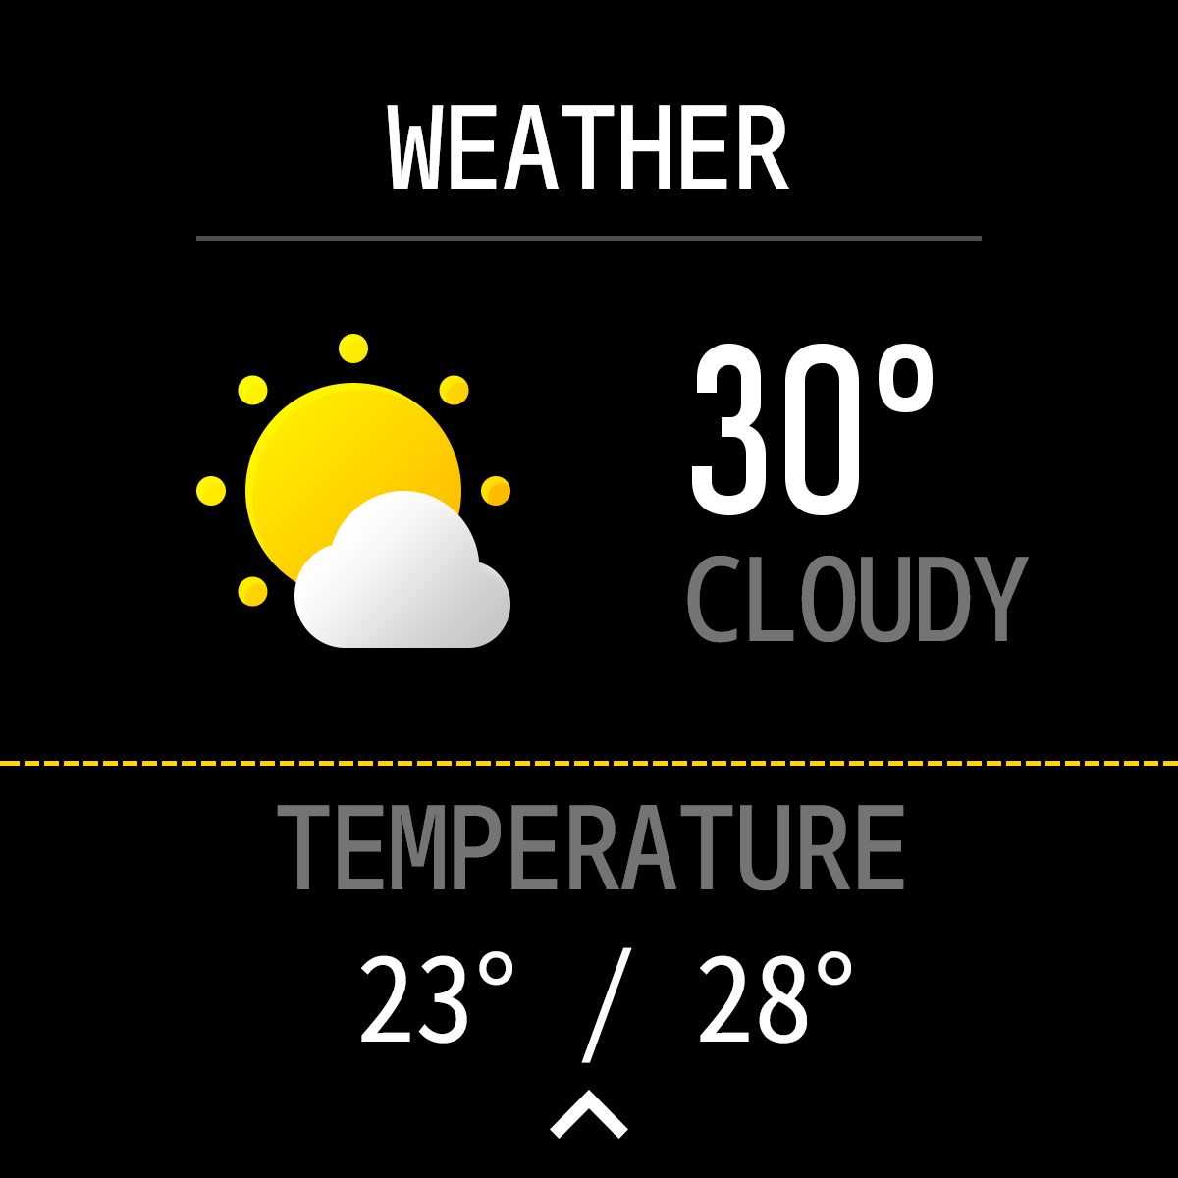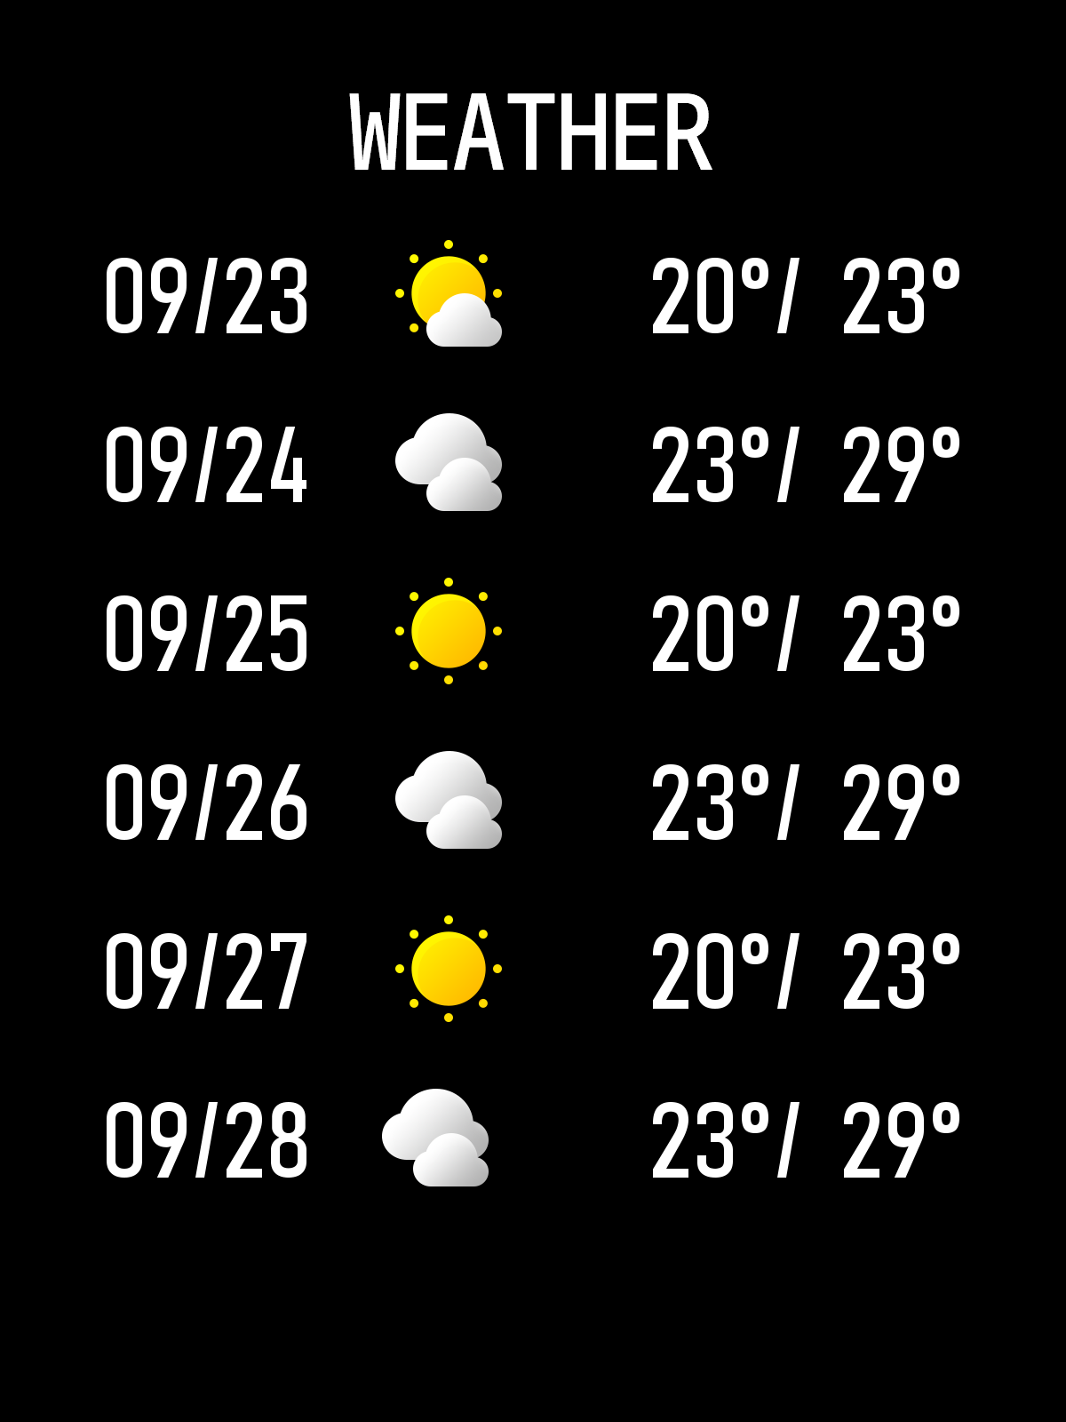
2.2.9.Shutter
Android:Turn on Dafit app, from smart bracelet enter “shutter” ,shake the bracelet or click to take photo.
IOS:Enter smart bracelet “shutter ”, make sure turn on mobile’s camera,shake the bracelet or click icon.
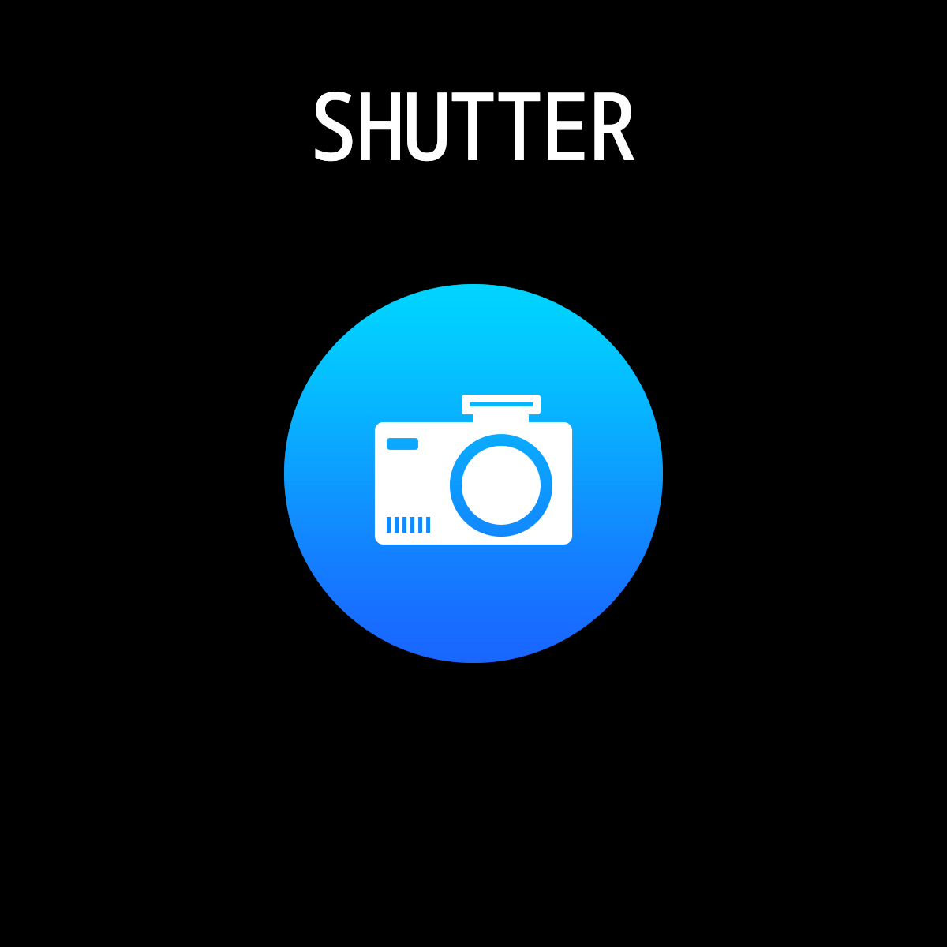
2.2.10.Player（Enter BT music,click middle icon to pause or continue，tap left icon to play last song，tap right icon to play next song）
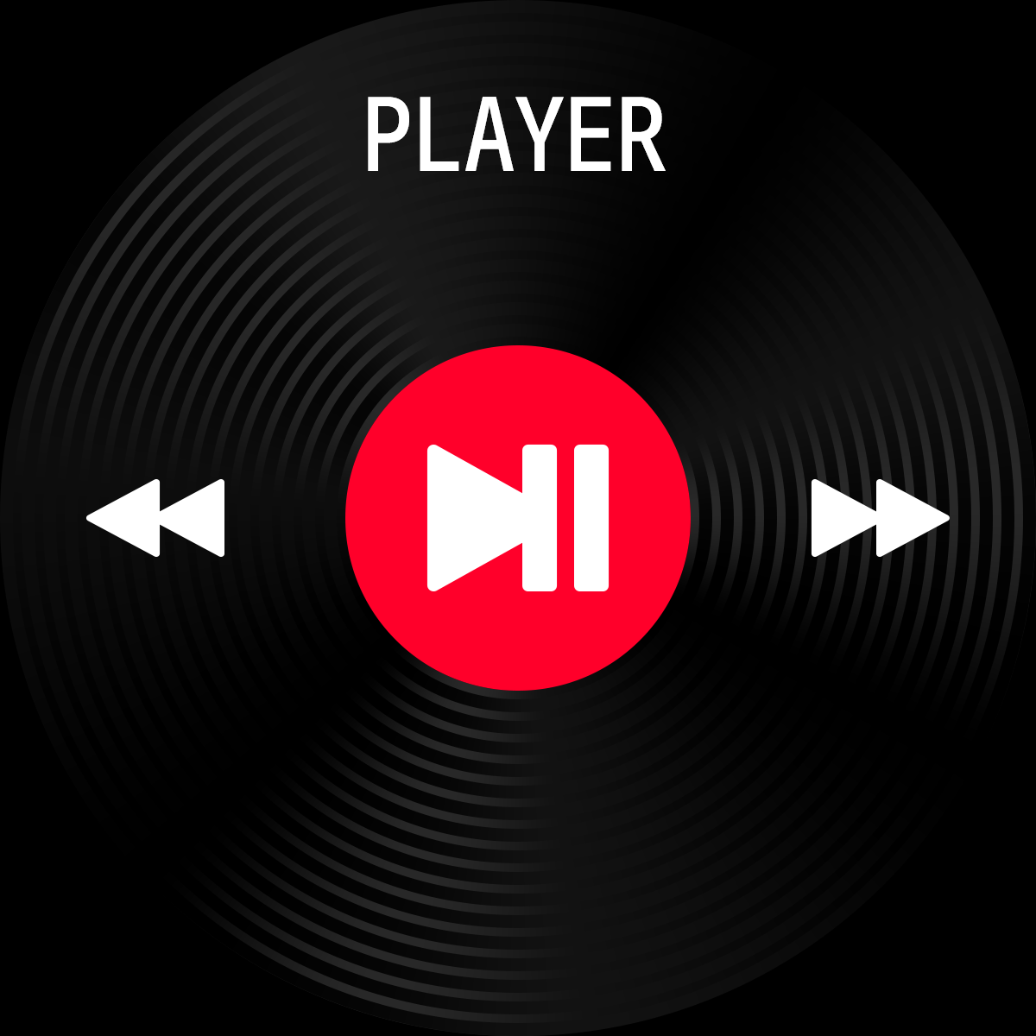
2.2.11.Notifications push（Turn on Dafit app”Notifications” social app like Facebook,Twitter,Skype etc,
Pay attention on Android mobile phone setup: Dafit app/Notification/Accessibility to turn on“Dafit”
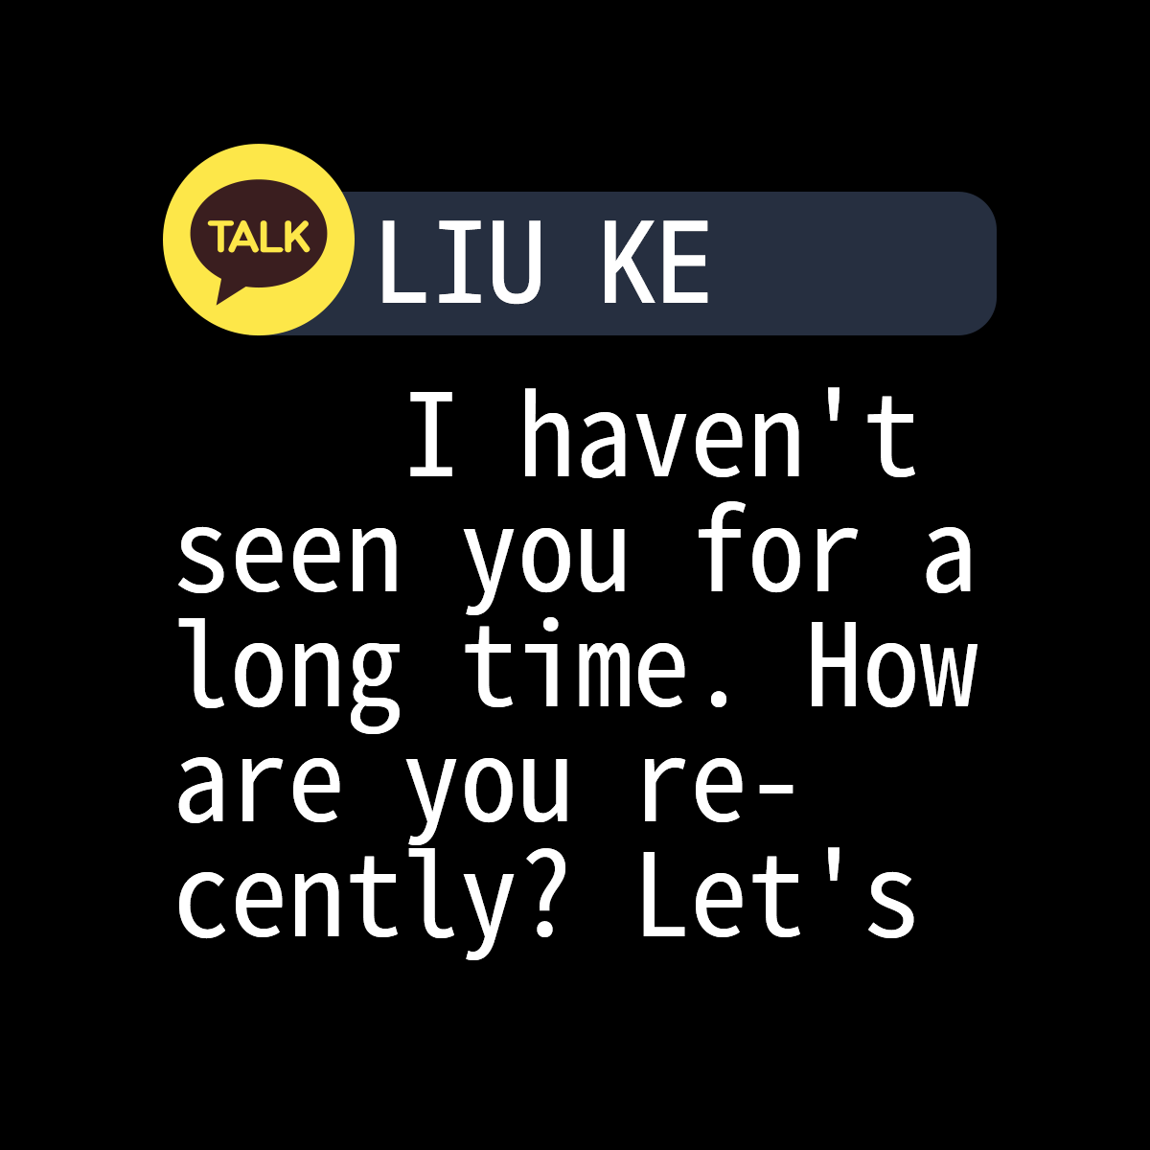
3.Pop-up menu（Slide down screen from main watch dial）
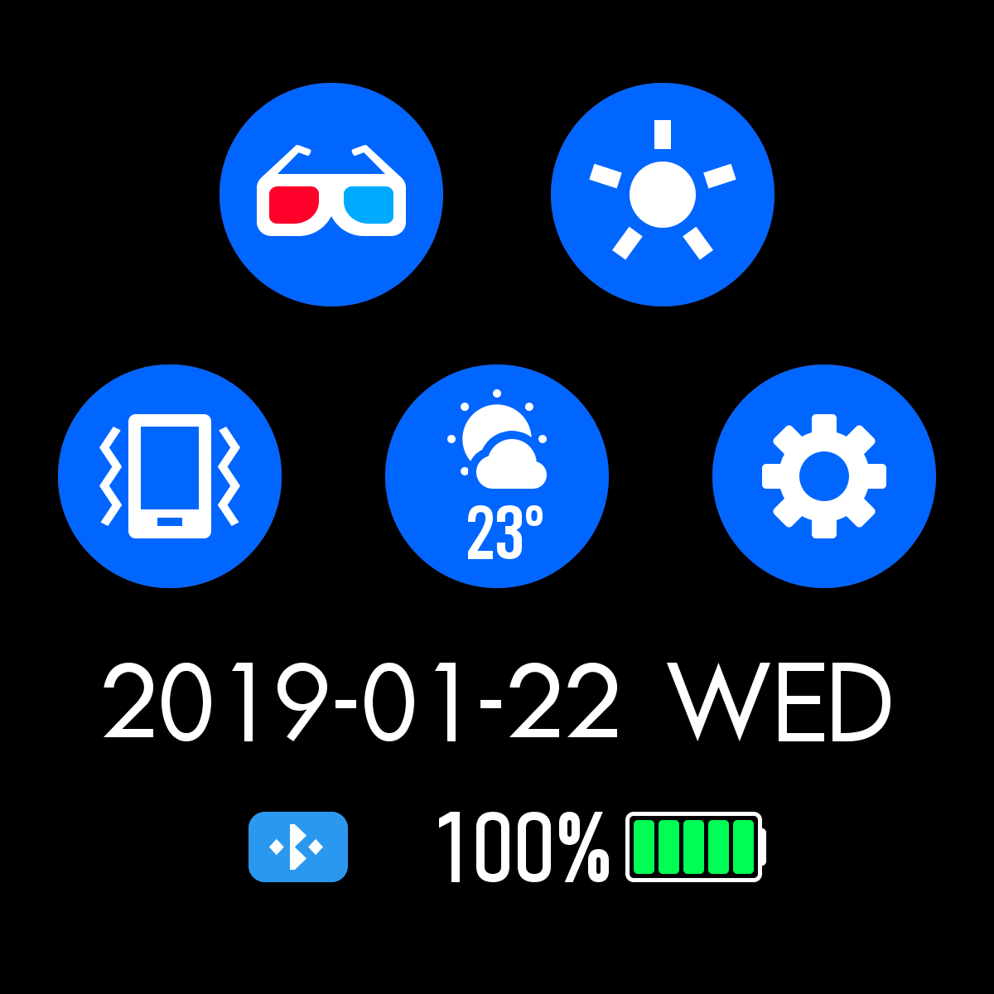
3.1.Theater mode
3.2.Brightness adjustment
3.3.Vibration or mute mode
3.4.Weather information
3.5.Setting：Stopwatch,alarm,countdown,brightness,shake:off,theater,reset,power off,about,APP code
4.Functions on Dafit App
4.1.Data sync
All measured data from smart bracelet will be sync on mobile phone Dafit app eg: step,sleep monitor,heart rate,blood pressure,blood oxygen and other data as below Pic.
4.2.smart bracelet connection interface
4.2.1 Watch Faces（5 interface options,and users can manually replace user-defined pictures or photos)
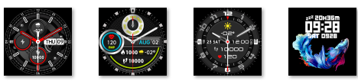
4.2.3 Notifications（Turn on social apps message push like WeChat, Facebook, whats’app, Twitter etc)
4.2.4.Alarms （3 options）
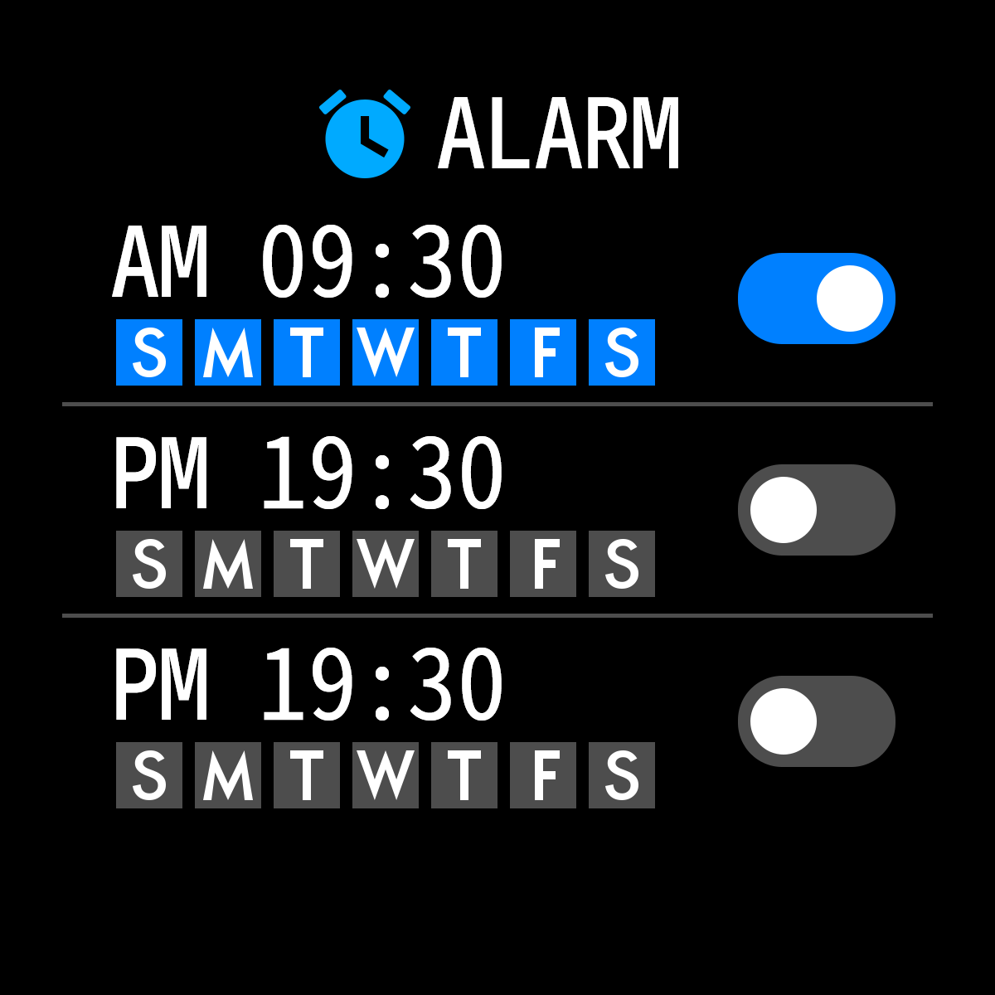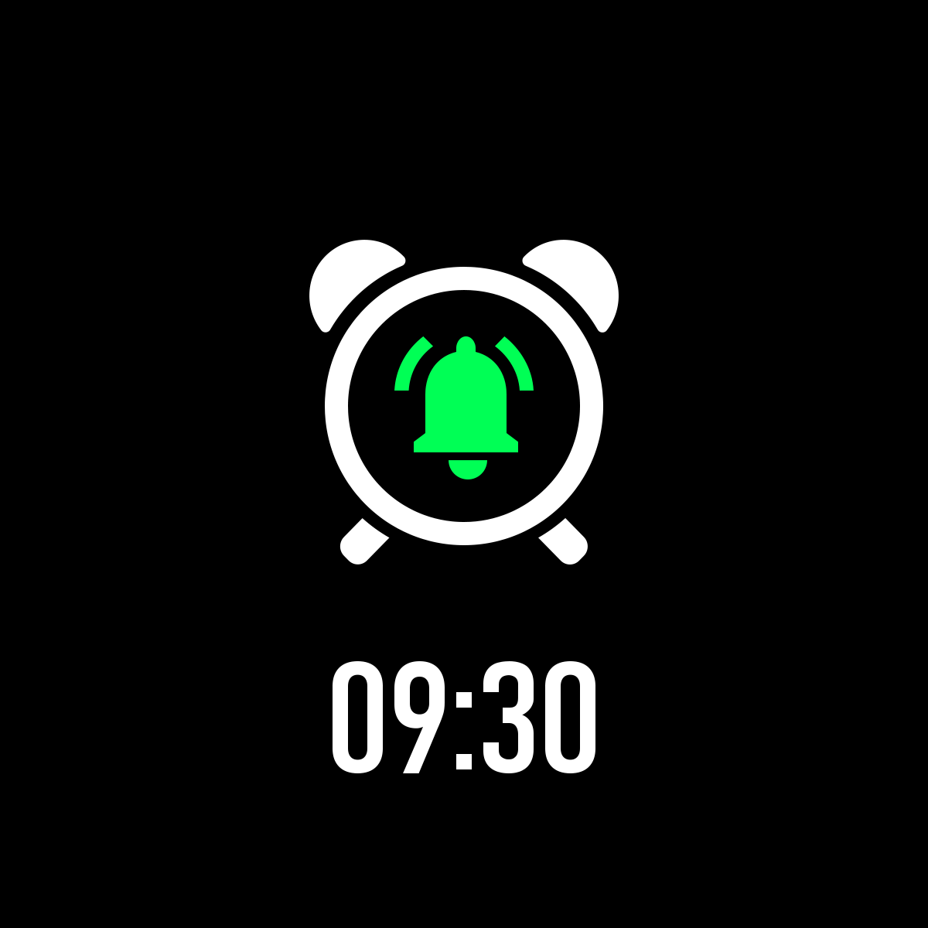
4.2.5.Shutter
4.2.6.Others（Find my smart bracelet, Time formats, Setting time of no disturbing, Sedentary reminder,Full-day hear-rate monitor，Quick View screen, Weather,Drink Water reminder,Physilogical cycle reminder）
A. Power on “Find my bracelet” mode,the bracelet will vibrate when the bluetooth is connected successfully between mobile phone and smart bracelet.
B.Time format（2 options of 12&24hours system）
C.Time format（2 options of 12&24hours system）
D.Setting mode of no disturbing
E.Sedentary reminder(Valid period
10:00AM-22:00PM)
F.Full day heart-rate monitor( Turn on it can detect your whole day heart-rate ）
G. Quick view screen: wake up screen（turn on it and choose valid time period)
H.Drink Water Reminder
I.Weather（Turn on the weather,choose the city you want or automatic location，the band will show the located city’s weather )
J.Physiological cycle reminder
（Notes：Please kindly note above functions are working based on activated and saved the related setup）
4．Warm notes
4.1 Connect Bluetooth：
4.1.1 Please power on your phone bluetooth and turn on smart bracelet bluetooth before connecting;
4.1.2 Please ensure your smart bracelet didn’t connect with other phone before connecting ；
4.1.3 Please keep close to you smart bracelet when you are connecting.
4.2 Please turn on mobile phone notifications and allow permissions to run in the background if your Mobile has installed “Mobile manager” or other similar Apps, otherwise you will not receive the messages.
4.3 Battery Recharge:Power adaptor : 5V 0.5~1A

{0><}0{>Disclaimer<0}
{0><}0{>Warning: This product is not a medical device. The smart band and its applications should not be used in diagnosis, treatment or as a preventive treatment for diseases and sickness. Please consult medical professionals before changing exercise habit or sleep habit to avoid serious injuries. The manufacturer reserves the right to modify and improve any functions description in this user guide and continuous update of the new content without further notice. This user guide is for reference only, the smart band for selling is subject to the final product.<0}

