Yak54 Assembly Manual
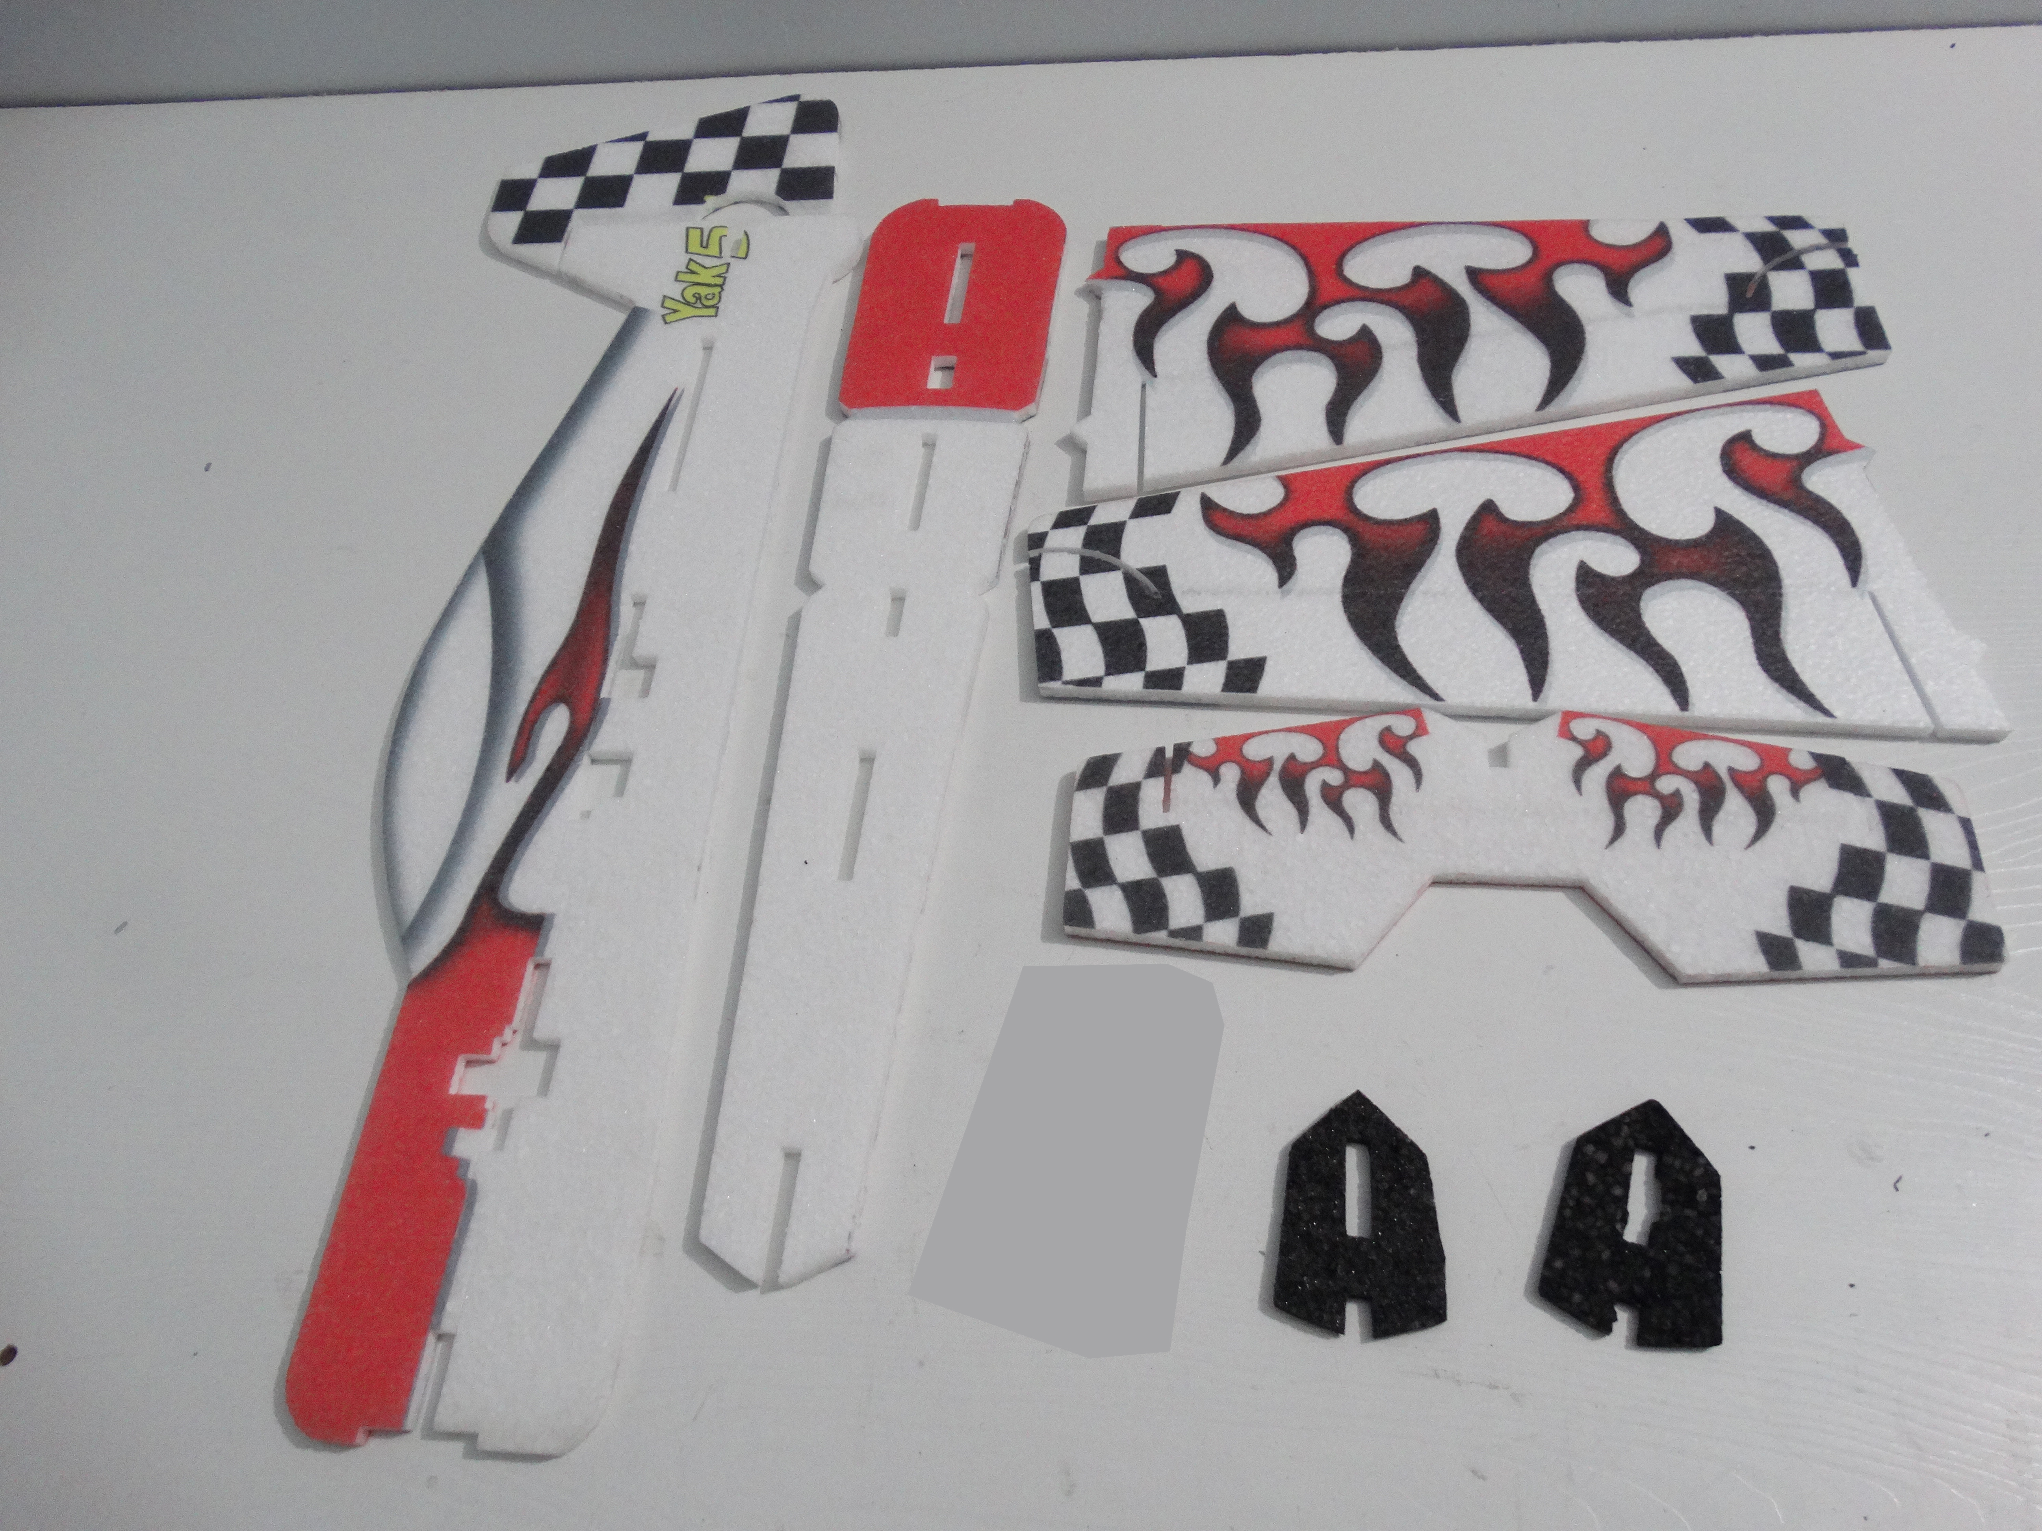
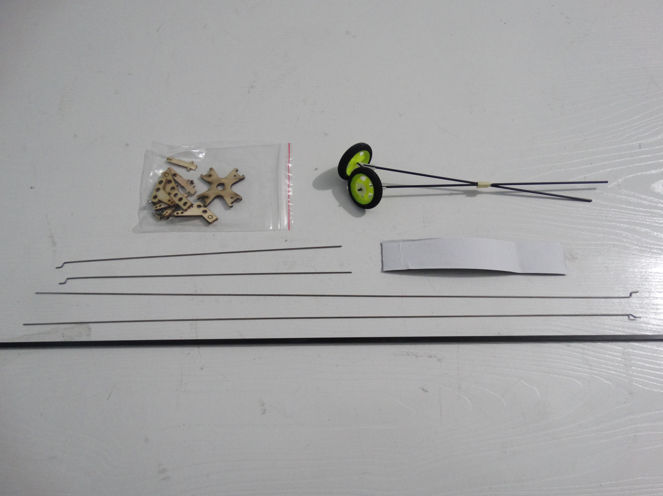

Packing list：
1: EPP Yak54 fuselage *1
2: Carbon tube 4*4*750mm*1
3: Pull rod *4
4: Motor mount *1
5: Quick rod adjuster *4
6: Hinge*4
7: Hook and loop tape*1
8: Wood strips *4
9: Landing gear*1

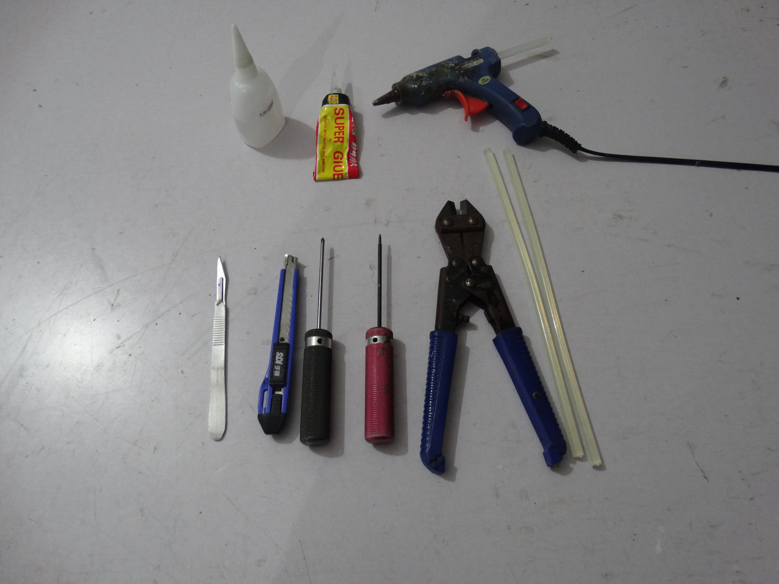
Tools：
1: 1.5mm allen wrench
2: Phillips screwdriver
3: Modelling knife
4: Wire cutters
5: Hot melt glue gun and glue sticks
6: Foam Glue
7: No.502 glue

Electronic equipment(Indoor flying)：
Motor：2204-2206 1400KV-1700KV*1
Prop：7-9 inch *1
ESC：6-12A*1
Servo：8/9g *1 4.5/4.7g*2
Battery：300-500mah 2S-3S *1

Electronic equipment(Outdoor flying)：
Motor：2206-2208 1400KV-1700KV*1
Prop：8-9 inch *1
ESC：12-20A*1
Servo：8/9g *3
Battery：500-1000mah 3S *1

Assemble the 2 pcs wings on horizontal fuselages using foam glue.
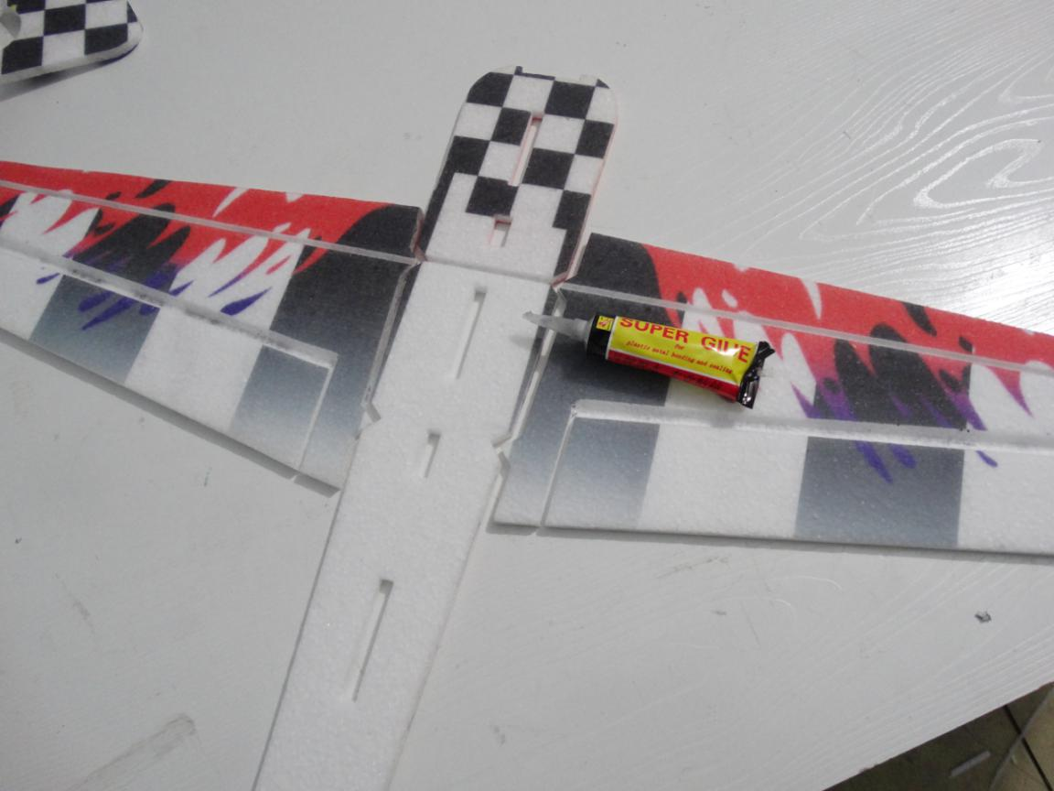

Install the carbon tube on fuselage using foam glue.
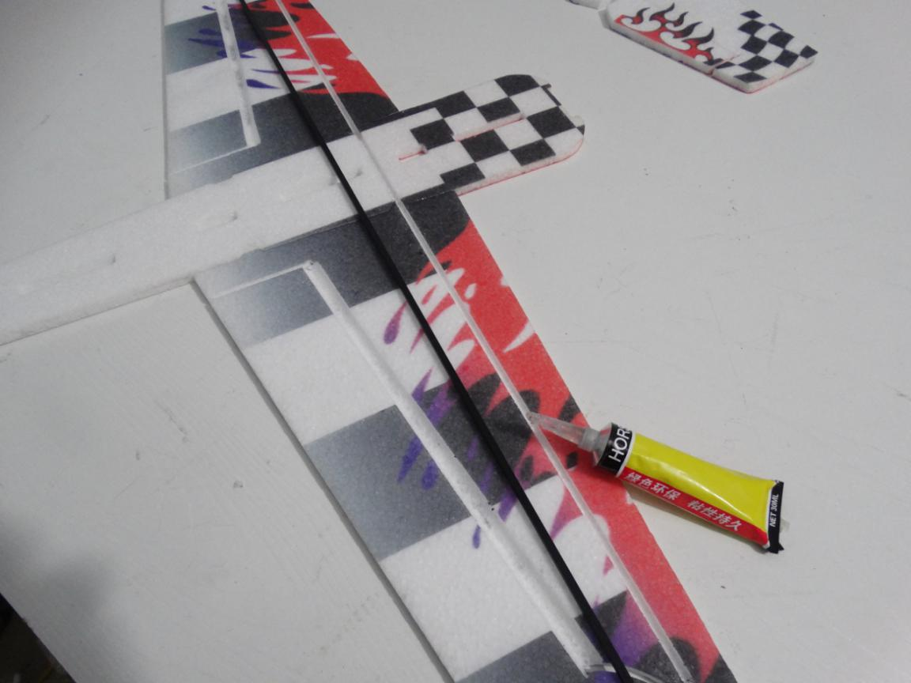
Assemble the horizontal tail on fuselage using foam glue.
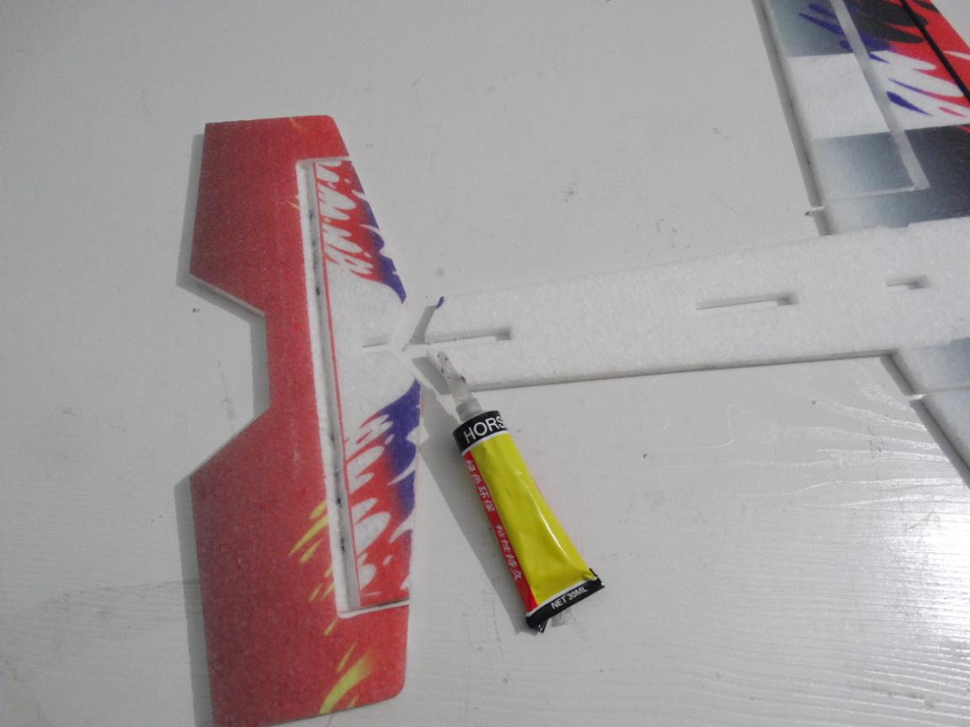

Wait glue dried. Then assemble bottom half fuselage into the horizontal fuselage using foam glue.
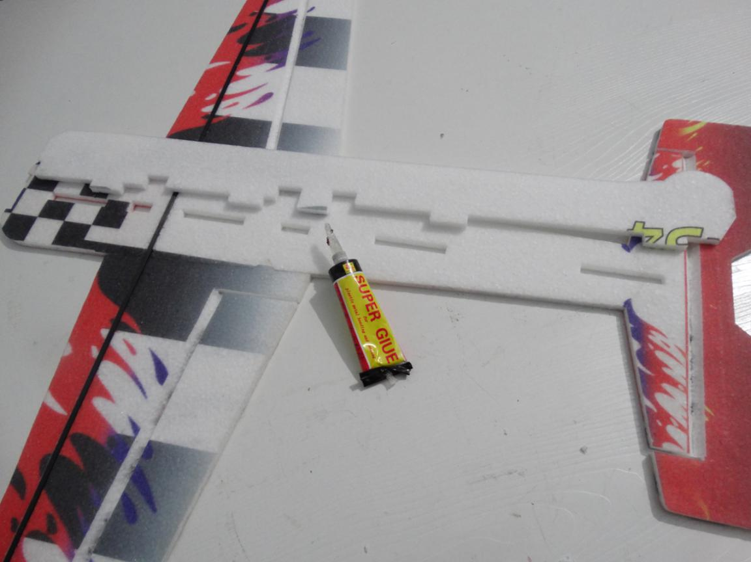
Must check whole fuselage to ensure orthogonality before glue dry.
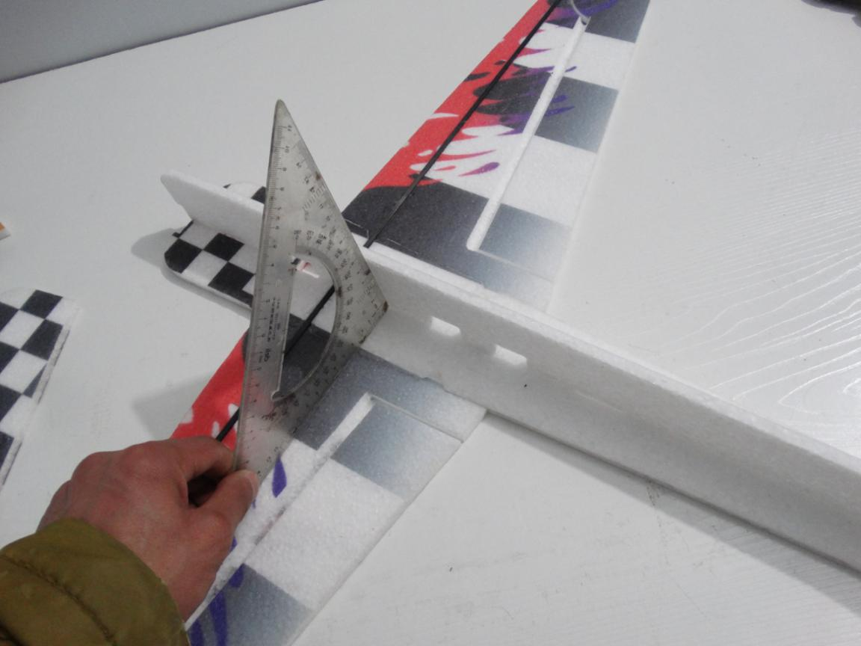
Electrify all servos to make sure the arm perpendicular to servo. Then install 8/9g servo on fuselage with long arm using foam glue.
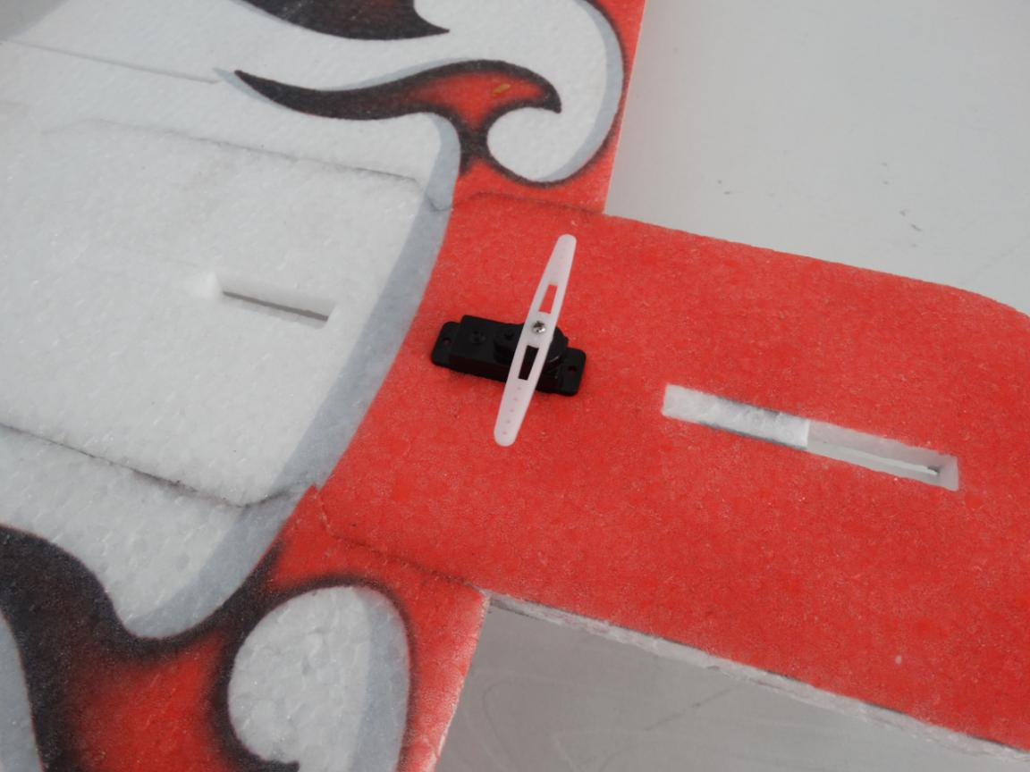
Assemble the upper half vertical fuselage on horizontal fuselage using foam glue with l-square.
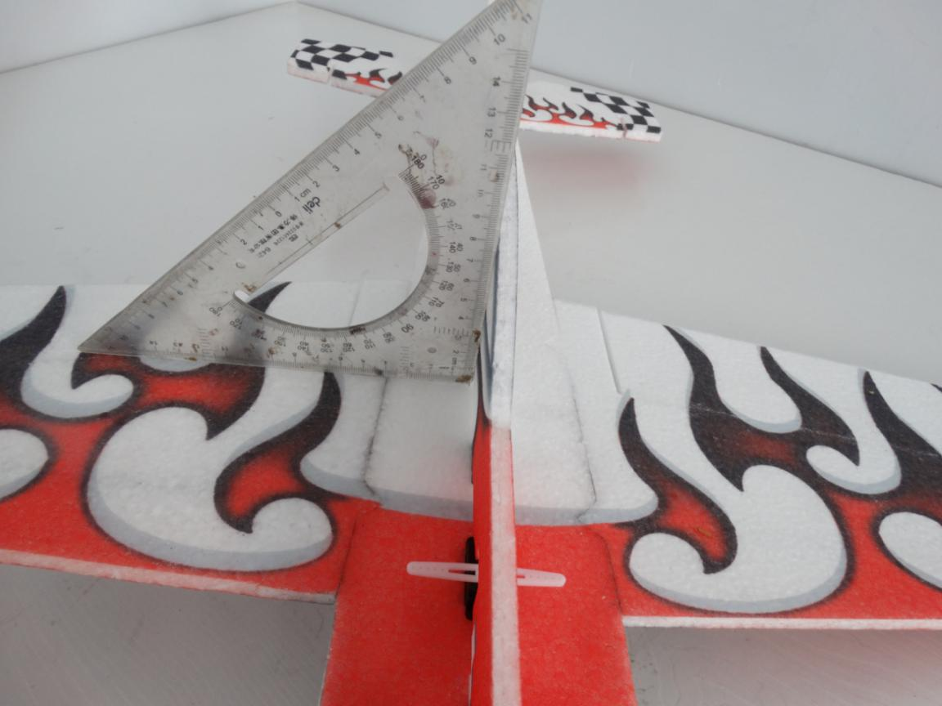

Assemble the vertical tail on upper half vertical fuselage using foam glue with l-square.
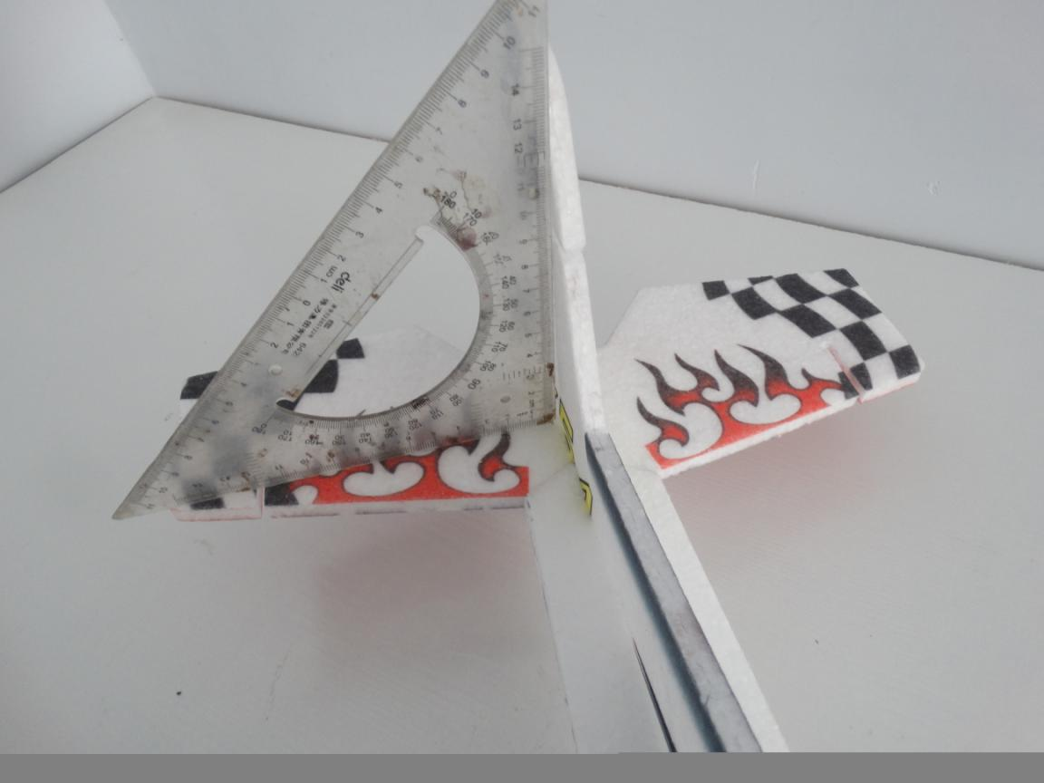
Glue bottom half vertical fuselage on horizontal fuselage with foam glue.
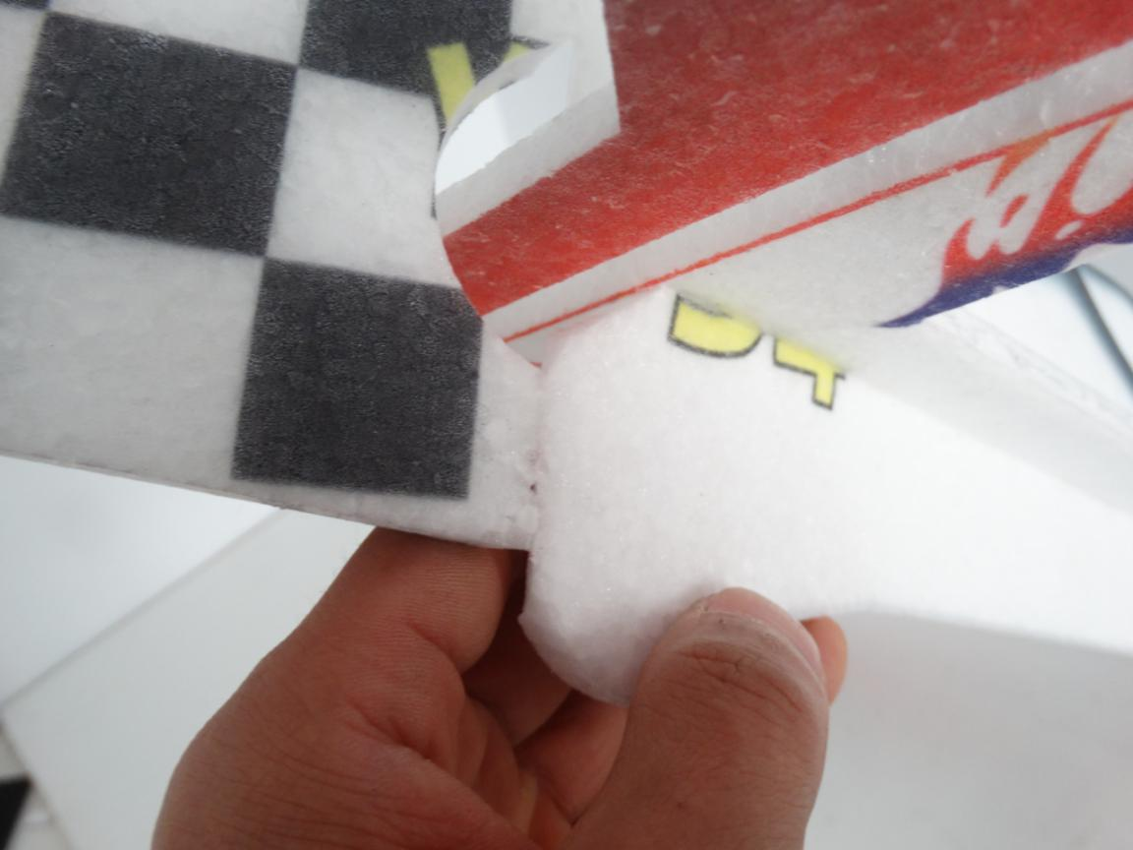

Drill a hole in fuselage under aileron servo and let the 2 pcs landing gears cross through the hole. Then glue landing gear on wing using No.502 glue.
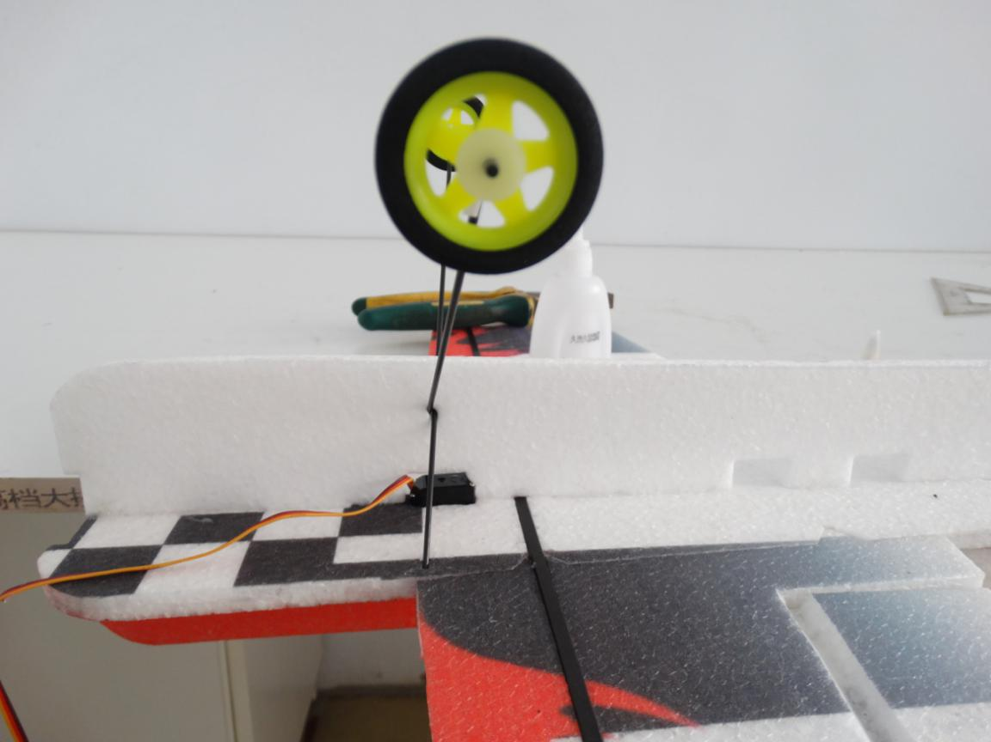
Adjust landing gear to make sure the wing be horizontal and then glue the hole.
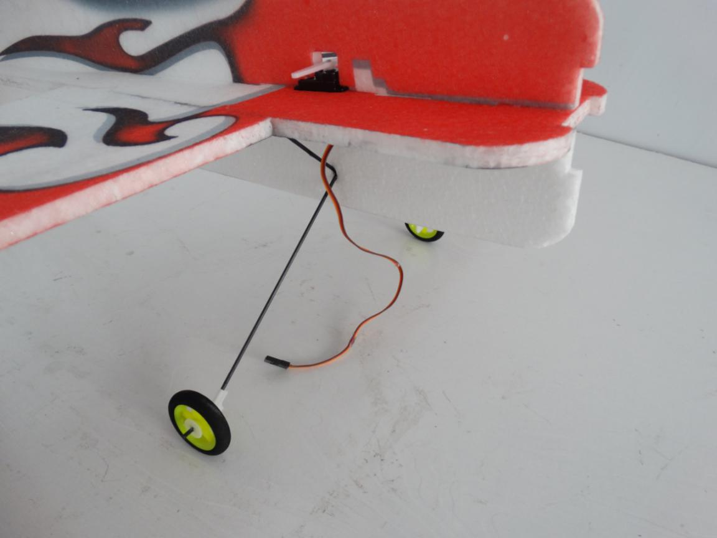
Assemble quick rod adjuster and install it on hinge(Notice the direction) , apply a little No.502 on the nuts. Then install hinge into the hole on aileron with No.502 glue.
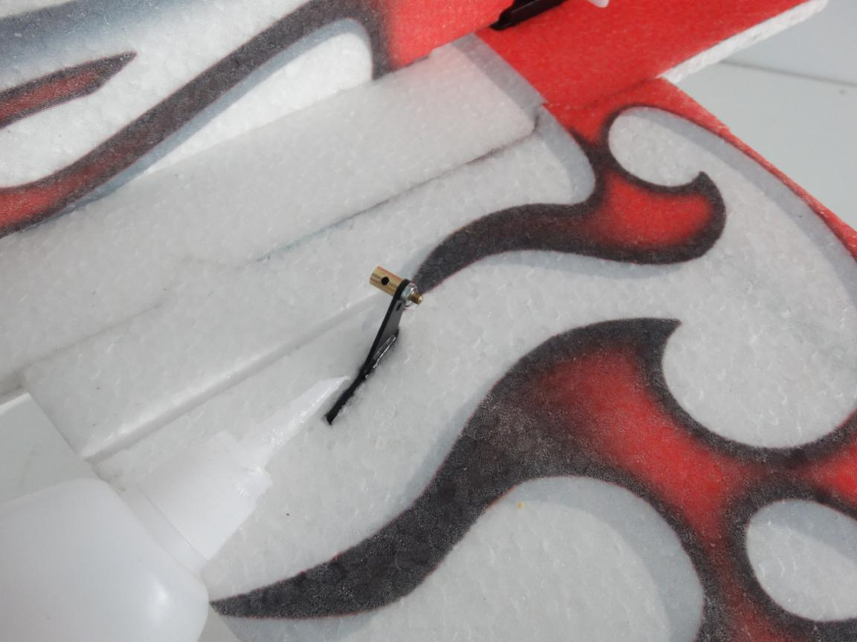
Install pull rod on servo and hinge,then adjust the rod’s length.
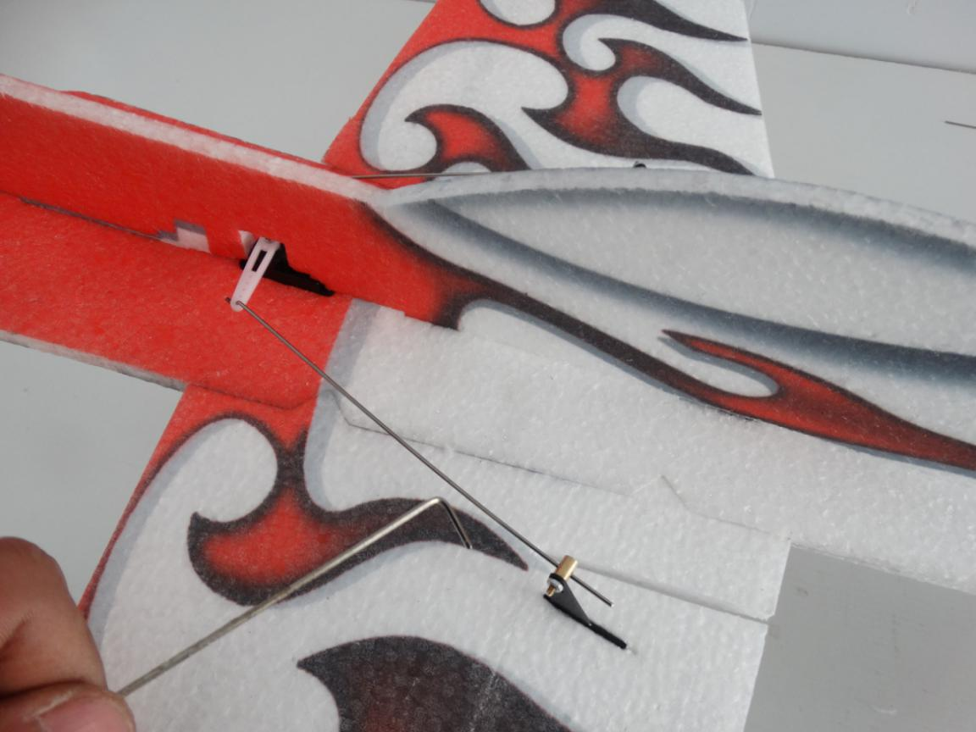

Install 2pcs 4.5/4.7g servo on fuselage with long arm using foam glue.
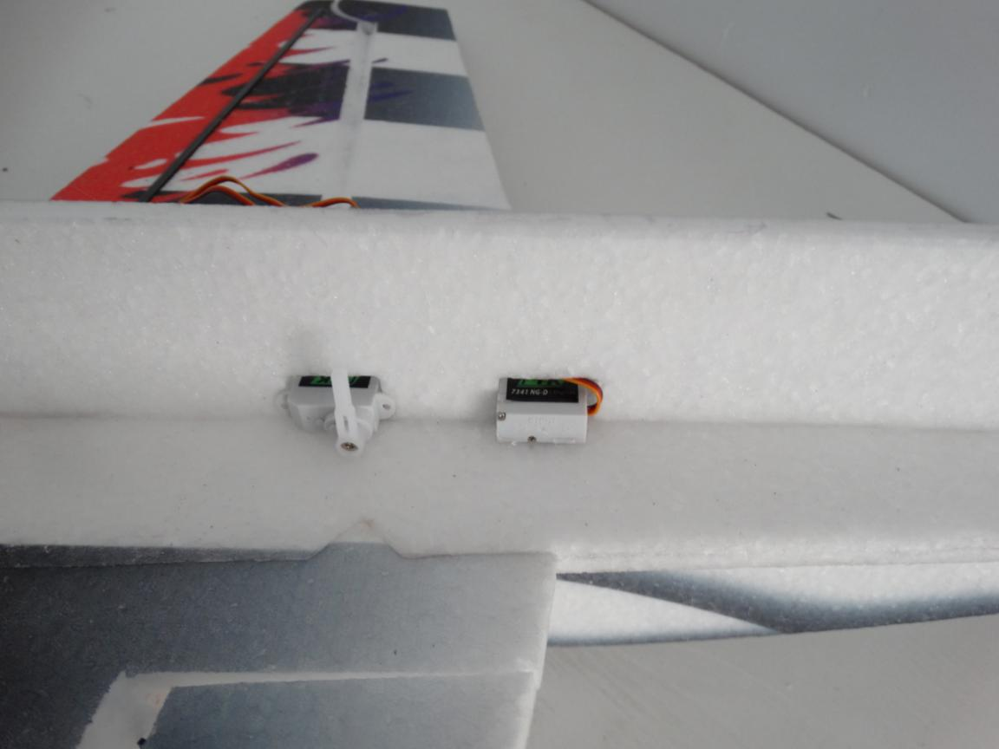
Install hinge into the hole on tail aileron(Need cut the hinge a little).
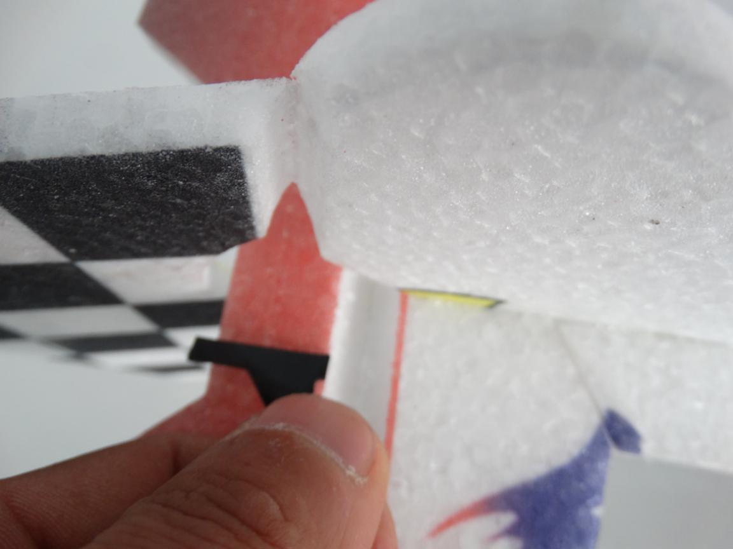

Install wood strip in the hole using No.502 glue. Notice must let pull rod through the hole on wood strip.
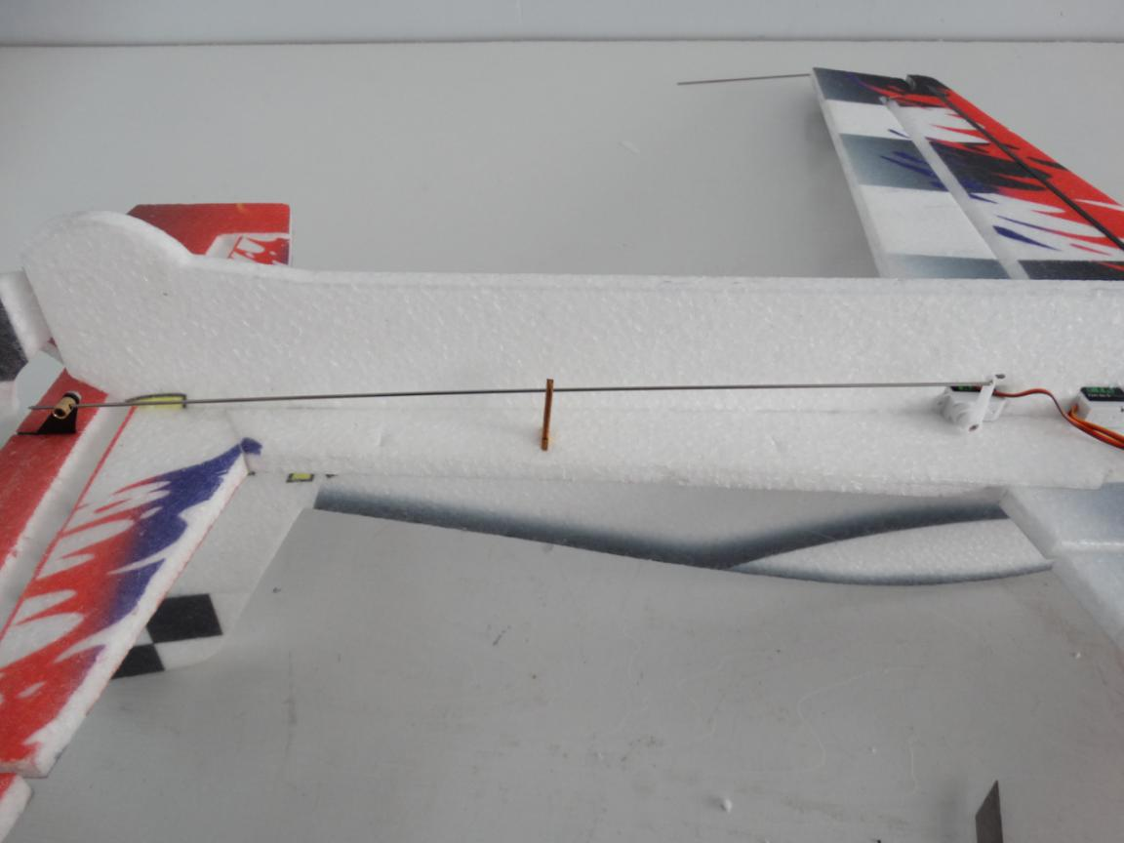
Same to another side.
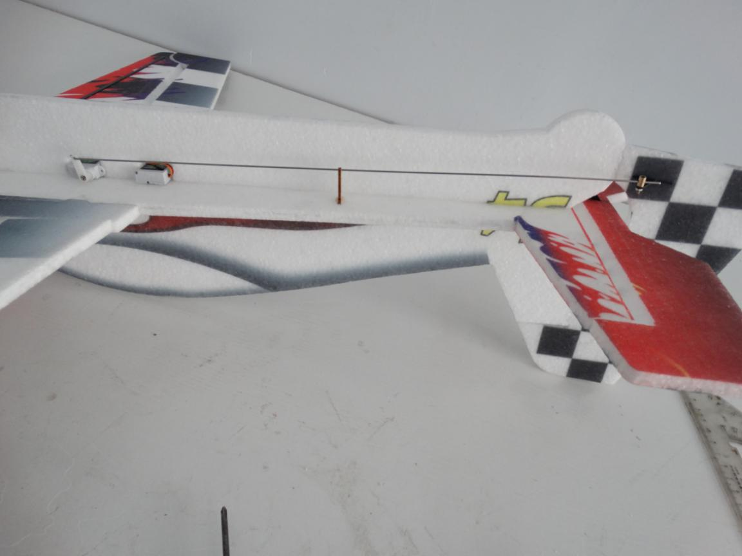

Assemble motor mount on fuselage using No.502 glue.
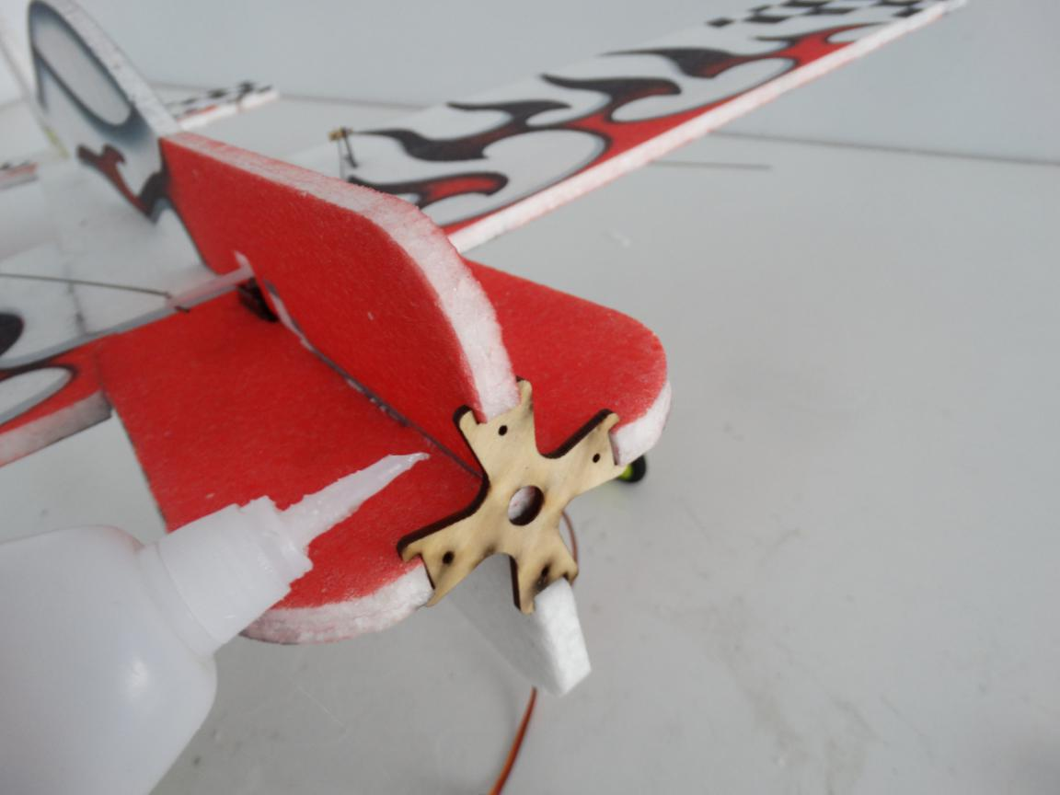
Assemble motor on the metal cross using screws. Then install motor on motor mount with tapping screws(we can use servo’s screws).
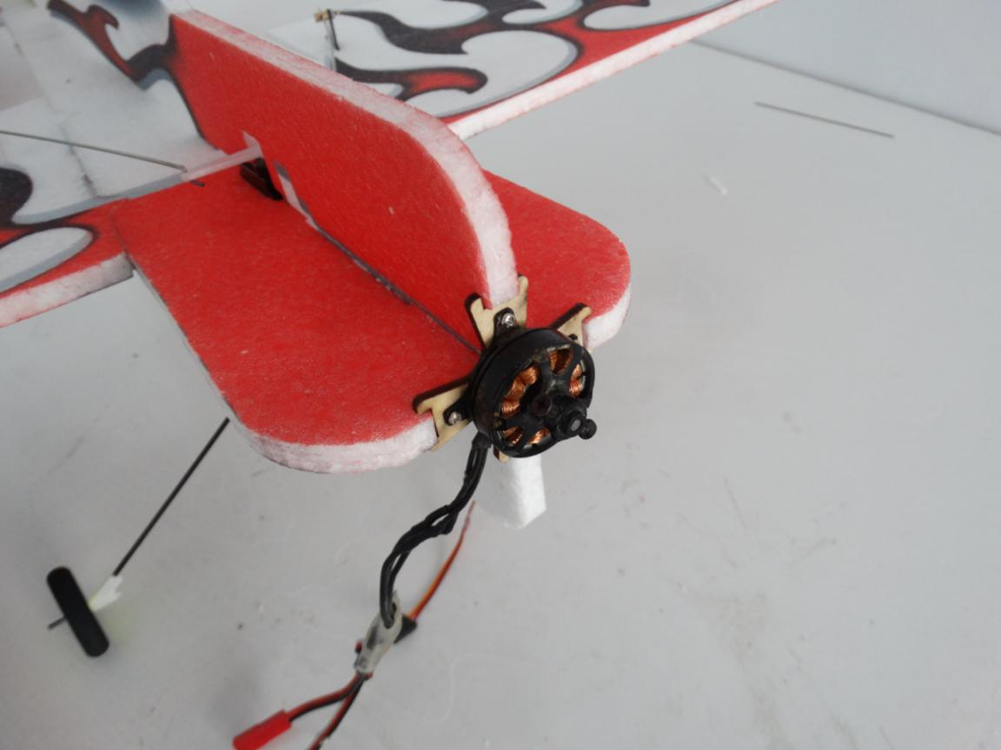

Put hook and loop tape on fuselage using foam glue. Then install ESC.
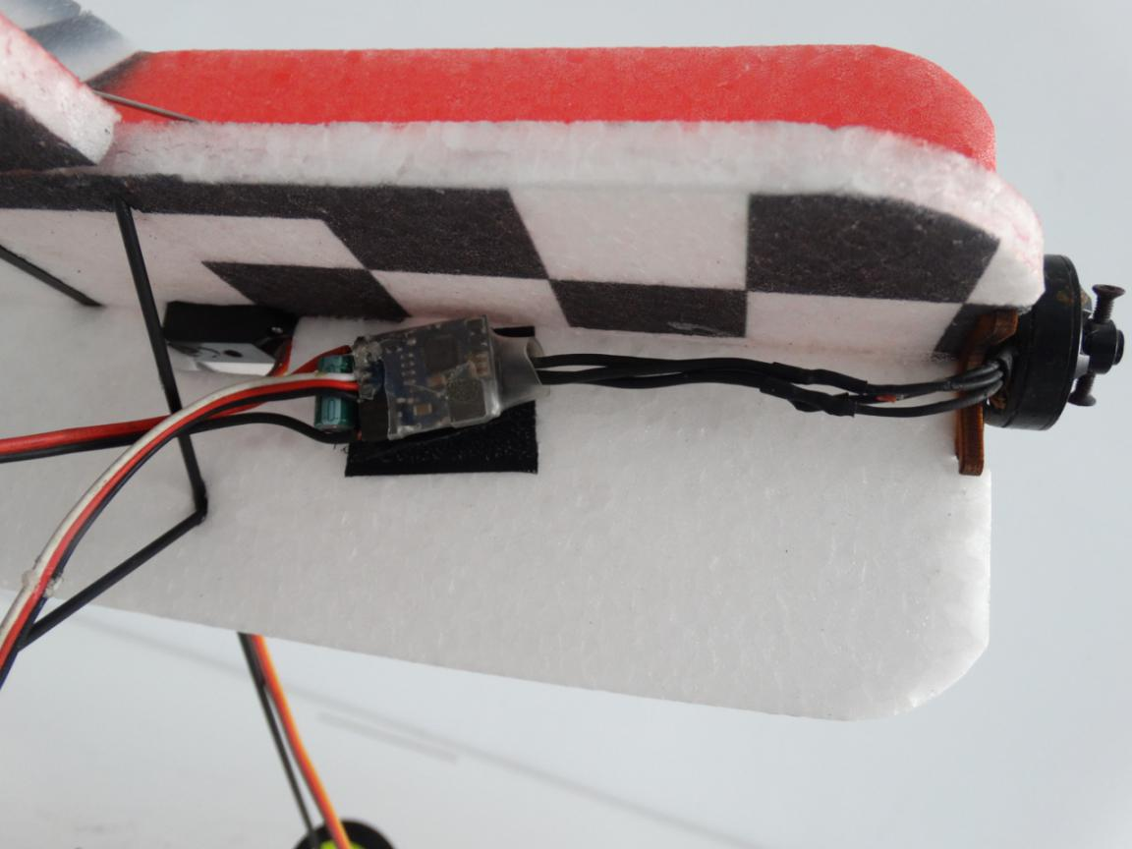
Same way to install receiver and battery on fuselage behind ESC.
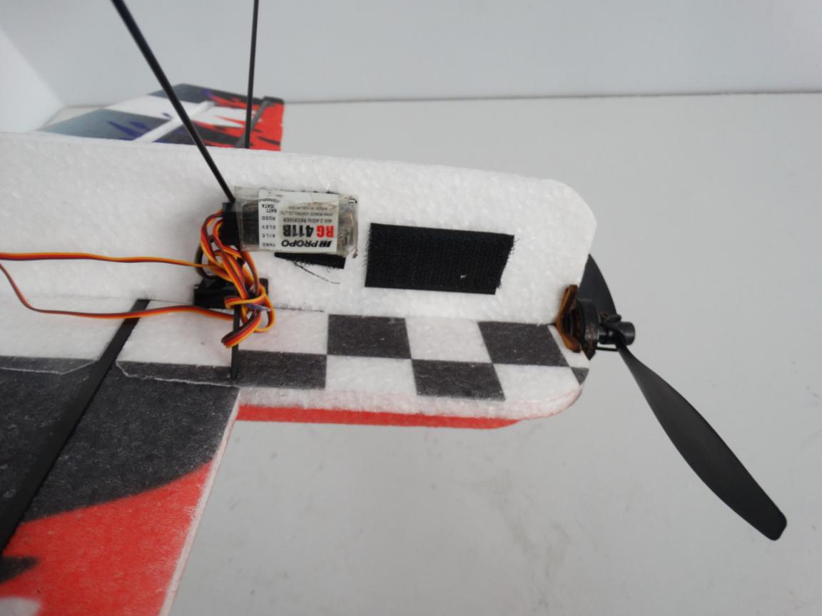

C of G is on the wing as shown in the picture below.
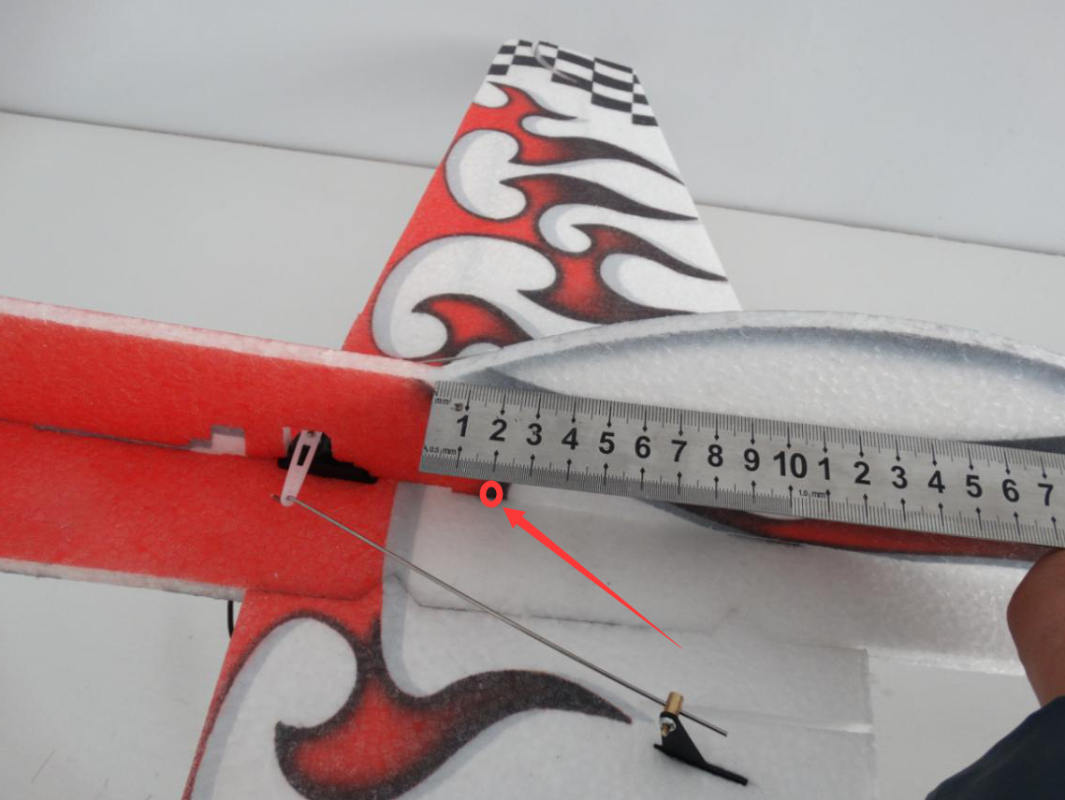
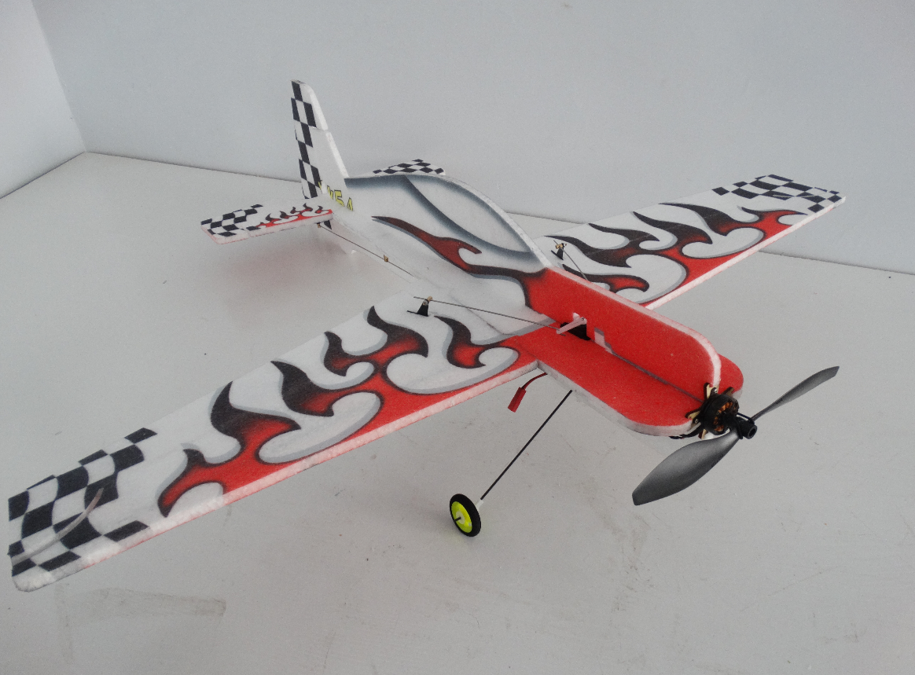
EPP Yak54 is a very good plane for F3D and F3P flying. It’s strong and easy to fix.

