- Welding
Put welding circuit clamp clip in workpiece and grasp the welding workpiece, looking into the eyepiece and let welding place touch tungsten electrode tip. Don push too hard for left space of automatic retraction, and the machine will welding naturally.
Attention：The two electrodes can never short-circuit

- Operation Tips
Pressure Hint: The indicator light below the Select button of panel will flash, when the gas pressure of argon can not reach the welding pressure demand.(According to current setting)

Waiting for welding：The button of wait is on means charging and the light turn to Ready means charge complete

Ready：Everything is right after boot and the Ready indicator lit, you can start welding.

- Replacement of Lens
There install an cover lens under electric protective filter because of it is too close to welding place. And the lens will bonding welding slag, you should replace it based on the bonding extend.

Note：The electric protective filter maybe diminished after two years using.
7
Contents
A.Safety Consideration ………………………………1
B.Main Instruments ……………………………………2
C.Operation Panel and Button Manual ……………3
D.Main Performance Parameters ……………………4
E. Application Method ………………………………4
  - Preparation for Instruments ………………4
  - Installation of Tungsten Electrode Welding ……………………………………………5
  - Instrumentation Settings ……………………5
  - Welding ……………………………………………7
  - Operation Tips …………………………………7
  - Replacement of Lens ……………………………7

We are very grateful for you choosing the product we manufactured. Our company is specialized in developing, exploiting and manufacturing dental equipment. Through our Unremitting efforts and concentrated research, the Pulse argon arc welding machine we developed owns the same level of the international product, is safe, green and environment protecting equipment. Equipment cost and running cost are far below laser welding machine. This machine is produced strictly according to international standard and the customer's requirements. The spot welding machine can be used in the field of dental technique, soldering of pure gold, cobalt-chromium alloy, pure titanium and orthodonitics treatment. And it with small size, safety and stability, easy and fast operating and maintenance-free.
A.Security Considerations
In order to avoid electric shock, fire and dangerous accident when using electrical equipment, be sure to pay attention to following basic safety measures.
1. Before using the instrument, please read this manual and precautions. Placing this manual near the instrument for convenient view.
2. Please keep the electrical equipment away from children and absolutely forbid children to play this electrical equipment, spare parts and other cables.
3. The operating of the equipment should maintain good ventilation and lighting, do not work in a humid and dusty environment thus to avoid accidents by abnormal environment.
4. Never let any liquid enter the instrument.
5. There will be a strong arc light when operating, irrelevant personnel should away from the work site for avoiding damage the eyes.
6. Do not use cable to drag equipment. Cables should be away from heat, oil and other sharp objects, so as not to damage the cable.
7. You must completely cut off the power before clean the equipment and open the case.
8. This machine with compact and reasonable structure does not need special and tedious maintenance. Paying attention to the cleaning of the instrument, especially the microscope. Not clean the attachments will seriously affect the observation of objects.
9.The instrument should be covered with a dust cover in non-working status.
10. For your security, please use the correct fittings.
1
Confirming the panel working pattern according to welding material, this equipment have set up 5 working pattern which almost meet operating demand. If you need change pattern, adjusting the 5 buttons on the panel to achieve the working condition you needed. Welding power and welding time nixie tube will indicate corespondent values.

If the 5 working pattern can not satisfied your need, you can adjust the quantity of welding power and the length of welding time so as to change the welding performance parameter.

Adjusting power, pushing the button ▼means decrease and ▲means increase. Adjust value of 1 to 10 integer and display of value×10 means the percentage of actual power. Adjusting time, pushing the button ▼means decrease and ▲means increase. And the value according to the multiple of 3, the units is second.

Setting the deflate time according the proficiency of worker, which means the time of workpiece touching tungsten electrode . Pushing the select button, you can choose 0.5,1,1.5 second as deflate time.

The equipment will automatically tune to Ortho working pattern without any action of machine in 5 minutes of power on. For avoid damage to the welding object with wrong operating.
6

2.The Installation of Welding Handle and Tungsten Electrode
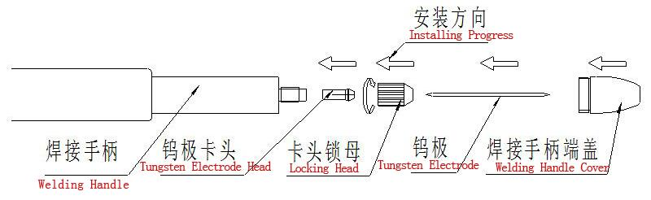
The order of installation is as shown.
Unplug welding handle cover in real practice and unscrew locking head, inserting tungsten electrode. Using the cover measure the tungsten electrode exposes 10-15mm after installation. Than screw locking head and cover。
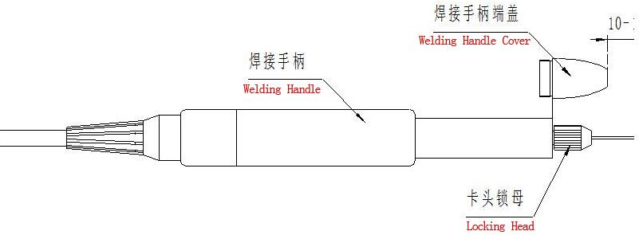

The tungsten electrode should keep sharp status, angle LE 25°. After use for a period, you need polishing until the tungsten electrode can not meet use length, please change in time.

3.Setting of Instruments
Turn on the power switch, make sure the gas supply pressure of argon is 0.1Mpa。

5

B.Main Instruments

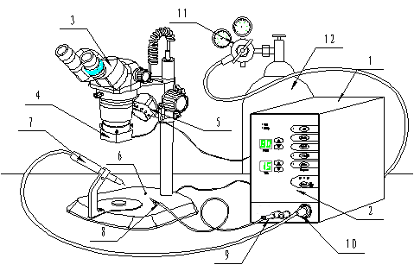

1 | Welding Host | 7 | Welding Handle
2 | Hosting Control Panel | 8 | Welding Circuit Clip
3 | Zoom-stereo Microscope | 9 | Loop Outlet
4 | Electric Protective Filter | 10 | Gas-Electric Connector
5 | Lighting Source | 11 | Argon Cylinder Regulato
6 | Microscope Frame | 12 | Argon Bottle

Attention：The user should settle the argon bottle by themselves.

2
C.Operation Panel and Button Manual

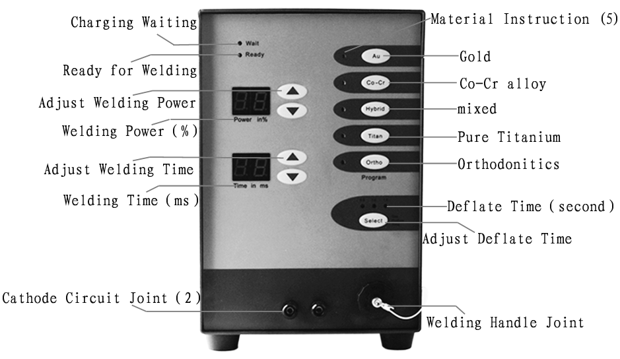
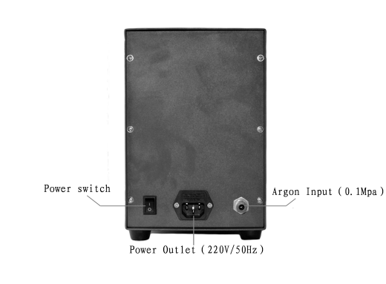
3
D.Main Performance Parameters
Input Voltage&Frequency | 110～220V/50Hz | Welding Voltage | 40V
Input Power | 100W | Welding Current | 50A～600A
Protective Tube | 250V/2.0A | Welding Time | 3ms～30ms
IP Grade | IP21 | Max Welding Frequency | 1Hz
Gas Supply Pressure | ≥0.1Mpa | Max Argon Consumption | 5L/min

