# Instructions of Mini Digital Torque Wrench

I. Overview

1.1 Main use and application range

The mini digital wrench is designed in a miniaturized shape and is more suitable for the operation in a narrow space. Meanwhile, it has complete operating functions including torque setting function, unit setting function, numerical value storage function, numerical value eliminating function, numerical value output function and user correction function. It is easy to operate. The mini digital torque wrench is provided with the digital display screen, so that the requirement on operators is reduced. The mini digital torque wrench is suitable for fastening and controlling bolts in automobile industry, machinery industry, etc.

II. Function features

2.1 It has a large screen and has the backlight function.

2.2 The clockwise accuracy is ±2%, and the counterclockwise accuracy is 2.5% (20% to 100% of the full measuring range).

2.3 It can be operated both in the clockwise direction and the counterclockwise direction.

2.4 The buzzer and the LED indicator are triggered when reaching a preset torque value (peak-limited mode).

2.5 It has four engineering units (N.m, kgf.cm, lbf.tf, lbf.in).

2.6 It has three measuring modes, i.e. real-time mode, peak mode and preset mode.

2.7 It has 999 sets of storable record values.

2.8 It can be automatically powered off in 5 minutes.

III. Functions and names of parts

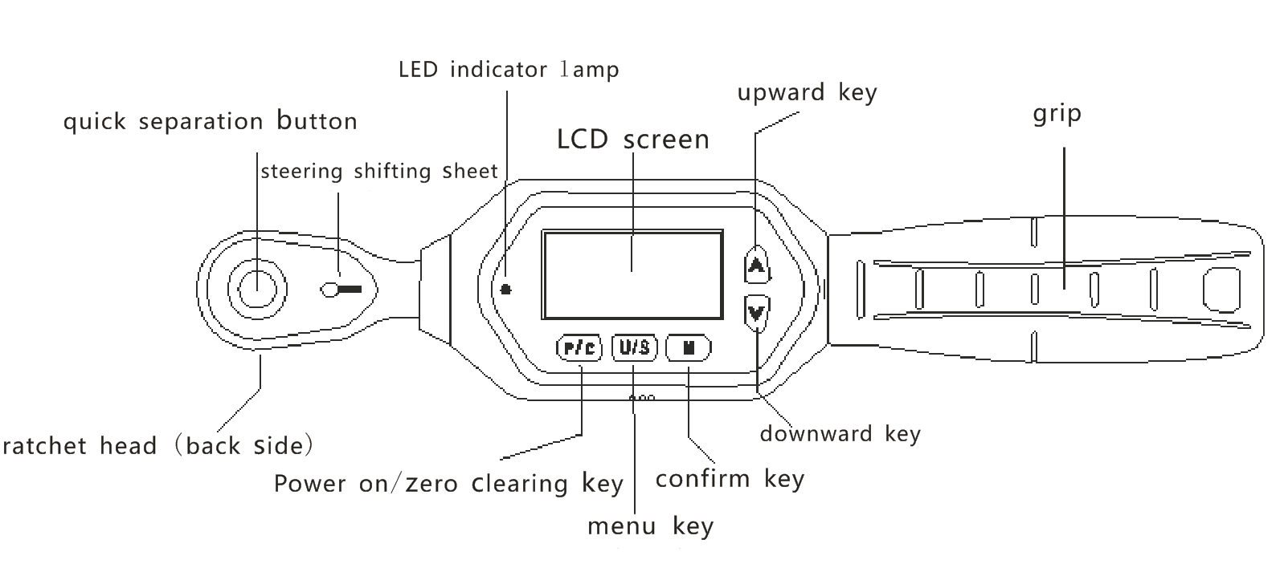

IV. Notes before use of wrench

4.1 Press the key “C” to turn on the power of the wrench

4.2 After the power is turned on and before the use, press the key “C” to reset the wrench

4.3 If there is already an external force applied to the wrench before the wrench is powered on, after turn on the power/reset, there is a deviation value displayed on the screen.

4.4 "N.m” is unit and is loaded from EEPROM. Once the unit or mode is changed by the user, EEPROM will exist forever.

4.5 The wrench is awakened when in sleeping

4.6 In order to save the power, when there is no operation, the wrench will enter the sleep mode in about 5 minutes. Press key “C” to awaken the wrench.

4.7 Low-voltage protection

4.8 If the system detects that the battery voltage is less than 2.2V, the wrench will be automatically powered off.

V. Technical specifications of products

*： Please refer to the comments at the end of the table

|  |  |  |  |  |
| --- | --- | --- | --- | --- |
| Model (with no communication) | 10 | 30 | 60 | 100 |
| Minimum division value | 0.01 | | | 0.1 |
| Maximum operating range  （N.m） | 10N.m/7.37ft.lb/88.50in.lb/101.97kgf.cm | 30N.m/22.12ft.lb/265.5in.lb/305.91kgf.cm | 60N.m/44.25ft.lb/531.04in.lb/611.82kgf.cm | 100N.m/73.7ft.lb/885.0in.lb/1019.7kgf.cm |
| Connector（inches） | 1/4 | | 3/8 | 1/2 |
| Setting range of buzzer（N.m） | 0.3~10 | 0.9~30 | 1.8~60 | 3~100 |
| Length (mm) | 230 | | 240 | 285 |
| Accuracy*1 | Clockwise：±2% Counterclockwise：±2.5% | | | |
| Data storage capacity | 999 | | | |
| Operating mode | Peak mode（P）/ Real-time mode（T）/ Preset mode（Pre） | | | |
| Unit | N.m, kgf.cm, lbf.tf, lbf.in | | | |
| Form of ratchet head | Bidirectional ratchet head | | | |
| Number of ratchet teeth | 72 teeth | | | |
| Number of keys | 5 | | | |
| Battery | Two AAA batteries | | | |
| Operating temperature | -10℃ to 60℃ | | | |
| Storage temperature | -20℃ to 70℃ | | | |
| Test falling height | one meter | | | |
| Vibration test condition*2 | 10G | | | |
| Service life test*3 | 10000 times | | | |

Note:

*1. The accuracy is ensured to be in a range of 20% to 100% of the maximum operating value. The torque accuracy is a normal value. The correction accuracy adopts an intermediate groove of five grooves on a grip as a correction point. In order to ensure the accuracy, it is suggested to correct once a year.

*2. The service life test includes the horizontal test and vertical test.

*3. "One time” refers to the process of applying the force from ON.m to the maximum operating value of the wrench and then returning to ON.m.

VI. Use method

6.1 Power on

Shortly press key “P/C” key to power on. After the starting, if the power is insufficient, it will be automatically powered off. After the battery is replaced, the wrench can be used normally.

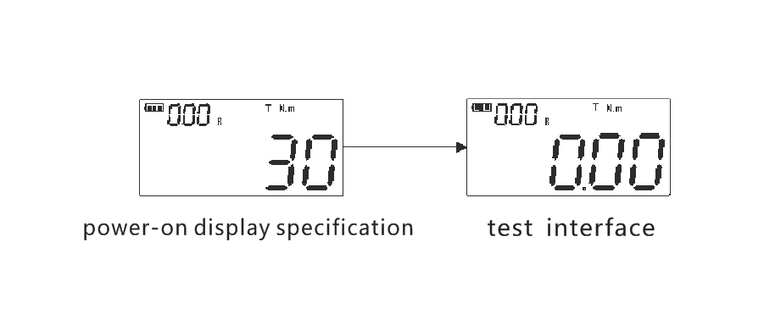

6.2 Unit switching

At the power-on state, on the use interface rather than the non-set interface, press key “U/S” to switch the four engineering units.

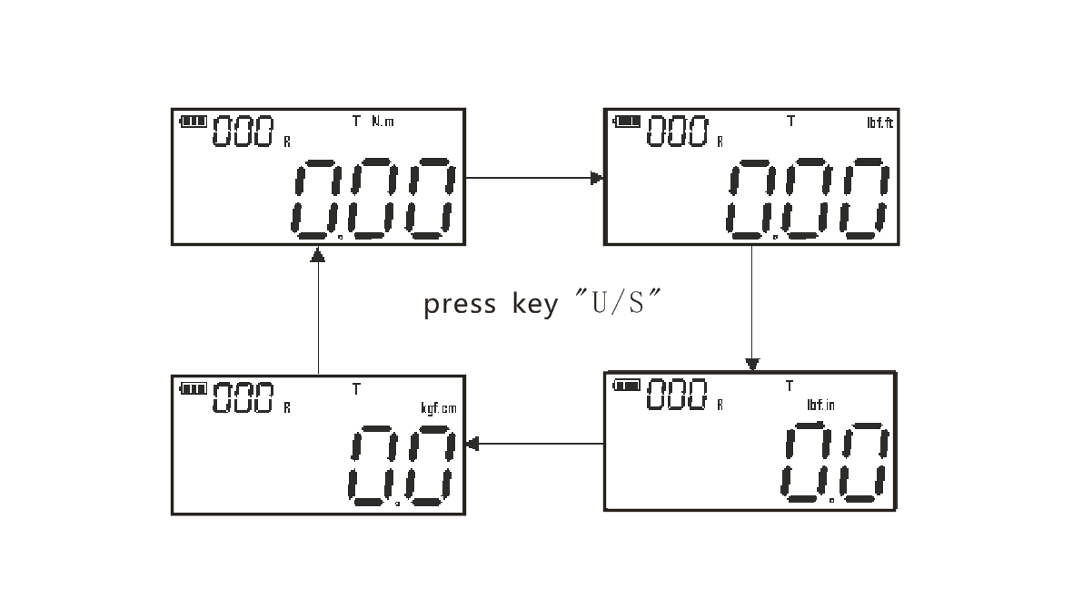

6.3 Mode switching

At the power-on state, press key “∧” to switch the mode. The digital torque wrench has real-time mode “T”/ peak mode “P”/preset mode “Pre”.

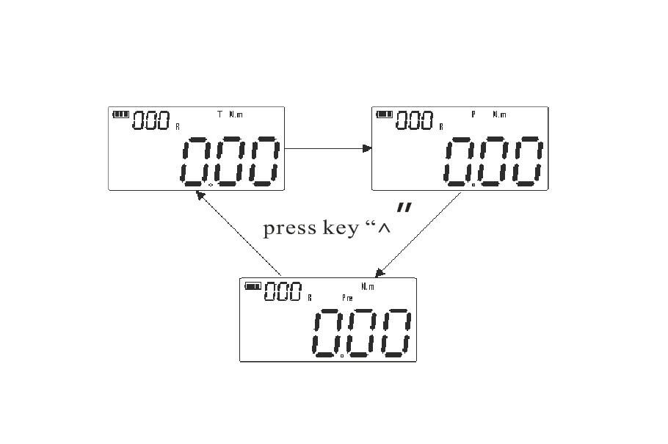

A. Real-time mode

At the real-time measuring mode, the applied torque value shall be tracked in real time. When the torque is unloaded, the torque value is automatically returned to zero. When “T” is displayed on the liquid crystal display, it is the real-time mode. Press key “∧” to switch the working mode.

B. Peak mode

At the peak measuring mode, when the torque is applied, the maximum torque shall be locked to the wrench and displayed on the liquid crystal screen. When the torque is unloaded, the peak torque is locked. When the torque is re-loaded, the LCD liquid crystal screen will not update the locked peak value. The liquid display screen displays P which is the peak mode. Press key “∧” to switch the working mode.

C. Preset mode

At the power-on state, long press the key“∨” to enter the setting of preset numerical value, then press the key “∧” to add the target value or press the key “∨” to reduce the target value or the preset value. After the setting is completed, press the key “U/S” to save/exit. After the buzzer is powered on, and when the preset target torque value is reached, the buzzer buzzes for a long time, and the red light is on for a long time. Press the key “∧” to switch the preset mode.

6.4 Zero clearing

At the measuring mode, press the key "P/C" to directly reset the force value. At the preset or peak mode, press the key "P/C" to reset a peak maintaining value.

6.5 Data saving

At the measuring interface, shortly press the key "M", when "Succ" is displayed, it means the success in saving. When "FAIL" is displayed, it means the failure in saving. When the force value is zero, it cannot be saved, and there is the prompt of "FAIL".

6.6 Data viewing

Press the key "P/C" to power on or at the power-on use interface, long press the key "M" to view the saved data. At the data viewing interface, the saving record can be viewed through the key "**∧" or "∨". After the viewing, shortly press the key "M" to exit.**

6.7 Data deletion

Press the key "P/C" to power on or at the power-on measuring interface, long press the key "M" to display the saved data. Press the key "U/S" to select the deleting way. "ALL" indicates deleting all at one time. "ONE" indicates gradually deleting the data one by one. After the deleting way is selected, finally press the key "P/C" to delete the saved data.

6.8 Factory setting restoring

By using this function, the user can restore the factory settings of the instrument. Long press the key "U/S" to enter the system menu. Shortly press the key "U/S" to select "RESET" menu, and then press the key "∧" to select the number 1 or 0. If the factory settings are restored, select "1" and shortly press the key "U/S" to exit the system menu, that is, the product is already restored to the factory settings. If the factory setting is not restored, select "0", and then shortly press the key "U/S" to exit the system menu.

6.9 Buzzer function

Long press the key "U/S" to enter the system menu. Then shortly press the key "U/S" to select the item "BUZZ". Shortly press the key "∧" to select whether to start the buzzer. If the buzzer is to be started, select "1", and then shortly press the key "U/S" to exit the system menu, that is, the buzzer is already started. If the buzzer is not to be started, select "0", and then shortly press the key "U/S" to exit the system menu.

6.10 Backlight function of display screen

Long press the key "U/S" to enter the system menu, and then shortly press the key "U/S" to select the item "LTON". Shortly press the key "∧" to select whether to open the backlight function. If the backlight function is to be opened, select "1" and then rapidly shortly press the key "U/S" to exit the system menu, that is, the backlight function is already opened. If the backlight function is not to be opened, select "0", and then rapidly shortly press the key "U/S" to exit the system menu.

6.11 Low power consumption function

Long press the key "U/S" to enter the system menu, and then shortly press the key "U/S" to select the item "LPOW". Shortly press the key "∧" to select whether to open the low power consumption. If the low power consumption is to be opened, select "1", and then shortly press the key "U/S" to exit the system menu, that is, the low power consumption is already opened. If the low power consumption is not to be opened, select "0", and then shortly press the key "U/S" to exit the system menu.

长按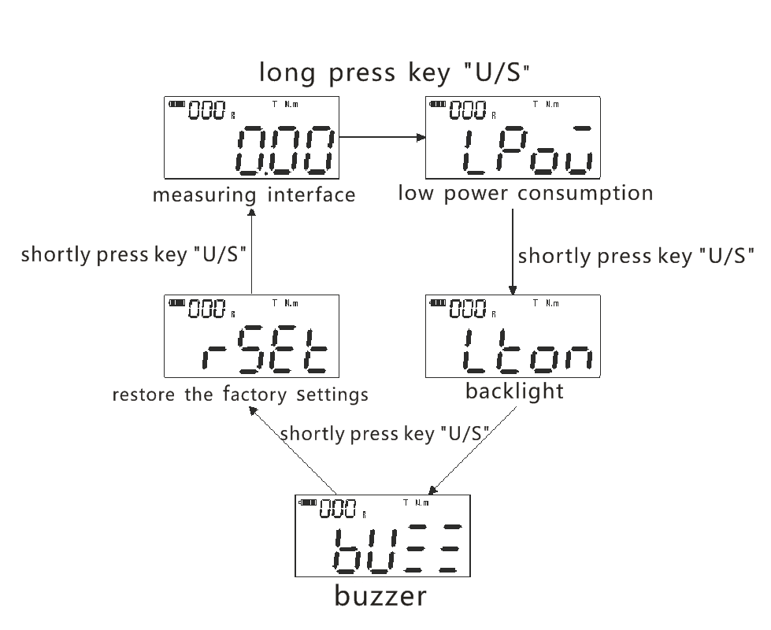VI. Maintenance and storage

7.1 The calibration period shall be conducted once a year.

7.2 The over-torque may lead to the damage or accuracy loss. Do not exceed 120% of the maximum torque.

7.3 Do not violently shake the wrench, drop the wrench on the floor or use the wrench as the hammer to knock at will.

7.4 When the battery power is low, replace the battery in time, please.

7.5 Do not place the wrench at the place at high temperature and high humidity or with direct sunlight.

7.6 Do not use the wrench nearby the water

7.7 If the wrench is carelessly wetted, wide dry the wrench with dry towel immediately.

7.8 Do not clean the wrench with organic solvent such as alcohol or paint diluting agent.

7.9 Do not approach the wrench to a magnetic object.

7.10 Do not place the wrench at the place with a lot of dust or sand, otherwise, it will severely damage the wrench.

7.11 Do not heavily press the LCD screen.

VI. List of accompanying accessories

|  |  |  |
| --- | --- | --- |
| 1 | Digital wrench | One |
| 2 | AAA battery | Two |
| 3 | Instructions | One |
| 4 | Qualification certificate | One |
| 5 | Warranty card | One |
| 6 | Drying agent | One packet |