**Smart Electronic Peephole Door Viewer/Video Doorbell**

**Instruction Book**

**Version No.:V6.0**

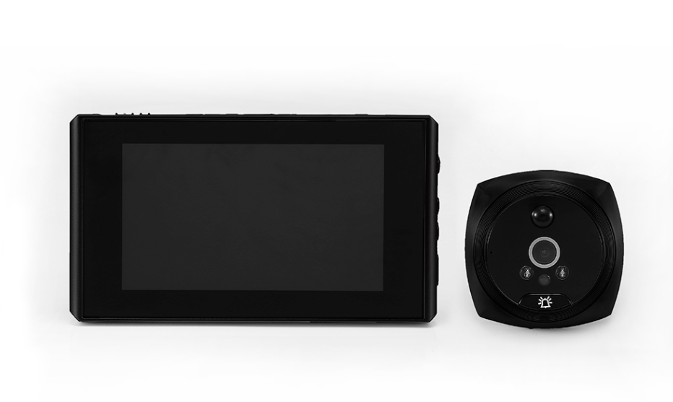

**Notice:**

* Please pay attention to polarity of the standard lithium battery when insert to the indoor device.
* To avoid falling and damage, please do not put the products in the unstable object surface; please don’t touch the motion detection sensor of the outdoor device.
* To avoid the damage of LCD screen and the panel, please don't press the LCD screen display area.
* Please pay attention to dust, dampness, moisture, and high temperature.
* Please insert the SD card (SD card beyond 8G) before installing the battery.
* Please align cable port fastened gently when install the flexible cable,cover the cable cover.
* To Maintain the surface cleaning of the outdoor camera lens.
* There is a protective film on the surface of the outdoor station, please tear it off when using, so as not to affect the clarity of the image

**Product Specification：**

A、 Indoor unit: 135*76*15.5MM

B、 Outdoor unit: 62*62*15MM

C、 Door opening range: 15—38MM

D、 Door thickness range::30-110MM

E、 LCD screen：4.3”

F、 Camera pixels：200W

G、 Lithium battery:2500MAH 3.7-4.2V

H、 Picture and video specifications：1080P

**Accessories：**

|  |  |  |  |
| --- | --- | --- | --- |
| **No.** | **Parts** | **Quantity** | **Description** |
| 1 | Indoor Unit | 1 | Indoor display part of LCD screen |
| 2 | Outdoor Unit | 1 | Outdoor camera and door bell button part |
| 3 | Screw | 4 & 10 | Standard screw, fixed bracket and outdoor device |
| 4 | Battery | 1 | 1500MA standard battery |
| 5 | Stainless steel bracket | 1 | Bracket for fixing outdoor / indoor device |
| 6 | Charger | 1 | To charge the device |
| 7 | Instruction book | 1 | Guide users to operate the product |

**Instructions of interface and key-press:**

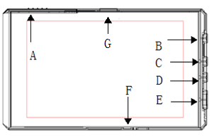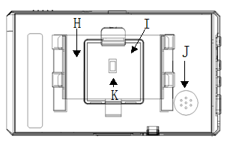

（ diagram 1） （ diagram 2）

A: Battery

B: Menu

C: Left or upper function selection

D: Right or down function selection

E: Power switch key / video playing key: press once for shooting picture or video after startup; it is the return key when turn to the menu interface; and power off after long press 2 seconds.

F: USB charging port

G: SD card slot

H: Stainless steel hanging plate

I: Back cover of FPC

J: SPK

1. Cat’s eye connection cable socket

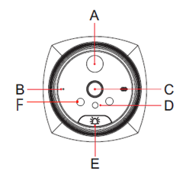

（diagram 3）

A:Motion detection sensor(infrared body sensors)

B:MIC hole

C:HD infrared night vision camera

D:Light detection

E:Doorbell button

F:Infrared night vision fill light

**Installation diagram：**

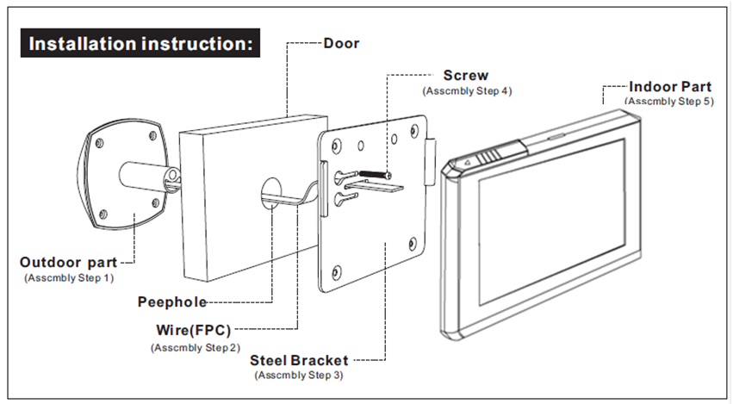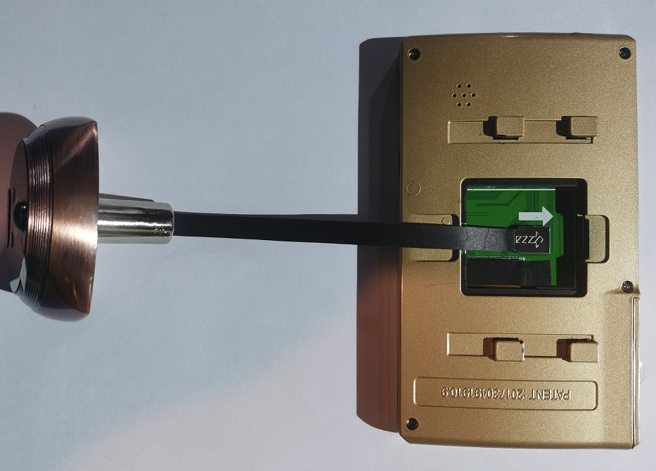

**Installation** **procedure：**

Step 1:

Remove the conventional optical lens peep outdoor part, recommended door hole between 15mm ~ 38m

Step 2:

Select the screw which is suit for the thickness of the door and screwed into the outdoor part screw hole,do not tighten, if the door thickness is greater than 95mm,in particular need the longer screw.

Step 3:

Rip the adhesive tape which on the outdoor part housing,**please note that the door bell button is down**,put the wire (FPC)and the screw(which fix in the outdoor device) together through the door hole,then adjust the position of outdoor part and adhesive on the door, **please note the cable connector should be down.**

Step 4:

Put the wire (FPC) through the center hole of the bracket,put screws through to the big hole from the left of bracket, slide bracket to the left until Align with the wire (FPC) center.

Step 5:

Tighten the screws to fixed the bracket, straighten FPC.

Step 6:

Take the wire (FPC) cover,to put the cable is inserted and fastened according to the arrow indicates direction,After connected the wire (FPC),please cover the wire (FPC) cover.

Step7:

Turn the indoor part back,straighten the wire (FPC).align and Insert to the bracket port of the device,vertical sliding down,Ensure that the device is firmly fixed on the door.

Step 8:

insert an SD card, and then install the battery, turned on to test the functions is working properly.

**Function interface instruction**

1. Starting up into the watching interface, press the power button to take photos or videos,pictures or video files will store in fixed folder of SD card.
2. Press menu button to enter the main menu interface,choose the function with pressing up or down button,press menu button to confirm.

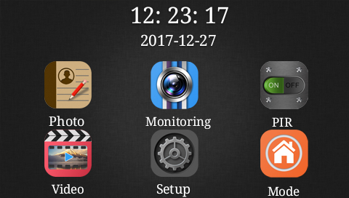

1. Photo :Press the menu button to confirm entering the album viewing interface, press the up button to see the previous picture (video), press the down button to see the next picture (video), long press the menu button under this interface to delete the picture, select "Delete Current" or "Delete All", and press the "on/off" button to return to the main interface.
2. Monitoring:Select Monitor and press enter key to return to the main screen. The camera can be manually focused.
3. PIR: Select the PIR and press the menu button to determine the working status of motion detection: delay of 15 seconds,30 seconds, 2 minutes, real-time, off etc.

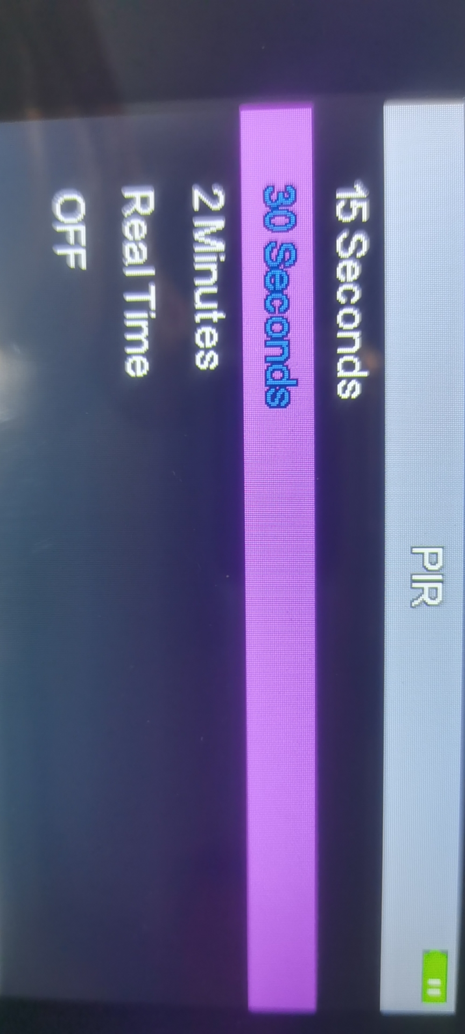

1. Night vision: The customer chooses whether to turn on the night vision function according to the light at the door.
2. Settings: press the menu key to enter the setting interface, which is divided into two pages.

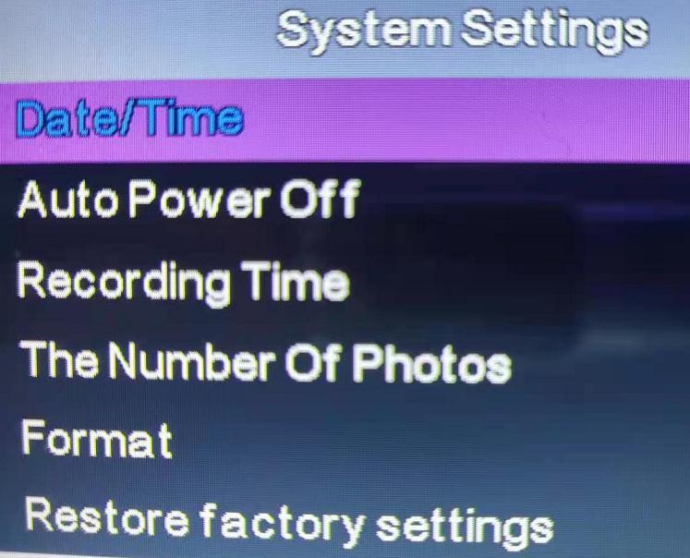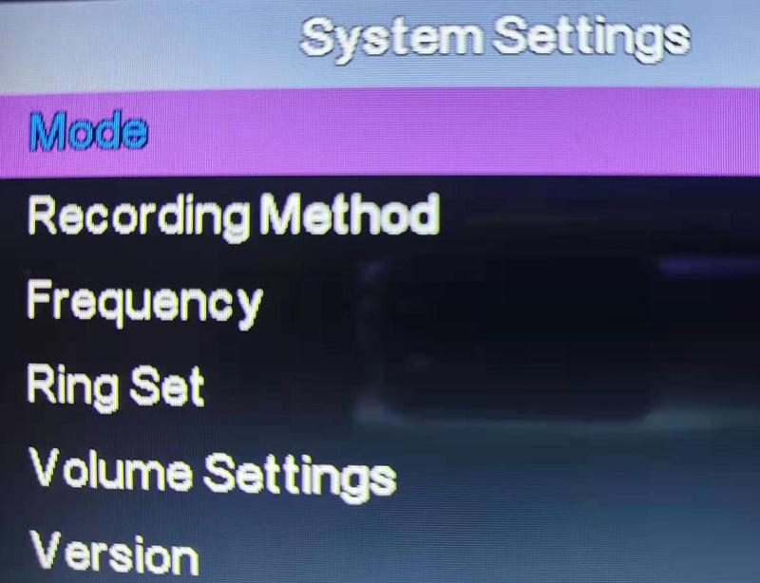

F. Language: here you can choose your own language, a total of 11, different development versions, the language will be different

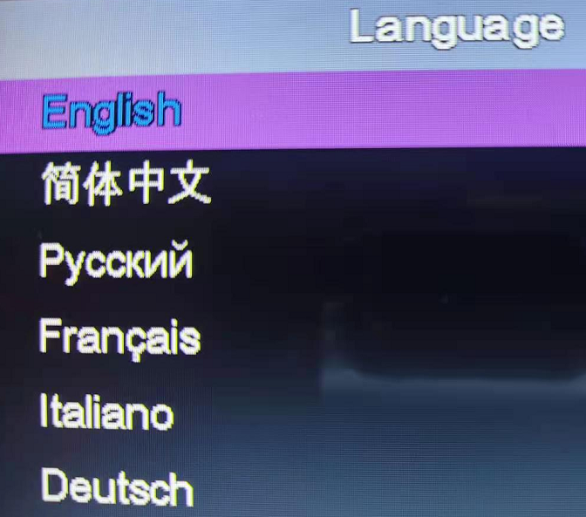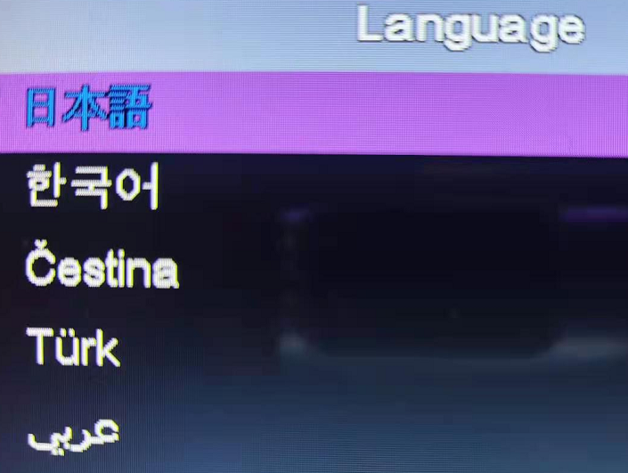

**System setting**：

1. Date/Time, set the current date and time.
2. Auto Power Off: set the shutdown time, divided into four status: close, 10s, 20s and 30s
3. Language Setting: language selection can be performed
4. Recording Time: you can choose 10S, 20S
5. The Number Of Photos: you can choose according to your needs(one, two, three)
6. Format: When the device cannot be stored normally, the SD card needs to be formatted  
   Note: Confirm that all files in the SD card will be permanently deleted after formatting
7. Restore Factory Settings: This feature can be selected in case of device setup disorder
8. Mode: Press the mode setting: 1. At Home 2. Do Not Disturb Mode 3.Leave Home

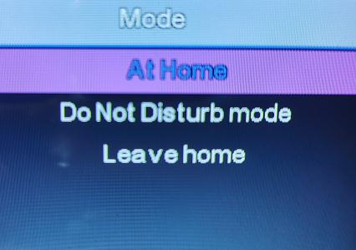

A: At home Mode: when visitors press the doorbell button, the screen will light up. When motion detection starts, the screen will automatically light up to take pictures or video (audio and video).

B:Do Not Disturb Mode: When a visitor rings the doorbell, the screen will not light up.When motion detection starts, it will automatically take pictures or video (audio and video).

C: Leave Home Mode: When visitors press the doorbell button, the screen will not light up but bell rings. When the motion detection starts, the screen will not light up and the camera will automatically take pictures or video (audio video). (Photo or video can be set in the "Mode" setting of the main menu)

1. Frequency: select "50Hz" or "60Hz" according to the light source in the working environment of the equipment. If the light jitters during shooting, you can try to switch it
2. Ring Set: different ring tones can be selected as the doorbell sound
3. Volume Settings: set the volume of different levels and confirm the ring tone
4. Version: displays the software version number of the current device
5. Update firmware: this function needs to be carried out under the professional guidance of the manufacturer

**FAQ**

|  |  |  |
| --- | --- | --- |
| **No.** | Phenomenon | Treating method |
| 1 | Can not close the battery cover | Check the battery and SD card inserted direction |
| 2 | Can not start up after installation | Confirm whether the battery insert in place, the soft ribbon cable (FPC) presence of buckle |
| 3 | Can not take a picture or video | Confirm whether is the SD card has been inserted and is a valid card of high speed |
| 4 | Fuzzy image | Check the camera surface if it is dirty |
| 5 | Motion detecting (PIR) no action | Check the motion detecting probe if it is damaged, confirm the indoor machine PIR is turning "on" |
| 6 | Fast power consumption | When the entrance flow is large, it is recommended to set the PIR to a longer delay interval or close It is recommended to plug in the data cable when opening the monitoring |