I10 User Manual
1, Quick Start
  - Warning
Please consult your doctor before starting a new sporting item, Smart Watch can monitor real- time dynamic heart rates, but it can’t be used for any medical purpose.
  - Equipment requirements
Support Android 5.1，IOS8.0 BT 4.0 and above.

2, Open Box and First time Quick Use.

Open the box Take out the I10 smart Watch
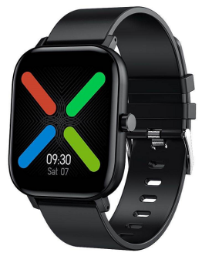

Charge the Watch
(First Time charge suggest 2 hours)
Use Your mobile phone scan below QR Code and Download the “WearFit 2.0” APP
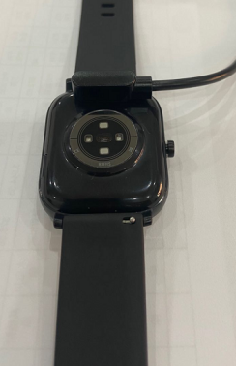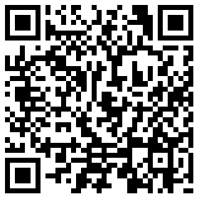
Both work for Android &IOS

Turn on Your Mobile Phone Bluetooth Step 1: Open “WearFit2.0 APP”--“Mine”--“Connection management”--“Bind Bracelet”--Find I10 and choose---“Pair”-- “Allow Write Data”--Done
Step 2: Go to your mobile phone Bluetooth-- on--other device--I10TH---connected.

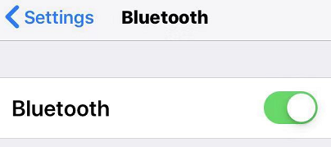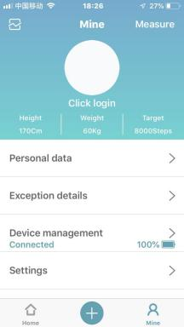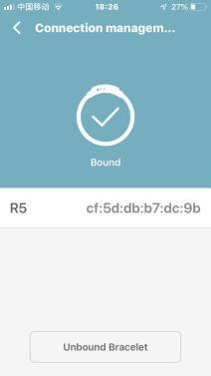

Tips for the first time use:
2.1 Open the box, like the photo showed above, use the I10 charging cable, then insert the USB to your laptop or any USB port with 5V to charge the Watch before use to ensure that the Watch is fully charged. The charging time is about 2 hours. To ensure that the charging contact is good. Please ensure that the metal surfaces are not dirty, oxidizing and impurities. When charging, the screen will display the charging symbol. If the device is not used for a long time, please be sure to replenish it every one month.
2.2 When the Watch is first paired with "APP", it will synchronize the time, date, and quantity of the Watch battery and display the symbol of success of the BT connection
2.3 How to Boot Device: Long press the watch button for 5 seconds and Watch will be booted.
2.4 How to Shut Down Device:
In the watch interface page, long press the button for 5 seconds, then choose to shut down. The watch will be turned off and with vibration.

3 Watch function interface
3.1 Watch face: long press the watch face, it can be changed to 4 different watch faces. showed Dates, Time etc.
Customized watch face: go to APP wearfit 2.0---Mine--Device management--Layouts--Select Image--Take photo/Choose photo--Choose--Send--Done. Then you can see the photo will be showed in your watch.

3.2 From the watch face page, put your finger slide to right page. Showed below.

Setting: In this page, you can set the dial mute,dial shake, call vibration.
Phone call: you can check phone call records, Contacts, keyboard,SOS, Dial settings.
Heart rate: measure your heart rates.
Weather: show weather status.
Status: show the step counts.
Sleep：show the sleep status, like sleep time, deep sleep time etc.
Music: you can control the music play in your mobile phone through this watch function.
Find phone: you can use this function to find your phone.
Stopwatch: use the stopwatch function.
Sports: there are 5 different sporting types for your choice.
QR code: wearfit 2.0 QR code for scan and download.
SP02: measure your SPO2 data.
BP: measure your blood pressure data.
Camera: control your mobile phone camera to take photos.
Timer: you can set the time to use the timer.

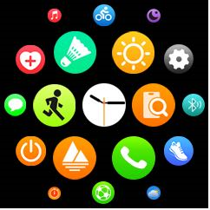

3.3 In the watch face page, finger touch from down to top can go to page like below.

Do not disturb: you can turn on or off do not disturb function.
UI style change: there are two options for you to define the UI format.
About: you can check the firmware version and Mac address.
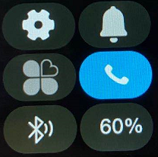

3.4 Raise the bright screen, Anti-lost reminder, Call reminder, SMS reminder, APP notifications.
App “WearFit2.0”-- “Mine” -- “Device Management”--- click and open the “Raise the bright screen”, “Anti-lost reminder”. then go to “Intelligent reminder”, open the “Call reminder”, “SMS reminder”, “APP Notifications” -- open ”WhatsApp”, ”Facebook” etc.
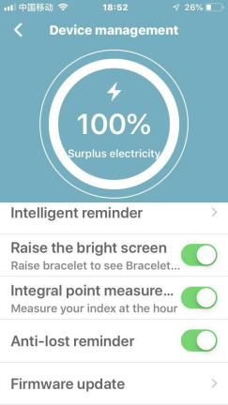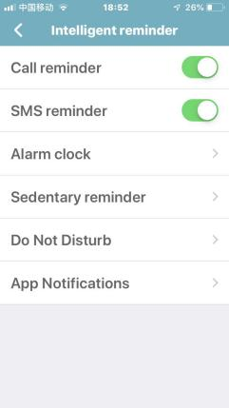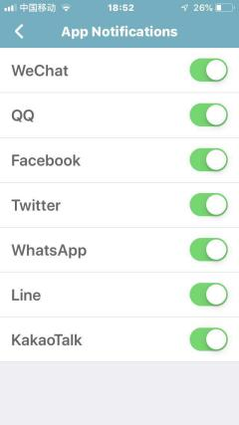

3.4.1 Find bracelet
Go to APP, Mine--Device management --find bracelet, the watch will vibrate.
3.4.2 Measure
Go to APP, choose the right up” measure”, “one key measurement”, the watch will measure the heart rate, blood pressure and oxygen at same time.

4 APP Other functions
4.1 “Home”
You can check all the data in this page, like Step, Sleep, HR, BP, SpO2, Fatigue etc.
4.2 Sedentary remind, Alarm clock.
“Mine”--“Device management”--“Intelligent reminder”--“Alarm clock”，can set 8 alarms.“Mine”--“Device management”--“Intelligent reminder”--“Sedentary remind”，can remind you for some exercise.
“Mine”--“Device management”--“Intelligent reminder”--“Do Not Disturb”，can set the not disturb time period.
4.4 Health weekly.
Open APP，click the left top “flash”, can enter into the health weekly reports. This page can check all the data for weekly like steps, sleep, HR, BP, Oxygen etc.

5 Parts introduction
Smart Watch *1
Charging Cable *1
Packaging * 1
User manual *1

