INTELLIGENT INDUCTION POSE

User Manual

Thank you for purchasing our intelligent induction pose. We have been trying to seek a smart and novel product, which supports automatic induction reminding and self-correction, and helps users develop good habits. We believe intelligent induction pose will bring you a new health experience.

**Product introduction:**

1. Ergonomic design, fit the curve of human body, scientific and comfortable;

2. The intelligent chip monitors the angle in real time. Different from the traditional forced correction, if the user sits with poor posture, the machine will automatically sense and remind in vibration for posture correction;

3. The product is equipped with screen memory function. You can check the number of bad sitting postures every day, and parents know children's improvement on behaviors and postures well.

4. Standard Mini-USB Android interface is used to charge the product, which is convenient, safe and reliable;

5. Elastic shoulder strap, comfortable to wear;

6. Large capacity lithium battery with long-lasting storage and uninterrupted correction;

Adjusting buckle

USB charging port

Switch knob

Elastic shoulder strap

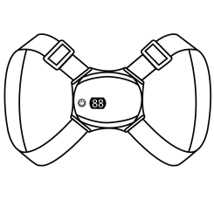

**Appearance introduction:**

**Packing list:**

Intelligent induction pose, USB charging cable, manual

The induction pose is made of healthy materials and has passed a rigorous skin allergy test, so please feel relieved to use.

**Charging function instructions:**

1. If it shuts down automatically during work, maybe it’s running out of the power and needs to be recharged to continue to use.
2. Connect the adaptor or USB port wirh the output of DC5.0V with the charging input port through the USB charging cable, then the screen will flash. After it is fully charged, it will light off.
3. The product is not allowed to be used when charging.

**Instructions for pose screen and button vibration:**

|  |  |
| --- | --- |
| **88** | Show the number of bad postures automatically |
| Short press for 1S | Start up or shut dowm (After shutdown, the value returns to zero) |



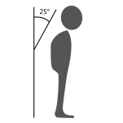

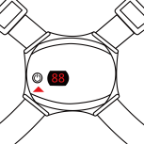

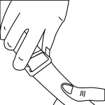

**Operation:**

Adjust the shoulder strap to proper length

Straighten your back and press the switch.

When the hunchback radian exceeds 25°, the induction pose will automatically vibrate to remind, and the value on the screen will add by 1 automatically

The induction pose remind you to stand upright through vibration

**Common faults:**

1. If the induction pose is not sensitive, please adjust the angle of the strap properly, and fit it close to the back;
2. If the induction pose is too sensitive, please stand normally, adjust the angle of the induction pose, and make it vertical to the ground;
3. If the machine cannot be started, please charge for 10 minutes, if the screen does not show anything, please contact customer service;

**Precautions:**

1. The person with serious symptom shall go to regular hospital for medical treatment;

2. The correction process is not easy, persistance is required to see the effect;

3. Insist on straightening the back is the only effective and healthy way;

4. Other forced correction product is harmful;

5. Please read the manual carefully;

**Main technical parameters:**

Charging port: Mini-USB Android port

Build-in battery spec.: 200mAh/3.7V

Input voltage: DC5V --- 0.25A

Output voltage: 3.7V --- 0.1A

Power: 0.25W

Charging time: about 1.5H

Material: ABS+PVC+high strength elastic nylon tape