ATU-150（200）Connection point：

1、POWR，DC12V，GND；

2、TO SCREEN
VCC to VCC
GND to GND
DAT to SDA
CLK to SCL

3、TUNE switch TUNE to switch GND to switch

4、RF IN RF IN to Block M by 50-3 coaxial line.

5、RF OUT
RF OUT to ANT by Metal end of porcelain post

6、GND GND to GND Screw
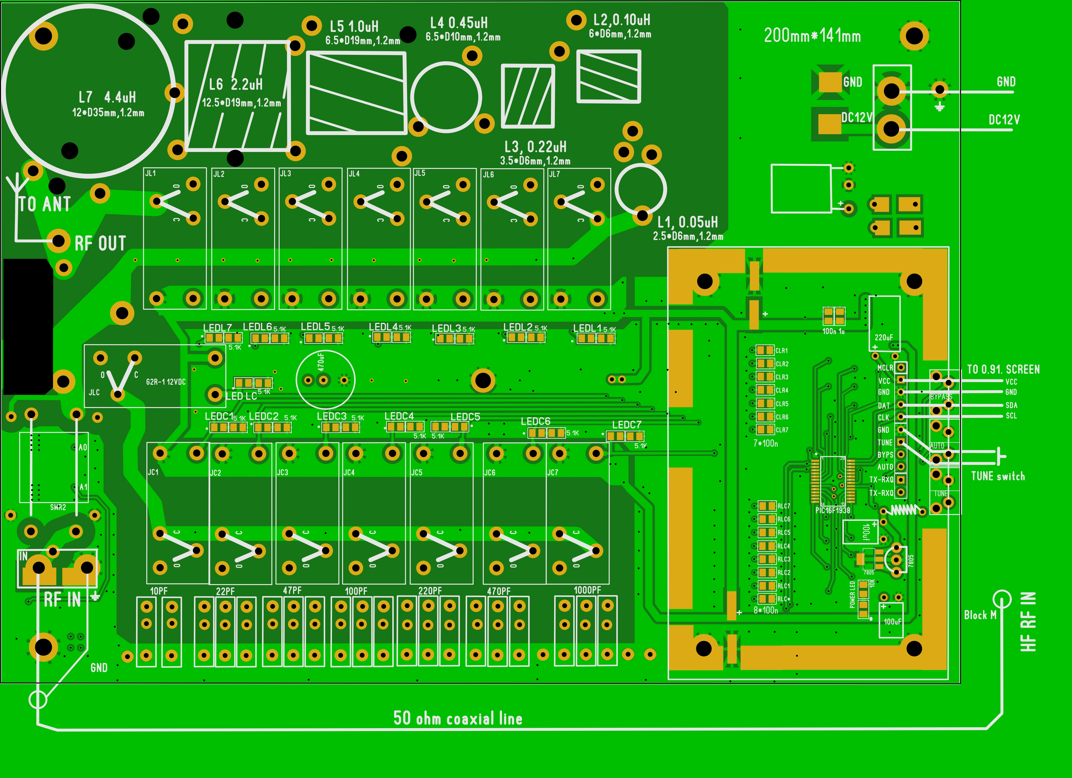

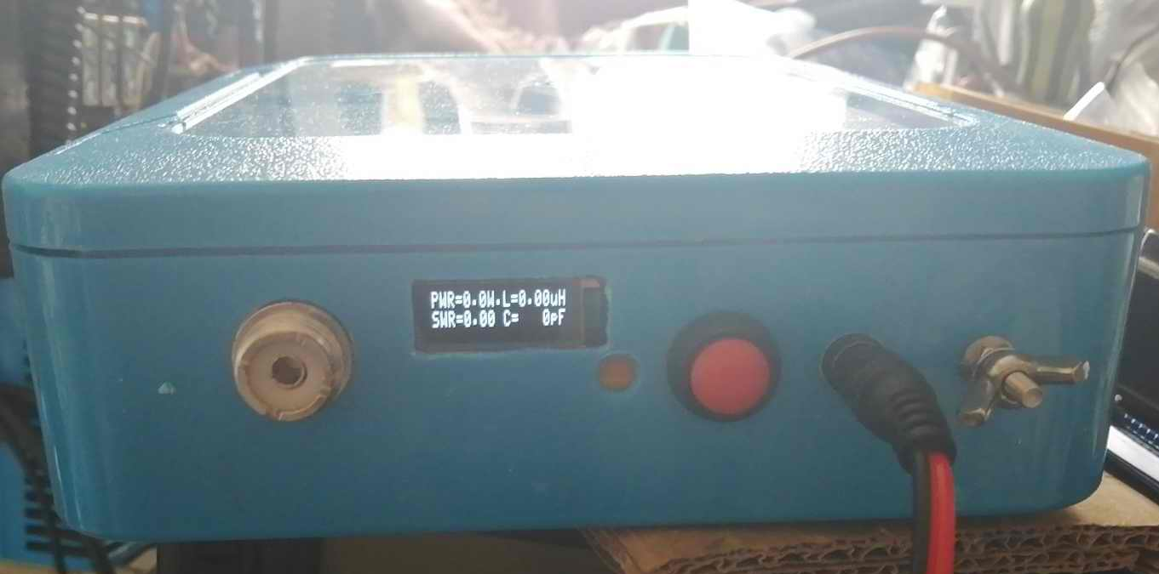

POWR line
GND
TUNE switch

0.91’ screen

50Ω
Block M

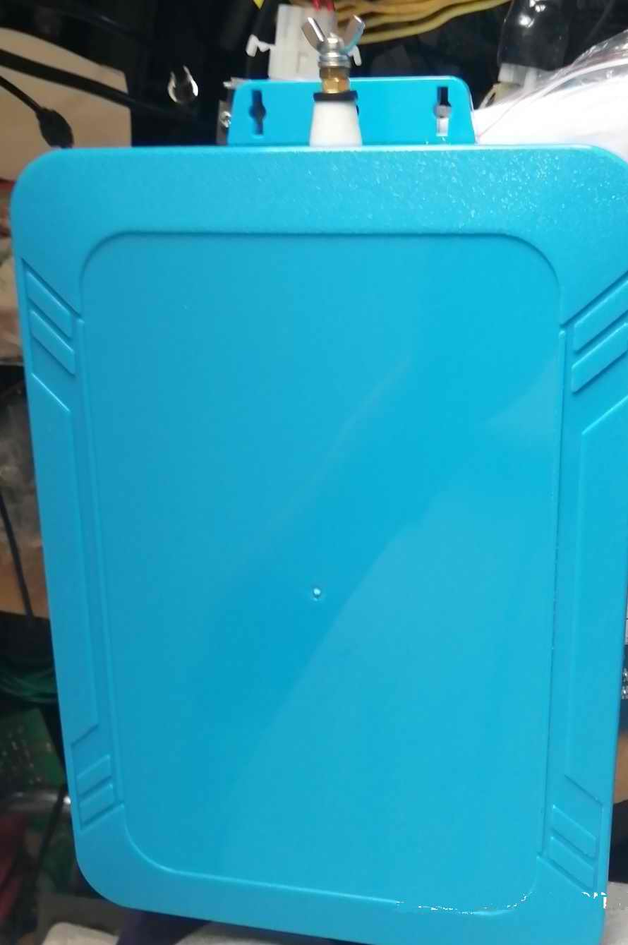
Metal end of porcelain post

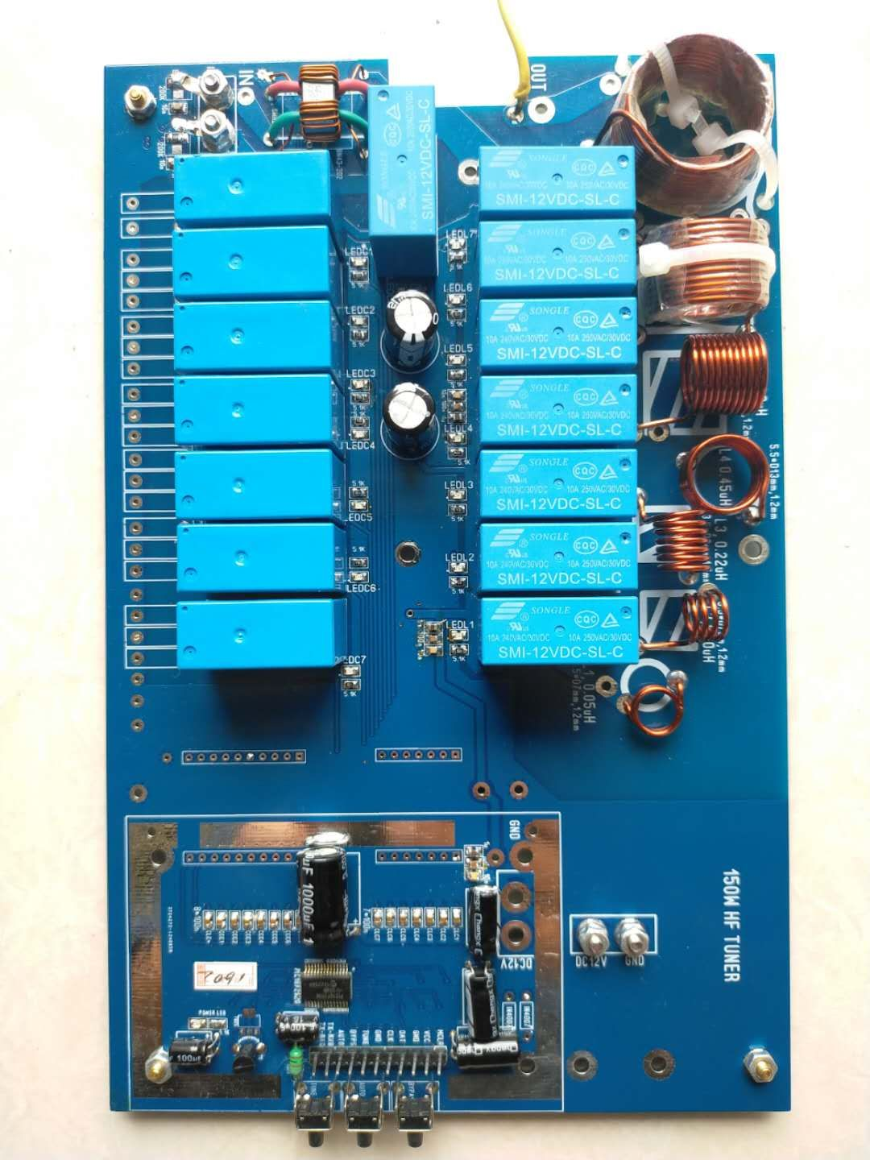
TO Metal end of porcelain post
RF IN
GND
50-3 coaxial line
TO 50Ω
Block M

DC12V
GND
TO 0.91’ screen

TO TUNE switch

