Smart bracelet
User manual
(Fitpro)

1,Introduction of main part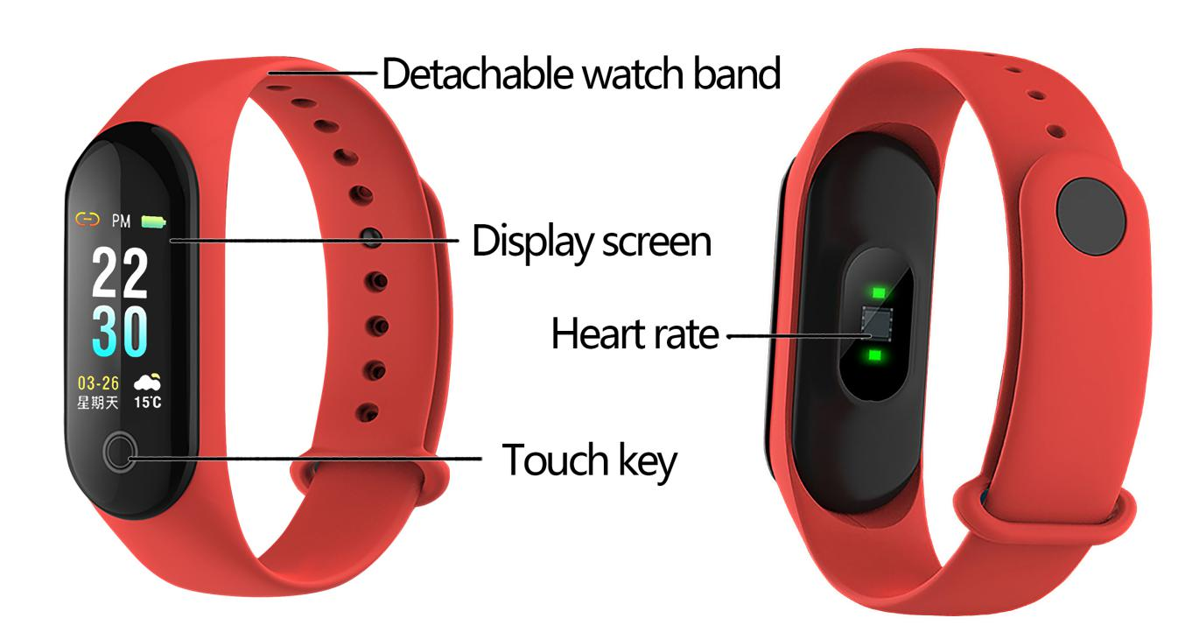
2,power on / off button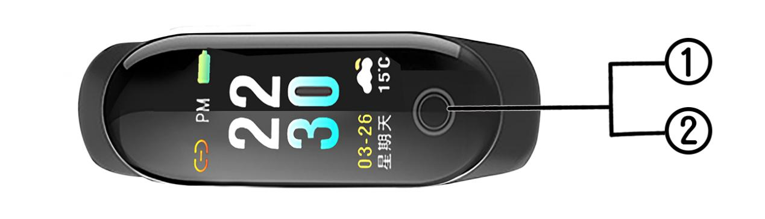
Long press power on/off button for around 4 seconds to power on/off.

3,charging
A,Both hands hold on to both sides of the band, and the thumbs of both hands press their teeth down, that is, they come out of the bracelet.
B, There are Micro 5PIN USB at the end of the bracelet, pointing at the data line socket, ready to charge, the bracelet will automatically turn on.
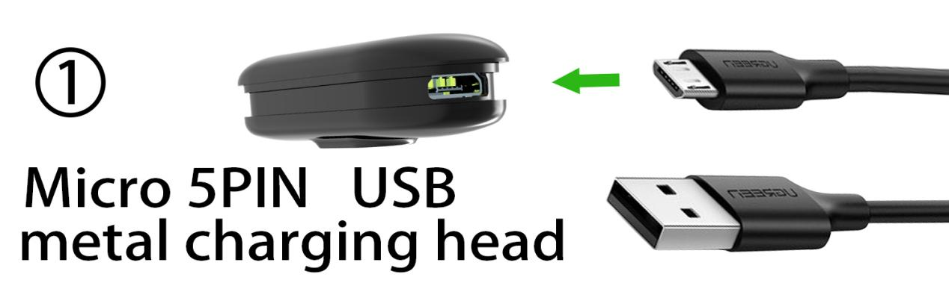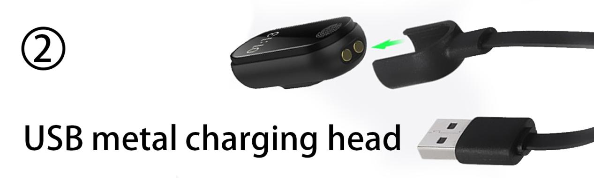

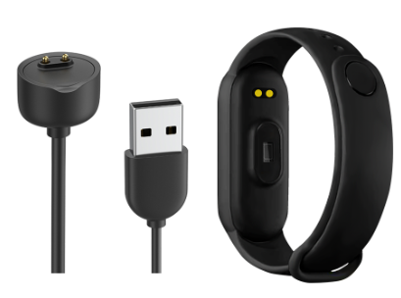
4,Install “Fitpro”APP on your phone
A,scan below QR code to download APP.
B,search "Fitpro" APP on IOS APP store or android market to download and install APP.
5,download and install APP.
After download APP in mobile phone,turn on mobile phone bluetooth,there is a MAC data on smart bracelet
interface,find it to connect bracelet with mobile phone APP.
For the first time connect APP,bracelet will sync time,date automatically.
(1) After pairing bluetooth,APP will save bluetooth ID,when open APP bluetooth will connect automatically.
(2)android mobile phone please make sure to allow APP to access.

6,APP functions and settings:
(1)personal data setting:
in APP,find “my data”, can set your personal informations: gerder,time system,birthday,height,weight,
target step,calorie,mileage.
(2)messages reminding:
when mobile phone have incoming calls,bracelet will
have vibration and show call number,when have SMS,
wechat,QQ,facebook messages,bracelet will also have
vibration to remind you.
(3)synchronize all data:
here to sync step,sleep monitor,kilometer,heart rate,
calories,blood pressure datas.
(4)band display setting:
Here to set bracelet different interface display:steps,
calorie,heart rate,blood pressure,MAC,mileage,find phone.
(5)band function setting:
Sedentary reminder:set time interval, bracelet will have vibration to remind you on time.
Drinking reminder: set time interval,device will remind you to drink water.
Smart anti-lost:turn it on,when bluetooth disconnected,bracelet will remind you.
Screen on upon raising:turn it on,when raise hand,will wake up bracelet screen.
Shake for selfie:turn it on,open up mobile phone camera APP,shake bracelet as a remote control to take pictures.
(6)smart alarm:set alarm here.
(7)search device:while connecting Bluetooth with
bracelet,click here bracelet will have viberation reminder

