MIG-200/250
Welding Machines Instruction Manual

1.Panel Direction
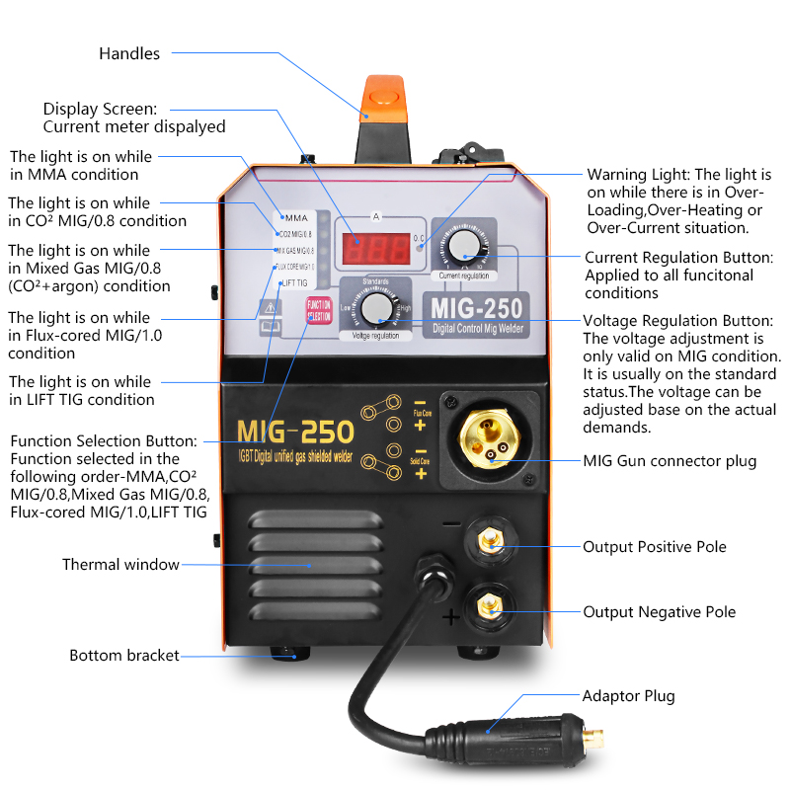
Operation Instruction
MIG-250 is a multi-function welding machine with ARC / MIG /TIG, we will introduce these functions and operation methods.
- MiG-200/250ARC/MMA Function
Input Power Voltage | AC220V±15%, 50/60Hz
No-load Voltage (V) | 60V
Rated Input power (KVA) | 8.3KVA
Output Current Range (A) | 20A-250A
Duty Cycle(%)(25℃) | 60%
Efficiency (%) | 85%
Power Factor (COS) | 0.73
Insulation Class | F
Electrode Diameter (MM) | 2.5-3.2mm
Housing IP grade | IP21

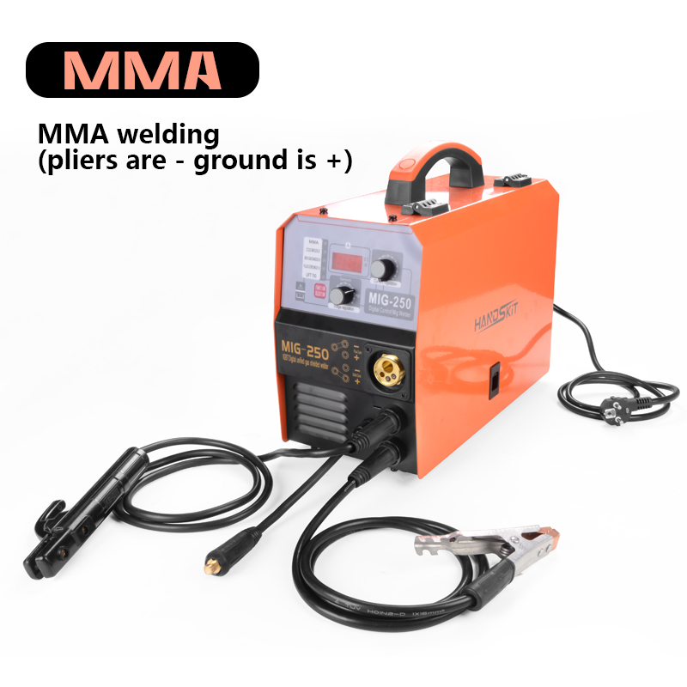

When you need to use the MMA function, you first connect the soldering handle to the- negative electrode and the alligator clip to the + Positive pole, then open power button, find the function button on the panel and adjust it to MMA and the green light will turn on can start work.

- MIG Function
Input Power Voltage | AC220V±15%, 50/60Hz
No-load Voltage (V) | 60V
Wire feed speed range(m/min) | 2～14
Output Current Range (A) | 20A-250A
Duty Cycle(%)(25℃) | 20%
Efficiency (%) | 85%
Power Factor (COS) | 0.73
Insulation Class | F
Housing IP grade | IP21
Noise(db): | ＜70
Applicable electrode/wire(mm): | 0.8/1.0/1.2MM

According to the welding wire classification, it can be divided into solid wire welding and flux cored wire welding.solid wire welding and flux cored wire welding.
CO2 MIG0.8 /MIX GAS MIG/ 0.8/FLUX CORE 1.0
The inert gas (Ar or He) shielded arc welding method with solid wire is called MIG welding (Metal Inert Gas Arc Welding); the argon-rich mixed gas shielded arc welding with solid wire is called MIG welding (Metal Inert Gas Arc Welding) for short.
MIG250--CO2 MIG0.8 (gas is required for factory /pronal use For ）
When you need to use the CO2 function, you first connect the soldering handle to the MIG hole and the alligator clip to the + Positive pole,The other connector on the machine is connected to the - negative pole， then open power button, find the function button on the panel and adjust it to CO2 and the green light will turn on can start work.

Carbon dioxide gas shielded arc weldinguses carbon dioxide gas as the shielding gas,
The method of welding. (Sometimes a mixture of CO2+Ar is used). The operation is simple in application, suitable for automatic welding and all-round welding. Poor wind resistance during welding, suitable for indoor operations. Because of its low cost and easy production of carbon dioxide gas, it is widely used in various large and small enterprises. Due to the special influence of the zero thermal physical properties of carbon dioxide gas, when using conventional welding power sources, the molten metal at the end of the welding wire cannot form a balanced axial free transition. It is usually necessary to use short circuit and droplet necking burst. Therefore, welding with MIG More splashes compared to free transition。
CO2 mig0.8 Front connection of the machine
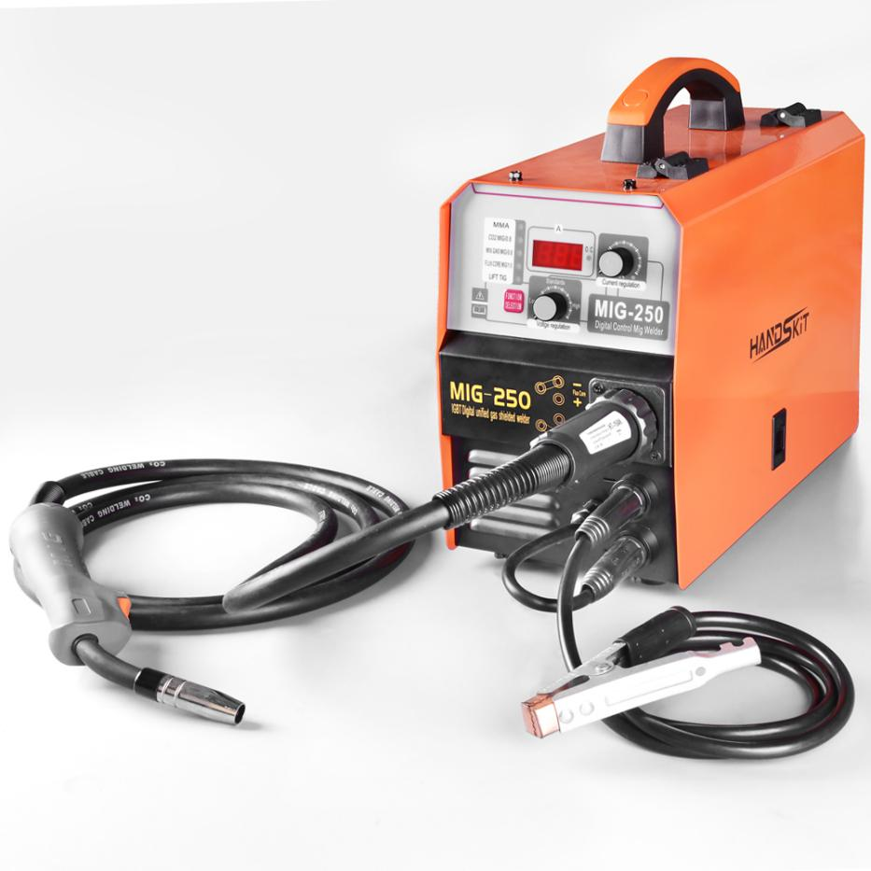
Connect gas behind the machine (do not operate without professional knowledge)

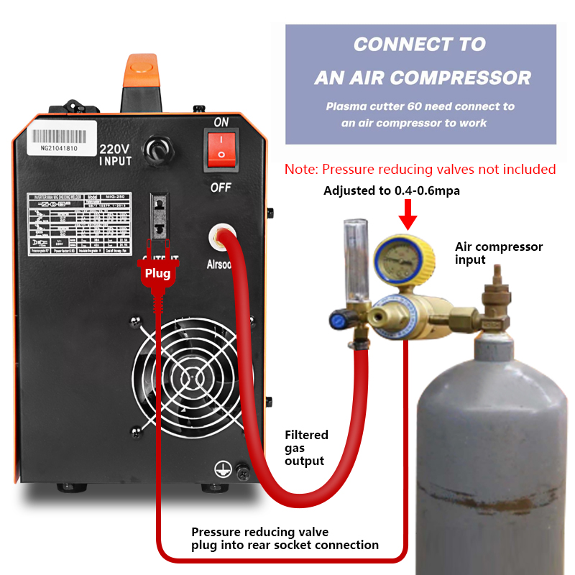

MIG-250 MIX GAS MIG/ 0.8 (professionals use with mixed gas

When you need to use the MIX GAS MIG/ 0.8 function, you first connect the soldering handle to the MIG hole and the alligator clip to the - negative pole,The other connector on the machine is connected to the + Positive pole，then open power button, find the function button on the panel and adjust it to MIX GAS MIG/ 0.8and the green light will turn on can start work.
According to the welding wire classification, it can be divided into solid wire welding and flux cored wire welding.solid wire welding and flux cored wire welding.
MAG welding (Metal Active Gas Arc Welding). CO2 gas shielded welding with solid wire, referred to as CO2 welding When using flux-cored wire, arc welding that can use CO2 or CO2+Ar mixed gas as shielding gas is called flux-cored wire gas shielded welding. It is also possible to add no shielding gas. This method is called self-shielded arc welding.
Solid welding wire is widely used in welding work, as a filler metal or at the same time as a conductive wire welding material. In gas welding and tungsten gas shielded arc welding, the welding wire is widely used as a filler metal. In submerged arc welding, electroslag welding and other molten electrode gas shielded arc welding, the welding wire is both a filler metal and a conductive electrode.
The adaptability of solid welding wire to steel requires re-smelting every time the alloy composition is adjusted. There are many processes and it is difficult to control, so it is difficult to meet the requirements of small dosage and large variety. In addition, some alloy steel solid wires have poor drawing performance, making it difficult to draw the required wires.

MIG-200/250 FLUX CORE 1.0 (No need gas /personal home /workshop)

When you need to use the CO2 function, you first connect the soldering handle to the MIG hole and the alligator clip to the + Positive pole ,The other connector on the machine is connected to the- negative pole， then open power button, find the function button on the panel and adjust it to FLUX CORE 1.0 and the green light will turn on can start work.

MIG-200/250 FLUX CORE 1.0 Front connection of the machine
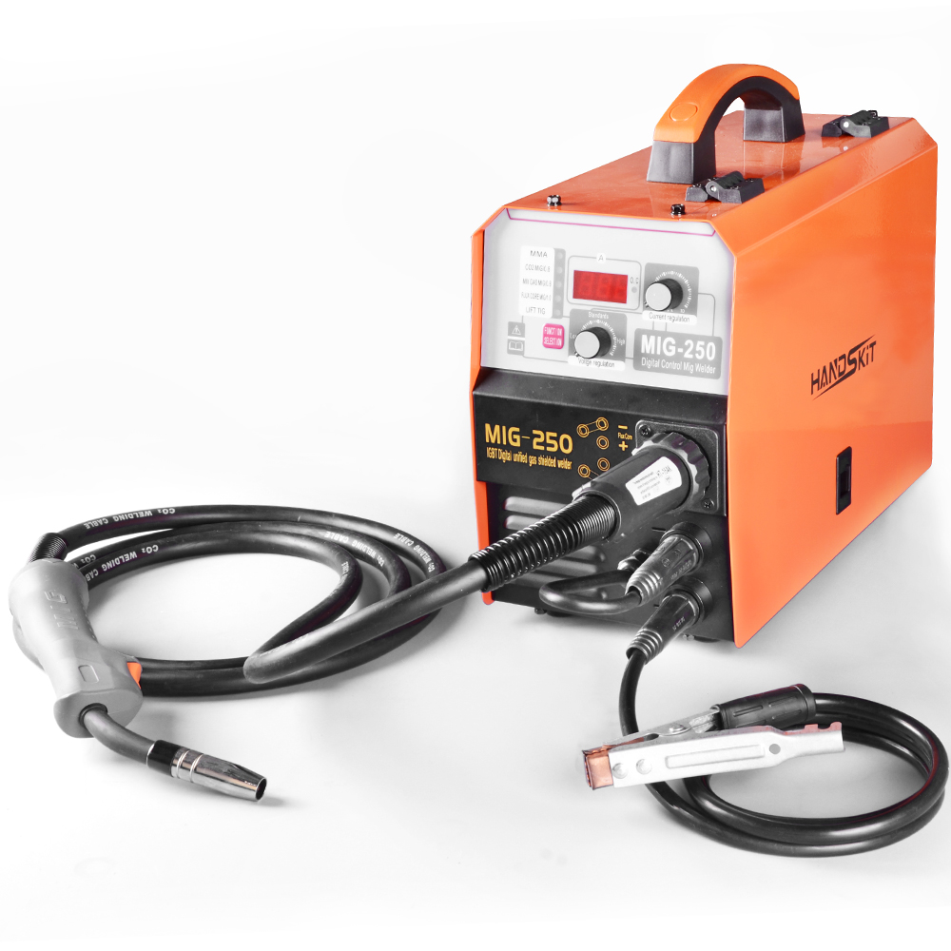

Flux cored wire is a new type of welding material with a promising future
(1) Advantages:
1) For the welding of various steels, it is highly adaptable to adjust the composition and proportion of the flux (general-purpose flux-cored wires are often referred to as flux-cored additives, and fluxes only appear in specific flux-cored wires). It is extremely convenient and easy. Can provide the required chemical composition of the weld.
2) Good process performance, beautiful welding seam shape. Adopt gas slag joint protection to obtain good shape. The arc stabilizing agent is added to make the arc stable and the droplet transfer uniform.
3) Fast deposition speed and high production efficiency. Under the same welding current, the flux-cored wire has a large current density and a fast melting speed. Its deposition rate is about 85%-90%, and the productivity is about 3-5 times higher than electrode arc welding.
4) All-position welding can be performed with larger welding current.
(2) Disadvantages
1) The manufacturing process of welding wire is complicated
2) When welding, wire feeding is more difficult than solid wire
3) The surface of the welding wire is easy to rust, and the powder is easy to absorb moisture, so the requirements for the preservation and management of the flux-cored welding wire are more stringent
3.1. The function of flux composition:
The same as the coated electrode, the flux cored wire manufacturer has its own unique formula for the flux composition. With the different functions of the welding material, the composition of the flux composition is also different.
MIG-200/250 TIG function
When you need to use the TIG function, you first connect the TIG gun to the - negative pole ，and alligator clip to the + Positive pole , then open power button and the green light will turn on can start work.
MIG-200/250 TIG Front connection of the machine

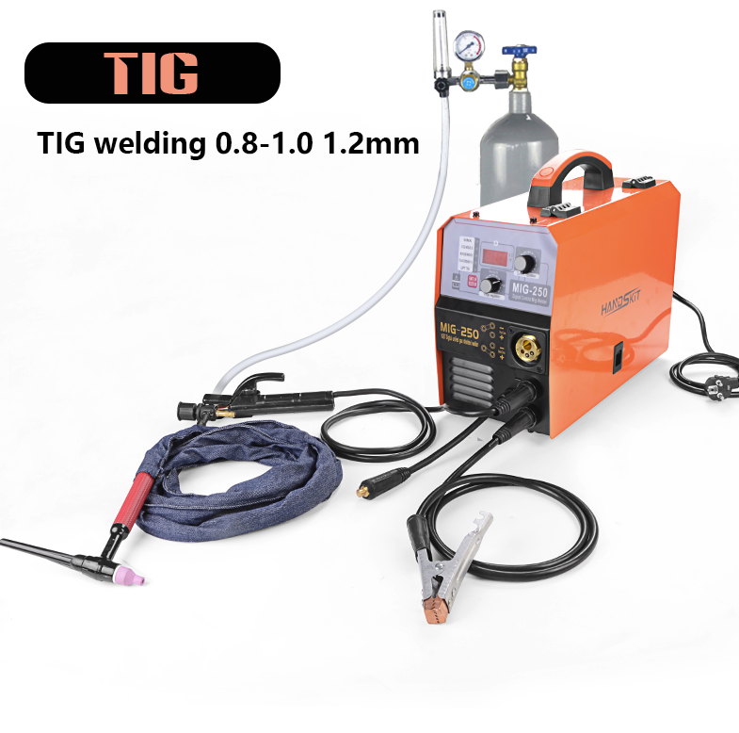
The advantages and disadvantages of argon arc(TIG) welding are argon arc welding: short for tungsten inert gas shielded welding. In the welding process, the tungsten electrode does not melt, and the arc generated between the tungsten electrode and the weldment is used as the heating source to melt the weld metal. At the same time, argon gas is sent from the nozzle of the welding torch to protect the molten metal of the weld, and additional filler metal can be added as needed. Internationally known as: TIG welding. Ordinary DC argon arc welding machine: It can weld almost all metals except aluminum and magnesium. The pneumatic ball valve is because this welding method uses inert gas to protect the molten metal in the weld after heating by arc. The inert gas protects the welding process , There are almost no other impurities and elements to participate in the welding process, which is basically completed by the process of melting and condensing of the welded metal by itself, so a very high-quality weld can be obtained.
1. Because the stable welding current of DC tungsten arc welding can be adjusted very small, 3-5A can be stable welding, so it can weld very thin plates that cannot be welded by other common welding methods, including common metals and their alloys. AC argon arc Welding machine: It is the best method for welding aluminum and magnesium among all the commonly used welding methods, because aluminum and magnesium are easily oxidized at room temperature.
2. An oxide film whose melting point is much higher than that of the metal itself is formed on the metal surface (the melting point of aluminum is 657°C, the melting point of alumina is 2050°C), so it is difficult to weld aluminum-magnesium and its alloys with high quality by ordinary welding methods.
3. In the AC argon arc welding machine, when the current is negative half-wave, the workpiece acts as an electrode and emits electrons outward, which will form a physical phenomenon called cathode crushing, which will break the refractory oxide layer on the surface of the workpiece.
Precautions for use of electric welding machine:
1. A reasonable welding process should be selected according to the technical conditions of the work. Overload use is not allowed, high current welding is not allowed, and electric welding machines are not allowed to perform metal cutting operations.
2. The temperature rise of the welding machine during load welding should not exceed 60 degrees for class A and 80 degrees for class B, otherwise, it should be shut down to cool down before welding.
3. The working place of the electric welding machine should be kept dry and well ventilated. When moving the welding machine, the power supply should be cut off, and the welding machine should not be moved by dragging the power supply. If there is a sudden power failure during welding, the power supply should be cut off.
4. During welding, it is not allowed to adjust the current. When the welding is stopped, use the adjustment handle to adjust, not too fast or too strong, so as not to damage the regulator.
5. It is forbidden to do welding work under the crane's running workpiece.
6. If welding is carried out in the area with crane wire rope, care should be taken not to make the welding machine ground wire touch the hoisted wire rope by mistake, so as to avoid accidents caused by sparks.
7. When construction must be carried out in a wet area, the welder must stand on an insulated wooden board and work. It is not allowed to touch the wire of the welding machine, and it is not allowed to use the arm to hold the live welding tongs.
GB4706.41-2005 EN 60335-2-45 2002+
Product Standards GB/T 7157-2008 EN 60335-1-2012+
Company: Shenzhen Hanqi Electronics Co., Ltd.
Address: Room 302, 36 Gongkenglang Industrial Zone, Guanjing Road, Guanlan Street, Longhua District, Shenzhen
Email: handskit@Foxmail.com

