** Overview**

The HW-XC901 is a dual-plate superimposed microwave induction module. According to the Doppler effect principle, a high-frequency electromagnetic wave is transmitted and received by a planar antenna, and then a small movement change of the folded-back wave is detected, thereby triggering the microprocessor to work, and finally the output is useful. Control level (H-1/L-0) or control status.

It is suitable for secondary development in other electronic fields such as intelligent electrical appliances, security products, and lighting products. This product can be widely used in security monitoring, intelligent control systems, lighting appliances (garage, corridor, road and other places).

** Characteristics**

● It can penetrate the shell induction (except for the metal shell), and the distance will have corresponding attenuation, generally about 10%-20%.

●It is not affected by temperature and humidity. Inductive sensitivity is not directional.

●The small room is reflected by the wall, which can achieve 360 degree induction and no dead angle.

●Reserved CDS welding position, plus light control function.

** Specifications**

|  |  |  |
| --- | --- | --- |
| Model | HW-XC901 |  |
| Operating Voltage | 6-24V | Built-in 7550, requires constant power supply, minimum drive 6v/300mA/ ±100mV |
| Static power | ＜15mA |  |
| output method | 3.3/0V | There is a sense of 3.3V, no induction 0V. (The output voltage can be adjusted to a minimum of 5V) |
| Trigger mode | Repeatable trigger |  |
| Transmitting frequency | 5.8GHZ | ±75MHZ |
| Sensing distance | 2-11m | Adjustable (dial switch 1, 2) |
| Delay time | 10-1800S | Adjustable (dial switch 3, 4, 5) |
| Photosensitive switch | 10lux-500lux | Adjustable (dial switch 6, 7, 8) |
| Operating temperature | -20--80℃ |  |
| Dimensions | 33.5*25*9mm | Support OEM |
| ● Repeat trigger: After the first trigger, when the sensing area is triggered again, the module delay time will be superimposed again when the first trigger time is not stopped. (For example, the module delay is 10S, the sensing signal is received again in 10S, and then 10S is superimposed. If there is no interruption in 10S, there will always be an output signal)  ● Delay time: refers to the duration of the high voltage signal output. Regardless of the delay, the delay is in milliseconds and can be rushed. | | |

** Detection diagram**

During dynamic sensing, the 2 pin outputs a high level, the MOS is turned on, and the power supply has a DC load circuit to the MOS, and the LED will be in a lit state.

The daytime mode CDS works, and the CDS-led is in the light state, indicating that the light is in a working state. (The photosensitive working condition is that the light is valid when the module is low level, and the photosensitive light is invalid when the module outputs a high level)

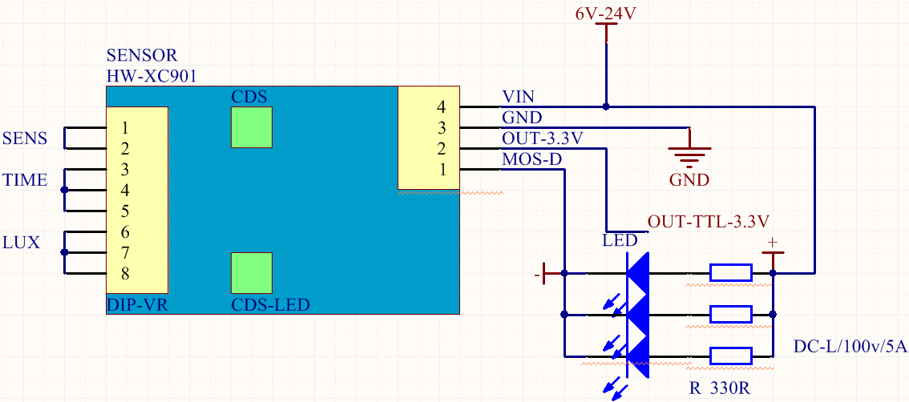

** DIP switch definition (upper ON, lower OFF)**

|  |  |  |  |  |  |  |  |  |  |
| --- | --- | --- | --- | --- | --- | --- | --- | --- | --- |
| Sensing distance 1-2 feet  unit（m） | | Delay time 3-5 feet  unit（S） | | | | Light control switch time 6-8 feet (0 is working all day)  unit（LUX） | | | |
| **11** | **2m** | **111** | **10** | **111** | **600** | **111** | **0** | **111** | **100** |
| **11** | **5m** | **111** | **30** | **111** | **900** | **111** | **10** | **111** | **200** |
| **11** | **8m** | **111** | **60** | **111** | **1200** | **111** | **20** | **111** | **300** |
| **11** | **11m** | **111** | **300** | **111** | **1800** | **111** | **50** | **111** | **500** |

** Size and physical picture**

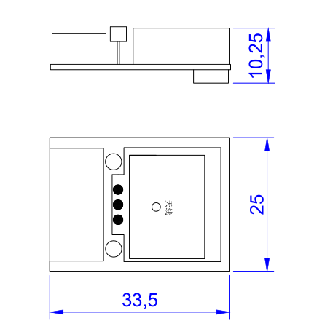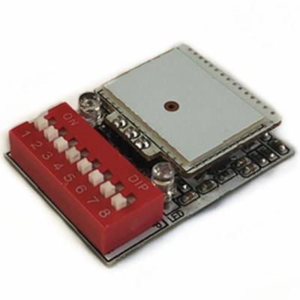

** Angle reference map**



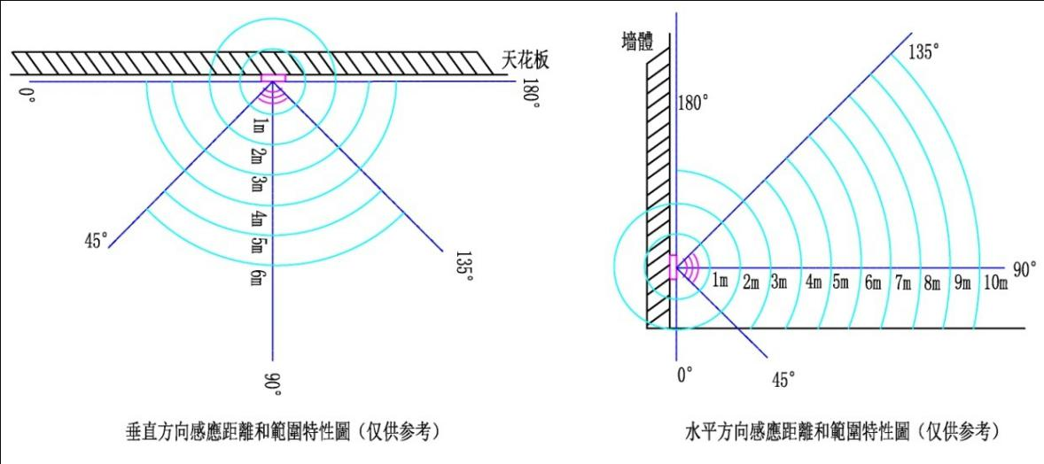

** Precautions**

●When installing and testing the product, please keep the module antenna board (S-shaped open PCB) at least 5mm in front of it, and it should not be close to the object or the outer casing.

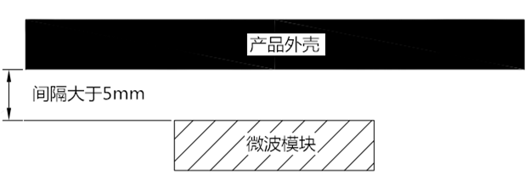

● There is approximately 5 s initialization time after power-on, during which time it is abnormal.

● The output current of the module is very weak. If the load is directly driven, it will cause a false alarm. Please refer to the wiring diagram.

● Try to avoid installing two or more modules face to face within the effective sensing range.

● Please use DC power supply with output voltage, current and ripple coefficient, etc. The power supply will be unstable, there will be false alarm, no induction, and the cycle will start.

● In the case where there are walls or obstacles reflecting microwaves around, the sensing distance and angle will have a gain. In the case of relatively empty surroundings, the sensing distance and angle will be attenuated, and the difference is about 20%.