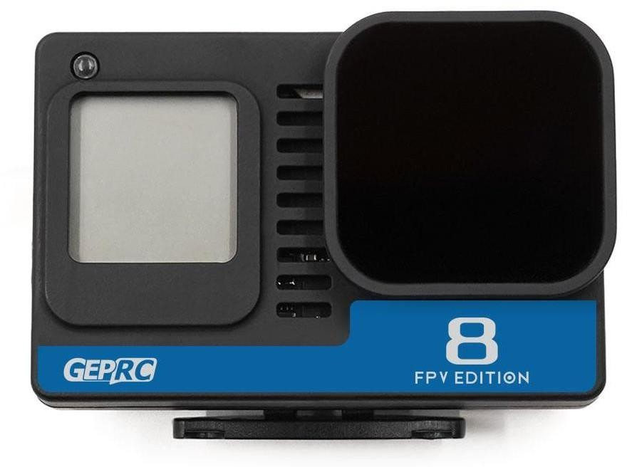

Overview . - 3 -
Feature.....................................................................................................................- 3 -
Specification.............................................................................................................- 3 -
Indicator status........................................................................................................ - 3 -
GEP GoPro Hero 8 Naked Manual........................................................................... - 2 -
GEP GoPro Hero 8 Naked BEC Board Diagram........................................................ - 3 -
GoPro Hero 8 Naked Set Guide............................................................................... - 4 -
Recording with remote control............................................................................... - 5 -
Scan the QR code to use WiFi through APP.............................................................- 7 - Appendix.................................................................................................................. - 8 -

GoPro8 Naked

Overview
GoPro hero 8 naked,specially designed by GEP team for quadcutter, finally meets you..The newly designed BEC is perfect for GoPro 8. Support 2-6s voltage input and output 5V@2A . It is equipped with POWER/MODE and REC button, and has a quick detachable GH1.25-3P connector to support remotecontrol.

Feature
- It's specially designed for quadcutter, and its ultra light weight is only 25.7g
●
The 4K ultra wide angle camera has a large field ofvision
- 4K@60fps,4K@30fps,2.7K@50fps Recording
- Scan preinstall QR code switch settings
- BEC board input volage 2S-6S,output5V-2A
- Integrated GoPro POWER/MODE button and REC button,operation quickly andconveniently.
- GH1.25-3P connetcor is used to connect flight control and realize remotecontrol
- Mounting seat, which is convenient and fast to install
- UV protection lens to protect the camera
- Nd16 filter to reduce the light input of camera sensor

Specification
- Model：GEP GoPro Hero 8 Naked
- Size：60*40*22.5mm
- Weight：25.7g
- Input voltage：2-6S
- Output：5V@2A
- Memory：SD card
- Connector：GH 1.25 3P

Indicator status
Connect GH1.25 Control cable with camera and input 2-6s power.LED will flash 1 times,BEC plate power light is always on（green light）.

Instructions | Operation | Indicator
Power on | Press the power/mode  switch once | Flash 3 times，off
Power off | Press and hold the power /  mode switch for 5 seconds | Flash 7 times，off
Start recording | Press the record switch once | Flash slowly
Stop recording | Press the record switch once | Flash 3 times，off
Switch mode | Press the power/mode  switch once | NONE
QR code switching recording  settings | Scan preset QR code | Flash 2 times，off

Born For FPV

GEP GoPro Hero 8 Naked Manual

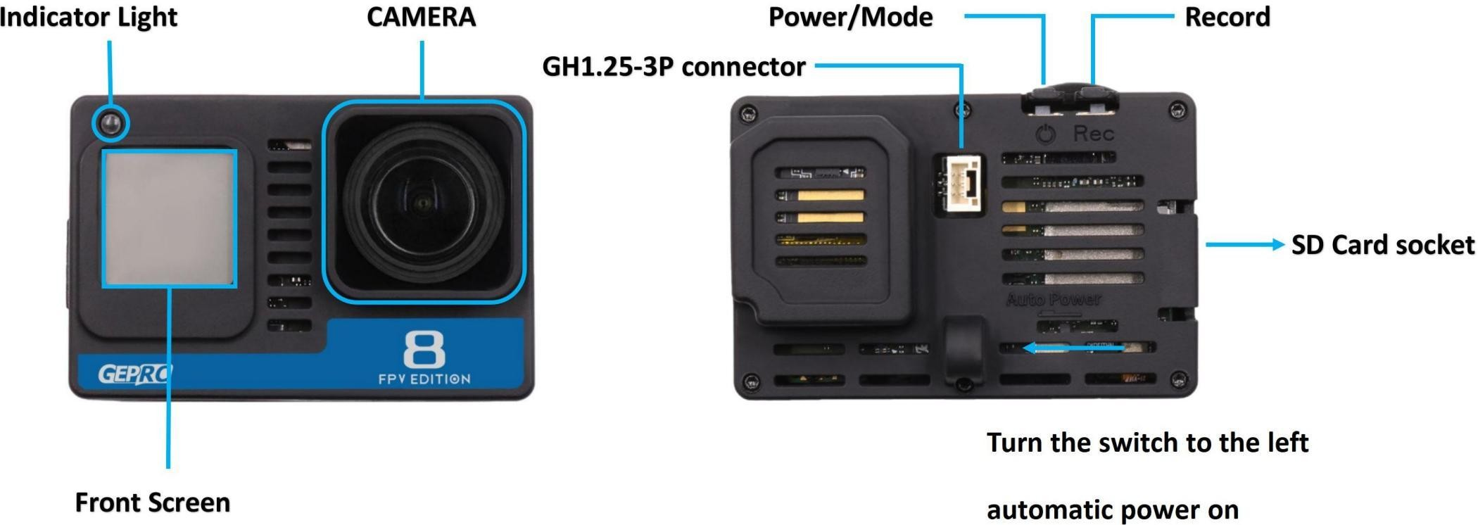

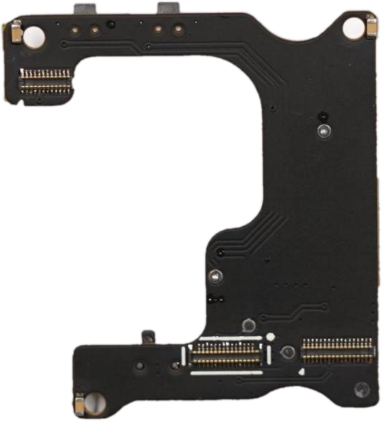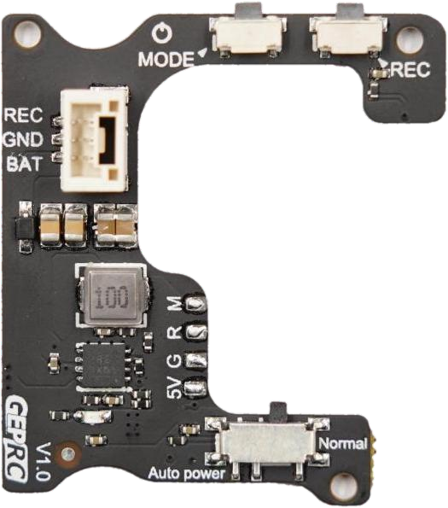GEP GoPro Hero 8 Naked BEC Board Diagram

GoPro Hero 8 Naked Set Guide

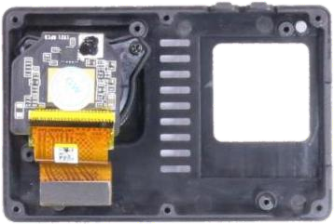 | 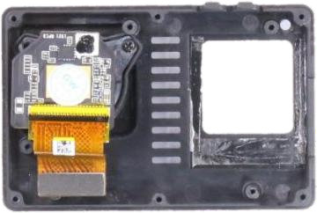 | 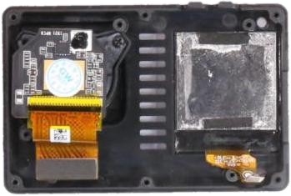
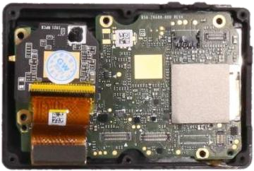 | 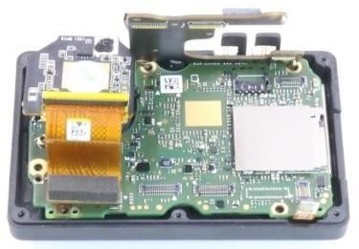 | 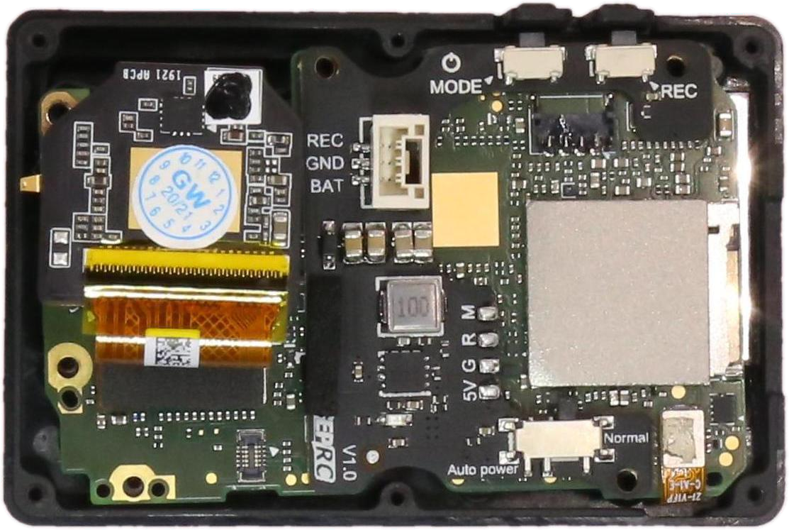
 | 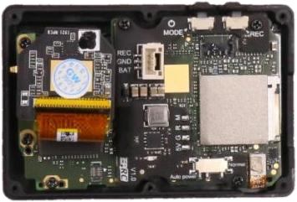 | 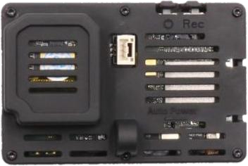

Recording with remote control
  - Weld control cable to FC
    - Red wire→FC positive pole
    - Black wire→FC negative pole
    - Yellow wire→FC LED
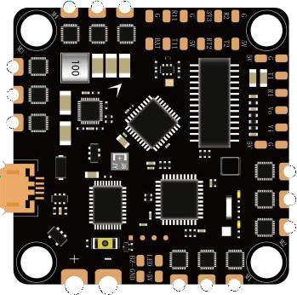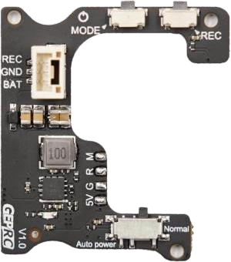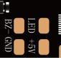

  - Connect FC to BETAFLIGHT ground workstation,enter the following command on the command wire,save.

resource LED_STRIP 1 NONE resource PINIO 1 A08
set pinio_box = 40,255,255,255 Save

  - Turn on the USER1 mode under the mode option,add range to Transmitter idleswitch.
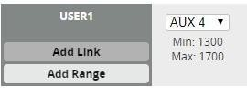

  - Turn the BEC power switch to left,connect the control cable.

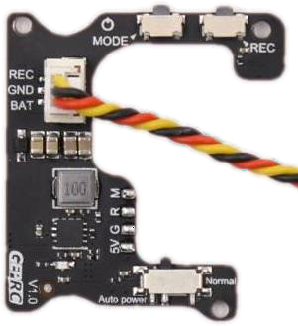

  - Supply power to FC,GoPro8 Naked will auto start.Operation remote control AUX4 switch,move the cursor from the white area to the yellow area and back to the white area to start the recording.Repeat the operation again to end the recoding.
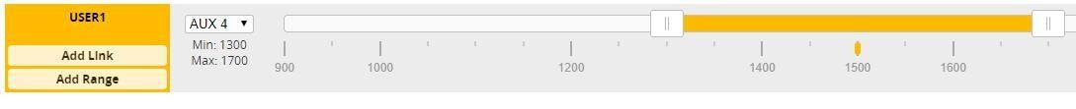

Notes:GEPRC-F722-AIO and F411-AIO have the same wiring but different codes,as follows:

resource LED_STRIP 1 NONE resource PINIO 1 A01
set pinio_box = 40,255,255,255 Save

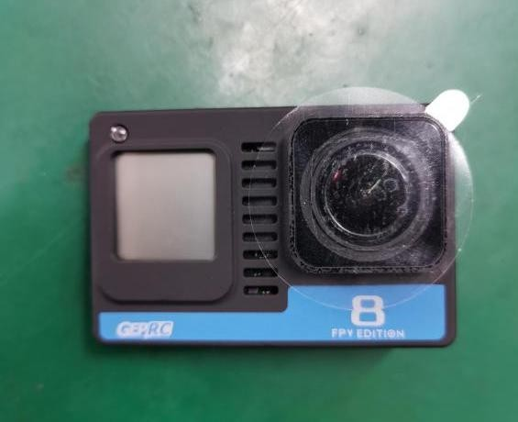
flashes twice

Scan the QR code to use WiFi through APP

- 1.STEP1 Open GoPro8 application

- STEP2 Power on GoPro8 and scan QR code,after the red light and the code scanning is confirmed to be successful,press quickly the record key three times immediately (make sure the WiFi is on)

- STEP3 Search and connect external WiFi

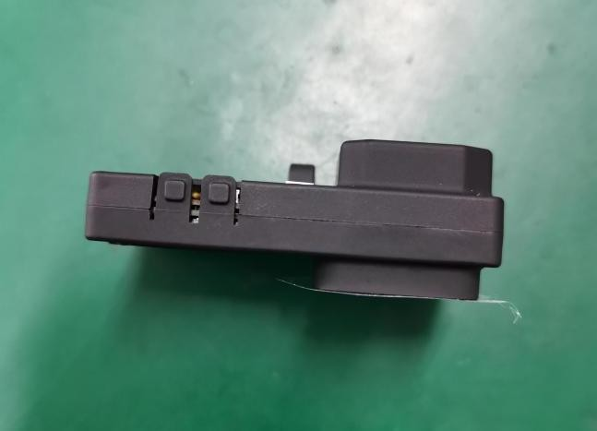
press the record key three times

Appendix
GEPRC Technology Taobao Store:https://geprc.taobao.com/ GEPRC Technology Official Website:https://geprc.com/ GEPRC Technology Official QQ Group:499699918

Facebook
facebook.com/geprc

BiLiBiLi
bilibili.com/geprc
Instagram
Instagram.com/geprc Manual
YouTube geprc.com/support

