Electric carpet loom tool
Manual

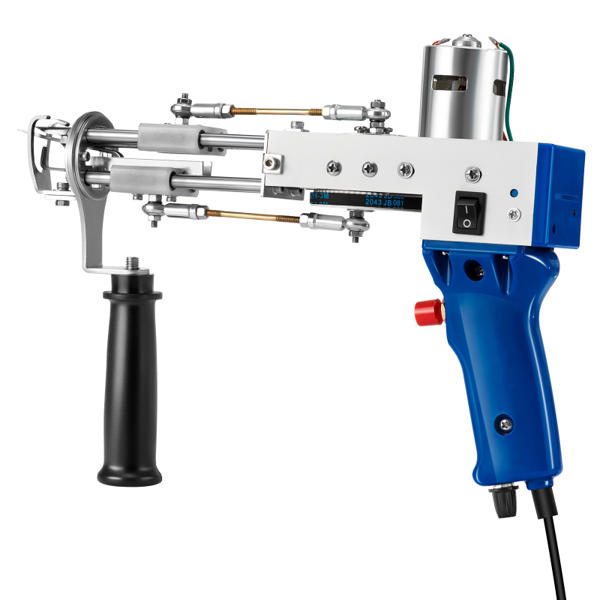

The user manual must be properly placed in the packing box to ensure that the manual is easily accessible and referenced.
The user manual must always be placed with the product, even for secondary sales.

Thank you for choosing our products. Please read this manual carefully before using.
Content
-（ install）
-（preventive maintenance）
-（service）

User requirements：
Before wearing the yarn, turn off the power switch of the machine or remove the power plug to avoid accidental harm to the user. Never touch the active parts on the machine when the machine is running.
All users must read and fully understand the instructions.

Safety Instructions for Use of Power Tools

Before the power tool is turned on, it is necessary to carefully check whether the movable parts and fixed parts of the tool are damaged and whether the damage degree will affect the normal function of the tool.
（2）
Before wearing the yarn, turn off the power switch of the machine or remove the power plug to avoid accidental harm to the user. Never touch the active parts on the machine when the machine is running.
（3）
Children are not allowed to approach or prohibit idle people from entering the workplace.
（4）
Power tools can not rain, can not be used in the presence of flammable liquid or gas power tools.
（5）
When power tools are not used, they should be kept in dry and inaccessible places for children.

Product Parameters

 |  | 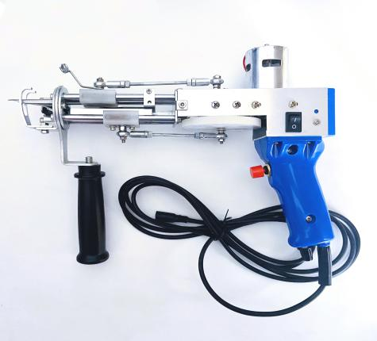
Model | Loop pile | Cut pile
Voltage range | 100V-240V | 100V-240V
Power | 70W | 70W
Frequency | 50-60HZ | 50-60HZ
Pile high | 157“-.55”（4-14mm） | 157-.75“（7-19mm）
Speed Range | 5-40  5-40stitches/sec adjustable | 5-40  5-40stitches/sec adjustable
Weight | 3 pounds（1.4kgs） | 3 pounds（1.4kgs）
Output DC | 24Vsmalladapter | 24Vsmalladapter
Protection | Over - current, over voltage, and short - circuit protection | Over - current, over voltage, and short - circuit protection
Package | Carton | Carton
Box size | 37*27*8cm | 37*27*8cm
G.Weight | 2.3kg | 2.3kg

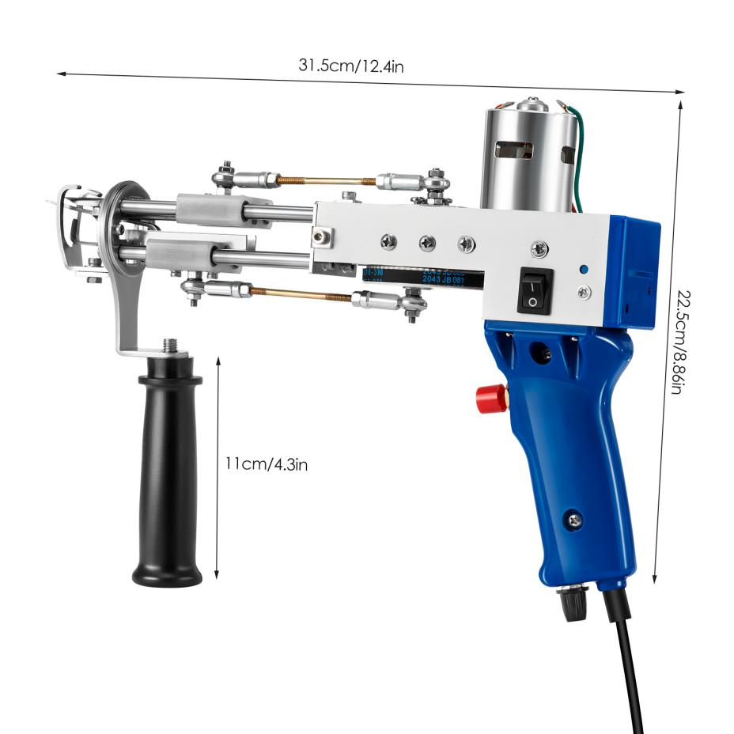

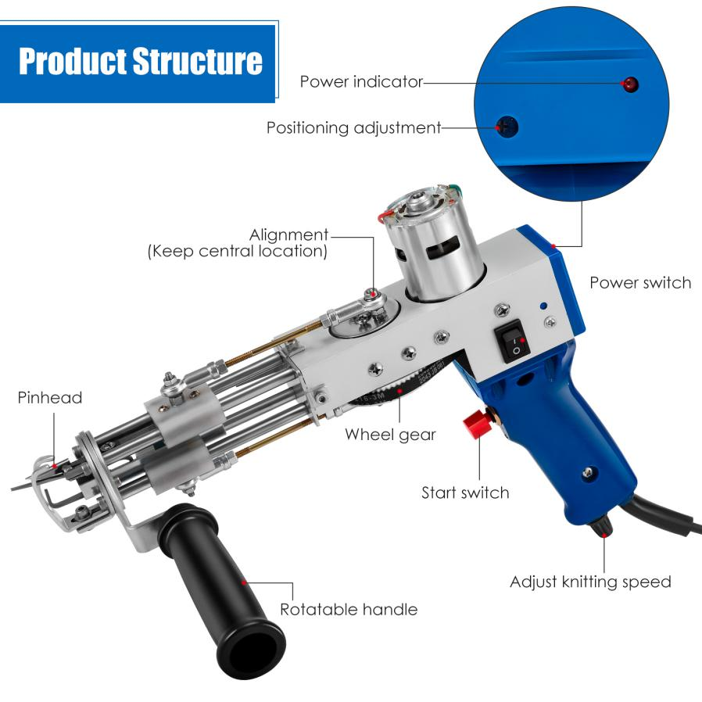
Power indicator
Positioning adjustment
Alignment.(Keep central location)
Power switch
Pinhead
Wheel gear
Start switch
Adjust knitting speed
Rotatable handle

Randomized standard

（ assemble）
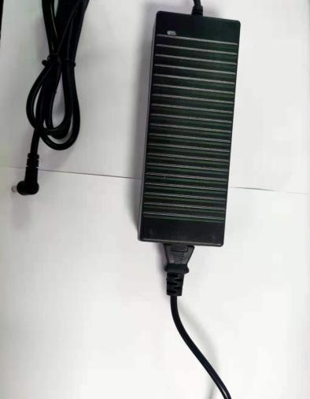

Connect the power cord to the power supply

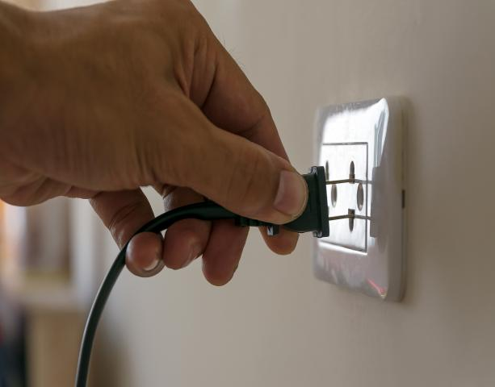

Insert the AC outlet to check the normal power supply.

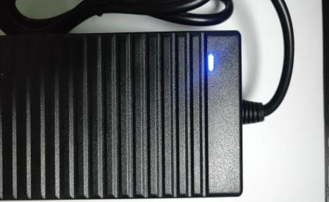

The power indicator lights See if the tool power switch is off
up after power on.

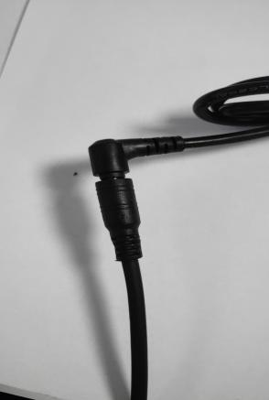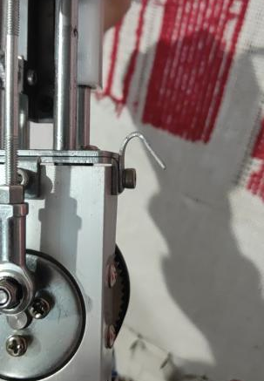

Connect the power output plug Bend the hook with pliers
to the power tool plug

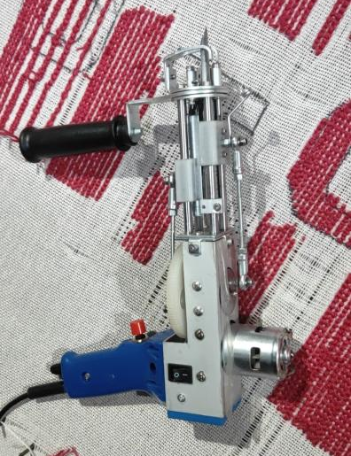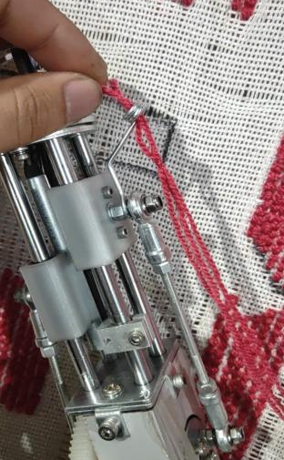

It can be hung on the cloth for threading. Pass the yarn through the coil first

Then the threader passes through the needle hole Bring the yarn into the needle with a threader

Turn on the power switch The front end of the needle is pressed on the cloth, and
the power tool is balanced from bottom to top.
（loop ）
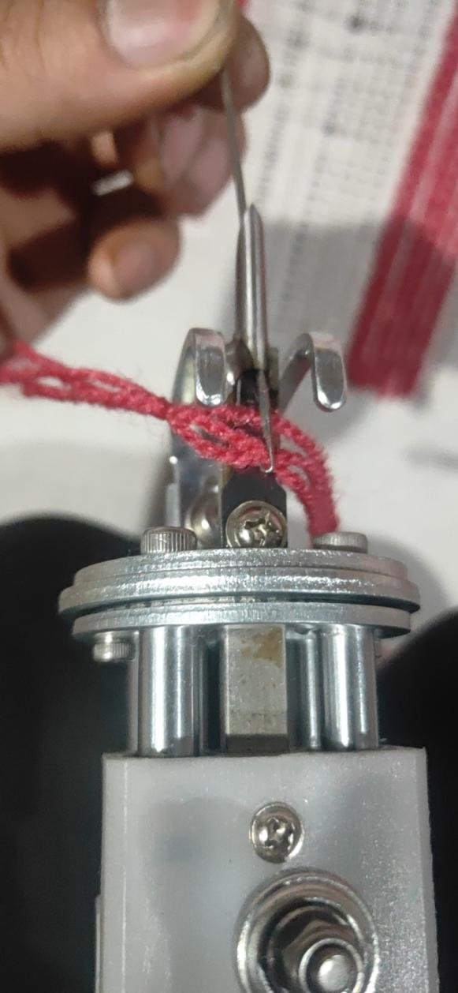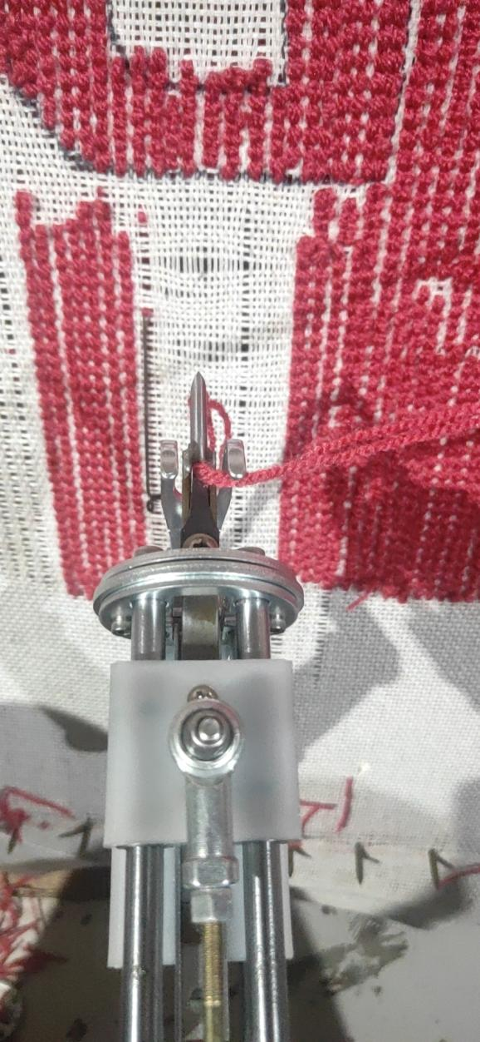

（preventive maintenance）

Add a drop of sewing machine oil to each linear bearing every 3 days to keep the power tool running smoothly.

The pile cutter should add a drop of oil to the scissors joint every week.

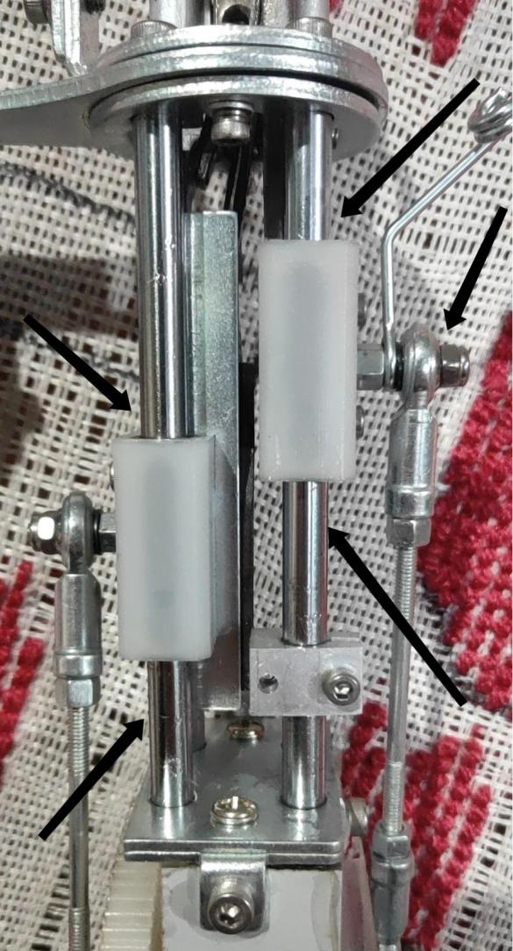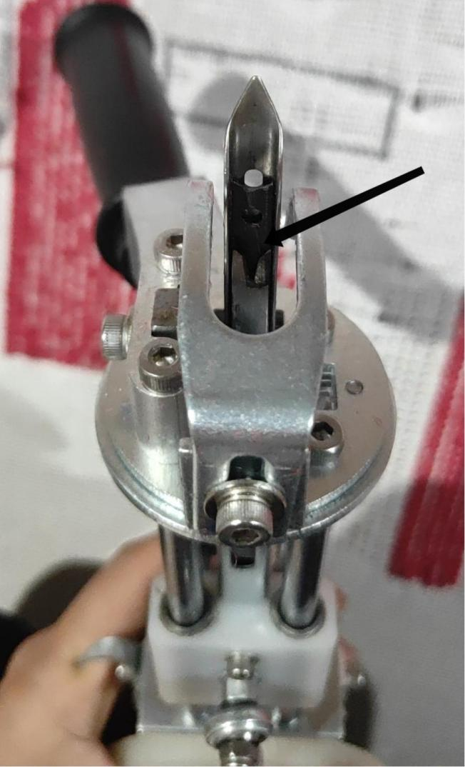

（service）

For the latest troubleshooting information, please send video to sales customer service, after-sales staff will help you solve as soon as possible.

