CA card support list
- Seca CAID 0100 for 19.2E Spain Movistar.
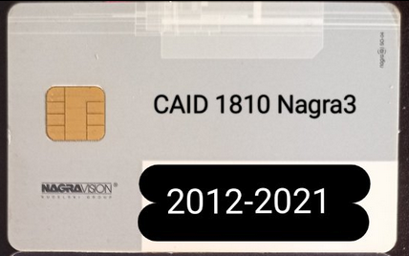
Programme list: https://en.kingofsat.net/pack-digitalplusa.php
- Nagra CAID 183E for 13E Italy Tivusat(the gold and grey) .
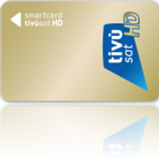
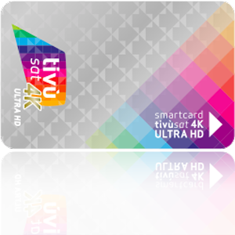
Programme list: https://en.kingofsat.net/pack-tivusat.php
- Nagra CAID 183D for 13E Italy Tivusat(old card).
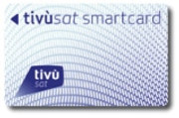
Programme list: https://en.kingofsat.net/pack-tivusat.php
- Nagra CAID 1805 for 13E Italy Mediaset Premium.
Programme list: https://en.kingofsat.net/pack-mediaset.php
- Nagra CAID 1805 for Italy DVB-T Mediaset Premium
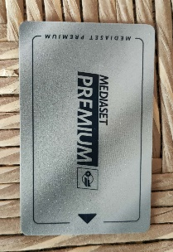
- Viacess CAID 0500 for 13E Switzerland SRG/SSR
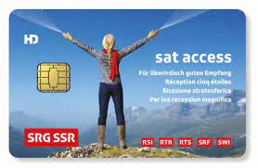
Programme list: https://en.kingofsat.net/pack-ssr.php
- Conax CAID 0B00 for 85.2E Russia Telekarta.
Programme list: https://www.lyngsat.com/packages/Telekarta-85E.html
- Conax CAID 0B01 for 13E Poland TNK.
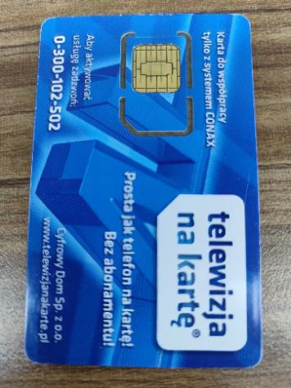
Programme list: https://en.kingofsat.net/pack-tvnakarte.php
- Seca CAID 0100 for 13E Poland CYFRA+.
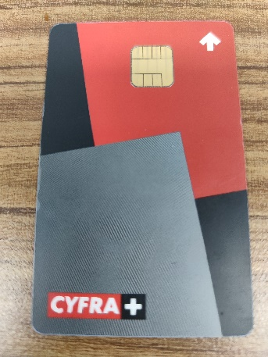
Programme list: https://en.kingofsat.net/pack-polsat.php
- Viacess CAID 0500 for 16E Croatia OIV.
Programme list: https://www.lyngsat.com/muxes/Eutelsat-16A_Europe-B_11637-V.html
- CryptoWorks CAID 0D98 for 19.2E Austria ORF ICE.
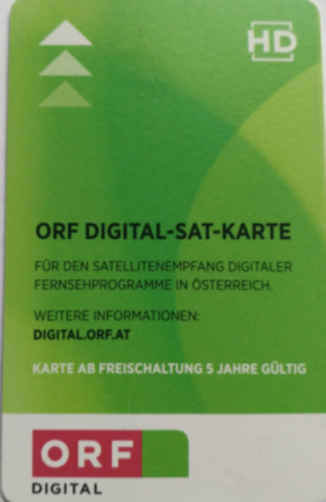
Programme list: https://en.kingofsat.net/pack-orfdigital.php
- Seca CAID 0100 for 19.2E/23.5E The Netherlands Canal Digitaal.
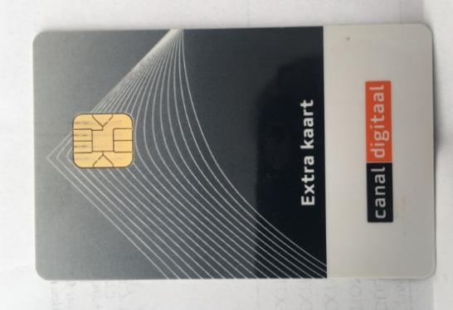
Programme list: https://en.kingofsat.net/pack-canaldigitaal.php
- CryptoWorks CAID 0D96 for 23.5E Slovakia SkyLink ICE.
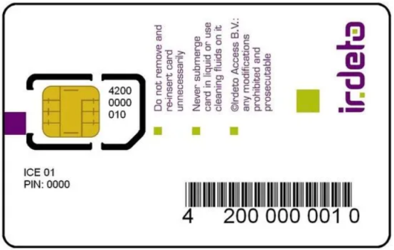
Programme list: https://en.kingofsat.net/pack-skylink.php
- NDS CAID 09AC for 91.5E Malaysia Astro.
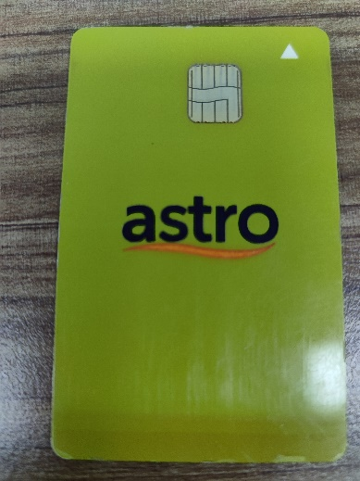
Programme list: https://www.lyngsat.com/providers/my/Astro.html
- Irdeto CAID 0602 for (unknown) Telekarta TV.
- Conax CAID 0B00 for Cable Turkey TV.
- Conax CAID 0B00 for Cable Bulgaria Blizoo BG.
- Viacess CAID 0500 for 5W Fransat.
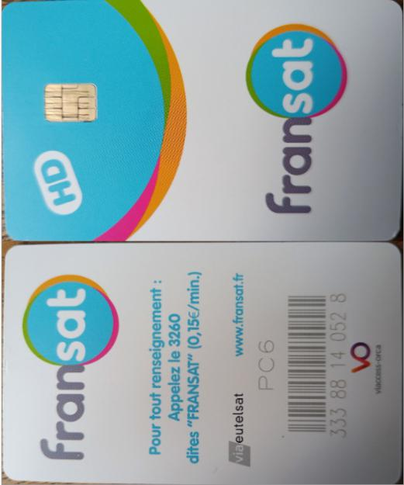
Programme list: https://en.kingofsat.net/pack-fransat.php

