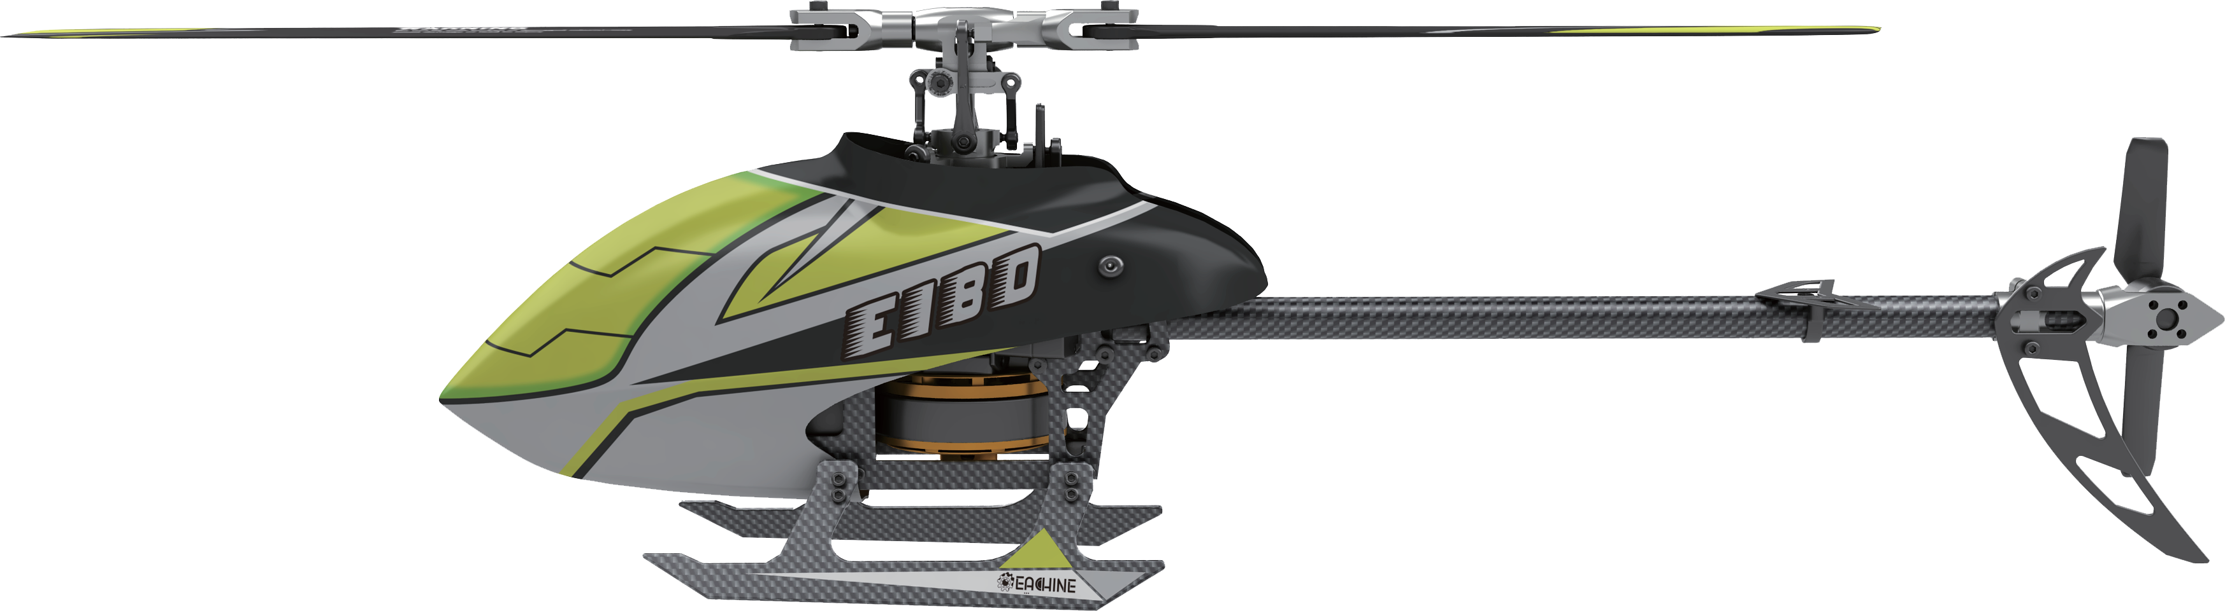
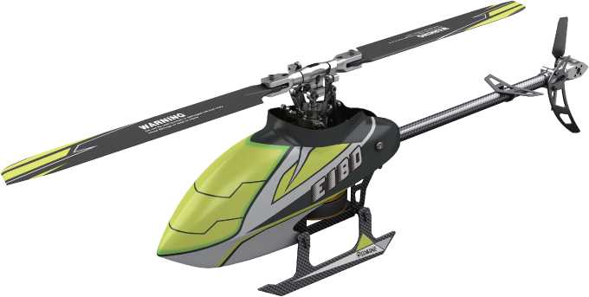

User Manual

Rev 1.0
This product is compatible with FUTABA 2.4GHZ S-FHSS regulations.
Powerful brushless main and tail motors , compatible with 3-axis gyroscope and 6-axis gyroscope modes, 3-axis for ultra-stable 3D flight and 6-axis for beginners.

ITEM LIST

NO. | PARTS | QUANTITY
1 | Gift Box | 1
2 | Sturdy PVC protective box | 1
3 | User Manual | 1
4 | Helicopter | 1
5 | Transmitter | 1
6 | Charger | 1
7 | Battery 11.1 v 700mah 30C | 1
8 | Cross Screwdriver / Hex Wrench | 1
9 | Main Blade | 2
10 | Tail Blade | 1

NOTICE
All instructions, warranties and other collateral documents are subject to change at the sole discretion of our company. For up-to-date product literature

WARNING
Read the ENTIRE user manual to become familiar with the features of the product before operating. Failure to operate the product correctly can result in damage to the product, personal property and cause serious injury. This is a sophisticated hobby product. It must be operated with caution and common sense and requires some basic mechanical ability. Failure to operate this product in a safe and responsible manner could result in injury or damage to the product or other properties. This product is not intended for use by children without direct adult supervision. This manual contains instructions for safety, operation and maintenance. It is essential to read and follow all the instructions and warnings in the

ADDITIONAL SAFETY PRECAUTIONS AND WARNINGS
1.Age Recommendation： Not for children under 14 years. This is not a toy. 2.Always operate your model in open spaces away from full-size vehicles, traﬃc and people.
- Follow the operation notice, warning and any support equipment (charger, battery, etc) carefully.
- Keep away from any chemicals； keep children away from any small parts and
electrical equipment.
- Always keep away from water, especially for this product don't have water- proof function; It will be damaged by moisture.
- Never place any portion of the model in your mouth as it could cause serious injury or even death.
- Never operate your model with low voltage transmitter batteries.

INTRODUCTION
This is a super classic helicopter with excellent ﬁght performance. Flybarless design, decrease resistance of rotor head. Quote to aerodynamics, the blades can supply strong power and keep stability. Using the latest technology of new gyro type, this helicopter is compatible with 3D and 6G modes. You can make a variety of stunts in 3D mode. 6G mode is especially suitable for beginners.
Once you have flown this mini helicopter, you will ﬁnd other similar mini helicopters are much inferior This is a incomparable and popular helicopter. Once it has been set up correctly, beginners will ﬁnd it is very easy to ﬂy. They can master or quickly learn new moves. The built-in ‘rescue’ or upright function in 6G mode (if set up properly), can save the helicopter in most cases.
The detailed instructions in this manual will help you understand more about the product. Please read it before operating your helicopter. It may help you to save both time and money due to incorrect settings etc.

TABLE OF CATALOG
ItemList·························································································1
Notice····························································································2
Warning·························································································2
Additional Safety Precautions and Warnings··························2
Introduction··················································································2
Table of Contents········································································3
Helicopter Parameters································································4
Warning and the Guide of Battery Usage································4
Battery Charging··········································································4
Notice Before Flight································································.····5
Pair the Transmitter with the Receiver·································.···5
Throttle Curve and Pitch Curve Setting Reference Table···.··6
Initial Flight····················································································7
Receiver Interface Diagram·························································7
About Remote Controller······························································8
Flight Battery Installment·····························································9
Troubleshooting·············································································9
Exploded View··············································································11
Accessory List················································································12
Accessories List·············································································13

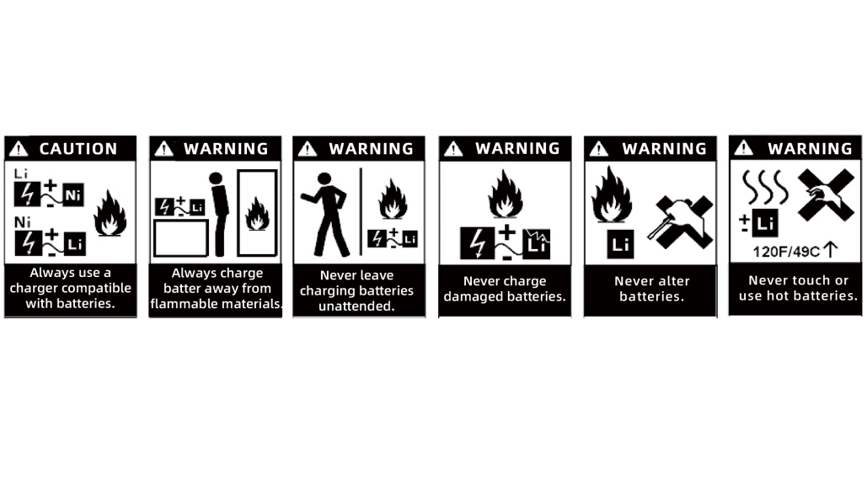
HELICOPTER PARAMETERS

Length | 400 mm
Height | 120mm
Weight | 297g
Length of Main Propeller | 410 mm
Diameter of Tail Propeller | 73mm
Battery Speciﬁcation | 11.1v 700mAh 30C
Flight Time | 6-10 Min
Main Brushless Motor | 3606
Brushless Tail Motor | 1104
WARNING AND THE GUIDE OF BATTERY USAGE

To ensure safety, please use the included supplied standard charger

WARNING：It is highly recommended to use the supplied charger to charge the battery.
Notice：When the battery voltage is lower than 11.1V, the lithium battery may be damaged, and may be no longer correctly charged. When the battery voltage is lower than 11.1V during a flight, the main ESC drops the head speed signiﬁcantly. Please land immediately and charge the battery as soon as possible.

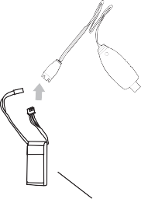
BATTERY CHARGING

  - To charge the battery, please connect the charger USB plug into a USB plug pack or to a USB port of a computer or a plug pack.
If no battery is connected, the USB charger red light will ﬂash.
  - Once the battery is plugged into the USB charger, the charger's red light is lit to indicate the charging is in progress.
  - When the battery is fully charged, the USB red light will stay oﬀ.

Warning
1.For maximum safety, please monitor the battery while charging.
2.Please do not allow children to carry out the charging by themselves but ensure adult supervision at all times.
3.Please use the original standard charger of this product for charging. The use of unknown charger may pose risks of ﬁre and explosion.
4.If available, it is recommended that users use own Lipo 3s @2A charger in lieu of using the USB charger. This helps to charge the battery at a much faster rate.
NOTICE BEFORE FLIGHT
1. Ensure the batteries for both the tx and helicopter are fully charged.
2. Before turn on the TX, please make sure the throttle control is at the lowest position and the TH.HOLD and 3D mode switches are in the back position (back cover direction).
3.Make sure the TX has paired with helicopter. If not or please carry out the pairing process.
4.Please turn on the TX ﬁrst, then connect the battery to the helicopter and wait until it paired with TX. When turn off, please unplug the power from the helicopter ﬁrst, and then turn oﬀ the TX.
4. Keep away from people, cars, high-tension power lines and water sources such as ponds, lakes, rivers etc.

BIND WITH TRANSMITTER

If you have the RTF package, the helicopter ia already paired by the factory. However, if you need to pair again, please follow the following steps.
  - First turn on the transmitter and make sure the throttle stick is at the
bottom position, 3D IDLE switch is in the OFF position
  - Remove the canopy for activating the binding switch.
  - Apply power to the helicopter, the red led ﬂashes slowly, press the code button for 1 second, then the red lamp will go out and get ready for pairing.
  - When the red and blue lights turn on solid, the pairing has been
successful.
  - While carrying out the pairing, ensure there are no other transmitters are operating nearby to avoid unintended pairing.

Tips: This product is compatible with all FUTABA 2.4GHZ S-FHSS
transmitter.

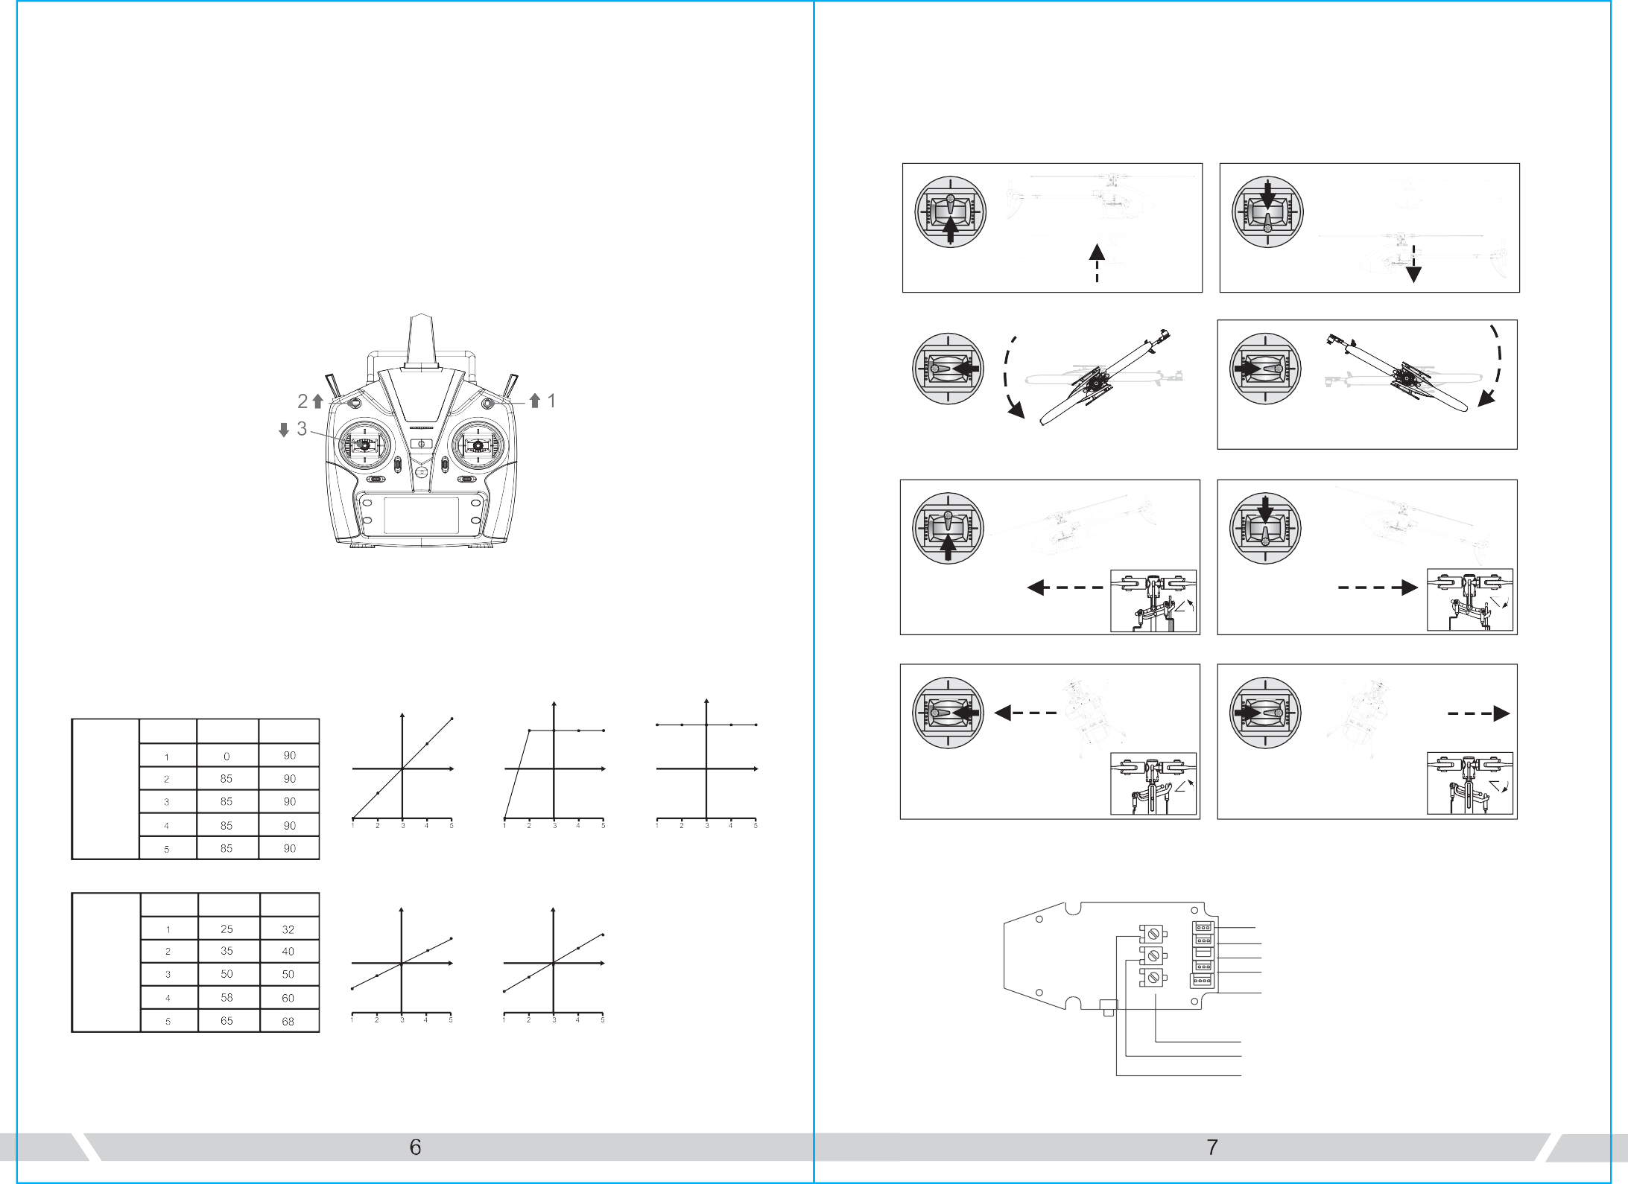
Notice：
Throttle up

Ascend
Throttle down

Descend
Rudder right
Right rotation
- When the transmitter is turned on and the throttle hold switch is in the ON position, the transmitter will beep as a warning. The switch should be switched to the OFF position.
- When the transmitter is turned on and the 3D switch is in the ON position, and the transmitter will beep. The switch should be switched to the OFF position.
- When transmitter is turned on and the throttle stick is not in the lowest position the transmitter will beep as a warning. The throttle stick should then be pulled down to the lowest position.
INITIAL FLIGHT
If you are not familiar with the controls of the E180, please take a few minutes to get
familiar with them and then try your ﬁrst ﬂight.
Throttle

Rudder

Rudder left Left rotation
Elevator

THROTTLE CURVE AND PITCH CURVE
Elevator up

Aileron

Forward
Elevator down

Backward

Throttle Curve

Position

Normal

3D Idle
Position
Normal
3D Idle

Aileron left

Left roll

Aileron right

Right roll

Pitch curve

Position Normal

3D Mode

Normal

3D Mode

RECEIVER INTERFACE DIAGRAM

Servo#1 Servo #2
Servo #3
5VS-BUS/PPM
3.3v DSM2/DSMX

The above information is for your reference only, you can set the parameters to your demand.
Swash plate sensitivity Swashplate agility
The lock tail sensitivity
Notes: 3.3V is suitable for DSM receiver and 5V is suitable for FUTABA (S-BUS) J receiver.

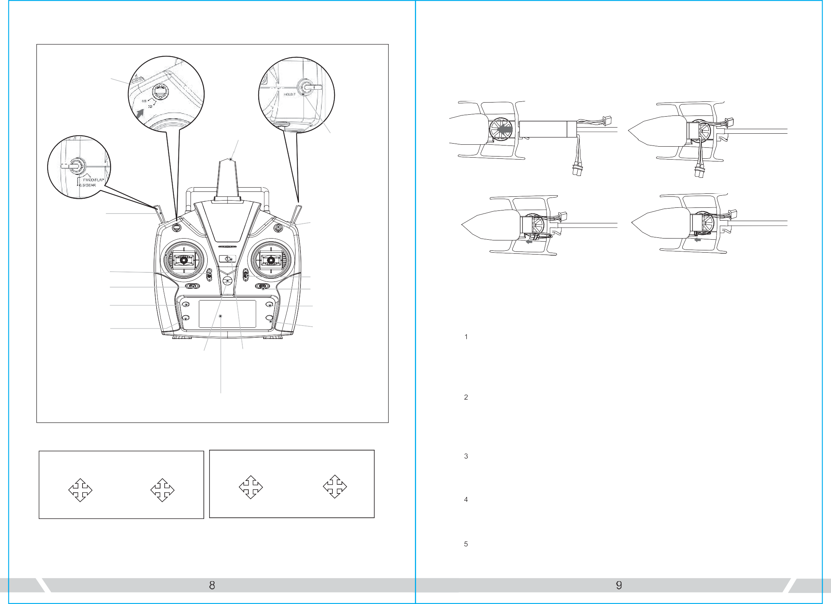
ABOUT THE TRANSMITTER
6CH/IDLE Switch
Antenna
TH.HOLD Switch
5GH/Gyro Switch
Servo Scale
Throttle Rudder
Joystick
Throttle Fine- tuning Rudder Fine- tuning Menu
Exit
Aileron/ Elevator
Joystick
Aileron Fine-tuning Aileron Fine-tuning
Page Up
Page Down
Flying Rings
Power Switch
Flying Rings
Forward
Right
Left Steering
Right
Left
Steering Sideward
Left Sideward
Backward
Right
Forward
Left Sideward
Left
Sideward Steering
Left
Right Steering
Backward

THIS SHOULD NOT HAPPENING

Right hand throttle
Left hand throttle

This transmitter supports CCPM 120 degree helicopter dedicated transmitter, with 3D 6G switching high/low rudder capacity for two joystick modes, main cutout switch (TH.HOLD) and other modes, large screen LCD display multi-function transmitter.

FLIGHT BATTERY INSTALLMENT
  - Put the throttle joystick to the bottom position.
  - Turn on the transmitter.
  - Install the battery into the rack and connect it properly with the receiving power. 4.Once the battery is connected, the signal starts to blink. Keep it still and wait until the signal light stops blinking, which means the receiver has completed self-inspection and gets ready for ﬂight.

TROUBLESHOOTING
 | Problem | Cause | Solution
 | LED on receiver ﬂashes constantly with no responses after connecting batteries to transmitter. | Transmitter is not bound to receiver.  Pairing of the transmitter and receiver failed. | Re-pair (Refer to P.5, Programming your Transmitter)
 | The helicopter has no response after connecting batteries to receiver. | Check whether the transmitter and receiver connecting to power； check the voltage of transmitter and receiver; Battery pole ﬂake contact is not good. | Open the transmitter, make sure the batteries connecting is good Replace and charge transmitter batteries Make sure the battery pole ﬂake contact is good.
 | When increasing throttle, the main motor does not start and the LED on the Receiver ﬂashes constantly | Low battery voltage, batteries connection is not good. | Replace and charge the batteries, reconnect the batteries to the receiver board.
 | ????? Helicopter takes oﬀ immediately, once the batteries and receiver connected. ????? | Didn't put the throttle to the  lowest | Put the throttle pole at the lowest position before open the transmitter.
 | Helicopter vibrates or  shakes in ﬂight. | Damaged rotor blades, bent main and FS shafts or blade grips too tight causing the main rotor movement not smoothly. | Replace the main rotor blades, bent main or feathering shafts, loosen the blade grips.

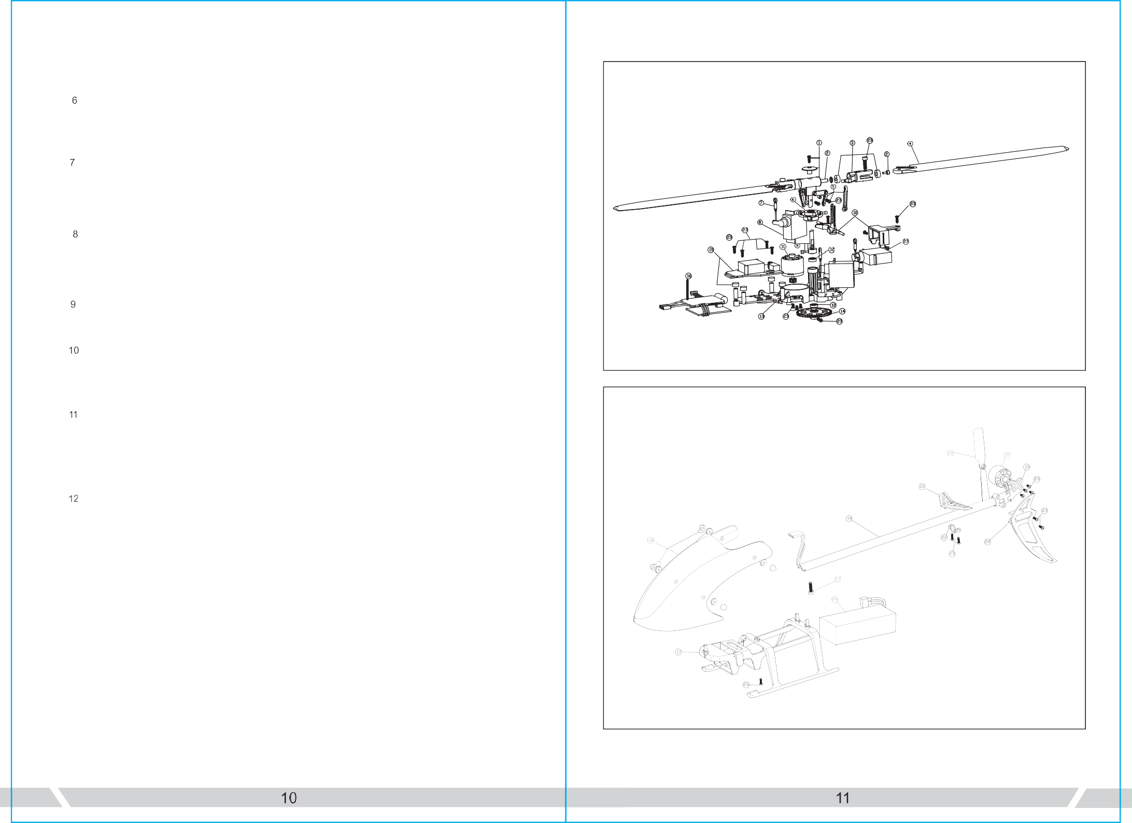
EXPLODED VIEW
Servo #2
Servo #1
Servo #3
 | Problem | Cause | Solution
 | Main rotor blades  shake during ﬂight. | -Feathering shaft or main shaft is bent. FS screw is not tight enough.  - possible broken gear in the servo, causing shakes. ????The loose between the swashplates. ???? | Replace the lateral axis. Tighten the lateral axis screw. Change the Bearing.  Remove the servo, and clear debris.  Compress the swash plates. change the tail rotor blades.
 | The sound of the main rotor becomes softer or drop in head speed | Low battery voltage of helicopter. | Land the helicopter immediately and  charge the battery or change to a fully charged battery.
 | Helicopter has no reaction  or does not ﬂy smoothly. | Failure of binding | Rebind the helicopter and transmitter, make sure you place the helicopter at a steady level close to the transmitter.
 | 3D/6G model helicopter appeared yaw | Swashplate servos do not go back in to mid-position or broken. | Recenter the servo arms.  Replace the servo
 | Tail does not lock in 6G mode | Helicopter requires to calibrate in 6G mode | Refer to 6G mode calibration procedure.
 | Helicopter took oﬀ spin to  the left. | Tail motor power shortage loose blades  Tail motor damage | Check with the tail rotor blades and the motor shaft, If loose replacement tail rotor blade. Motor damage  Replace the tail motor
 | ???? Helicopter power is turned supreme speed governor electric sound ????? | Brushless speed governor fault or poor contact | Check the connectors  replace speed governor

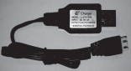
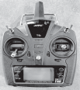
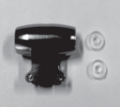
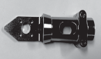
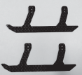
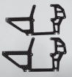
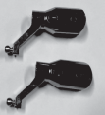
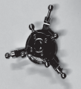
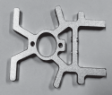
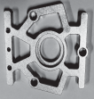
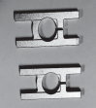
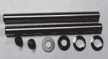
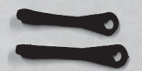
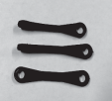
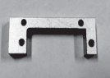
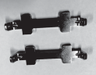
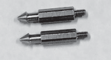
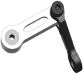
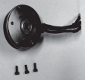
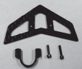
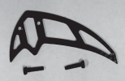
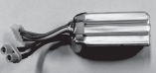
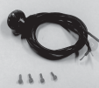
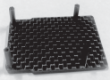
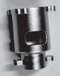
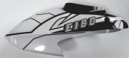
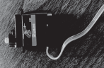
ACCESSORY LIST
Part No: 2.32.01 .Fl80-001  Part Name: Rotor Head Set | Part No: 2.32.01 .Fl80-002  Part Name: horizontal axis | Part No: 2.32.01 .Fl80-003  Part Name:Rotor Clip Set | Part No: 2.32.01 .Fl80-004  Part Name: Rotor Blade Set
Part No: 2.32.01 .Fl80-005  Part Name: Upper Rocker Arm Set | Part No: 2.32.01 .Fl80-006  Part Name: Upper Linkage Set | Part No: 2.32.01 .Fl80-007  Part Name: Swashplate Set | Part No: 2.32.01 .Fl80-004  Name:Under Linkage Set
Part No: 2.32.01 .Fl80-009  Part Name: Servo Set | Part No: 2.32.01 .Fl80-010  Part Name: Main Shaft Set | Part No: 1.02.07.F180-033  Part Name:Elevating Servo Platen | Part No: 2.32.01 .Fl80-011  Part Name: Main Motor Set
Part No: 2.32.01 .Fl80-009  Part Name:Main frame Bearing | Part No: 1.02.07.F180-031  Part Name: upper Stand Set | Parit No: 1.02.07.F180-032  Part Name:Under Stand Set | Part No: 2.32.01 .F180-013  Part Name:Tail Rod Fbdng Frame
PartNo: 2.32.01 .Fl 80-014  Part Name: Electronic Pallet Set | PSrtﬀc: 2.32.01 .M 80-015  Part Name： Ending Skid Bracing | Part No: 2.32.01.F180-016  Part Name: Side Plate Set | Part No: 2.32.01 .F180-017  Part Name: Landing Skid Set
Part No: 2.32.01 .Fl 80-018 Part  Part Name: Canopy Fixing Leg | Part No: 2.32.01 .Fl 80-019  Part Name: Canopy Set | PajtN©: 2.32.01.F180-021  Part Name: Battery Set | Part No: 2.32.01 .F180-022t  Part Name: Batteiy compartment
Part No:1.02.08.03.F180-001  Part Name： Tail Rods Set | Part No: 2.32.01 .Fl 80-023  Part Name:: Horizontal Tail | Part: No: 2.32.01.F180-021  Part Name:Tail Motor Frame Set | Part No: 2.32.01 .F180-022  Part Name: VerticaI Tail Set
Part No: 2.32.01 .Fl 80-025  Part Name： Tail Motor Set | Part No: 2.32.01 .M 80-026  Part Name: Tail Blade Set | Part No: 1.03.04.F180-001  Part Name:USB Charger Set | Part No: 2.03.01 .F180-001  Part Name: Transmitter Set

NO. | PARA NAME | QUANTITY
 | Rotor Head Set
 | Horizontal Axis Group
 | Rotor Clip Set
 | Paddle Group
 | Link Group
 | Swash Plate Group
 | Lower Link Group
 | Rudder Unit
 | Spindle Group
 | Servo Pressure Plate Group
 | Main Motor Unit
 | Bearing Set
 | Main Rack Group
 | Big Gear Set
 | Flight Control Motherboard
 | Governor Group
 | Landing Gear Group
 | Chassis Group
 | Tailstock Group
 | Tail Motor Unit
 | Chassis Group
 | Rear Wing
 | Screw Set
 | Battery
 | USB Charger Set
 | the transmitter Unit

Notice for beginners:
- Please ﬂy with an instructor until you are confident enough.
- Before ﬂying the model for the first time, you need to fully understood all of the functions provided by the transmitter and the responses of all of the switches.
- Don't attempt to fly in 3D mode yet. Practice ﬂying and hovering in 6G mode until you are familiar with it. Then you can practice ﬂying and hovering ﬂight under 3D mode. Once you are familiar with these two modes you can vary out practicing inverted ﬂight with an instructor.
- Practice hovering ﬂight of inverted moves to build a foundation that making more brilliant ﬂying.
- This model is not a toy and it can cause damages to people and property. If unsure, it is recommended that you practice with a simulator on a computer before doing real 3D ﬂy with this model to minimize the damage.

ACCESSORIES LIST

