**Features:**

1. Frequency band：UHF 400-470MHz( Receiving/ Transmitting)
2. CTCSS, DCS standard sub-tone

3: High and low power

4: 16 storage channels

4: 10 ringtone options

5: VOX function

6: Dual frequency waiting

7: Time Out Timer(TOT)

8: Scanning function

9: Battery saving function

10: Low voltage warning

11: wide/narrow band

12: Computer programming password reading and writing frequency

13. Special sub-tone (frequency hopping function)

14: Busy lockout function

15: Scramble function

16: Emergency flashlight function

17: LCD display

18: Type-C charging

19: K head audio interface

20: Keyboard lockout function

21: monitoring function

**Display and key description:**

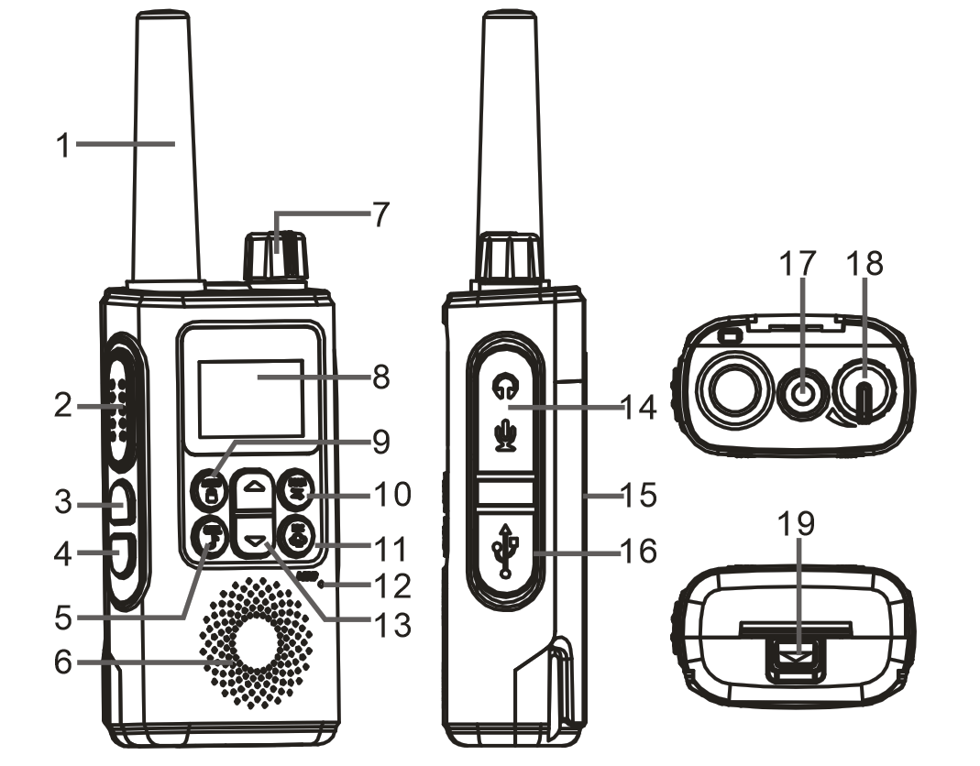

1: Antenna 2: PTT button 3: Flashlight/Alarm button 4: MONI button 5: CALL button 6: Horn 7/18: Power/volume control switch 8: LCD screen 9: MENU function button 10: SCAN button 11: Dual frequency waiting button 12: MIC microphone 13: Up and down setting button 14: Headphone jack 15: Case 16: Charging jack 17: Flashlight 19: Battery Shackle

**Button function definition:**

|  |  |
| --- | --- |
| PTT | Press this button to transmit, show TX🡪, HI indicates high power transmission。Shows TX-->, LO indicates low power transmission. |
| Release the PTT button and receive the call, then show RX🡨.  *In the menu settings, pressing PTT will forcefully return to the standby state and save the settings. |
| LAMP/SOS  Flashlight/Alarm | Short press once to turn on the flashlight; short press twice, the flashlight flashes quickly, turn on the sound and light alarm, the speaker will sound an alarm, short press three times to turn off the flashlight.  Note: In the shutdown state, press the LAMP button to turn on the flashlight, and press again to turn off the flashlight, this is for temporary needs. |
| MONI monitoring | Press this button to turn on the monitoring function, the screen displays RX<--receiving status, release the button to exit the monitoring function. |
| /MENU lock/Menu | Short press to enter the function menu, long press to enter lock and unlock. |
| Long press to lock some functions of the walkie talkie, the screen displays the lock  icon. At this time, the scan function, D/W button, up and down keys, and menu functions are all prohibited. CALL, LAMP, MONI, PTT function buttons allow to be operated.  Note: If there is no operation, the keyboard will be automatically locked after 15 seconds. |
| CALL | Short press to initiate a call and ring, TX---> Icon indication.  Note: When CL is set to OF, pressing the CALL key is invalid, and the operation prompt sound is invalid. |
| SCAN | Short press to activate the channel scan function, automatically scan 1-16 channels, and display the Scan icon. If the channel has a sub-tone code set, the scan channel and sub-tone code will be displayed at the same time; short press the SCAN button again to exit the scan. |
|  | In the menu mode, it is used to select the menu and various options. Used to select various options in the menu settings.  In the standby state, it is used to select the upper and lower channels. |
| D/W | Dual frequency waiting button switch, long press to turn on dual frequency waiting, DW icon is displayed. Long press again to turn off dual frequency waiting. |

**Prepare before use, charge the walkie-talkie**

Open the accessory plastic cover, insert the Type-C charging cable into the Type-C charging port of the walkie talkie, the battery icon on the LCD dynamically displays the charging process. The walkie talkie can be operated when the battery is fully charged.

**On/off walkie talkie**

If you need to turn it on, please turn the [Power Switch/Volume Control] knob clockwise until you hear a "click", and a short beep will sound. If you need to turn it off, please turn this knob counterclockwise until you hear a "click" sound, then turn off the walkie talkie.

**Note: The full screen lights up when the device is turned on, which is used to test whether the LCD screen is normal.**

**Volume adjustment**

After turn it on, turn the [Power Switch/Volume Control] knob clockwise to increase the volume, and turn it counterclockwise to decrease the volume.

**Transmit and receive**

After confirming the intercom channel, press the [PTT] button to initiate an intercom, and the screen will display the TX icon. Release the [PTT] button to receive the call from the other parties, and the screen displays the RX icon.

**Monitor**

After confirming the monitoring channel, press the [MONI] button, the screen displays the RX icon and activate the monitoring function of the current channel. Release the [MONI] button to exit the monitoring function.

**Emergency call**

In the standby state, short press the [CALL] button, the screen will display the TX icon, and the receiver will continue to ring for 3 seconds. 10 kinds of Call Tone settings, when set to OF, the CALL button is invalid.

**Function lock**

In standby mode, long press the [****/MENU] button, the screen will display  the icon. At this time, the scanning function, D/W dual-frequency waiting, up/down keys, and menu functions will all be prohibited. CALL, LAMP, MONI, PTT function keys allow to be operated.

**Channel scanning**

In standby mode, short press the [SCAN] button, the screen will display the Scan icon and activate the channel scan function, automatically scan 1-16 channels, stay in the active channel, and can initiate a call by pressing the [PTT] button when staying in the active channel. Short press [SCAN] or [PTT] again to exit scanning.

**Emergency alert**

In standby mode, short press the [LAMP] button on the left to enable the emergency flashlight function.

Short press the [LAMP] button once to turn on the flashlight; short press the [LAMP] button twice, the flashlight flash quickly, and activate the emergency alarm, the speaker emits a high-decibel alarm sound, and the flashlight flashes at the same time, then achieve the sound and light alarm function. Short press the [LAMP] button three times to turn off the flashlight.

**Note: The emergency alarm function is only used in emergency situations.**

**Note: In the shutdown state, short press the LAMP button to turn on the flashlight, and short press twice to turn off the flashlight.**

**Menu function settings:**

Short press the MENU button to enter the menu-->CALL (OFF, 1-10)--->VOX switch--> Touch-tone BP-->Battery power saving mode--->Dual frequency DW waiting channel (OFF, 1-16).

Short press the [/MENU] button to enter the function menu, allowing the following operations:

**Channel selection**: 1: In the standby state, press “/” key to select a channel, the options range is from 1 to 16 channels.

**Calling ringtone**: 2: Press the [/MENU] button once to select the ringtone, display “CL” and the current ringtone type (the ringtone sequence flashes), press the up and down buttons to select the ringtone number, you can listen to the ringtone, and press the PTT button to confirm the option. The options range is from 0F, 1-10, among which 0F means turn off the ringtone. After turning off the ringtone, press the CALL button to have a forbidden operation prompt (beep prompt).

**VOX emission**: 3: Press the [/MENU] button twice, VOX function setting, display VOX and voice control level (level number flashes), press the up and down button to select the voice control level, and press the PTT button to confirm the option. The options range is OF and 1-4, where OF means turn off the voice control function. After the VOX function is turned on, the VOX icon is displayed on the screen.

**Prompt tone BEEP**: 4: Press the [/MENU] button three times to set the prompt tone, display , and press “/” to select ON or OFF. Note: OF means turn off the button tone; ON means turn on the button tone.

**Battery saving mode SAVE**: 5: Press the [/MENU] button four times to enter battery saving settings, display “SU”, press “/” to select OF or 1-3. Note: OF means battery saving mode is turned off; 1-3 means battery saving level.

**Dual frequency waiting**: 6: Press the [/MENU] button five times to set the dual-waiting function, display DW and the waiting channel (the waiting channel flashes), press the “/” button to select the channel to be waited (option range is OF and 1-16 channels). Note: If the waiting channel is the same as the normal channel, the dual waiting function is automatically turned off. OF means turn off dual frequency waiting. Turn on the dual frequency waiting function, the DW icon flashes, and the intercom channel and the waiting channel flash alternately.

**DCS CTCSS sub-tone number:**

**CTCSS QT**

|  |  |  |  |  |  |
| --- | --- | --- | --- | --- | --- |
| Number | CTCSS | Number | CTCSS | Number | CTCSS |
| OFF | OFF | 13 | 103.5 | 26 | 162.2 |
| 1 | 67.0 | 14 | 107.2 | 27 | 167.9 |
| 2 | 71.9 | 15 | 110.9 | 28 | 173.8 |
| 3 | 74.4 | 16 | 114.8 | 29 | 179.9 |
| 4 | 77.0 | 17 | 118.8 | 30 | 186.2 |
| 5 | 79.7 | 18 | 123.0 | 31 | 192.8 |
| 6 | 82.5 | 19 | 127.3 | 32 | 203.5 |
| 7 | 85.4 | 20 | 131.8 | 33 | 210.7 |
| 8 | 88.5 | 21 | 136.5 | 34 | 218.1 |
| 9 | 91.5 | 22 | 141.3 | 35 | 225.7 |
| 10 | 94.8 | 23 | 146.2 | 36 | 233.6 |
| 11 | 97.4 | 24 | 151.4 | 37 | 241.8 |
| 12 | 100.0 | 25 | 156.7 | 38 | 250.3 |

**DCS DQT**

|  |  |  |  |  |  |
| --- | --- | --- | --- | --- | --- |
| Number | DCS | Number | DCS | Number | DCS |
| 39 | 023 | 67 | 174 | 95 | 445 |
| 40 | 025 | 68 | 205 | 96 | 464 |
| 41 | 026 | 69 | 223 | 97 | 465 |
| 42 | 031 | 70 | 226 | 98 | 466 |
| 43 | 032 | 71 | 243 | 99 | 503 |
| 44 | 043 | 72 | 244 | 100 | 506 |
| 45 | 047 | 73 | 245 | 101 | 516 |
| 46 | 051 | 74 | 251 | 102 | 532 |
| 47 | 054 | 75 | 261 | 103 | 546 |
| 48 | 065 | 76 | 263 | 104 | 565 |
| 49 | 071 | 77 | 265 | 105 | 606 |
| 50 | 072 | 78 | 271 | 106 | 612 |
| 51 | 073 | 79 | 306 | 107 | 624 |
| 52 | 074 | 80 | 311 | 108 | 627 |
| 53 | 114 | 81 | 315 | 109 | 631 |
| 54 | 115 | 82 | 331 | 110 | 632 |
| 55 | 116 | 83 | 343 | 111 | 654 |
| 56 | 125 | 84 | 346 | 112 | 662 |
| 57 | 131 | 85 | 351 | 113 | 664 |
| 58 | 132 | 86 | 364 | 114 | 703 |
| 59 | 134 | 87 | 365 | 115 | 712 |
| 60 | 143 | 88 | 371 | 116 | 723 |
| 61 | 152 | 89 | 411 | 117 | 731 |
| 62 | 155 | 90 | 412 | 118 | 732 |
| 63 | 156 | 91 | 413 | 119 | 734 |
| 64 | 162 | 92 | 423 | 120 | 743 |
| 65 | 165 | 93 | 431 | 121 | 754 |
| 66 | 172 | 94 | 432 | --- | --- |

**Technical parameter :**

**General specifications：**

Frequency range UHF 400– 470MHZ

Storage channels 16

Operating voltage DC 3.7V

Frequency stability ±2.5ppm

Operating temperature -20℃~+50℃

Operation mode Same frequency simplex

Antenna impedance 50Ω

**Emission**

Output power： High power/low power

Emission current ≤1300 mA

Maximum frequency deviation (Broad band) ≤5KHz

Stray power ≤7.5uW

Adjacent channel power ≤-65dB

Signal-to-noise ratio ≥-45dB

Sub-tone/digital sub-tone bias 0.7±0.1KHz

Modulation sensitivity 8~12mV

**Receiving**

Sensitivity -122dBm (12dB SINAD)

Audio power ≥350mW

Audio distortion <10%

Intermodulation ≥50dB

Adjacent channel selectivity ≥50dB

Clutter suppression ≥50dB

Receiving current ≤450mA

