Operation Instruction of the USB Microscope

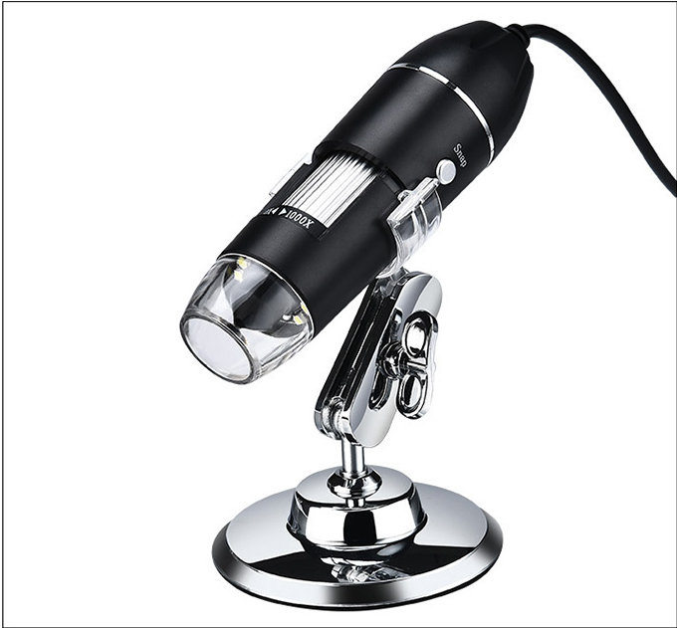
PC terminal operating guidance
1. Unpack and pick out microscope, connect the microscope and host computer well (make ensure the microscope and computer joggles inserted on position, no loosen)
2. Installation software
Please login https://soft.hvSCam.com, select icon and open after downloaded software well, then click the next one step→Receive→install→finish
3. Double click  icon on the table and open software, you will see the below interface after enter into the software:
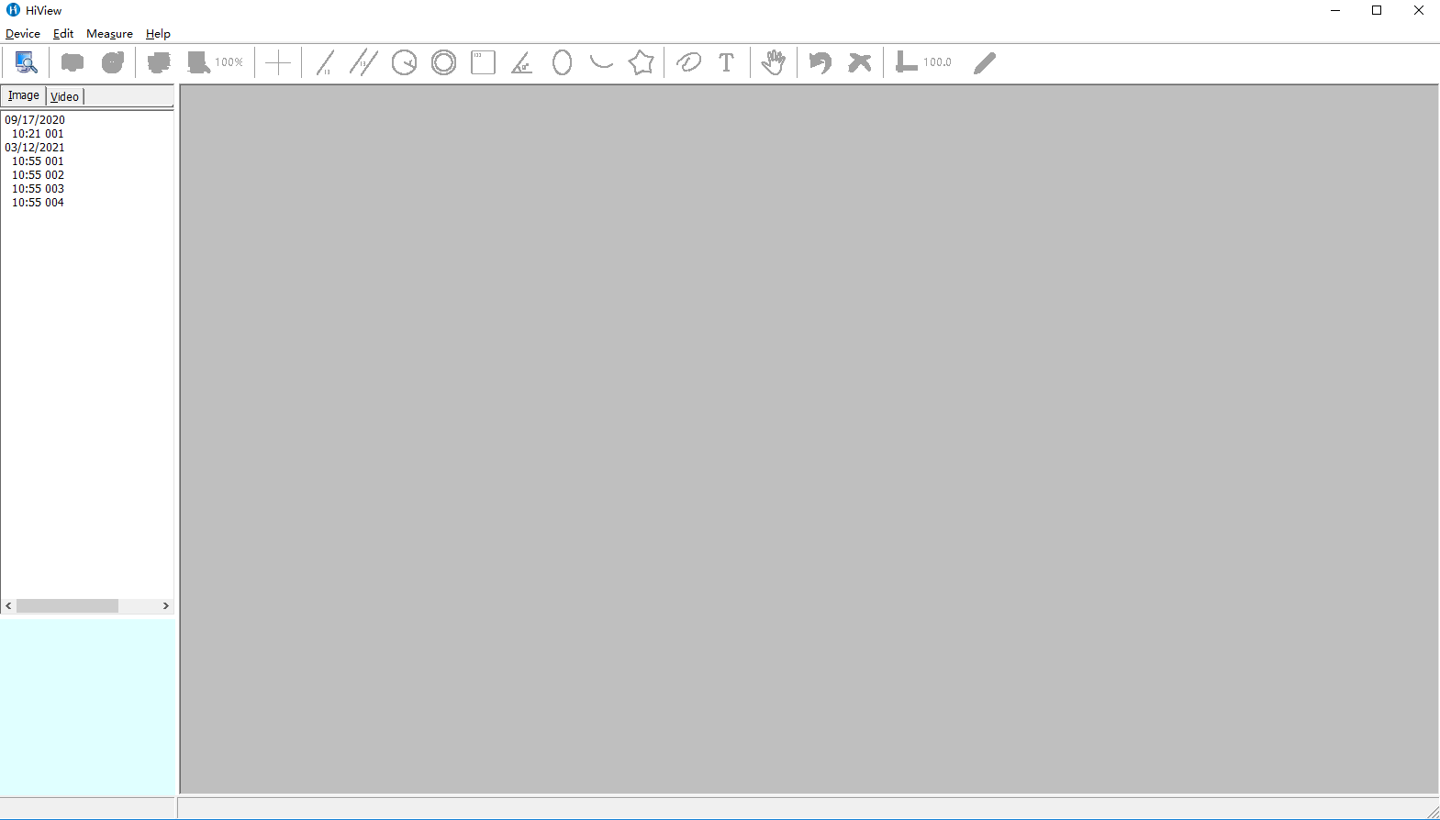

PC terminal operating guidance

4. Click “Equipment” in menu bar then click “Open” to select the microscope equipment name, color/compress and image resolution ratio, etc:
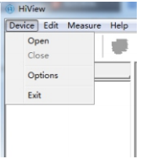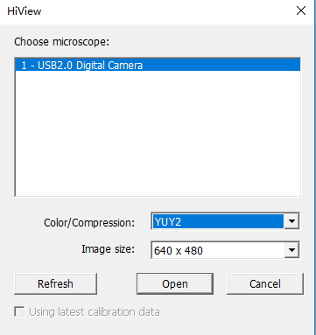

5. Click “Open” and enter into system page then can execute each item operation, shown as the below picture: (Attention! Please download the electric manual of operating specification of microscope and software)
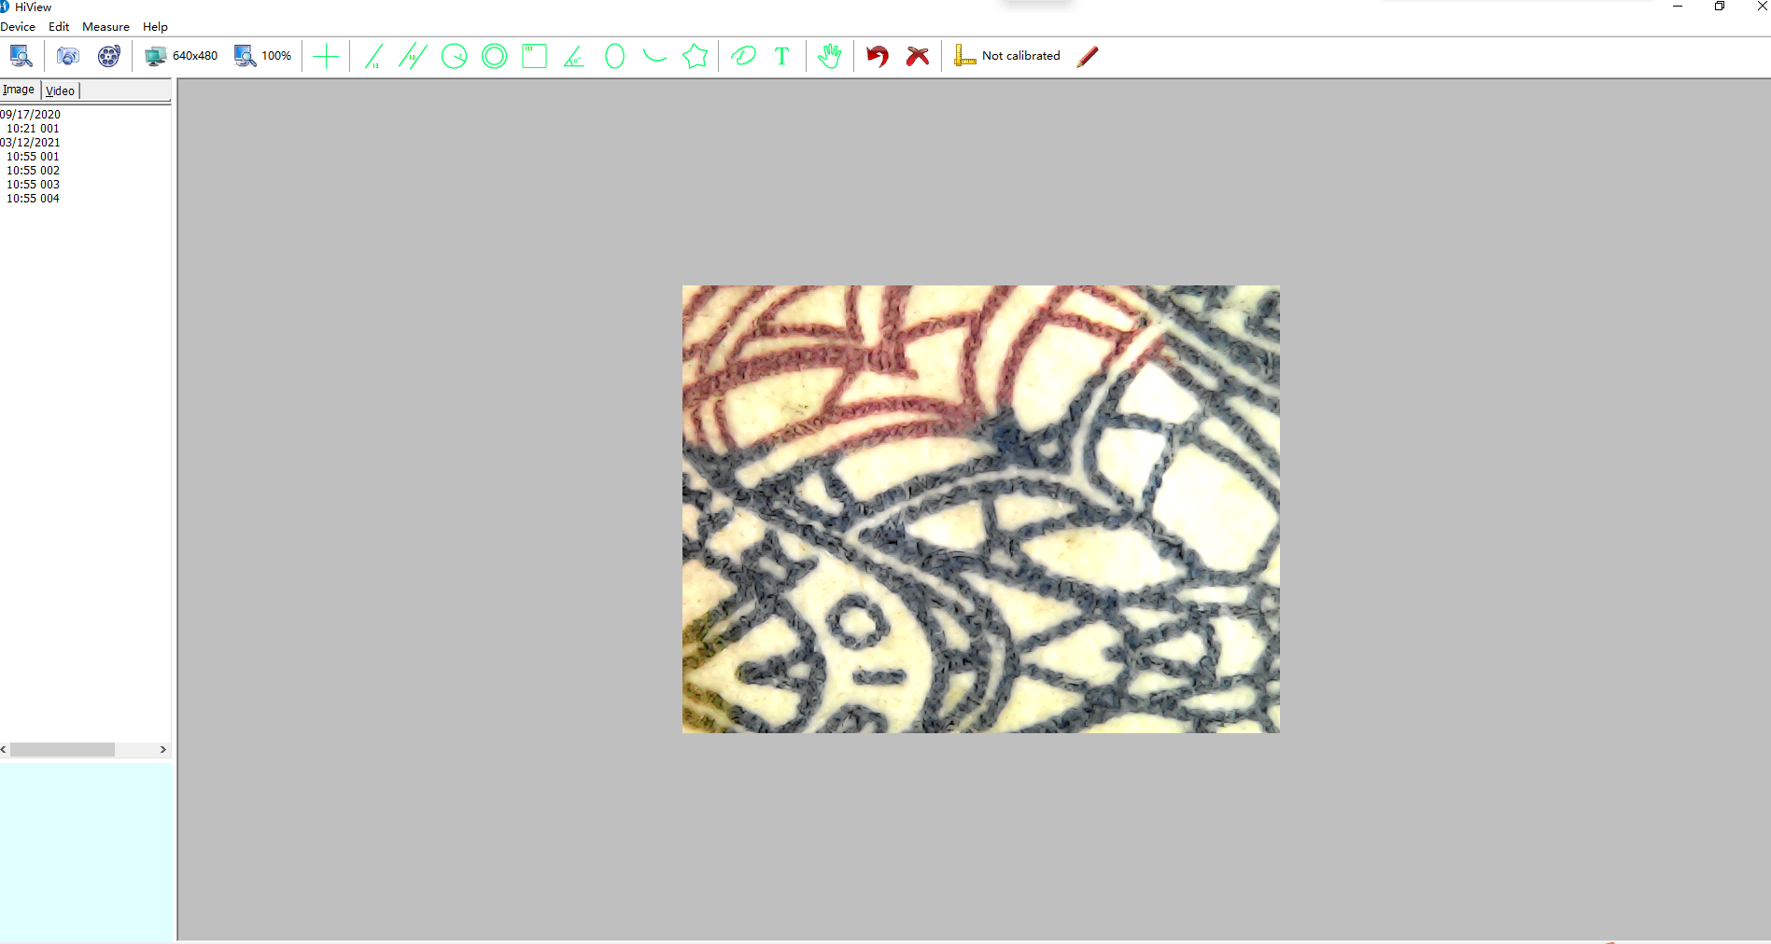
PC terminal operating guidance
6. Measure marked line and other operating sample, shown as the below picture
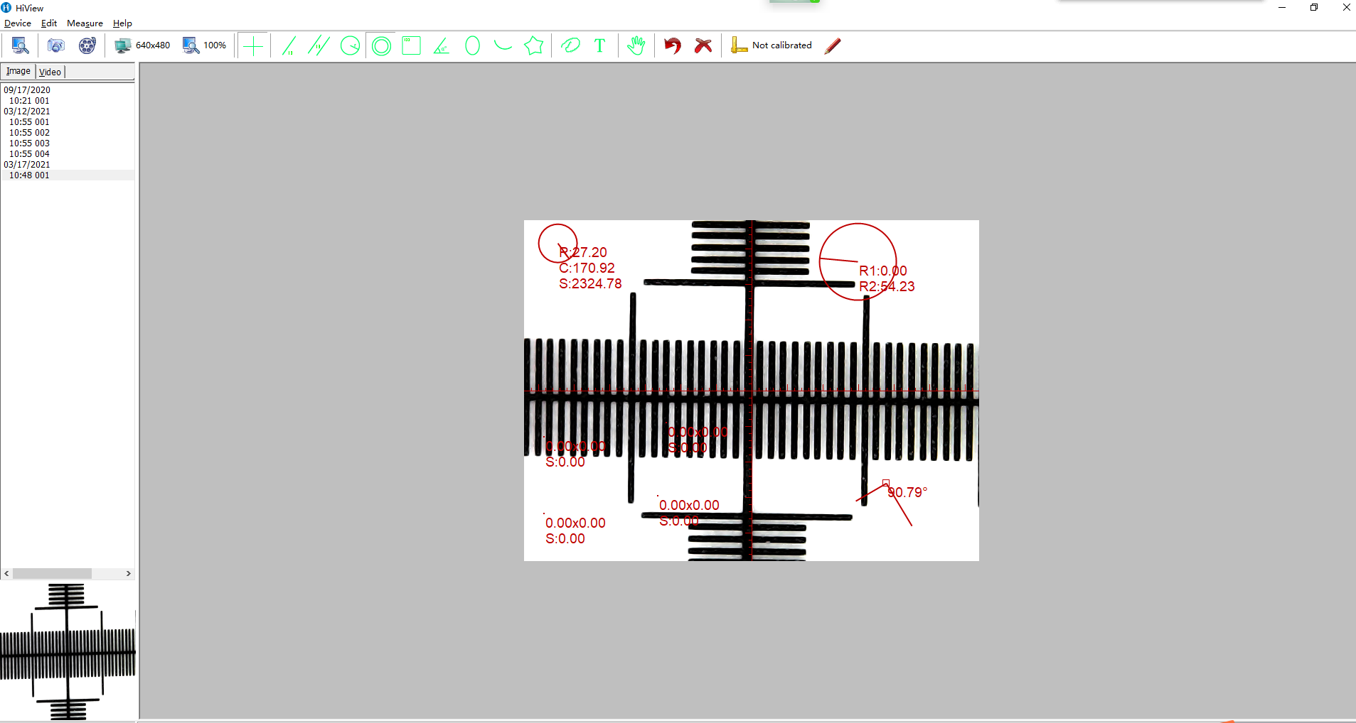
Note: the original machine ZOOM key unable to be used because product software updated, please use this function at “Modify display scale” in the software.

