MIG-200
Welding Machines Instruction Manual
1.Panel Direction
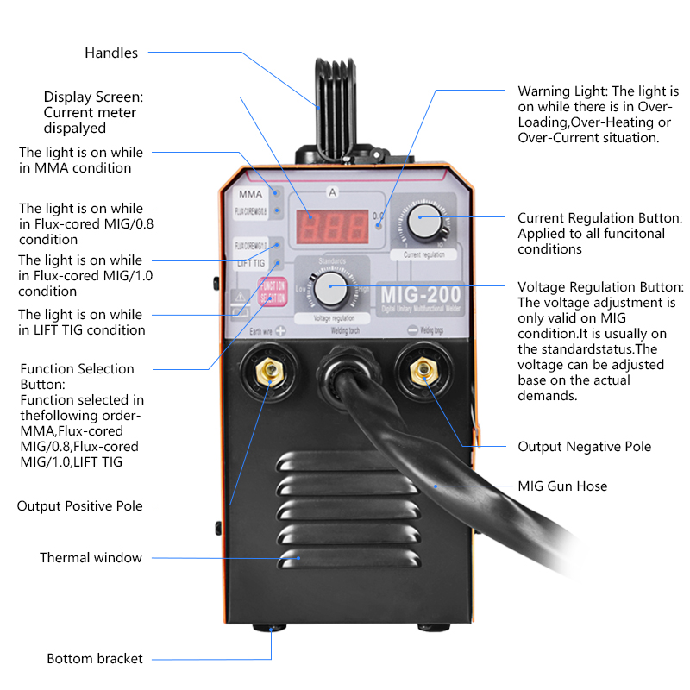
Operation Instruction
MIG-200 is a multi-function welding machine with ARC / MIG /TIG, we will introduce these functions and operation methods.

- MiG-200 ARC/MMA Function
Input Power Voltage | AC220V±15%, 50/60Hz
No-load Voltage (V) | 60V
Rated Input power (KVA) | 8.3KVA
Output Current Range (A) | 20A-250A
Duty Cycle(%)(25℃) | 60%
Efficiency (%) | 85%
Power Factor (COS) | 0.73
Insulation Class | F
Electrode Diameter (MM) | 2.5-3.2mm
Housing IP grade | IP21

When you need to use the MMA function, you first connect the soldering handle to the- negative electrode and the alligator clip to the + Positive pole, then open power button, find the function button on the panel and adjust it to MMA and the green light will turn on can start work.

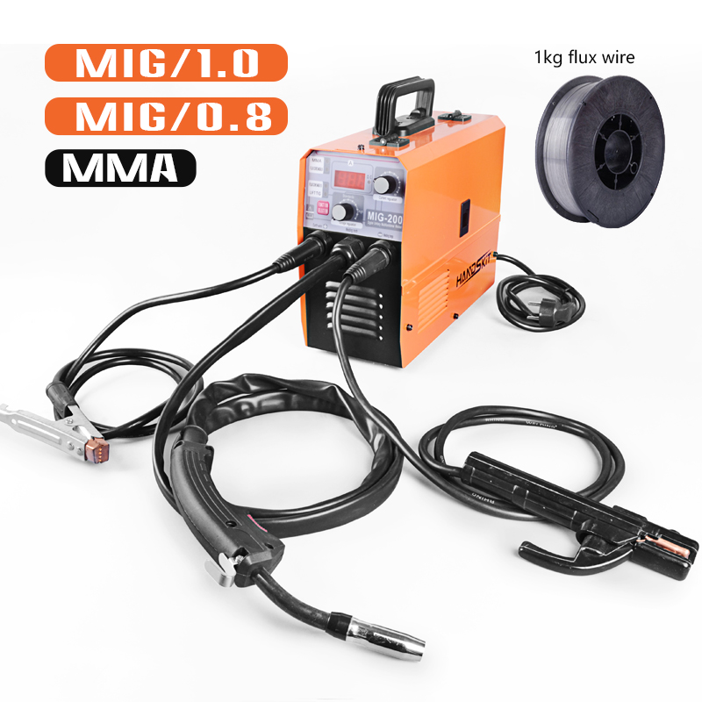
- MIG Function
Input Power Voltage | AC220V±15%, 50/60Hz
No-load Voltage (V) | 60V
Wire feed speed range(m/min) | 2～14
Output Current Range (A) | 20A-200A
Duty Cycle(%)(25℃) | 20%
Efficiency (%) | 85%
Power Factor (COS) | 0.73
Insulation Class | F
Housing IP grade | IP21
Noise(db): | ＜70
Applicable electrode/wire(mm): | 0.8/1.0/1.2MM
According to the welding wire classification, it can be divided into solid wire welding and flux cored wire welding.solid wire welding and flux cored wire welding.
MIG-200 FLUX CORE 1.0 (No need gas /personal home /workshop)
When you need to use the CO2 function, you first connect the soldering handle to the MIG hole and the alligator clip to the + Positive pole ,The other connector on the machine is connected to the- negative pole， then open power button, find the function button on the panel and adjust it to FLUX CORE 1.0 and the green light will turn on can start work.
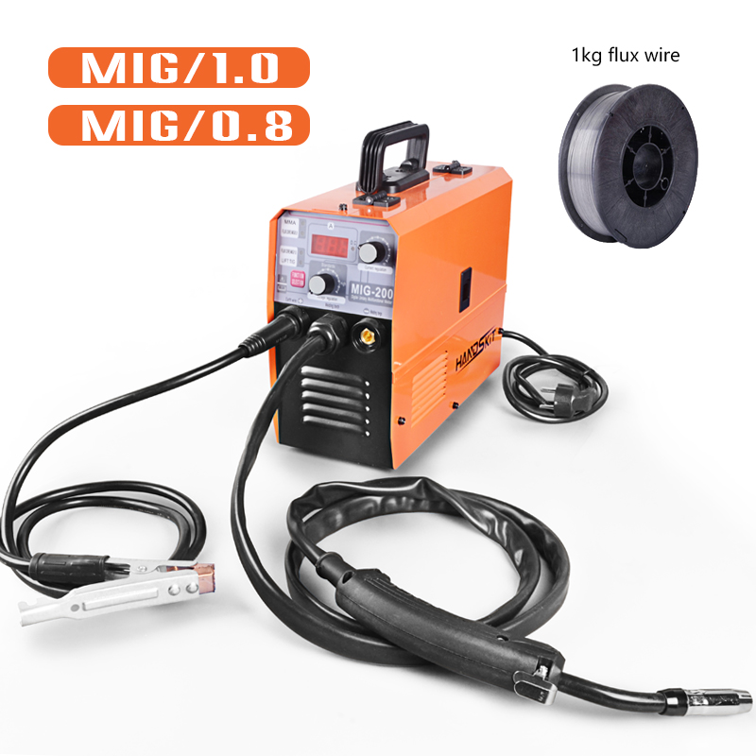

Flux cored wire is a new type of welding material with a promising future
(1) Advantages:
1) For the welding of various steels, it is highly adaptable to adjust the composition and proportion of the flux (general-purpose flux-cored wires are often referred to as flux-cored additives, and fluxes only appear in specific flux-cored wires). It is extremely convenient and easy. Can provide the required chemical composition of the weld.
2) Good process performance, beautiful welding seam shape. Adopt gas slag joint protection to obtain good shape. The arc stabilizing agent is added to make the arc stable and the droplet transfer uniform.
3) Fast deposition speed and high production efficiency. Under the same welding current, the flux-cored wire has a large current density and a fast melting speed. Its deposition rate is about 85%-90%, and the productivity is about 3-5 times higher than electrode arc welding.
4) All-position welding can be performed with larger welding current.
(2) Disadvantages
1) The manufacturing process of welding wire is complicated
2) When welding, wire feeding is more difficult than solid wire
3) The surface of the welding wire is easy to rust, and the powder is easy to absorb moisture, so the requirements for the preservation and management of the flux-cored welding wire are more stringent
3.1. The function of flux composition:
The same as the coated electrode, the flux cored wire manufacturer has its own unique formula for the flux composition. With the different functions of the welding material, the composition of the flux composition is also different.
MIG-200/TIG function

When you need to use the TIG function, you first connect the TIG gun to the - negative pole ，and alligator clip to the + Positive pole , then open power button and the green light will turn on can start work.
MIG-200/250 TIG Front connection of the machine
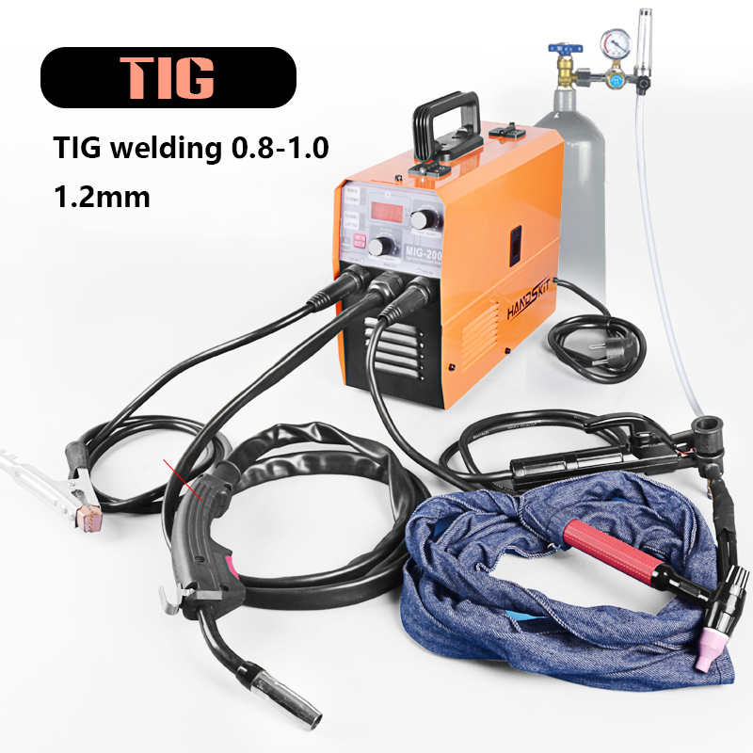

1. Because the stable welding current of DC tungsten arc welding can be adjusted very small, 3-5A can be stable welding, so it can weld very thin plates that cannot be welded by other common welding methods, including common metals and their alloys. AC argon arc Welding machine: It is the best method for welding aluminum and magnesium among all the commonly used welding methods, because aluminum and magnesium are easily oxidized at room temperature.
2. An oxide film whose melting point is much higher than that of the metal itself is formed on the metal surface (the melting point of aluminum is 657°C, the melting point of alumina is 2050°C), so it is difficult to weld aluminum-magnesium and its alloys with high quality by ordinary welding methods.
3. In the AC argon arc welding machine, when the current is negative half-wave, the workpiece acts as an electrode and emits electrons outward, which will form a physical phenomenon called cathode crushing, which will break the refractory oxide layer on the surface of the workpiece.

Precautions for use of electric welding machine:
1. A reasonable welding process should be selected according to the technical conditions of the work. Overload use is not allowed, high current welding is not allowed, and electric welding machines are not allowed to perform metal cutting operations.
2. The temperature rise of the welding machine during load welding should not exceed 60 degrees for class A and 80 degrees for class B, otherwise, it should be shut down to cool down before welding.
3. The working place of the electric welding machine should be kept dry and well ventilated. When moving the welding machine, the power supply should be cut off, and the welding machine should not be moved by dragging the power supply. If there is a sudden power failure during welding, the power supply should be cut off.
4. During welding, it is not allowed to adjust the current. When the welding is stopped, use the adjustment handle to adjust, not too fast or too strong, so as not to damage the regulator.
5. It is forbidden to do welding work under the crane's running workpiece.
6. If welding is carried out in the area with crane wire rope, care should be taken not to make the welding machine ground wire touch the hoisted wire rope by mistake, so as to avoid accidents caused by sparks.
7. When construction must be carried out in a wet area, the welder must stand on an insulated wooden board and work. It is not allowed to touch the wire of the welding machine, and it is not allowed to use the arm to hold the live welding tongs.

GB4706.41-2005 EN 60335-2-45 2002+
Product Standards GB/T 7157-2008 EN 60335-1-2012+
Company: Shenzhen Hanqi Electronics Co., Ltd.
Address: Room 302, 36 Gongkenglang Industrial Zone, Guanjing Road, Guanlan Street, Longhua District, Shenzhen
Email: handskit@Foxmail.com

