V I C u r v e T e s t e r
B 路位置可调,方便对比测量.
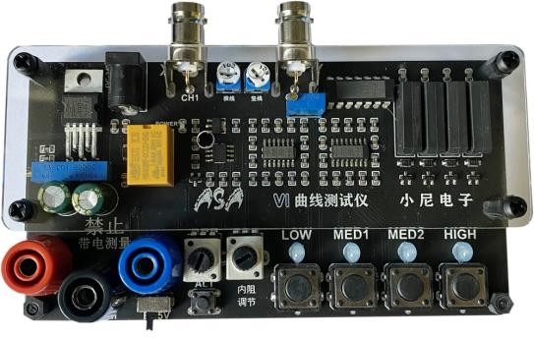
Acrylic ，alternately , finished version
1: Dual signal input, alternate display 4 levels of frequency, internal resistance adjustable, alternating speed adjustable.
2: Channel B is signal multiplexing and can be selected as trigger output.

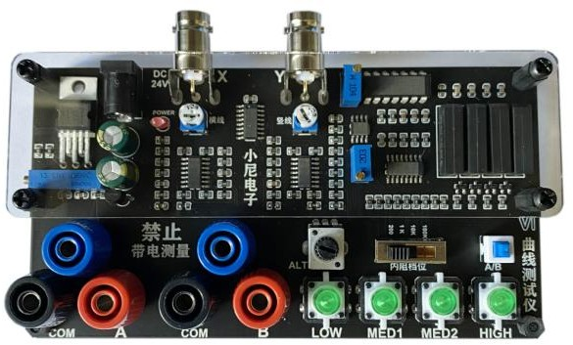
Acrylic， two-channel, finished version
1: Dual signal input, dual display at the same time ,4 levels of frequency, 4 levels of internal resistance adjustable

2: One key to turn on the dual display, the position of B channel is adjustable

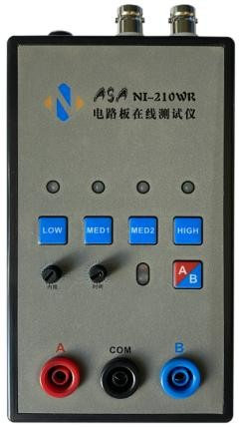
Plastic shell, alternately version

1: Dual signal input, alternate display, 4 levels of frequency, adjustable internal resistance, adjustable alternate speed.
2: One key to turn on, single channel/alternate display.

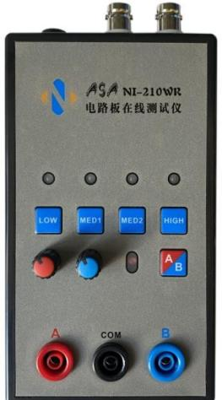
Plastic shell, two-channel version
1: Two-way signal input, two-way display at the same time, 4 gears of frequency, 4 gears of internal resistance adjustable, alternating speed adjustable.
2: One key to turn on, single/dual display.

content_copy
share

.

Acrylic ，alternately , finished version
24V I n p u t
Signal output CH1
横竖线调节
信号输出 CH2
测量电压调节
正负电压调节
A 路信号输入
信号公共端
B 路信号输入端
5V 触发输出端
蓝色端子
功能选择开关
开启交替显示
电位器调速
内阻调节
100R---50K
频率调节 4 档

Acrylic， two-channel, finished version

24V 电源输入
横线调节
长短调节
信号输出
CH1
信号输出
CH2
竖线调节
长短调节
测量电压调节
B 路水平调节
正负电压调节
4 档内阻调节
单路/双路选择
测量公共端
4 档频率选择
A 路信号输入
测量公共端
B 路信号输入
B 路位置调节

Plastic shell, alternately version
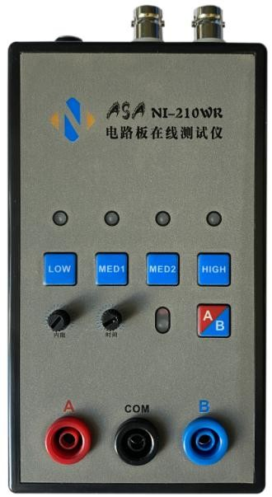
24V 输入
信号输出
CH1
信号输出
CH2
4 档频率调节
频率档位指示灯
内阻调节
A/B 路开关
交替速度调节
A 路信号输入
A/B 路指示灯
测量公共端
B 路信号输入

Plastic shell, two-channel version
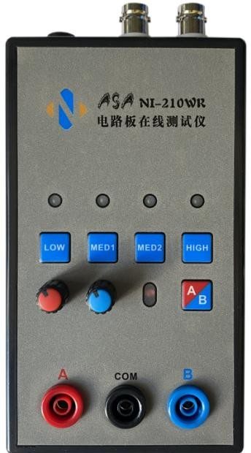
24V 输入
信号输出
CH1
信号输出
CH2
4 档频率调节
频率档位指示灯
4 档内阻调节
双路开关
B 路位置调节
A 路信号输入
双路指示灯
测量公共端
B 路信号输入

Oscilloscope parameter setting

share

* Adjust the oscilloscope to X-Y mode (different oscilloscopes have different adjustment methods, please explore by yourself)
volume_up
content_copy
share

* Adjust the vertical parameters of the X Y 2 channels to 1V/div, and you only need to adjust one of the single-track oscilloscopes.

* The analog oscilloscope does not need to adjust the time base, the digital oscilloscope time base is adjusted to between 1-5ms

*After the connection is correct, the oscilloscope will display a horizontal line. If a vertical line is displayed, the XY plugs will be reversed.

*Adjust the vertical and horizontal parameters, the horizontal and vertical lines are in the display box.

Method of connecting analog oscilloscope
The analog oscilloscope connection is relatively simple, and different oscilloscopes are slightly different. Adjust the oscilloscope to X-Y mode. Some oscilloscopes can be selected by pressing the keys, while others can be selected by the knob to XY mode. Please study by yourself. Connect the oscilloscope with the BNC cable and power on. Normally, a horizontal line will be displayed. Adjust the XY vertical channel parameters, which is about 1V/div, and then adjust the XY attenuation so that the horizontal line is in the display frame. It can also be passed on the VI test board. The X attenuation potentiometer is used to adjust the length of the horizontal line. If the test pen is short-circuited, a vertical line will be displayed under normal conditions. If the vertical line is too long or too short, you need to adjust the Y channel parameters to make the vertical line in the display frame. Grid or 1 grid to the edge is better. If the horizontal and vertical lines are normal, you can enter the normal measurement.

How to connect a digital oscilloscope

When using a digital oscilloscope, enter the XY mode through the menu or keys, and adjust the X and Y channels to
1V/div, the single-track oscilloscope only needs to adjust the Y channel. Adjust the time base to 1-5 milliseconds.
The X Y channel selects DC coupling, and the attenuation is 1X.
When the oscilloscope is not connected, the screen should be a bright spot. Adjust the horizontal and vertical to make the bright spot center. Connect the VI tester. Normally, it should be a horizontal line. Adjust the 103 potentiometer at the top of the VI board so that the horizontal line is in the display frame. , Half a grid or 1 grid to the edge is better. Short-circuit the test leads, the display should be a vertical line at this time, adjust the Y channel parameters to make the vertical line in the display frame. So far, debugging is basically over.

Note: When testing the circuit board online, the circuit board cannot be charged. If there is a large capacitor on the circuit board, discharge the capacitor first, otherwise the VI test board will be burnt out easily.

