Radiation Dosimeter

GM-100/A

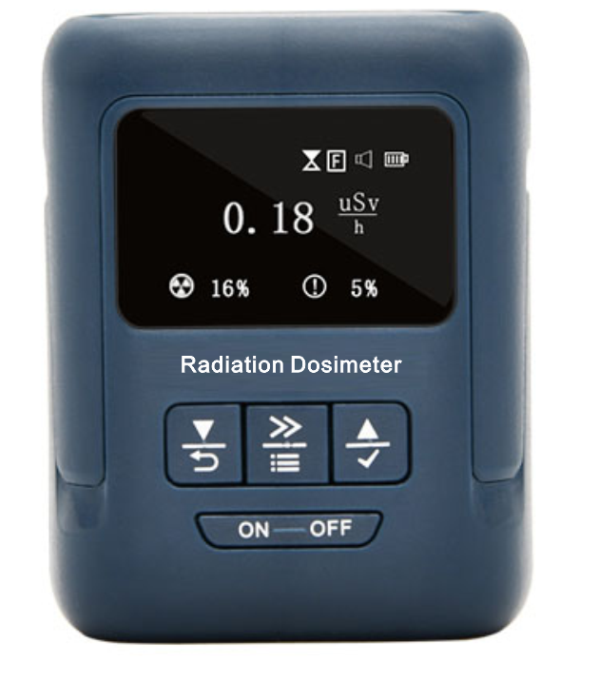

● Before use, please do read these Operation Instructions carefully so as to use this product properly.
● Please keep these Operation Instructions properly after reading them.

Table of Contents
- Purposes and Characteristics .....................................................................................................3
- Technical Indicators ................................................................................................................3
III. An Introduction to Buttons ........................................................................................................4
IV. Menu Operation ......................................................................................................................5
4.1 Collection Setting ...................................................................................................................6
4.2 Alarm Setting .......................................................................................................................7
4.3 Calibration Factors ...............................................................................................................8
4.4 Dose Duration .........................................................................................................................9
4.5 Language Setting .................................................................................................................10
4.6 Display Setting .....................................................................................................................10
V. Warranty Terms and Conditions .................................................................................................11
VI. Troubleshooting ........................................................................................................................11
VII. Product List ..............................................................................................................................12

Scope of application:
- Integration of personal dosimeters and radiation monitoring devices
- Test of the protection against medical radiation
- Application of the test of nuclear wastes
- Check of X-ray equipment leakage
- Transport and protection of neutrons and other radioactive sources
- Measurement and warning of other radiactive materials
- Supporting the customization and development of counting tubes

Product characteristics:
● Full metal GM counters，accurate indication, quick response and long service life;
● Having maximum value holding function, capable of checking curve trends for the latest hour;
● Sound/shock double alarm, and the user can set alarm values;
● Switching between Chinese and English language menus;
II. Technical Indicators

No. | Description | Parameters
1 | Type of measurement | Hard β-ray, γ-ray and x-ray
2 | Type of detectors | Metal geiger counters  (GM-100A imported from Russia)  (GM-100 made by CNNC)
3 | Service life of detectors | 2X10¹⁰ times
4 | Range of measurement | GM-100A: 0.00～36000uSv/h  GM-100: 0.00～1000uSv/h) overload range at 1800)
5 | Range of peak value | 0.1～1000 mR/sec(GM-100A)
6 | Range of accumulated doses | 0-999mSv
7 | Measurement accuracy | ±15% +6/p
8 | Alarm value | Capable of automatically setting alarm values
9 | Alarm mode | Sound and shock
10 | Energy response range  GM-100A | Gamma γ: 0.1～1.25Mev  Beta β: 0.25～3.5Mev  X-ray: 0.03～3.0Mev
11 | Language selection | Chinese and English menu
12 | Measurement unit | uSv/h, mR/h，uSv
13 | Accumulated dose duration | 1-9999 minutes to be set
14 | Accumulated dose | Automatic accumulation and manual clearance
15 | Maximum value holding | Automatically holding the maximum value of the current accumulated doses
16 | Curve atlas | The curve map of the latest hour, automatic calculation of maximum values and average values, and automatic tracking of maximum values to display curves
17 | Measurement mode | Rapid and smooth mode
18 | Operating environment | -30℃～60℃, 5%-95%RH (no dew)
19 | Power supply | One AA dry batteries
20 | Weight | Overall unit at 90 grams
21 | Dimension | 74*58*29 mm (excluding protruding portion)

- An Introduction to Buttons
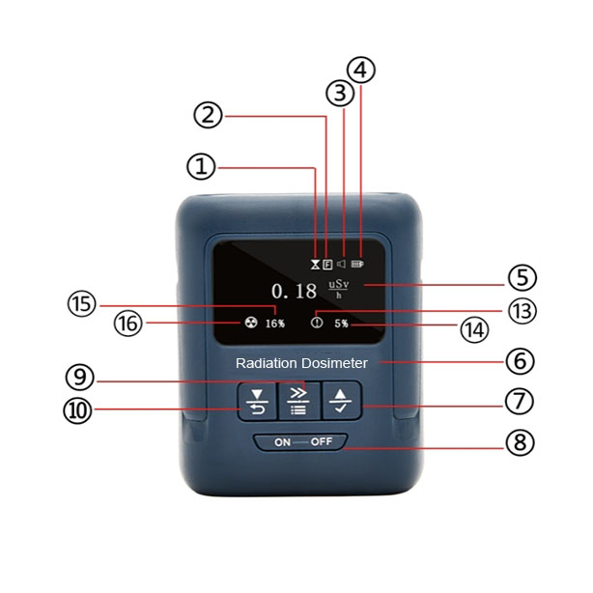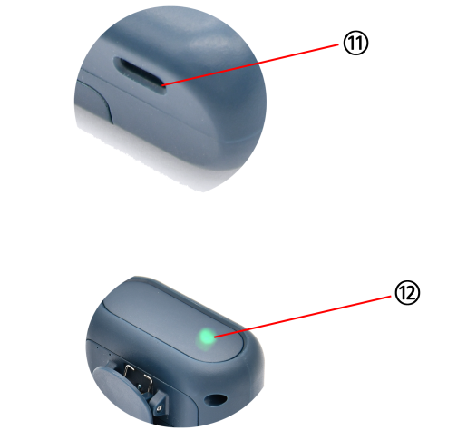
① Accumulated measurement in process, and accumulated measurement completed
② Sampling mode, quick mode, and smooth mode
③ Sound and light switch, sound and light alarm switch is on, and sound and light alarm switch is off
④ Current battery power
⑤ currently measured data and unit
⑥ name and model of instrument
⑦ Up. Long press the OK button. From the measurement interface, shortly press it to switch measurement units. From the menu interface, shortly press it to perform data + operation and set turning down from the top. Long press it to select option setting and return to the previous menu.
⑧ power supply button. Long press it for power off.
⑨ Shift and Menu button. From the measurement interface, long press it to enter the menu interface. From the menu interface, shortly press it for data shift and select by moving it right. Long press it to exit the menu interface and return to the measurement interface.
⑩ Down. Long press the Return button. From the measurement interface, shortly press it to switch the measurement units. From the menu interface, shortly press it for data - operation and set turning down from the top. Long press it to cancel option and return to the previous menu.
⑪ USB power supply port. USB-TYPE-C can be inserted for power supply to perform measurement for long.
⑫ Run indicator. The run indicator is located at the top left of the instrument used to indicate the run state of the instrument. When power is on to display the model and version number of the instrument, the run indicator is on. In the preheating period, the run indicator is out. After it enters measurement, the run indicator flashes every 5 seconds.
⑬ Accumulated dose gives alarm to flash the icon.
⑭ The alarm setting value of relative dose of the accumulated dose is up to 100%, it flashes, and the alarm icon of the accumulated dose also starts flashing.
⑮ Percentage of the alarm setting value of relative dose rate of the curent dose rate. The alarm icon starts flashing when it is up to 100%of dose rate.
⑯ dose rate alarm. The icon flashes.
- Menu Operation
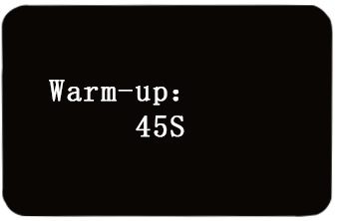
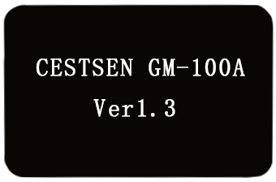
- Long press the power supply button for power on. The run indicator is on, and the buzzer sounds. The model and version number information of the instrument is displayed on the screen. After it holds for 1 second, the instrument goes to preheating count down. (The instrument is preheated for 45 seconds. In the preheating process, button operation is ineffective.)

Go to the measurement interface:
Shortly press the Down and Cancel return button or the Up and Ok button to switch displaying μSv/h,mR/h, dose data curve interface for 1 hour.
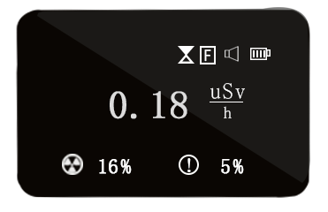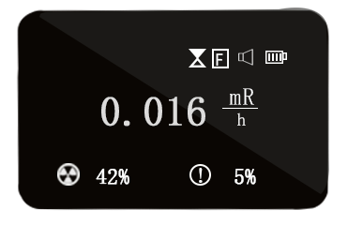
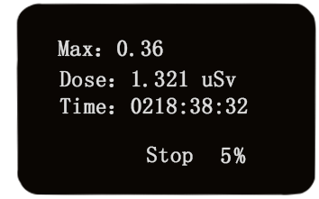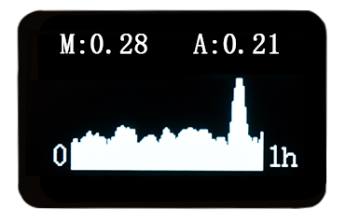

The maximum value in the current accumulated dose, the current accumulated dose value and the current accumulated dose duraction are displayed respectively. Press the Shift and Menu button to be able to start and stop. When the right lower corner is full at 100%, completion will be displayed.
A indicates the mean value within 1 hour, and M indicates the maximum value within 1 hour. The Y-axis scale displaying curves will be adjusted according to the change in the maximum value. (with the data unit as uSv/h)

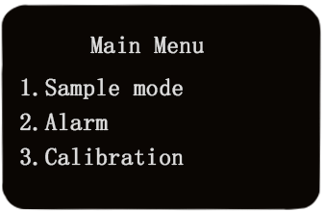
Menu operation

Long press the shift and menu keys to enter the menu interface. In any menu operation interface, long press the menu key to return to the measurement interface display without saving the settings.Long press the Shift and Menu button to go to the menu interface. From any interface for menu operation, long press the Menu button not to save the settings and return to the measurement interface to be displayed.

4.1 Collection mode
The collection mode is mainly set for different dose rates. There are two modes such as quick mode and smooth mode. It is recommended that the smooth mode be used in the environment below 1μSv/h. The smooth mode is characteristic of even sampling and steady data, while the quick mode is used for the environment where the dose rate is higher, so the real-time measurement and data updating is quicker. The difference between the two modes lies in that the data in the smooth mode is steadier while the readings in the quick mode are quicker.

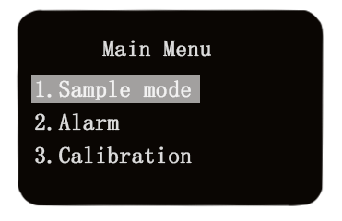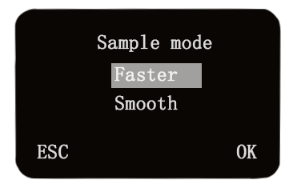
Long press Shift and Menu button to go to the menu, press the Up and OK return button and Dow and Cancel return button to select the sampling mode. After the selection, long press the Up and OK return button to go to the sampling mode. For the next step, press the Up and Ok return button and the Down and Cancel return button to select two modes. After selection, long press the Up and Ok return button for confirmation (it will quit automatically after confirmation).

4.2 Alarm Setting
The instrument has sound and shock alarm functions. When the dose rate or the accumulated dose rate is greater or equal to the alarm setting value. The buzzer gives the sound like tick, and the instrument vibrates. There is automatic display on the screen to remind the attention of the user. When the alarm value setting is 0.00, the alarm function is deactivated, with the icon of the main interface displaying as .
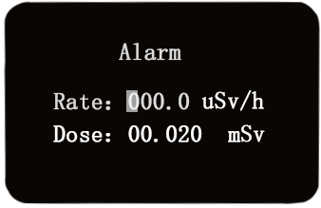
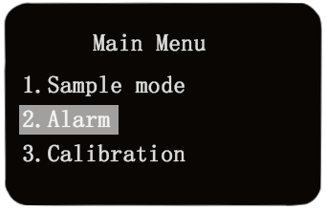

Long press the Menu button, long press the Shift and Menu button to go to the menu. Press the Down and Cancel return button to select the alarm setting. After selection, long press the Up and Ok return button to go to the alarm setting. After entry, press the Shift and Menu button to go to numbers, and then press the Up and Ok return button and the Down and Cancel return button to select numbers. After selection of the first numnber, press the Shift and Menu button to select the second number, so on and so forth. After selection, long press the Up and Ok return button for confirmation. After confirmation, it will skip to “dose rate”, and then you can press the Down and Cancel return button to go to “dose”, and then press the Shift and Menu button to go numbers. The step is the same as the “dose rate” for the operation of number selection. After selection, long press the Up and Ok return button for confirmation, and then long press the Menu button to return to the main menu.Return to the main interface.

4.3 Calibration Factors
The calibration factors are used for data calibration, with the default value as 100, and the value calculation formula as: original value times calibration factors divided by 100. The default calibration factor is 100, namely, the displayed value is equal to original value. For example, when the calibration factor is set as 200, the displayed value doubles the original value.
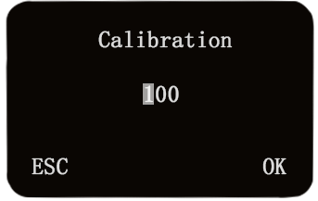
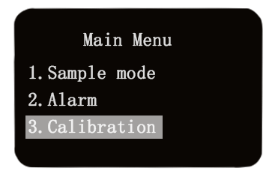
Long press the Shift and Menu button to go to the menu. Press the Down and Cancel return button to select the calibration factor. After selection, long press the Up and Ok return button to go to the calibration factor. After entry, press the Up and Ok return button and the Down and Cancel return button to select numbers. After the first number is set, press the Shift and Menu button to select the second number, so on and so forth. After selection, long press the Up and Ok return button for confirmation (after confirmation, it will quit automatically).

4.4 Dose Duration

The dose duration setting includes dose duration and dose clearance. The unit of dose duration is hour. After clearance, the dose starts to accumulate from the beginning. The accumulation stops until the dose duration is up.
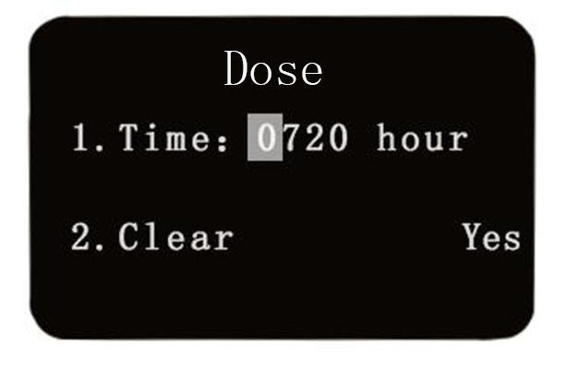
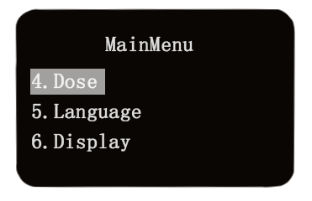

Long press the Shift and Menu button to go to the menu. Press the Down and Cancel return button to select the dose duration. After selection, long press the Up and Ok return button to go to the dose duration. After entry, press the Shift and Menu button to select the first number, and then press the Up and Ok return button and the Down and Cancel return button to select numbers. After the first number is set, press the Shift and Menu button to select the second number, so on and so forth. After selection, press Up and Ok return button for conformation and saving (After saving is ok, it will skip to “1. duration”), and after that, you can long press the Shift and Menu button to return to the main interface.

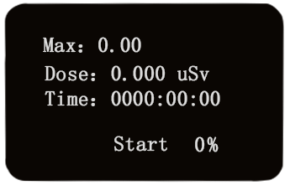
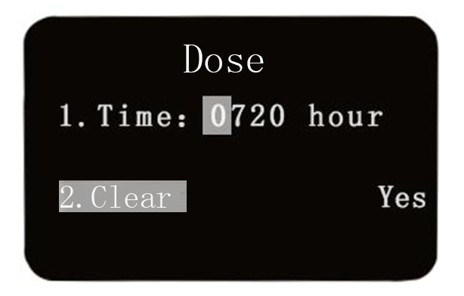

The “2. Clear” function can clear dose data from the main menu, which has nothing to do with “1. duration”. When you go to the dose duration, you can press the Down and Cancel return button to go to “2. Clear”, and then press the Shift and Menu button to go to “Yes”. Then long press the Up and Ok return button for confirmation (after it is Ok, it will skip to “2. Clear”). After that, long press the Shift and Menu button to return to the main interface.

4.5 Language setting
The instrument support display in both Chinese and English.

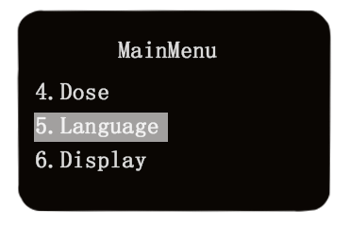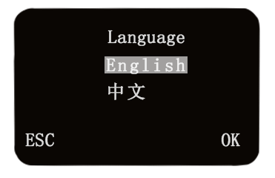
Long press the Shift and Menu button. Press the Down and Cancel return button to select language setting. After selection, press the Up and Ok return button to go to language setting. After entry, press the Up and Ok return button and the Down and Cancel return button for language selection. After selection, long press the Up and Ok return button for confirmation (After confirmation, it will quit automatically).

4.6 Display setting
The unit of display duration includes minutes. After button operation for the last time, it starts timing. After it counts to the display time, the screen is out. It is mainly used to reduce power consumption of the instrument and extend the operating time of the instrument.
Brightness adjustment displays screen brightness. The higher the display screen brightness value is, the brighter the display screen will be. The greater power the instrument consumes, the less operating time there will be.
After selection of the normal brightness, the screen of the instrument is always lit. It is used in some conditions where normal brightness is required.

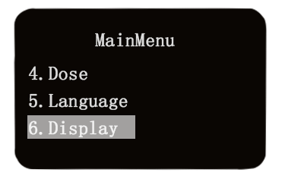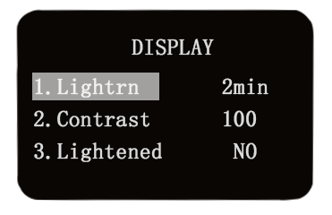
Long press the Shift and Menu button to go to the menu. Press the Down and Cancel return button to select language setting. After selection, long press the Up and Ok return button to enter language setting. After entry, press the Shift and Menu button, and then press the Up and Ok return button and the Down and Cancel return button to select time. After it is finished, long press the Up and Ok return button to return to “1. Display duration”. If is unnecessary to set brightness and normal brightness mode, long press the Shift and Menu button to be able to return to the main interface. If setting is required, please refer to the following.

For “2. Brightness” setting, press the Down and Cance return button to select brightness. Press the Shift and Menu button to go to values, and then press the Down and Ok return button and the Down and Cancel return button to adjust values. Upon completion, long press the Up and Ok return button to return to “2. brightness”. If it is not required to set the normal brightness mode, long press the Shift and Menu button to be able to return to the main interface. If setting is required, please see the followings.

“3. Normal brightness mode”: Press the Down and Cancel return button to select the normal brightness mode. Press the Shift and Menu button to go to “No”. Then press the Up and Ok return button and the Down and Cancel return button to select “Yes” or “No”. After selection, long press the Up and Ok return button to go to “3. normal mode”: Finally, long press the Shift and Menu button to return to the main interface.

V. Warranty Clause
■ Effective warranty period: within one year from the date of purchase.
■ Artificial damage, natural disaster and damage caused by improper use will not be covered by the warranty.
■ If repair is required within the warranty period, it is required to mail it to this Company for check and quotation, and the Company only charge cost of production and can make repairs and mail them back after cost of repair is paid.

VI. Troubleshooting

Failure | Cause | Troubleshooting
Value display as 0 | Sensor failure | Delivered back to the original manufacturer for repair
Display data remain unchanged | Failure in circuit boards | Delivered back to the original manufacturer for repair
Instrument reset repeatedly | Battery power low | Replace the battery
Response time becomes slower | Dust jam in probes  Sensor failure  Circuit board failure | Clear dust off protective hood  Replace the sensor  Delivered back to the original manufacturer for repair

VII. Auxiliary products
1、GM-100/A personal dosimeters…………………………………………………………1 set
2、USB cords ……………………………………………………………………........……1 piece
3、5# battery……………………………………………………………………..............… 1 unit
- Operation instructions ………………………………………………………………...…1 copy
- Product packaging box…………………………………………………….…………..…1 unit

Declaration:
The parameters as described in these Operation Instructions may be changed. Please base on the actual materials.

