C181 User Manual
- Product features
- The unique metal appearance design , simple operation
- 800W HD Lens
- Small shape design, portabel hand -held DV
- High definition video recording can be performed under low illumination
- Video resolution:1080P（30fps) 720(30fps)
- Separate recording function
- High speed transmission USB 2.0 port
- Up to 64G TF cards can be supported
- Built -in battery can keep recording for 180-240 minutes
- Structure description
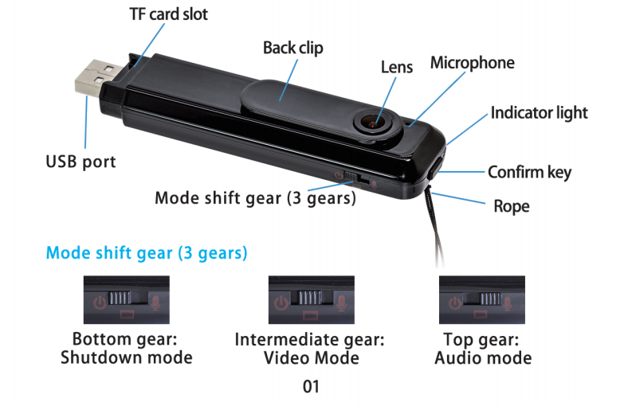
Attention:
- Green light flash prompts low power and automatically stops video recording out of power.
- If there is no TF card in the camera when starting ,blue light will always flash .
- When the TF card is full ,the blue and green lights flash at the same time.
- When there is no operation ,remember to toggle the power switch to shut down it.

Resolution / Loop Video Switching
The product supports 720P (default) and 1080P video recording and loop video recording ( default on ) switch customization,Connect the device to PC with USB or using card reader, create a new document named settings.txt in the root directory of the TF card, and then enter the ( X,X ),X is 0 or 1
The first “ X “ means modifying video resolution:
“0” means 1280*720P “1” means 1920-1080P
The second “X” means On/Off loop video:
“0” means turning off loop video
“1” means turning on loop video
After the setup is completed ,save the document , start the equipment when the TF card is inserted into the card slot, then can set the video resolution , turn on / off the loop video recording ,and the new TXT document will disappear after the success.
Video:
The mode is switched to the video mode and the blue lightis on, Press the “ Confirm” key once for a short time ,and the bluelight will flash off a few times slowly ,recording video and audio; Press the “Confirm” key again to stop the video recording ,Audio files are automatically saved in segments ,one segment for 5 minute then continuously recorded.
Audio:
The mode is switched to the audio mode and the green light is on . Press the “ Confirm” key once for a short time , and the green light will flash off a few times slowly , recording audio ; Press the “ Confirm” key again to stop the audio recording.
- Operation guide:
Charging:
Built-in rechargeable lithium battery ,please charge first when using it for the first time as follow:
- Use the USB cable to connect PC for charging.
- Video can be recorded while charging( connect USB port 5V charger or mobile power supply)
- The red light is always on when charging ,and goes out when it is full (After the red light goes out , please charge for about 30 minutes to ensure that battery is 100% full)
Connect PC:
Connect to your PC using USB cable ,green light will flash slowly and can read and write TF card , Also it can be used as computer cameras
Time setting:
It can be set by modifying the time in the txt text named “ settime” under the root directory of the TF card .After modifying and saving , disconnect the computer and restart it.
- Product parameter
Item | Parameter
Video Format | AVI
Video Encoding | Motion JPEG
Video resolution | 1980*1080P
Video frame rate | 30FPS
Media Player | Operating system’s own or mainstream video players
Picture format | JPG
Image scale | 16:9
System Supported | Windows ME/2000/XP/2003/Vista Mac os Linux
Battery capacity | 560mAh
Working time | About 180-240 minutes
Charging voltage | DC-5V
Interface Type | Micro 5 pin sub
Storage Support | Up to 64G TF cards can be supported
Battery Type | High capacity Polymer lithium battery

