**Transistor Tester User's Manual**

**1. Language Setting:**

Turn it on and the logo will appear (like picture 1), then press

the “TEST” button long time till the Language Setting appear

(like picture 2). Next, choose the suitable language and then

press the “TEST” button long time till the test page appear.

1. **Operating Instruction:**

>> The pins of the electronic components can be connected to the 1,2,3 pin optionally. This multifunctional meter is automatic identification type, which can detect the pin sequence, graphic display and parameters automatically.

>> Eg. If you want to test a triode, you do not need to worry about the BEC order of 1,2,3 pin.

You just insert the triode into the testing interface optionally and then push the testing

button. The meter will identify it if it is triode, field-effect tube, controlled silicon or resistance capacitance. After that, the tester will detect it if it is NPN OR PNP and then the BCE order and other information.

**Note:**

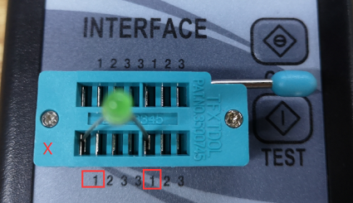The test pin couldn’t be stuck into the socket in same number like 1 and 1, 2 and 2, 3 and 3(like picture 3, 4 ,5 ), or it will lead to short circuit. Please stick it in different number such as 1 and 2, 1 and 3, 2 and 3.

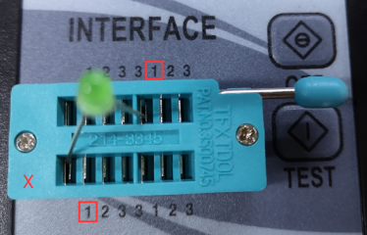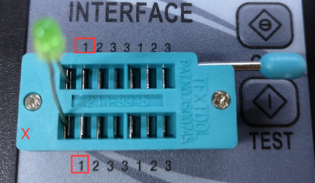

*Picture 3 Picture 4 Picture 5*

Discharge is required before testing the capacitor