Smart Camera Instruction

Download Yi IoT app

Scan QR code below | Search and download  Yi IoT app  In Google play  In App store

Sign up and log in
Select country or region
Account and password
Sign up

How to add camera
Click add button

How to connected with Wi-fi
Click WiFi connection

how to watch via hotspot
Step 1/5
Click Other ways to connect

Step 2/5

Click Hotspot Direct Watch

Step 3/5
Click to connect
Notice here

Step 4/5
In your phone system setting

Step 5/5
Back to app, connected

how to get online via hotspot
Step 1/3
Click Hotspot config to wifi

Step 2/3
Fill wifi password
Your phone is connected to wifi

Step 3/3
Pairing successful

How to connect with network cable
Step1/5
Click Network cable connect

Step2/5
Notice and click Next

Step3/5
Select device and Next
Step4/5
Waiting for pairing
Step 5/5
Success

How to use app
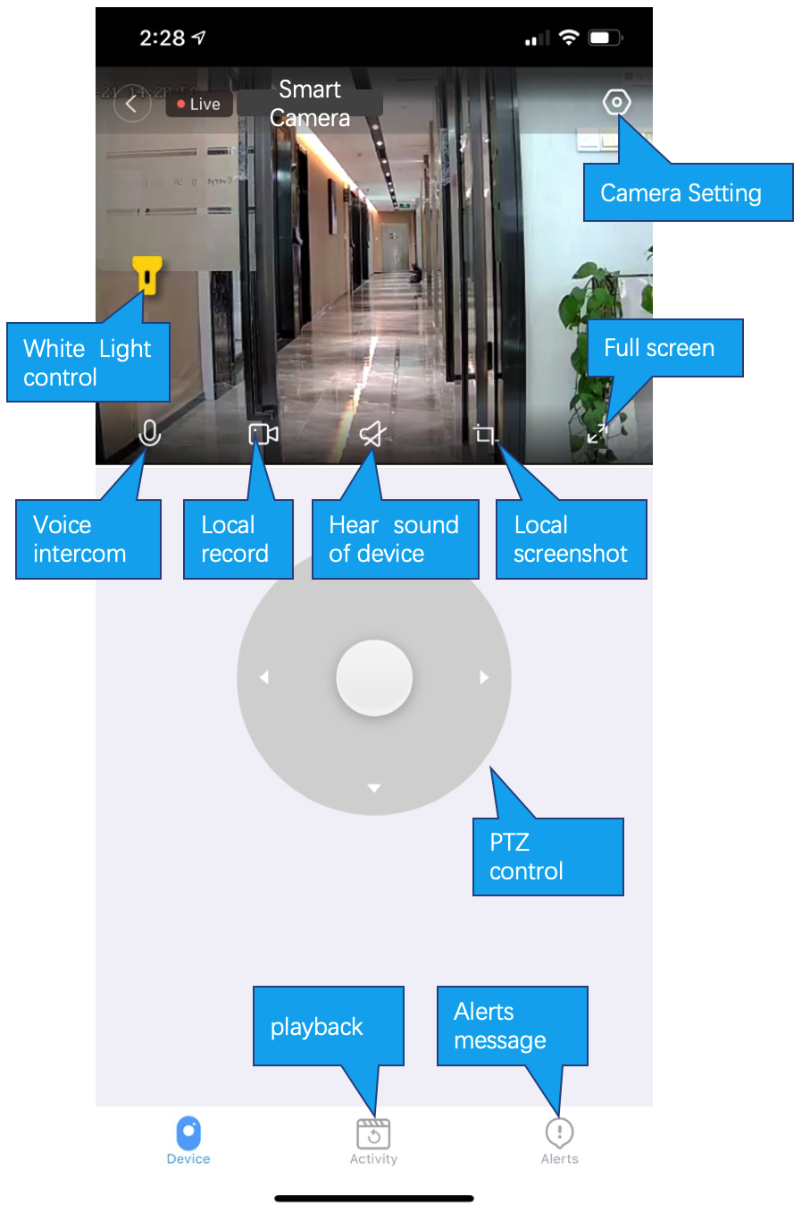

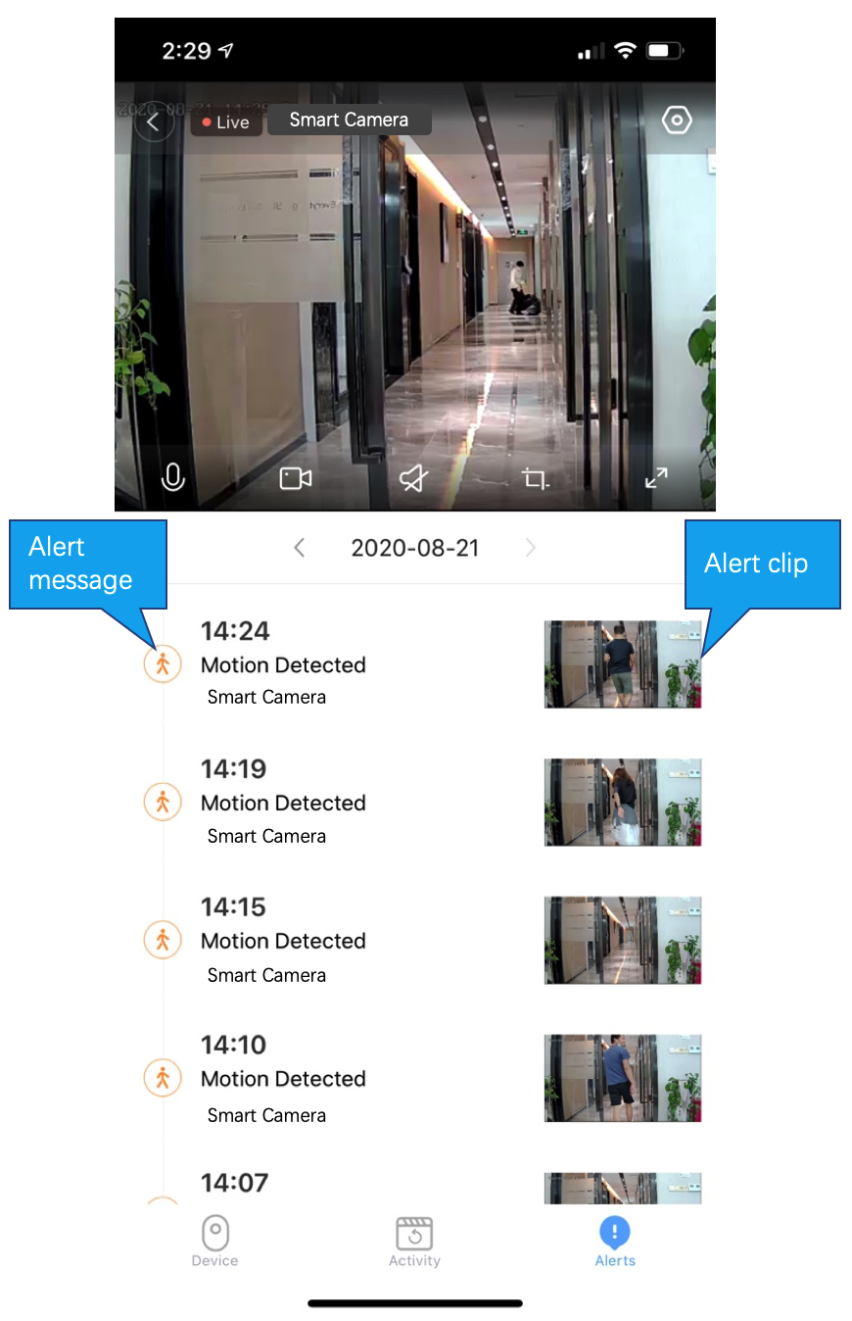
Alarm message
Live stream and play back

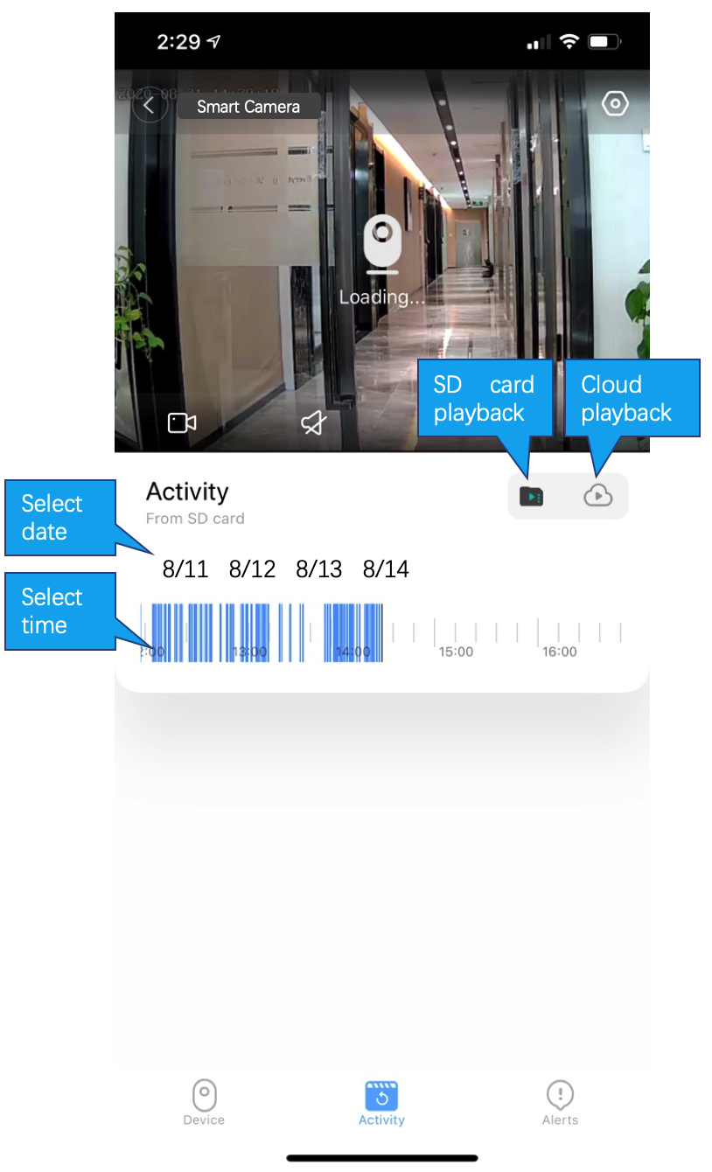

Cloud storage
Cloud storage subscription
Cloud storage subscription

Common problem
Q: The camera is offline or offline
- Check if the power supply is working properly
- Power off and restart the device to reconnect to the network
- The signal coverage is weak
- Signal interference shielding in special places
Q: How does the camera store video
- The camera supports the F32 format with a maximum capacity of 128G. After the card is recognized, it automatically records, and when the storage is full, it automatically overwrites the original recording and loops recording;
- Support opening cloud storage service to store video;

Special statement
The product is subject to the actual product, the instruction manual is for reference only
Mobile phone app and device firmware version support update, users can upgrade through the app.
The manual may contain technical descriptions or inconsistencies with product functions or typographical errors. Please understand, please refer to the final interpretation of our company.
Do not install the product in a place where it is damp, dusty, high temperature, flammable or explosive and out of reach of children.

