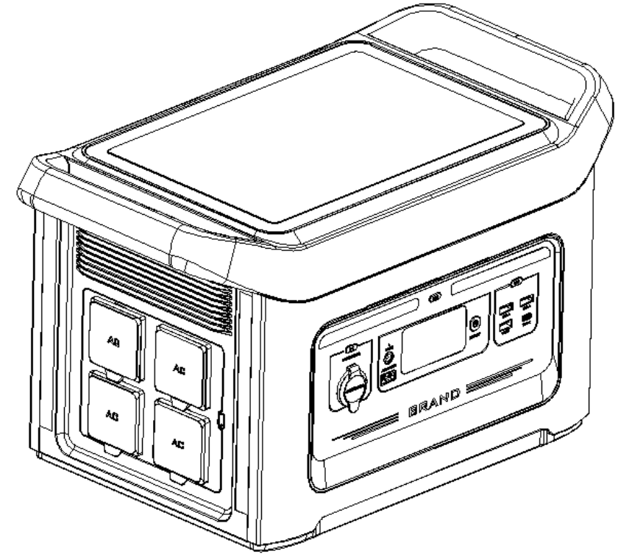

1500W Portable Power Station
user manual

Function Introduction
- Function definition on front panel
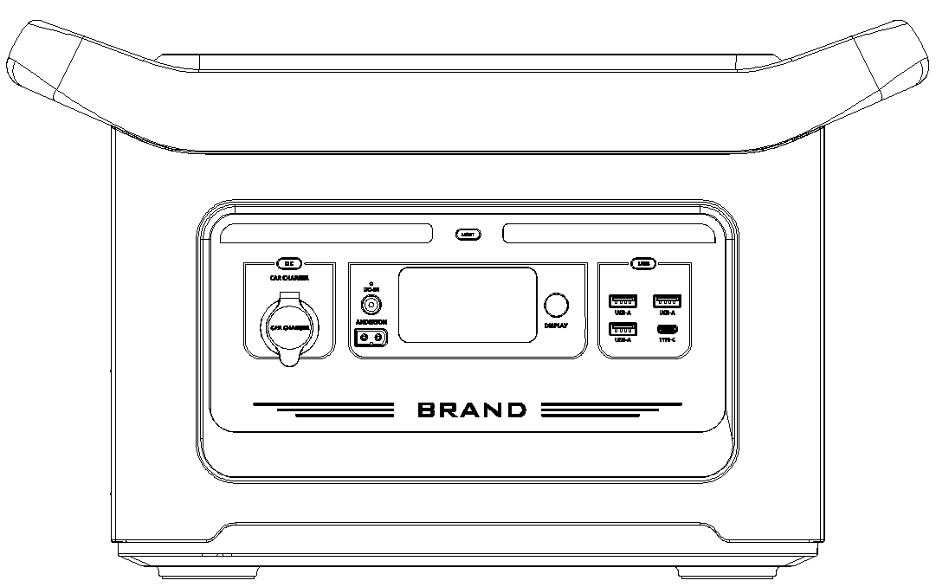
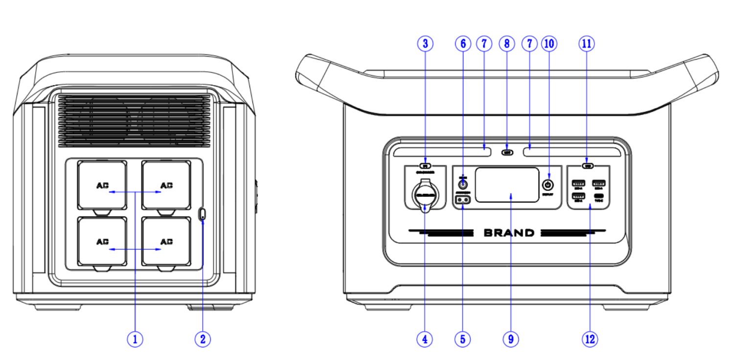

1 | AC output port | 2 | AC output button | 3 | Cigarette outlet socket output button
4 | Cigarette socket output | 5 | XT 60 fast charging port | 6 | 6530 DC charging port
7 | LED lighting | 8 | LED light illuminated button | 9 | display screen
10 | main power button | 11 | USB and Type-C output button | 12 | USB Type A and Type C output ports
2. LCD screen
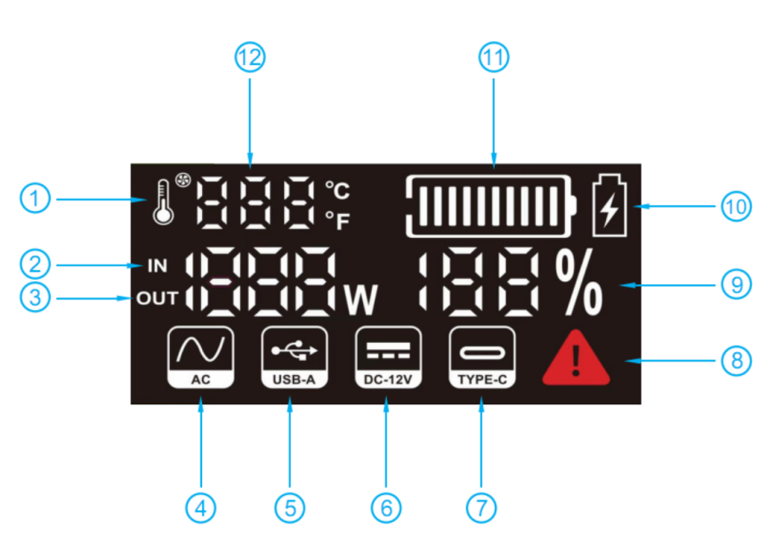
1 | Temperature and Fan icon | 7 |  | TYPE-C output
2 | input power | 8 |  | Temperature abnormality alarm
3 | Output Power | 9 |  | battery percentage
4 | AC switch indication | 10 |  | Fast charging logo
5 | USB - A output |  | 1 1 | battery column
6 | DC - 12V output _ |  | 1 2 | Cell temperature
Note: The display shows the remaining battery power. There are 10 partial signs , indicating 0 %~100% of the power . During use, the segment will disappear from the display to indicate the remaining charge . While charging, you will notice a battery segment flashing at 1 -second intervals , indicating that the battery is charging and displaying real-time charging power . Once it's fully charged, all battery segments will light up and stay steady .

Charging instructions
1. AC charger to charge the product ( Please use the standard AC charger included with the product )
6530 Port
XT 60 ports | 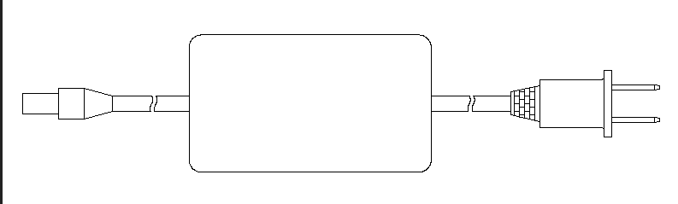 | 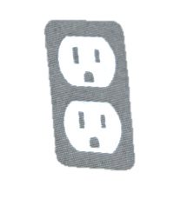
- Connect one end of the AC charger in the package to the 6530 DC port (as shown in the picture), and plug the other end into the socket to charge the product;
- Use the XT60 cable to connect one end to the XT60 port (as shown in the figure), and the other end needs to be inserted into a 24.5-25V (11A) DC power supply;
- takes about 7.5 hours to fully charge the product with the AC adapter . When charging is complete, unplug the charger.
Note: Simultaneous charging of 6530 terminal and XT60 terminal is not supported . During the charging process of this product, it is normal for the lead wire and the energy storage power supply to have slight heat. Make sure that the charging area is dry and free from flammable and explosive items, and it is forbidden to be covered by blankets. Make sure that the wiring is in good contact, otherwise the contact terminals may heat up severely, causing melting or ignition.
- Car charger to charge the product
6530 port
 | 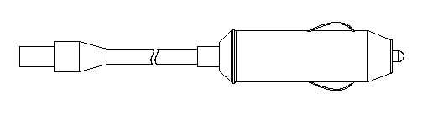 | 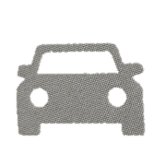
- the car charging cable to the 6530 DC port (as shown in the picture), and insert the other end into the cigarette lighter of the car, and charge the product after starting the car.
Note: It is normal for the lead wire and energy storage power supply to have slight heat during the charging process of this product. Make sure that the charging area is dry and free from flammable and explosive items, and it is forbidden to be covered by blankets. Make sure that the wiring is in good contact, otherwise the contact terminals may heat up severely, causing melting or ignition.

- Solar panels to charge the product
6530 port |  | 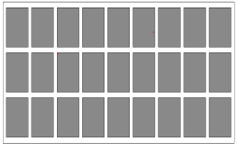
- Choose the right solar panel (DC 1 1 v~ 28 v/60w~200w) ;
- Place the solar panel under strong sunlight, with the front facing the sun;
- Take the solar charging cable, connect one end to the 6530 port of the product (as shown in the picture), and connect the other end to the solar panel;
- When the product is fully charged by the solar battery, it will automatically stop charging. Please remove the charging cable and turn off the product.
Note: It is normal for the lead wire and energy storage power supply to have slight heat during the charging process of this product. Make sure that the charging area is dry and free from flammable and explosive items, and it is forbidden to be covered by blankets. Make sure that the wiring is in good contact, otherwise the contact terminals may heat up severely, causing melting or ignition. Please charge in a temperature environment of 0~40 ℃ . The light intensity is different, and the charging time is different.
Operation Guide
1. Button operation
- main power button
Power on: Press and hold the " POWER " button for 3 seconds , the display will light up and the product will power on.
Power off: When the display is on, press and hold the " POWER " button for 5 seconds , the product and display will be turned off.
- DC power button
12V DC power on: Short press the "DC -OUT " button, the display "DC -OUT " indicator will light up, and the DC output is on. When the cigarette lighter output is over-current or short-circuit protected, the port output is closed , and the DC-OUT icon flashes to warn . Short press the "DC" button again after troubleshooting to turn on the 12V DC output again .
12V DC power supply off: Short press the "DC -OUT " button, the display "DC -OUT " indicator turns off, and the DC output is turned off.
- AC power button
AC power on: Long press the "AC" button, the display " AC-OUT " indicator will light up, and the AC output is on. When the AC output is over-current or short-circuit protected, the port output is closed , and the " AC-OUT " icon on the display screen flashes to warn . After troubleshooting, press and hold the "AC" button again to turn on the AC output again.
AC power off: Long press the "AC" button, the " AC-OUT " indicator on the display is off, and the AC output is turned off.
- USB power button
USB ON: Short press the "USB" button, the " USB " indicator light on the display will light up, and the USB is ON. When the USB output is over-current or short-circuit protected , the port output is closed, the USB output is closed, and the " USB " icon on the display screen flashes for warning . Short press the "USB" button again after troubleshooting to turn on the USB output again .
USB off: Short press the USB button, the display " USB " indicator is off, and the USB output is turned off.
- illuminated button
Lighting power on: Short press the "LED" button, the lighting will be highlighted in the first gear ; short press the "LED" button again, the lighting will be in the second gear ; short press the "LED" button again, the lighting will be in the The third gear flashes ; short press the "LED" button again, the lighting is in the fourth gear SOS ; short press the "LED" button again, the lighting will be turned off.
Lighting power off: In any gear, just press and hold for 2-3 seconds to turn off the lighting mode .

Note: When not in use, turn off these buttons to save power. Without any operation for a period of time, the display will automatically turn off after 5 minutes , and the system will enter sleep mode, and it will turn on again when the " POWER " button is long pressed . If the USB/light/cigarette port is turned on for 8 consecutive hours and the total system power is less than 5W , these outputs will be turned off to save power. After the AC is turned on, there is no load, and when the total system power is less than 5W (excluding the self-consumption power when the inverter is turned on) for 8 consecutive hours, it will automatically shut down to save power .
2. Connectable devices
- AC AC output port: notebook computers, cameras, display devices and other AC power supply working equipment
- USB output port: smartphones, MP3 players, digital cameras, e-readers, tablet computers, etc.
- Type-C PD protocol output port: mobile phones, laptops, tablets, etc.
- DC12V cigarette lighter output port: car 12V equipment
Instructions: a) DC output is suitable for most products on the market, some products may trigger over-current protection due to instantaneous high current; b) Please make sure that the connected electrical products can work normally before using this product ; c) The AC output can only supply power to electrical products with a power of less than 1500W , and the use of rated power above 1500W is not allowed (such as air conditioners, motors and other equipment that require instantaneous high power); d) After overload/short circuit protection, the output will stop automatically, if the output stops repeatedly, please stop using it immediately. At the same time, please contact the system installation and maintenance personnel, and you can continue to use it only after troubleshooting; e) Noise may occur when equipment such as radio or video players or televisions are connected to this product.
3. Estimated backup time
Time (H) approximate = 1400 Wh/ power consumed by load
Rice cooker ( 500W ) | 2.8 H | Laptop (AVR 24W) | 700H
Car refrigerator (65W) | 21.5 H | Electric blanket (60W) | 23H
Hand drill (300W) | 4.5 H | LED lighting ( 10W ) | 140H
IPHONE 14.5Wh 96 times
Note: The above data are for reference only. The standby time will vary with different load power.

4. Technical specifications
Battery specification
Battery |  | Battery type | LiFePO4
 |  | Battery capacity | 1400Wh
output
AC output | Rated voltage |  | 100~120Vac /220~240Vac 50/60HZ
 | rated power |  | 1500W
 | peak power |  | 1700W
 | Overload Threshold 1 |  | 1650 W ≤ load < 1750 W @ ≤10 S
 | Overload Threshold 2 |  | 1750 W≤ load< 2000 W@≤3S
 | Overload Threshold 3 |  | 20 00W ≥ load @ ≤200mS
AC output | Rated voltage |  | 100~120Vac 50/60HZ
 | rated power |  | 1200W
 | peak power |  | 1400W
 | Overload Threshold 1 |  | 1350 W ≤ load < 1450 W @ ≤10 S
 | Overload Threshold 2 |  | 1450W ≤ load < 1700 W @ ≤3 S
 | Overload Threshold 3 |  | 1700W≤ load @≤ 200mS
DC12V cigarette lighter port  output | Rated voltage |  | 12.5~13.9Vdc
 | rated current |  | 8A _
 | overcurrent protection |  | 11-12.5A _
3*USB output | Rated voltage |  | 5V-
 | Rated Current |  | 3A
 | overcurrent protection |  | 5.5-8A
Type-C  output | port protocol |  | PD3.0 (one-way can only discharge)
 | Rated output |  | 5V/3A, 9V/3A, 12V/ 3A , 15/3A , 20/3A
Input
6530 charging port | Input voltage |  | 12-29 Vdc
 | Input Current |  | Max 8 A _
 | charging power |  | Max 200W _
XT60 charging port | Input voltage |  | 24.5-25Vdc
 | Input Current |  | 10A
AC adapter | Input voltage |  | 100~240Vac
 | Input Current |  | Max 3.5 A
 | The output voltage |  | 27V _
 | Output current |  | MAX 8.5 A
MPPT solar charging | Input voltage |  | 15 ~ 29Vdc
 | Input Current |  | Max 8 A _
 | charging power |  | Max 200W
other
working environment |  |  | Humidity: 0% ~65 % RH
 |  |  | Temperature: 0 °C ~ 40 ° C
storage temperature |  |  | -20 ~ 60 ℃
size |  |  | 470*239*267(mm)
weight |  |  | About 17.8KG _ _
5. Storage and maintenance
- Fully charge the machine and turn off all power buttons before storing.
- If there is dirt on the surface of the product, wipe it with a damp cloth after wringing it out.
- Do not use gasoline, volatile oil, thinner, kerosene and other solvents that can dissolve resin for wiping.
- Store in a dry, dust-free place at a temperature between 0 and 40 °C, away from direct sunlight.
- Please charge the product at least every six months.
Instructions: Do not store in the car, in the trunk, on the loading table or in other high temperature places exposed to direct sunlight. This may cause product failure, degradation or thermal problems. When charging and discharging, make sure that the area around the power supply is dry and away from combustible objects.
6. Troubleshooting
If the product cannot charge or power other devices, please follow the steps below to check:
- Make sure the power button is turned on;
- Make sure the AC , DC, USB and Power buttons are turned on;
- Check the battery capacity, if it is lower than 10% , please charge the product as soon as required;
- Make sure that the connected load power does not exceed the rated power of this product, because each port has a maximum power limit.
7. Answers to questions
- How to check charging status?
The battery icon on the display shows the battery level and charging status.
- How to use this product to charge other electronic devices?
(1) Check the user manual or search for such information online to know the charging parameters of the electronic device.
(2) Check the power rating of each output port. For example, the maximum rated output power of the AC output port is 1500W, which means that the power of the connected electronic equipment cannot exceed 15000W for a long time , otherwise the AC output port will turn off the output.
- What is the depth of discharge?
In order to prolong the battery life, try not to set the power supply to 0% during use, and try to discharge it to 10 % to avoid battery damage due to excessive discharge.
- Can it charge and discharge at the same time?
Yes, the DC port can be charged and discharged at the same time ; the AC port cannot be charged and discharged at the same time . But it is not recommended to charge and discharge at the same time to protect battery life.
- 2 solar panels be charged in parallel?
Yes, just make sure the total output voltage (VOC) of the solar panel is less than 29 V. Otherwise, the charging overvoltage protection may be triggered or the product may be damaged.
- Can the AC output power a refrigerator or air conditioner?
Suitable for low power, not recommended to exceed 1500W(220-240Vac)/1200W(100-120Vac). The starting power of refrigerators and air conditioners is generally 5 to 7 times the rated power, which can easily trigger AC overload.
- Can I charge it immediately after using the AC output for a long time ?
No, it is recommended to wait for 5 to 10 minutes before charging
- Can two energy storage power supplies be used in parallel?
Cannot

Packing list
Before unpacking, please check whether the package is damaged, after unpacking, please check whether the appearance of the product is damaged or missing accessories
sequence | project | quantity
1 | 1500W Portable Power Station | 1
2 | AC adapter | 1
3 | car charging cable | 1
4 | solar charging cable | 1
5 | Product Manual | 1
6 | QC PASS certificate | 1

Warning
- Do not disassemble, repair or modify this product, otherwise it may cause dangers such as electric shock, overheating and fire.
- Do not place the product near the fire source, do not put it in the fire, and do not place it near flammable and explosive items, otherwise it will cause danger of fire or burns. When charging and discharging, make sure that the area around the power supply is dry and away from combustible objects.
- This product cannot be charged and used in dew, bathroom, rain and other places; do not wash the product with water, otherwise it will cause electric shock, heat, fire and other dangers.
- Do not touch the product or the connector plug with wet hands, as it may cause electric shock hazard.
- Do not touch the AC output connector with metal, it may cause electric shock, overheating, fire and other dangers.
- If the liquid in this product accidentally gets into the eyes, do not wipe the eyes easily. Rinse with plenty of water and seek medical attention immediately. It may cause blindness.
- Please do not dispose of it as general waste. There is a possibility of causing risks such as electric shock, heat generation and fire in the garbage collection vehicle.
- Do not use AC connections other than those specified. It may cause electric shock, shock, fever, fire, etc.
- Please confirm the rated specification of the connection interface, and do not exceed the specification when connecting the machine. It may cause electric shock, fever, fire, etc.
- Please do not use a hammer or drop it to cause strong impact on the product, which may cause electric shock, heat generation, fire or damage to the device.
- Do not place, store and use in places where it is easy to fall or fall (such as high shelves). It may cause electric shock, overheating, fire or damage, etc.
- Do not move the product while charging or in use. Due to vibration and shock during movement, it may cause heat generation, fire, electric shock or damage, etc.
- When using and storing, please keep the place clean. Powder or small metal contact terminals can cause accidents such as short circuits, smoke, or fire.
- Be sure to check before use. If there is any abnormality such as damage, cracks, leakage, heat generation, or broken AC line, please stop using it immediately.
- Be careful not to damage the AC power cord. For example, do not move the AC wire at random, do not unplug the AC wire from the input port, keep the AC wire away from heat sources, and do not step on or pull the AC wire, etc. These are the causes of AC wire damage, heat generation, fire, electric shock.
- Do not allow children to use this product. Or it may cause an accident or injury.
- Do not use if the connector is loose or deformed and cannot be fully inserted, otherwise it may cause electric shock, heat generation, fire, etc.
- Do not use in places with a lot of dust, it may cause smoke, fire, etc.
- Do not place in the car, trunk, carrier or other high temperature places exposed to direct sunlight, otherwise it may cause product failure, degradation or overheating.
- When the liquid in the product sticks to the skin or clothes, please rinse it with clean water immediately, otherwise it may cause skin damage, etc.
- In the event of a lightning strike during charging, remove the AC cable from the outlet.
When there is a thunderstorm, the large current generated from the socket may cause accidents such as heat generation, fire, fire, etc.
- Please charge within the specified voltage range, otherwise it may cause heat, damage, fire and other accidents.
- When using and storing, please do not place this product upside down or horizontally. Otherwise, it may cause leakage, overheating, fire and other accidents
- If there is any abnormality, please stop using it immediately. Such as rust, odor, fever, etc.
- The transportation of products should comply with the regulations on the transportation of dangerous goods stipulated by laws and regulations.
- When transporting the product by car, etc., secure the product so that it cannot be moved. Failure to do so may cause damage to the product, resulting in electric shock, heat generation, fire, etc.
- Do not allow this product and the AC cable to get wet with water or other liquids. It may cause short circuit, heat generation, fire, etc.
- Please charge, use and store this product within the range of 0 ~ 40 ℃ , otherwise it may cause poor performance or heat.
- In case of accidental drop and collision, the product itself may be damaged and cause electric shock, heat generation, fire, etc., please stop using it immediately. To prevent accidents, please contact the local designated system installation and maintenance personnel immediately.
- Please read carefully the operating instructions of the electrical product to be installed. If you are not familiar with the performance of the electrical product, misuse may cause accidents or injuries.
- Before connecting an electrical product, make sure that the product is stopped (power off), otherwise the electrical product may start suddenly and cause an accident or injury.
- During storage, be sure to turn off the main power button to prevent unnecessary discharge of the battery and to prevent electric shock.
Note: This equipment has been tested and found to comply with the limits for a Class B digital device, pursuant to Part 15 of the FCC Rules . These limits are designed to provide reasonable protection against harmful interference in a residential installation. This equipment generates, uses and can radiate radio frequency energy and, if not installed and used in accordance with the instructions, may cause harmful interference to radio communications. However, there is no guarantee that interference will not occur in a particular installation. If this equipment does cause harmful interference to radio or television reception, which can be determined by turning the equipment off and on, the user is encouraged to try to correct the interference by one or more of the following measures:
Readjust or place the receiving antenna.
Increase the separation between the equipment and receiver.
Connect the equipment into an outlet on a circuit different from that to which the receiver is connected.
Consult the dealer or an experienced radio / TV technician for help.

Instructions: Please read this manual and follow its instructions before use, and please keep this manual for future reference. Pay attention to fire prevention, rupture and high temperature when using this product. In order to use the product safely, there are clear pictorial labels attached, please refer to the pictorial instructions in this manual, and do not operate in violation of regulations.
 | Danger | Situations where improper operation may result in massive death or serious injury
 | warning | Situations where improper handling could result in death or serious injury
 | Notice | Improper operation may cause personal or property damage
Warning: Due to product improvement, some changes in appearance and specifications may be made without prior notice.
● It is for personal use only, and this manual cannot be reproduced without permission.
● If the product needs maintenance, please contact the designated local system installation and maintenance personnel.
Disclaimer
● The company is not responsible for any damage caused by force majeure such as fire, typhoon, flood, earthquake, etc. or by the customer's intentional negligence, misuse or use under other abnormal circumstances
● Defects caused by non-standard connectors will not be compensated.
● The company is not responsible for any damages caused by failure to operate the product in accordance with the operating instructions.
● This product is not suitable for nuclear energy equipment, aerospace equipment, transportation equipment, medical equipment, etc. that involve personal safety, or equipment that relies heavily on uninterruptible power supplies must be guaranteed. Assuming that the product is used in the above-mentioned equipment or machines, the company is not responsible for any personal accidents, fire accidents or failures caused by product failures.

