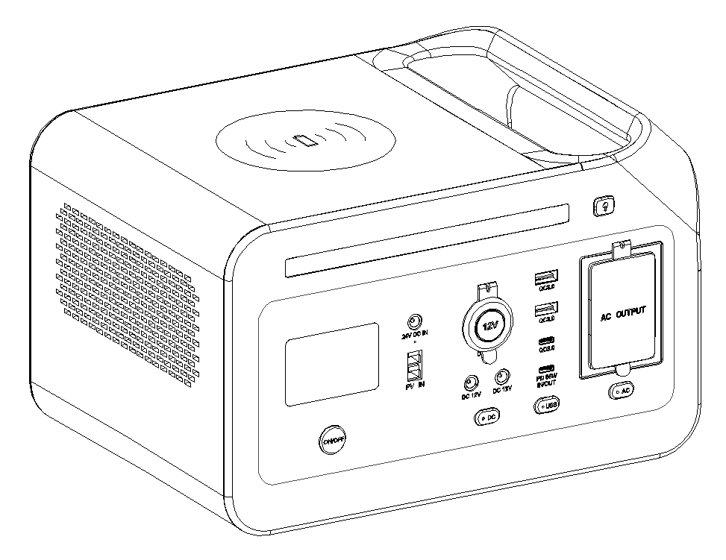

600W Portable Power Station
User Manual

Function Introduction
1、Function definition on front panel
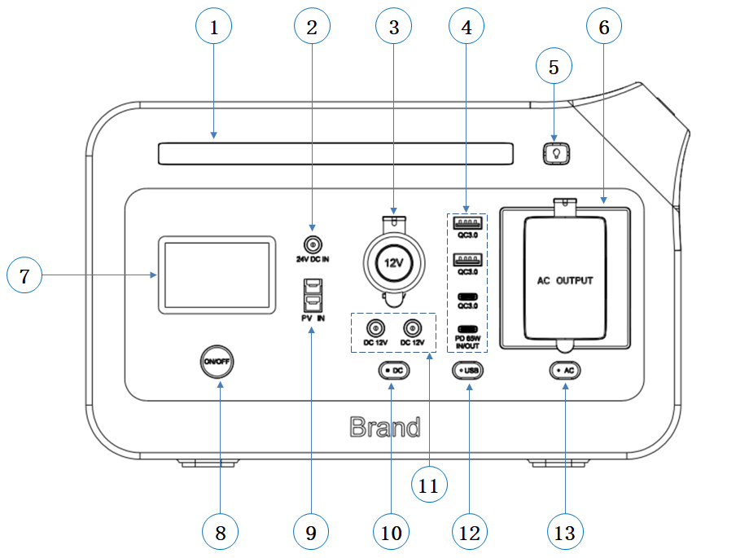

1 | 5525 DC charging input port | 8 | Main power button
2 | LED light | 9 | Anderson charging input port
3 | Cigarette lighter socket | 10 | DC 12V output button
4 | USB-A and USB-C output port | 11 | DC 12V output port
5 | LED light button | 12 | USB and Type-C output button
6 | AC output port | 13 | AC output button
7 | LCD Screen
2、LCD Screen
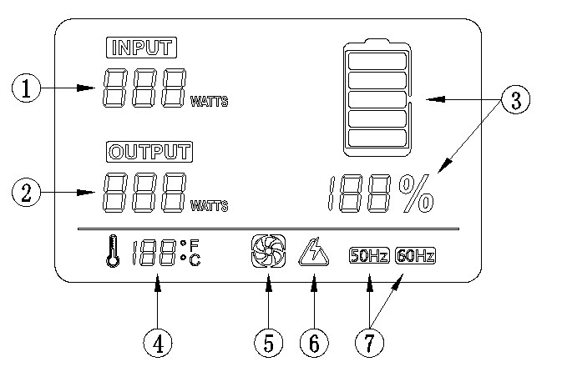
1 | Input charging power | 5 | Fan icon
2 | Output power | 6 | Protection icon
3 | Battery capacity indicator | 7 | AC output frequency
4 | Internal temperature
Note: The LCD screen shows the remaining battery power. There are 5 partial segments, which are about 20%~40%~60%~80%~100% of the capacity. During using, the display segment will disappear from the display, indicating the remaining power. When charging, you will notice that a battery segment flashes at 1 second intervals, which means that the battery is charging and the real-time charging power is displayed. Once it is fully charged, all battery segments will light up and remain stable.
Charging Instruction
- AC charger to charge the product(Please use the standard AC charger included with the product)
DC5525 Input port

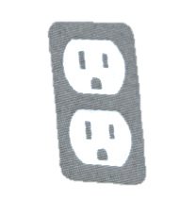
- Use the AC charger in the package to connect with DC5525 Input Port of the product as shown in the figure, and plug the other end into the socket to charge.
- It takes about 2.5 hours to fully charge the product using the AC adapter. After charging is complete, please unplug the charger.
Note: It is normal for this product to generate heat during charging. Make sure that the wiring is in good connection, otherwise the connection terminal may become severely heated and cause melting or ignition.
2、Car charger to charge the product
DC5525 Input port

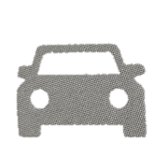
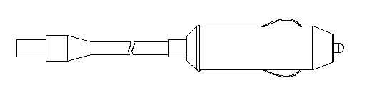
- Use the car charger to Connect with DC5525 Input Port of the product as shown in the figure, and plug the other end into the cart’s cigarette lighter port, to start the car to charge.
- Charge the product after starting the car.
Note: It is normal for this product to generate heat during charging. Make sure that the wiring is in good connection, otherwise the connection terminal may become severely heated and cause melting or ignition.
3、Solar panels to charge the product
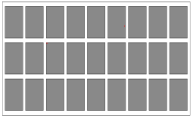
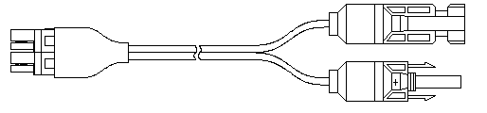
Anderson Input port

- Choose a suitable solar panel (DC 11v~28v/60w~200w).
- Place the solar panel under strong sunlight and face the sun.
- Take solar charging cables to connect solar panel with the Anderson Input Port of the product as shown in the figure to charge.
- When the product is fully charged by the solar panel, it will automatically stop charging. Please take out the charging cable and turn off the product.
Note: It is normal for this product to generate heat during charging. Please make sure that the positive and negative poles of the solar panel are connected correctly and the wiring is in good connection, otherwise it will cause serious heat generation in the joints, high temperature and fire. Please charge in a temperature environment of 0~40℃. The light intensity is different, and the charging time is different.
Operation Guide
1、Button operation
- Main power button
Turn on the machine: Press the "ON/OFF" button for 2 seconds, the LCD screen lights up, and the product turns on.
Power off: When the LCD is on, press and hold the "ON/OFF" button for 2 seconds, the product and the LCD screen will turn off.
- DC power button
Turn on the 12V DC power supply: Short press the "DC" button, the DC indicator will light up in green, the LCD will display "OUTPUT", and the DC output will be turned on. When the indicator light is red (in over-current and short-circuit protection status, the indicator is red), the DC output is turned off. After removing the fault, short press the "DC" button again to restart the 12V DC output.
Turn off the 12V DC power supply: Short press the "DC" button, the green indicator light will go out, the display will not show the "OUTPUT", and the 12V DC output will be turned off.
- AC power button
AC power on: Short press the "AC" button, the AC indicator will light green, the LCD will display "OUTPUT", and the AC output is on. When the indicator light is red (protection status), the AC output is turned off. After removing the fault, short press the "AC" button again to restart the AC output.
AC power off: Short press the "AC" button, the green indicator light goes out, the LCD does not display the "OUTPUT", and the AC output is turned off.
- USB power button
USB on: Short press the "USB" button, the USB indicator will light green, the LCD will display "OUTPUT", and the USB is on. When the indicator light is red (protection status), the USB output is turned off. After the fault is resolved, short press the "USB" button again to restart the USB output.
USB off: Short press the USB button, the green indicator light goes out, the LCD does not display "OUTPUT", and the USB output is turned off.
- Lighting button
Lighting power on: Press the "LED" button for 1 second, the lighting will light up at the first brightness level; short press the "LED" button, and the lighting will be at the second brightness level; short press the "LED" button again, the lighting is at the third brightness level; short press the "LED" button again, the lighting is at the fourth brightness level, and the lighting flashes intermittently; press the LED" button for 1 second, the lighting will turn off.
Lighting power off: No matter what brightness level the lighting brightness is at, keep pressing the "LED" button, the lighting will be turned off.
- Combination button
Temperature unit switch: Press the "USB" button and "LED" button at the same time until the temperature unit icon on the LCD screen is switched, and the switch is completed.
AC output frequency switching: When the AC is off, press the "AC" button and the "LED" button at the same time until the LCD screen displays 50HZ or 60HZ to complete the conversion, and then turn on the AC output, the output frequency will be on the screen show.
Note: When not in use, turn off these buttons to save power. If you do not perform any operation for a period of time (no output indicator is on), the LCD screen will automatically turn off after 100 seconds, and the system will enter sleep mode. It will turn on again when you short press the "ON/OFF" button. If 12VDC or USB or AC output is not connected to the load within 24 hours, these outputs will be turned off to save power.
2、Connectable devices
- AC output ports: laptops, cameras, display devices and other equipment powered by AC power
- USB output ports: smart phones, MP3 players, digital cameras, E-book readers, etc.
- Type-C PD output ports: mobile phones, laptops, tablets, etc.
- DC12V 5521 output port: 12V electronic devices.
- DC12V cigarette lighter output port: vehicle-mounted 12V devices and some other 12V devices.
Note: a) DC output is suitable for most products on the market, some products may trigger over-current protection by instantaneous high current; b) Before using this product, please make sure that the connected electrical product can work normally; c) AC output can only be used for electrical products with power lower than 600W, rated power above 600W is not allowed (such as air conditioners, motors and other device requiring instantaneous high voltage); d) After overload/short circuit protection, the output will automatically stop. If the output stops repeatedly, please stop using it immediately. At the same time, please contact the system installation and maintenance personnel. Only after troubleshooting, can you continue to use it; e) Noise may occur when radio or video players or TVs are connected to this product.
3、Estimated running time
Time（H）approx. = 480Wh ÷ Load power consumption
Rice cooker（500W） | 0.9H | Laptop（AVR 24W） | 20H
Car refrigerator（65W） | 7H | Electric blanket（60W） | 6H
Hand Electric drill（300W） | 1.5H | LED light（10W） | 45H
IPHONE 14.5Wh charging for 30 times
Note: The above data is for reference only. The standby time will vary due to different load powers.
4、Technical specification
Output
AC output | Rated voltage |  | 100~120Vac
 | Rated power |  | 600W
 | Peak power |  | 1200W
 | Overload protection 1 |  | 680W≤ load <800W@10S
 | Overload protection 2 |  | 800W≤ load <1200W@3S
 | Overload protection 3 |  | 1200W≥ load @200mS
DC12V cigarette lighter output | Rated voltage |  | 11~13Vdc
 | Rated current |  | 10A
DC12V 5521  output | Rated voltage |  | 11~13Vdc
 | Rated current |  | 5A
USB output | Port protocol |  | QC3.0、QC2.0、FCP、AFC、BC1.2、APPLE2.4A
 | Rated output |  | 5V/3A、9V/2A、12V/1.5A
Type-C  output | Port protocol |  | QC3.0、QC2.0、FCP、AFC、BC1.2、APPLE2.4A
 | Rated output |  | 5V/3A、9V/2A、12V/1.5A
Type-C IN/OUT  output | Port protocol |  | PD3.0（bidirectional、PD 60W）
 | Rated output |  | 5V/3A、9V/3A、12V/3A、15V/3A、20V/3A
Input
AC charger charging | Input voltage |  | 24V
 | Charging power |  | 200W Max.
Anderson MPPT solar charging | Input voltage |  | 11~28Vdc
 | Charging power |  | 200W
Type-C input charging | Input voltage |  | 5~20Vdc
 | Charging power |  | PD 60W
AC charger + Type-C charging | Charging power |  | 200W + 60W = 260W
Others
Working environment |  | Humidity：10%~90%RH
 |  | Temperature：0~40℃
Size |  | 279mm*200mm*174mm
Net Weight |  | 5.9KG
5、Storage and maintenance
- Before storing, fully charge the product and turn off all power buttons.
- If there is dirt on the surface of the product, use a damp cloth to wring it out and wipe it clean.
- Do not use solvents that can dissolve resin, such as gasoline, volatile oil, thinner, and kerosene, for wiping.
- Store in a dry, dust-free place, at a temperature of 0-40°C, and avoid direct sunlight.
- Please charge the product at least once every six months.
Note: Do not store in a car, trunk, stage or other high-temperature places exposed to direct sunlight. This may cause product failure, degradation, or heat generation issues.
6、Troubleshooting
If the product cannot charge or power other devices, please follow the steps below to check:
- Make sure that the power button is turned on;
- Make sure that the AC and DC power buttons are turned on;
- Check the battery capacity, if it is lower than 10%, please charge the product as soon as required;
- Ensure that the connected load power does not exceed the rated power of this product, because each port has a maximum power limit.
7、Frequently Asked Questions
- How to check the charging status?
The battery icon on the LCD screen shows the battery level and charging status.
- How to use this product to charge other electronic devices?
(1) Check the user manual or search for such information online to understand the charging parameters of electronic devices.
(2) Check the rated power of each output port. For example, the maximum rated power of the AC output port is 600W, which means that if the rated power of the connected electronic device exceeds 600W for a long time, the inverter will shut down the output.
- What is the depth of discharge (DOD)?
In order to extend the battery life, the DOD of the product is set to 90%, which means that 90% of the battery capacity can be discharged, and 10% is reserved to avoid battery damage caused by over-discharge.
- Can it be charged and discharged at the same time?
Yes, the DC output port can discharge when be charged; the AC output port cannot discharge when be charged. But it is not recommended to charge and discharge at the same time to protect the battery life.
- Can I use 2 solar panels to charge in parallel?
Yes, make sure that the total output voltage (VOC) of the solar panel is less than 28V. Otherwise, the charging overvoltage protection may be triggered or the product may be damaged.
- How to extend the use time of CPAP?
It is recommended to turn off its humidifier and heater and set a lower pressure.
- Can the AC output power the refrigerator or air conditioner?
Suitable for low power, it is not recommended to exceed 200W. The starting power of refrigerators and air conditioners is generally 5 to 7 times the rated power, which can easily trigger AC overload.
- Can it be charged immediately after using the AC output for a long time?
No, it is recommended to wait for 5-10 minutes before charging.
- Can two Portable Power Stations be used in parallel?
No.
Packing list
Please check whether the package is damaged before unpacking, and check whether the appearance of the product is damaged or lack of accessories after unpacking
No. | Item | Quantity
1 | 600W Portable Power Station | 1
2 | AC Charger | 1
3 | Car charger | 1
4 | Solar Charging cable (MC4 to Anderson) | 1
5 | User manual | 1
6 | QC PASS certificate | 1

Warning
- Do not disassemble, repair or modify this product, otherwise it may cause electric shock, heat generation, fire and other hazards.
- Do not place the product near the fire source or in the fire or heat, otherwise it may cause fire or burns and other dangers.
- This product cannot be charged and used in places such as dew, bathroom, rain, etc.; do not wash the product with water, otherwise it will cause dangers such as electric shock, heat, and fire.
- When your hands are wet, do not touch the product or the connector plug, which may cause electric shock.
- Do not use metal to contact the AC output interface, it may cause electric shock, heat generation, fire and other hazards.
- If the liquid in this product accidentally enters your eyes, do not wipe your eyes lightly. Please rinse with plenty of water and seek medical attention immediately. It may risk blindness.
- Please do not dispose of it as general waste. There may be risks of electric shock, heat generation, and fire in the garbage collection truck.
- Do not use AC connections other than those specified. It may cause electric shock, shock, fever, fire, etc.
- Please confirm the rated specifications of the connection interface, and do not exceed the specifications when connecting to the machine. It may cause electric shock, fever, fire, etc.
- Do not use a hammer or drop it to cause a strong impact on the product, which may cause electric shock, heat generation, fire or equipment damage.
- Do not place, store and use in places where it is easy to fall or fall (such as high shelves). It may cause electric shock, heat generation, fire or damage.
- Do not move the product while charging or using it. Due to the vibration and impact during the movement, it may cause heat generation, fire, electric shock or damage.
- When using and storing, please keep the place clean. Powder or small metal contact terminals may cause accidents such as short circuit, smoke or fire.
- Be sure to check before use. If there is any abnormality such as damage, cracks, leakage, heat, AC line break, etc., please stop using it immediately.
- Please pay attention to the operation so as not to damage the AC power line. If you do not move the AC power cord at will, do not unplug the AC power cord from the input port, keep the AC power cord away from heat sources, and do not step on or pull the AC power cord. These are the causes of damage to AC wires, heat generation, fire, and electric shock.
- Do not let children use this product. Or it may cause an accident or injury.
- If the interface is loose or deformed and cannot be fully inserted, do not use it, otherwise it may cause electric shock, heat generation and fire.
- Do not use in dusty places, it may cause smoke, fire, etc.
- Do not place it in a car, trunk, stage or other high-temperature places exposed to direct sunlight, otherwise it may cause product failure, degradation or heat generation.
- When the liquid in the product sticks to the skin or clothes, please rinse it with clean water immediately, otherwise it may cause skin damage.
- When a lightning strike occurs during charging, remove the AC cable from the socket. When thunder, the large current generated from the socket may cause heat generation, fire, fire and other accidents
- Please charge within the specified voltage range, otherwise it may cause heat generation, damage, fire and other accidents.
- When using and storing, please do not put this product upside down or horizontally. Otherwise, it may cause leakage, heat generation, fire and other accidents
- If there is any abnormality, please stop using it immediately. Such as rust, peculiar smell, fever, etc.
- The transportation of the product shall comply with the regulations on the transportation of dangerous goods stipulated by laws and regulations.
- When using a car to transport the product, please fix the product so that it cannot be moved. Otherwise, the product may be damaged, resulting in electric shock, heat generation, fire, etc.
- Do not let this product and AC cable get wet with water or other liquids. It may cause short circuit, heat generation, fire, etc.
- Please charge, use and store this product within the range of 0~40℃, otherwise it may cause poor performance or heat generation.
- If you accidentally drop or collide, it may damage the product itself and cause electric shock, heat generation, fire, etc., please stop using it immediately. To prevent accidents, please contact the local designated system installation and maintenance personnel immediately.
- Please carefully read the operating instructions of the electrical product to be installed. If you are not familiar with the performance of the electrical product and incorrectly operate it, it may cause accidents or damage.
- Before connecting electrical products, please ensure that the products are stopped (power off), otherwise the electrical products may start suddenly and cause accidents or injuries.
- During storage, be sure to turn off the main power button to prevent unnecessary discharge of the battery and prevent electric shock.

Note：This equipment has been tested and found to comply with the limits for a Class B digital device, pursuant to Part 15 of the FCC Rules. These limits are designed to provide reasonable protection against harmful interference in a residential installation. This equipment generates, uses and can radiate radio frequency energy and, if not installed and used in accordance with the instructions, may cause harmful interference to radio communications.

However, there is no guarantee that interference will not occur in a particular installation. If this equipment does cause harmful interference to radio or television reception, which can be determined by turning the equipment off and on, the user is encouraged to try to correct the interference by one or more of the following measures:

Reorient or relocate the receiving antenna.
Increase the separation between the equipment and receiver.
Connect the equipment into an outlet on a circuit different from that to which the receiver is connected.
Consult the dealer or an experienced radio/TV technician for help.

Note: Please read this manual and follow its instructions before use. At the same time, please keep this manual for future reference. When using this product, pay attention to fire prevention, cracking, and high temperature. In order to use the product safely, a clear graphic label is attached. Please refer to the graphic description in this manual and do not operate in violation of regulations.
 | DANGER | A situation in which improper operation may cause a large number of deaths or serious injuries
 | WARNING | Circumstances that may cause death or serious injury to personnel due to improper operation
 | ATTENTION | Improper operation may cause personnel or property damage
Warning: Due to product improvements, some changes in appearance and specifications may be made without prior notice.
● It is for personal use only, and this manual is not allowed to be copied without permission.
● If the product needs maintenance, please contact the local designated system installation and maintenance personnel.
Disclaimer
● The company is not responsible for any damage caused by force majeure such as fire, typhoon, flood, earthquake, or the customer's deliberate negligence, misuse, or use under other abnormal conditions.
● Defects caused by non-standard connectors will not be compensated.
● The company does not assume any responsibility for damage caused by operating the product not in accordance with the operating instructions.
● This product is not suitable for nuclear energy equipment, aerospace equipment, transportation equipment, medical equipment, etc. that involve personal safety, or equipment that relies heavily on uninterruptible power supplies must be guaranteed. Assuming that the product is used in the above-mentioned equipment or machinery, the company is not responsible for any personal accidents, fire accidents or malfunctions caused by product failures.

