**User manual**

MT13S Thermal Imaging Multimeter

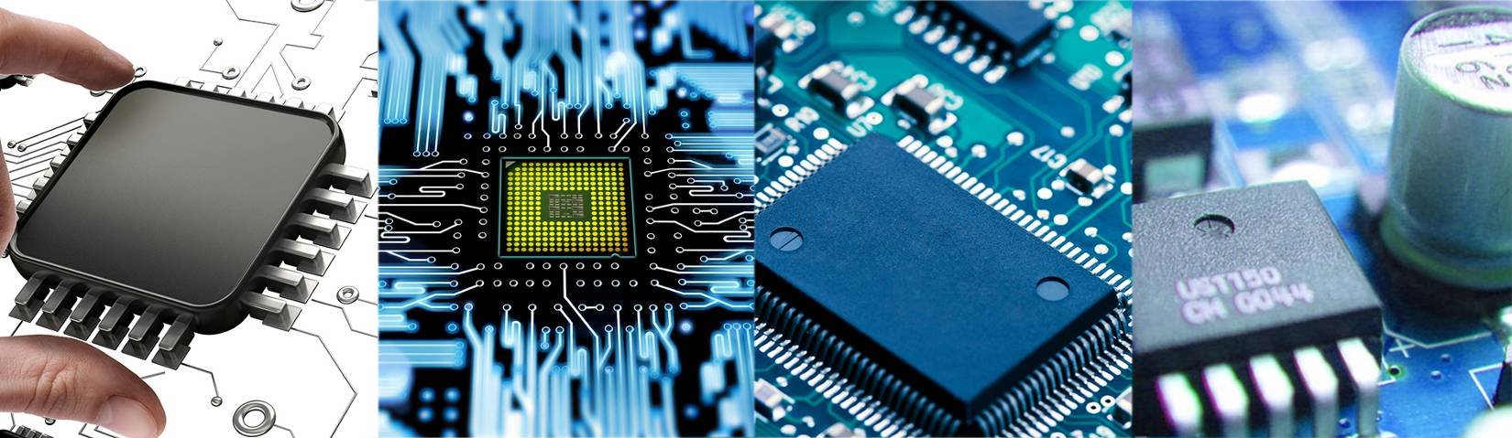Quick Start User Manual

**Rev1.1 December 2023**

Catalogue

Ⅰ、Safety instructions--------------------------- -4

Ⅱ、 Technical Features--------------------------- 5

Ⅲ、 Product Appearance Description ---------6

Ⅳ、 Thermal imaging operation instructions7

Ⅴ、 Multimeter Operation Instructions ------8

Ⅵ、 System Settings Description -------------11

Ⅶ、 Upper computer usage -------------------13

Ⅷ、 Technical indicators -------------------------14

* **Ⅰ、 Safety instructions**
* **To prevent potential electric shock, fire, or personal injury, and to ensure safe operation of this product:**
* **Before using the product, please read all safety instructions.**
* **Do not modify this product and only use it for designated purposes, otherwise it may weaken the protective function provided by this product.**
* **When the low battery indicator is displayed, please replace the battery to prevent incorrect measurement.**
* **If the product is working abnormally, please do not use it.**
* **If the product has been modified or damaged, please do not use it.**
* **For actual temperature, please refer to emissivity information. Reflective objects can cause the measured temperature to be lower than the actual temperature. These objects pose a risk of burns.**
* **Do not place the battery and battery pack near heat or fire sources. Please do not expose to sunlight.**
* **Do not disassemble or squeeze the battery and battery pack. Batteries contain hazardous chemicals that may cause burns or explosions. If in contact with chemicals, please wash with water or seek medical attention.**
* **If the product is not used for a long time, please remove the battery to prevent battery leakage and damage to the product.**
* **Keep the battery and battery pack clean and dry. Clean the joints with a dry and clean cloth.**
* **If there is a battery leak, please repair this product before use.**
* **If the rechargeable battery becomes hot during charging (>50 ℃), it is necessary to disconnect the battery charger and move the product or battery to a cool, non flammable location.**
* **Do not put metal objects into the joint.**
* **Please have authorized technicians repair the product.**

**To avoid electric shock, be sure to unplug the probe before disassembling the battery, connecting USB, charging, or disassembling the case.**

Table 1 lists the symbols used on the thermal imager or in this manual.

Table 1 symbol

|  |  |  |  |
| --- | --- | --- | --- |
| Symbol | Illustrate | Symbol | Illustrate |
| 警告 | Warning, danger |  | Data retention prompt |
| 高电压 | Warning, dangerous voltage. Electric shock hazard |  | Automatic range prompt |
| AUTO | Automatic gear measurement | NCV | Non contact AC voltage measurement |
| LIVE | Live recognition of live lines |  | Temperature measurement |
| V/AC | AC voltage measurement |  | Waveform recording icon |
| V/DC | DC voltage measurement |  | Screenshot icon |
|  | Resistance measurement |  | Delete icon |
|  | Diode, PN junction forward voltage drop measurement |  | Format storage icon |
|  | Circuit on/off measurement |  | System settings icon |
|  | Capacitance measurement |  | Return icon |
| Hz % | Frequency and duty cycle measurement |  |  |

**Ⅱ、 Technical characteristics**

**1. Small in size, lightweight, and convenient to carry.**

**2. Thermal imaging images can be saved; The image can be viewed locally.**

**3. Thermal imaging images can be combined with computer software to achieve temperature reproduction function.**

**4. Multimeter measurement can achieve data waveform storage function; Combined with computer software, waveform reproduction function can be achieved.**

**5. Automatic gear measurement function. It can automatically recognize input signals (such as resistance, AC/DC voltage, on/off function, etc.).**

**6. The multimeter has functions such as DC voltage, AC voltage, resistance, diode, on/off, capacitance, temperature, NCV (contactless measurement), LIVE (zero live wire recognition), etc.**

**7. The maximum reading displayed on the multimeter is 9999;**

**8. Simulate pointer bar display.**

**9. Multimeter polarity display: automatic.**

**10. Multimeter range: automatic or manual.**

**11. The multimeter updates approximately 3 times per second.**

**12. Data dual display. Display frequency when measuring voltage, and display ambient temperature value when measuring other signals.**

**13. Support simulating USB drives for software upgrades.**

**14. Internal power isolation of equipment to prevent electric shock.**

**15. Touch screen operation, the function is achieved with just one click.**

**16. Chinese, English, and German can be set.**

**17. Powered by lithium batteries, supports USB charging.**

**18. Automatic screen rest and automatic shutdown function.**

**Ⅲ、Product appearance description**1.

1.Instrument front

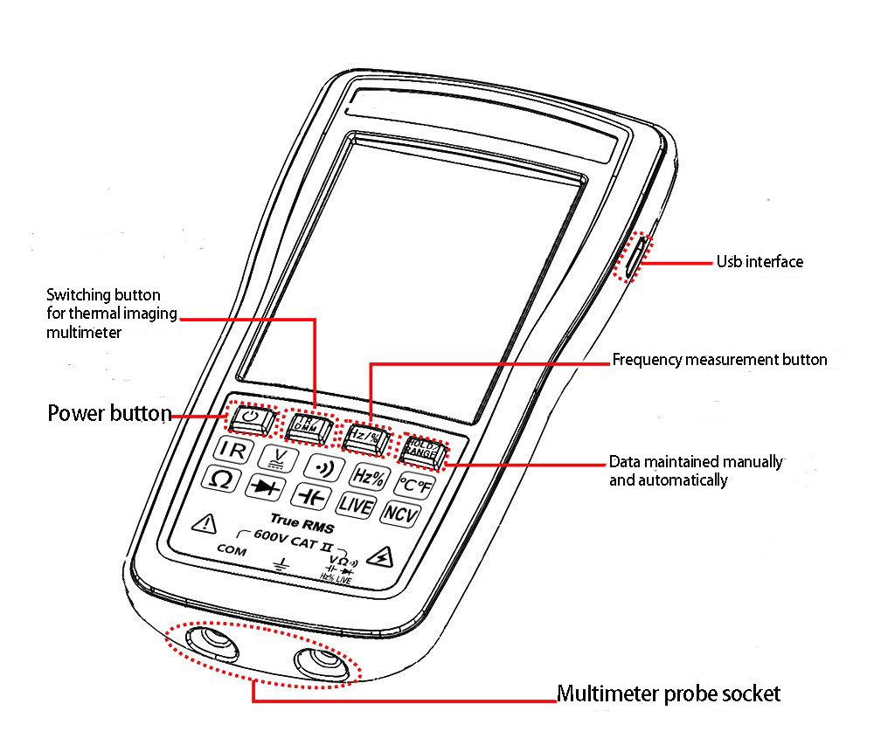

2. On the back of the instrument

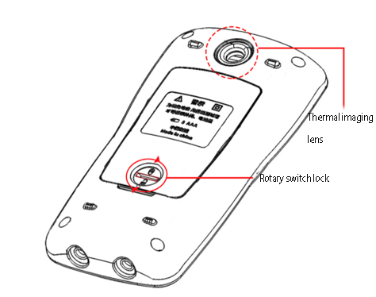

### Ⅳ、Thermal imaging operation instructions

**The thermal imaging interface has measurement functions such as center temperature, maximum temperature, and minimum temperature, and displays the measurement data of the multimeter (default to automatic gear, which can automatically recognize signals such as voltage, resistance, and on/off). The following figure shows the functional description of the thermal imaging interface.**

Note: The larger the temperature difference, the better the display effect.

Note: It is normal for the interface to stutter and hear a "click" mechanical sound during measurement. Thermal imaging is sensitive to changes in ambient temperature, and internal movement temperature changes can cause inaccurate measurement temperature and blurry images. Therefore, automatic calibration will be performed internally.

Note: Inaccurate measurement gear settings may result in blurry images. It is possible to estimate the approximate temperature of the object being measured and set the temperature measurement gear accordingly.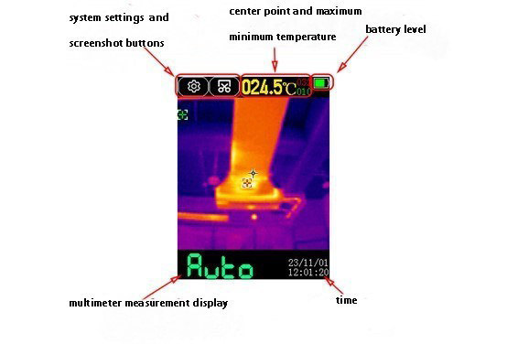

#### Figure 1

#### 1.Screenshot saving function

#### Click the "screenshot button" in the upper left corner of the screen, and a save prompt box and progress bar will appear in the center of the screen. After the progress bar is completed, the prompt box will automatically disappear and the screenshot save is completed. To view the screenshot file, you can click the "System Settings" button in the bottom left corner to enter the system settings interface, and then click the "Storage" menu to view the saved content.

#### 2. Temperature measurement

#### Mobile devices can move the crosshairs in the center of the screen to the object being tested to measure the current temperature of the object; The temperature pseudo color can be selected in the system settings to suit your preferences.

#### 3. Emission rate change

#### Click the system settings button in the upper right corner to enter the settings menu ->thermal imaging interface to change emissivity. The default emissivity is 0.95, which can be set according to the measured object.

#### 4.Temperature gear switching

#### Click the system settings button in the upper right corner to enter the settings menu ->thermal imaging interface to change the temperature level. The default gear is the automatic gear, which can be switched according to the temperature range of the object being tested. The high temperature gear is suitable for measuring objects between 100-550 ℃, and the low temperature gear is suitable for measuring objects between -20-150 ℃.

#### In automatic mode, it is normal for the screen to lag for 2-3 seconds when the temperature of the measured object switches from low temperature to high temperature or from high temperature to low temperature.

### Ⅴ、Multimeter operation instructions

The multimeter has data measurement functions such as automatic gear, DC voltage, AC voltage, resistance, diode, on/off, capacitance, temperature, NCV, LIVE, frequency, duty cycle, etc. It can perform automatic gear measurement, manual gear measurement switching (default automatic gear), and hold data storage functions. It also has a powerful data waveform recording function, which can be combined with upper computer software to achieve voltage waveform reproduction function.（Note: To avoid electric shock, please remove the probe before connecting the USB device. The multimeter function will be disabled during charging）

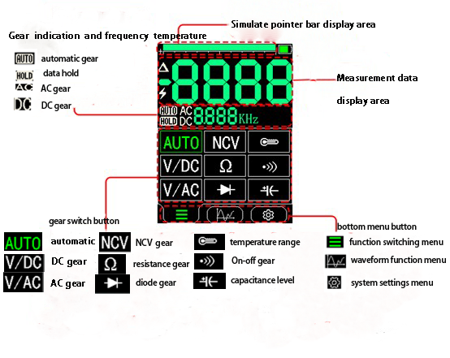

Figure 2（Multimeter Interface Description）

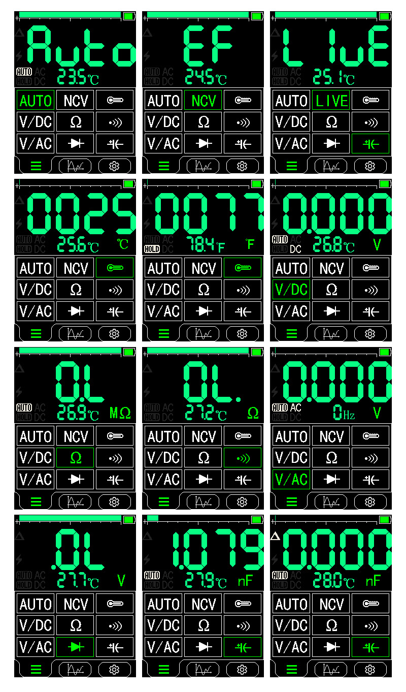

Figure 3

#### 1. Gear shift

#### According to the desired measurement data, click the button in the gear switch button area to automatically switch to that gear, and the current measured gear icon will be displayed at the top, as shown in Figure 3. When switching to the NCV gear, clicking on the NCV gear again will switch to the LIVE gear. When switching to the temperature gear, clicking on the temperature gear again can switch to the current temperature unit. When switching to the capacitor level, click on the capacitor level again to enter the relative value measurement.

#### 2. Frequency and duty cycle measurement

#### Press the physical button "Hz/%" at the bottom of the screen in the AC/DC voltage range to enter frequency measurement. At this time, the measurement unit will change to "Hz". Press the physical button "Hz/%" again to switch to duty cycle measurement. At this time, the measurement unit will change to "%". Press the button again to switch to the voltage range.

#### 3. Manual and automatic range switching

#### Firstly, it is necessary to confirm that the button currently set on the device is the RANGE function. You can open Settings ->Multimeter ->Button Mode to set the reuse function of the button. Press the HOLD/RANGE button at the bottom of the screen to switch to manual mode. In manual range mode, press it once to jump up one gear, and then continue to press this button to jump to the lowest gear and cycle in sequence. Frequency and capacitance measurements cannot be manually measured. Click on any other gear on the screen to exit manual gear mode.4.数据保持功能

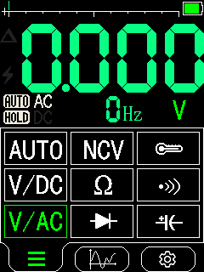

Figure 1

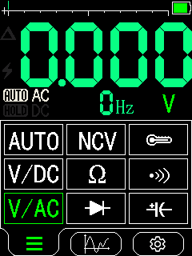

Figure 2

#### Firstly, it is necessary to confirm that the button currently set on the device is the HOLD function. You can open Settings ->Multimeter ->Button Mode to set the reuse function of the button. Press the HOLD/RANGE button at the bottom of the screen to turn on the data hold function. At this time, the HOLD icon is displayed on the screen as shown in Figure 5. Pressing the button again will release the data hold, and the HOLD icon on the screen will disappear as shown in Figure 5.

#### 5. Data waveform function

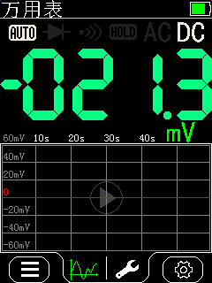

Figure 6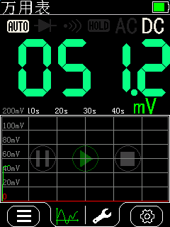

Figure 7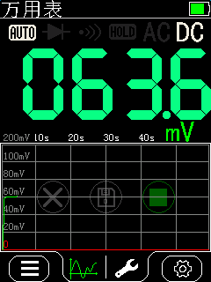

Figure 8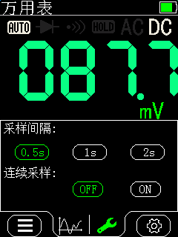

Figure 9

Click the "Waveform Function" button in the menu button at the bottom of the screen to enter the data waveform function. Click the start button in the middle of the screen, as shown in Figure 6, to start recording the current measurement value. At this time, the buttons on the screen will become three buttons: pause, start (green), stop, etc. as shown in Figure 7. Click the stop button, and the buttons on the screen will become three buttons: cancel, save, stop (green), etc. as shown in Figure 8, Click the save button to save the current measurement result, click the cancel button to delete the current measurement result and start the next measurement. The saved data can be viewed in the Settings ->Storage menu, and the specific waveform data needs to be viewed on the computer using the accompanying software.

The interval and continuous sampling of data measurement can be set in the settings menu at the bottom of the waveform menu, as shown in Figure 9. The sampling interval can be set to three levels: 0.5 seconds, 1 second, 2 seconds, etc; Continuous sampling or non continuous sampling can be set. When continuous sampling is enabled and data collection overflows, the original data will be overwritten from the starting position to continue recording.

### Ⅵ、System Settings Description

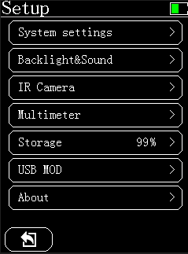

Figure 10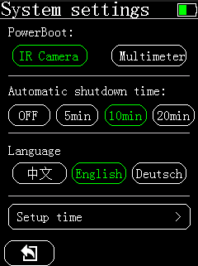

Figure 11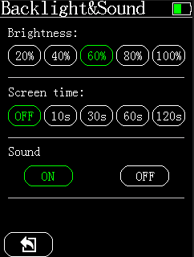

Figure12

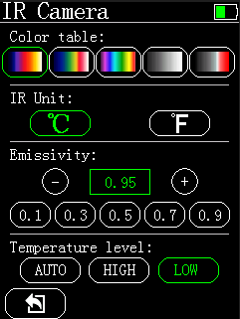

Figure13

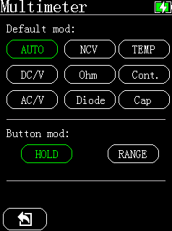

Figure14

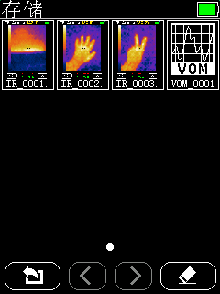

Figure15

#### 1. System settings

#### Power on mode: defaults to thermal imaging mode or multimeter mode when turned on.

#### 2. Backlight&Sound Settings

#### Reducing backlight brightness and turning on screen rest time can effectively extend battery life.

#### The on/off gear buzzer in the multimeter is not affected by sound shutdown.

#### 3. Thermal imaging settings

#### Color strip: can modify the display relationship between thermal imaging temperature and color.

#### Unit: Modify the unit for measuring the overall temperature.

#### Emissivity: Emissivity can be set based on the measured object, and can be quickly set by clicking the bottom gear button.

#### Temperature range: It is recommended to set according to the actual measured temperature. When selecting the automatic gear, it is normal for the temperature to experience a lag of about 2-3 seconds when shifting from low temperature to high temperature or from high temperature to low temperature. The high temperature range is suitable for 100~550 ℃, and the low temperature range is suitable for -20~150 ℃.

#### 4. Multimeter settings

#### Power on mode: Set the default gear when entering the multimeter for the first time.

#### Button mode: Set the function of multiplexed HOLD/RANGE buttons at the bottom of the screen.

#### 5. Storage settings

#### You can preview the saved thermal imaging screenshot, click on the thumbnail to open its corresponding image, and once the image is opened, you can delete it; In the thumbnail state, click the erase button in the bottom right corner of the screen to format the storage.

#### 6. USB mode

#### Entering this USB mode allows you to connect the device's USB to the computer's USB and view the files inside the device; If you exit this mode, the USB will disconnect (note: to avoid electric shock, please remove the probe before connecting the USB to other devices).

### Ⅶ、Upper computer usage

### The upper computer can achieve temperature reproduction of thermal imaging images and waveform reproduction of multimeter data.

### 

Figure16

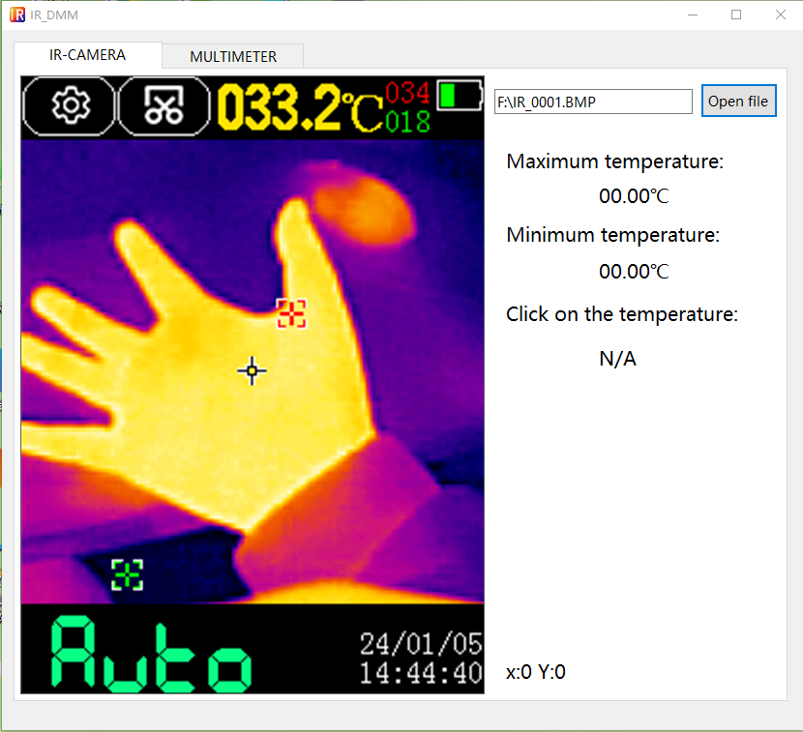

Figure17

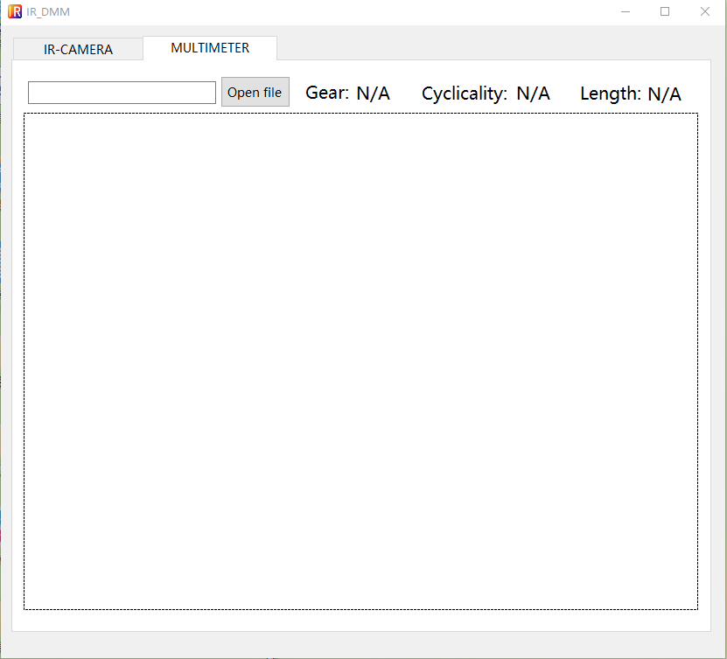

Figure18

1. Thermal imaging temperature reproduction:

### Firstly, open the upper computer as shown in Figure 16, select the thermal imaging tab, click the open button, and select the image of the thermal imaging screenshot as shown in Figure 16

### In Figure 17, by clicking the left mouse button in the thermal imaging image area, the temperature value of the current clicked area can be obtained.

### 2. Multimeter data waveform reproduction:

### Firstly, open the upper computer as shown in Figure 16, select the multimeter tab, click the open button to select the waveform data file of the multimeter as shown in Figure 18. Move the mouse to the waveform area, and wave the mouse scroll wheel to achieve waveform amplification and reduction.

### Ⅷ、技术指标

|  |  |
| --- | --- |
| Thermal imaging parameters | |
| Sensor | Vanadium oxide (VOx) |
| Image capture frequency | 20Hz |
| Thermal imaging pixels | 192x192 |
| Display image resolution | 240x240 |
| Field of View (FOV) | 50.0°(H) × 50°(V) /72.1°(D) |
| Temperature range | 0.1 – 0.99 adjustable,(0.95 by default) |
| Temperature range | -20℃ ~ +550℃ |
| Gain mode | Auto Gain |
| Accuracy | Iron Red, Rainbow, Fusion, White Heat, White Heat Highlights |
| Accuracy | ±2℃or±2% |
| Measurement resolution | 0.1℃/0.1℉ |
| Multimeter parameters | |
| DC maximum input voltage | 1000V |
| AC maximum input voltage | 750V |
| The maximum resistance | 99.99MΩ |
| The maximum capacitance | 99.99mF |
| Duty cycle test range | 0.1% ~ 99.9% |
| Diode test range | 0V ~ 3V |
| Continuity test | 999.9Ω |
| Display word count | 9999counts, Updates3/sec |
|  |  |

|  |  |  |  |
| --- | --- | --- | --- |
| **Accuracy** | | | |
| Function | Range | Resolution | Accuracy |
| AC Volts | 400mv | 0.1mV | 2% +3 |
| 9.999V  99.99V  999.9V | 0.001V  0.01V  0.1V | 1.0% +3 |
| DC Volts | 400mv | 0.1mV | 2% +3 |
| 9.999V  99.99V  999.9V | 0.001V  0.01V  0.1V | 1.0% +3 |
| Resistance | 999.9 Ω  9.999KΩ  99.99KΩ  999.9KΩ  9.999MΩ | 0.1 Ω  0.001 kΩ  0.01 kΩ  0.1 kΩ  0.001 MΩ | 0.5% + 3 |
| 99.99MΩ | 0.01 MΩ | 1.5% + 3 |
| Diode Test | 3.000V | 0.001V | 10% |
| Capacitance | 9.999nF  99.99nF  999.9nF  9.999uF  99.99uF  999.9uF | 0.001nF  0.01nF  0.1nF  0.001uF  0.01uF  0.1uF | 2% +5 |
| 9.999mF  99.99mF | 0.001mF  0.01mF | 5% +5 |

|  |  |  |
| --- | --- | --- |
| **Other parameters of the equipment** | | |
| Display type | 2.8 inches320*480 pixels |
| Touch screen | Resistive touch screen |
| Data transmission | Type-C USB |
| Storage capacity | 3.5MB |
| lmage storage format | BMP |
| Battery Type | Li-ion battery |
| Storage temperature | -20～60℃（-4～140℉） |
| Operating temperature | 0～50℃（32～122℉） |
| Operating Humidity | ＜85%RH （ non-condensing)） |
| Size (HxWxL) | 134 mm * 69 mm * 25 mm |
| Weight | 130g |