**SEEKNITE L6T Flashlight parameters**

**Product material:**Aluminium alloy

**Surface treatment:**Oxidized black

**Product size:**Head diameter:74Mm Hand leverDiameter:34MmCabinet minister:253Mm

**Product weight:Single flashlight**500G (excluding batteries)

**Type of light cup:**Aluminum alloy vacuum coating (Plain noodles)

**Use light source:**CREE XHP70D HI

**Use the battery:**Two sections26650 series (MustUse 26650 pointed lithium battery)

**Dustproof and waterproof:**Rainproof life (cannot dive)

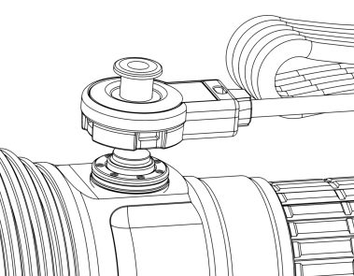**Charging method:**USB switch charging

**Charge the flashlight:**Press the charging connector firmly on the flashlight switch (as shown in the figure), and connect the USB cable to the charging power supply (charging voltage 5V charger).

The charging connector has three windows to see the charging.

Electrical status: If there is a red and green flash, it means that it cannot be charged.

At this time, you need to press the back OFF/NO switch. Red indicates that it is charging, and green indicates that it is fully charged.

**Gear:**

　　UseSwitch: Press the forward switch at the end, responsible for turning on and off, and have a point shooting function.,Switch the gear in the middle.

Gear:High-light gear 100% about two hours → medium bright gear 30% about 5 hours → low-light gear 5% about 20 hours → moonlight gear 0.5% (cycle) double-click flash, with memory gear

**Important note:**

(1) When the flashlight is not used for a long time, the battery needs to be removed to protect the normal service life of the battery;

(2) When taking it out and placing it, you need to loosen the tail cover more than half a circle to avoid turning on the flashlight by mistake.

