GEEKNEST All-Band Radio V5A Kit -- Assembly Instructions

*The kit accessories are shown in the following figure;
**Please choose SMA external screw internal needle wipe antenna for this radio.
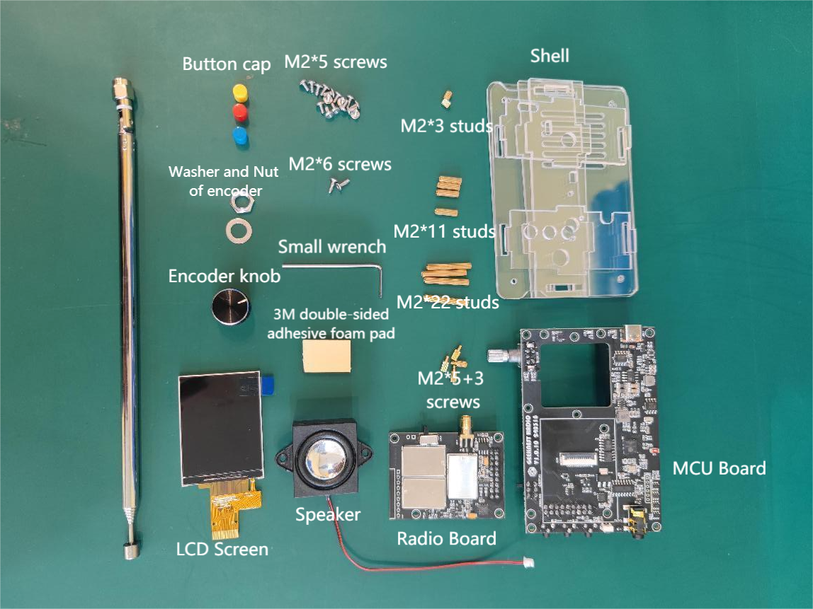

- Installation of Speaker

- Place the speaker into the hole of the MCU Board. Pay attention to the installation direction. The speaker wire needs to be pull out from the gap above the circuit board, as shown in the figure below:
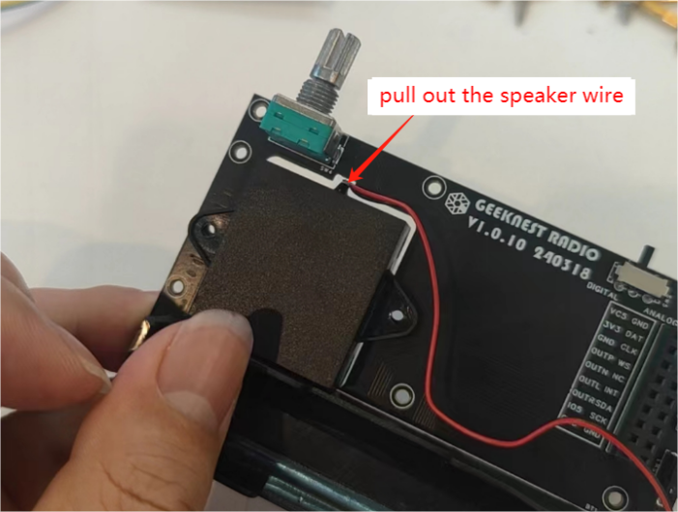
- Use a M2*6 screw to pass through the mounting hole of the speaker from the front of the MCU Board, and then use a M2*3 double threaded stud to tighten to the M2*6 screw, as shown in the figures below:
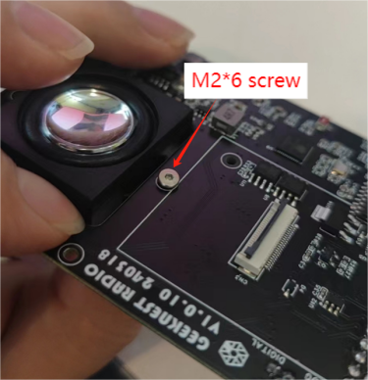
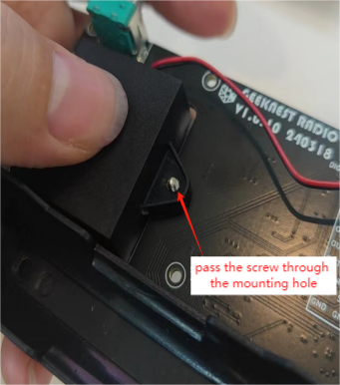
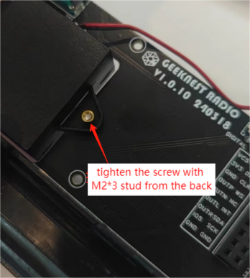
- Refer to the above steps to install the other three screws of the speaker, and then use a small wrench to reinforce the screw. After the installation is completed, plug the speaker wire into the SPK port of the MCU Board. Pay attention to the direction, plugging it in the wrong direction may cause difficulty in insertion or damage to the port! Then arrange the wires, place them nearby, do not wind them too far, otherwise it may cause unnecessary interference. This step is shown in the figure below:
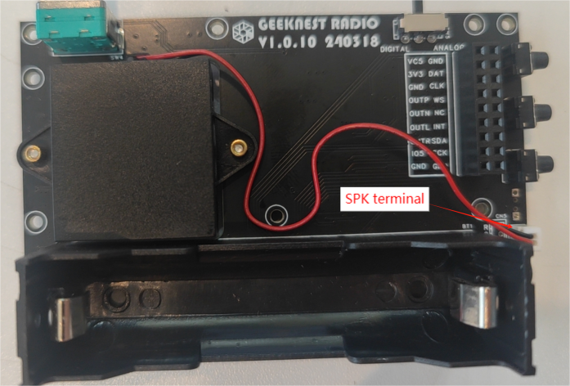

II. Installation of Radio Board

- Use M2*5 screw to pass through the Radio Board mounting hole (around white rectangular screen printing on the left of MCU Board) front of the MCU Board, and then use M2*11 double threaded stud tighten the screw from the back of the board. Install all the 4 screws at 4 corners as shown in the figure below:
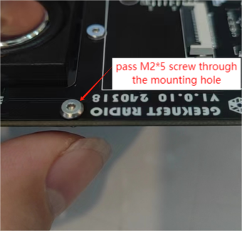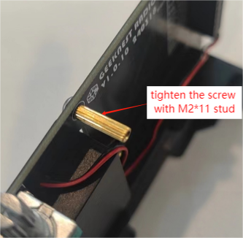
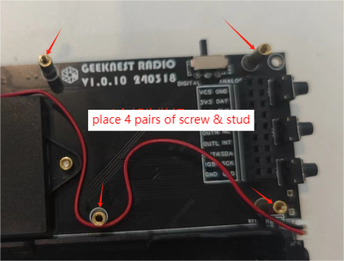
- Connect the Radio Board and the MCU Board with Pin Header and Female Header. It is important to note here that it must be connected pin-to-pin, any misplace may cause permanent damage to the MCU Board. After connection, use 4 M2*5 screws to tighten them into the mounting holes, as shown in the figure below:
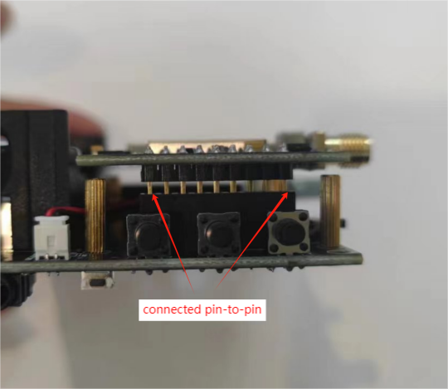
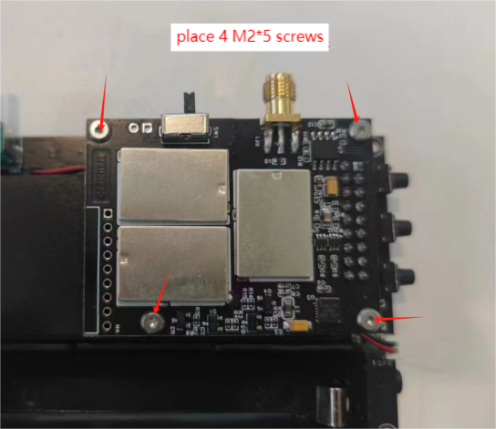

III. Installation of Screen

- Find the position aground the 22-pin LCD screen connector, stick one side of 3M double-sided adhesive foam pad on the MCU Board, press gently with your hand to make it firmly, as shown in the figure below:
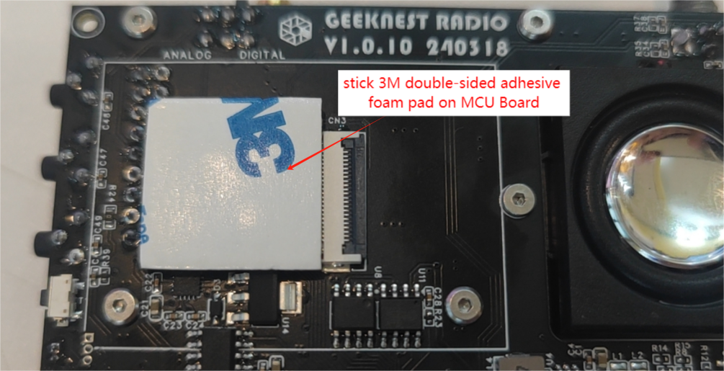
- Open the 22-pin LCD screen connector cover, then insert the screen's ribbon cable into the connector. Notice: the contact surface of the screen ribbon cable faces down, do not insert it in wrong direction, and do not pull the ribbon cable forcefully, then close the FPC connector cover, as shown in the figure below:
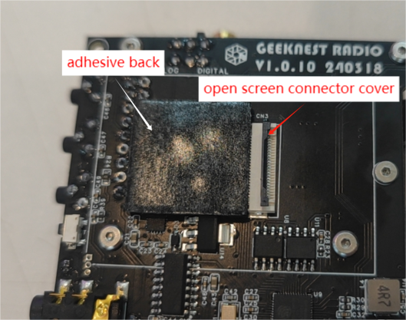
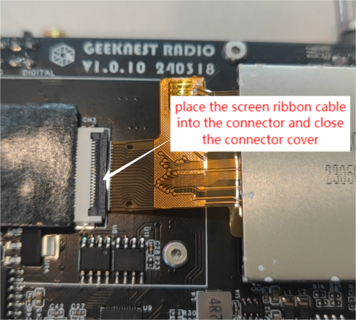
- Align the screen with the rectangular silk screen printing on the MCU Board and stick LCD screen on the foam pad. Notice: Press gently, do not use too much force, otherwise it may crush the screen!
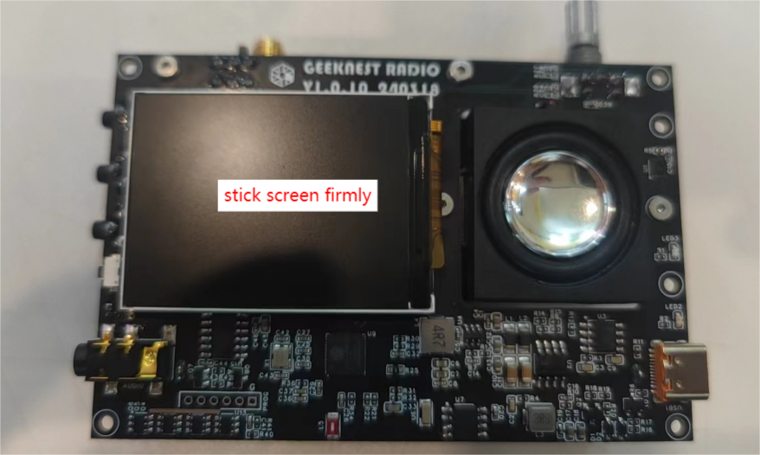

IV. Installation of Battery

Notice: Please read each note carefully before battery installation. Please use QUALIFIED 18650 Li-ion batteries with the discharge rate above 1C, regardless of capacity.

- Before installing the battery, check the polarity of each battery on an insulated desktop or in other safe ways, and also confirm the polarity and direction of the battery box on the MCU Board to avoid burning out the MCU Board due to the battery being installed incorrectly!
Notice: Wrong direction of the battery installation will cause permanent damage to the radio!!
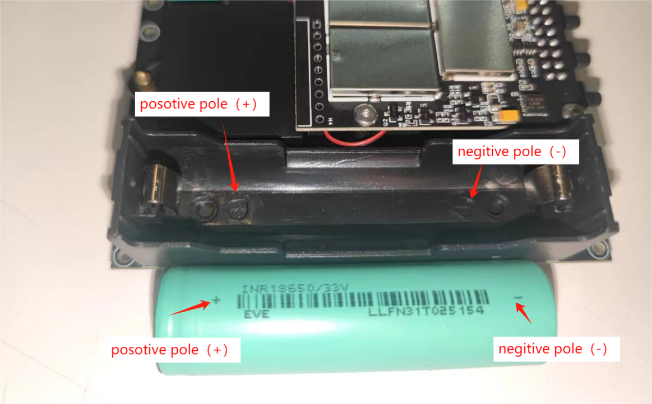
- Install the battery. Do not use brute force to install the battery, and be careful not to crush the screen! Please follow the precautions in the instructions. Because of the spring of the battery shell may relatively tight, when installing the battery, you can first place the positive pole and then place the negative pole, which is more safer. If you place the negative pole first and then the positive pole, it is very likely to crush the battery skin and cause a short circuit!
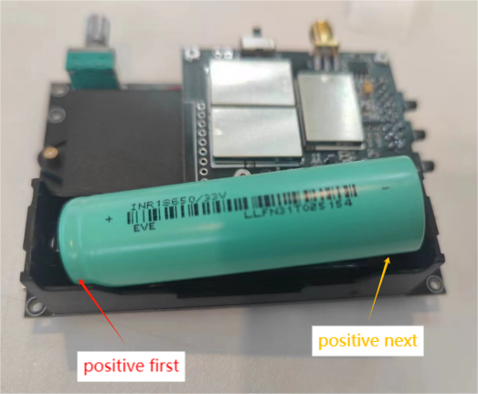

V. Preliminary Testing before Installing the Shell

- After installing the battery, you can use the TYPE-C cable charger to plug in for charging and activation, and conduct a simple test. After plugging in the charger, the LED3 on the MCU Board (close to the TYPE-C cable charger) will light up, indicating that the battery is under charging; LED2 will light up when the charging is complete. At the same time, the screen will also light up, and all the data in the lower left corner of the screen is displayed in green, indicating that the self-check of the whole machine is OK.
If there is any red color error text shown in the startup screen , you may try to:
- Pull out the battery
- Re-connect the Radio board and MCU Board
- Re-install the battery and retry
Or press the reset button, power on and try again.
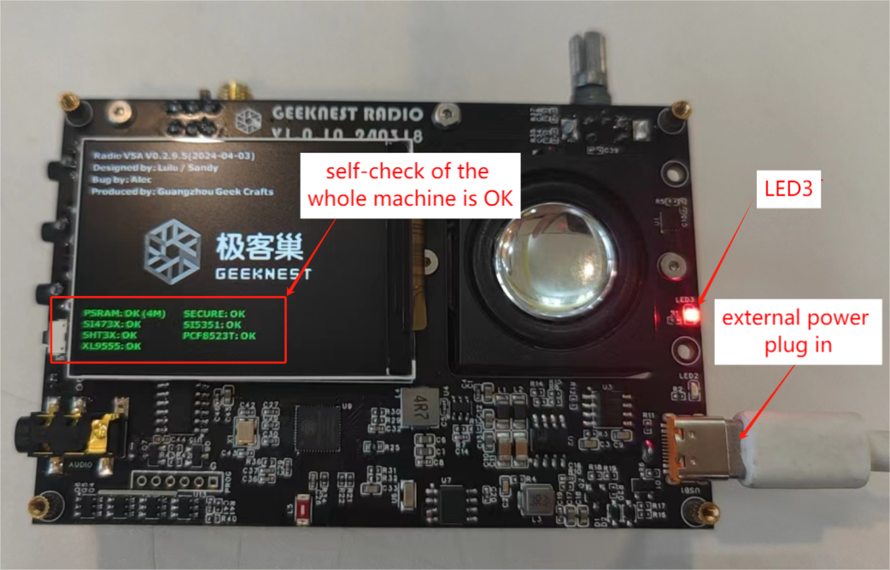

VI. Installation of the Shell

- Use M2*5+3 single-head copper screws to pass through the mounting holes around the corner of the MCU Board, and then use M2*22 double threaded stud to tighten them from the back, as shown in the figure below:
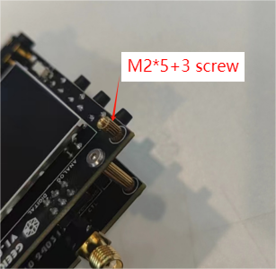
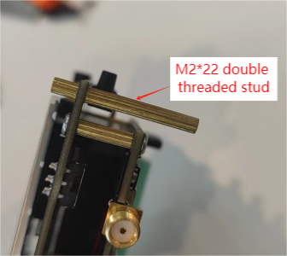
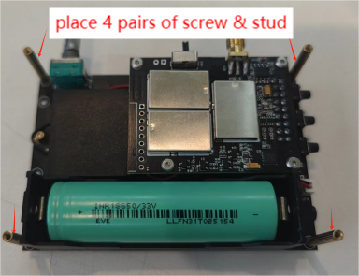
- Then install the top plate of the shell, align its mounting holes with installed studs, and then place the washer and nut of the encoder, as shown in the figure below:
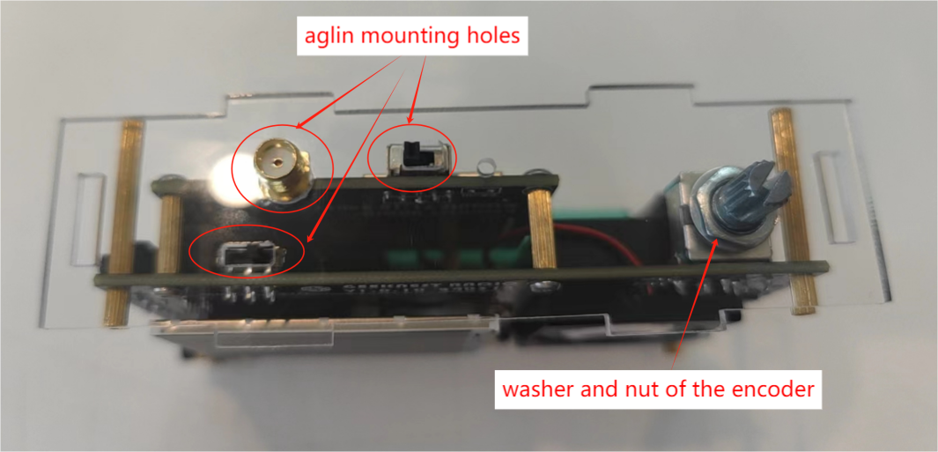
- Then attach the left and right side plates and the bottom plate, as shown in the figure below:
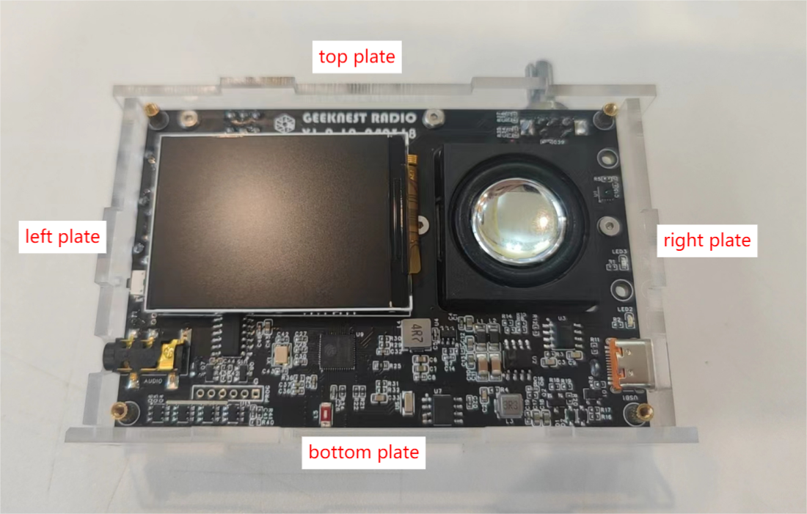
- Place the front panel and tighten it with 4 M2*5 screws, as shown in the figure below:
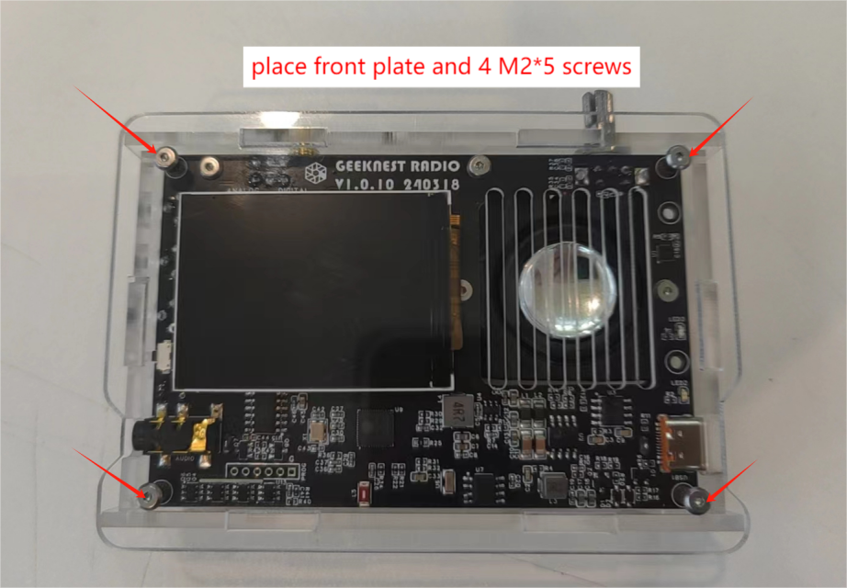
- Place the back panel and tighten it with 4 M2*5 screws, as shown in the figure below:
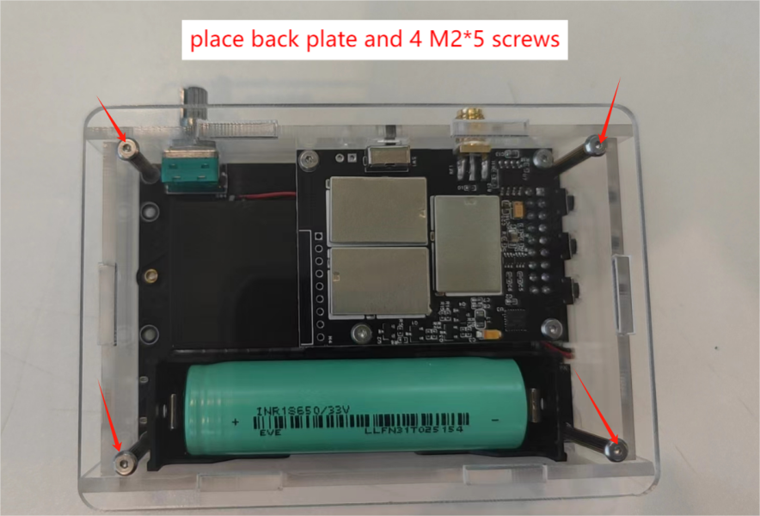
- Install the encoder knob and button cap on the left. Do not press too hard during installation, as shown in the figure below:
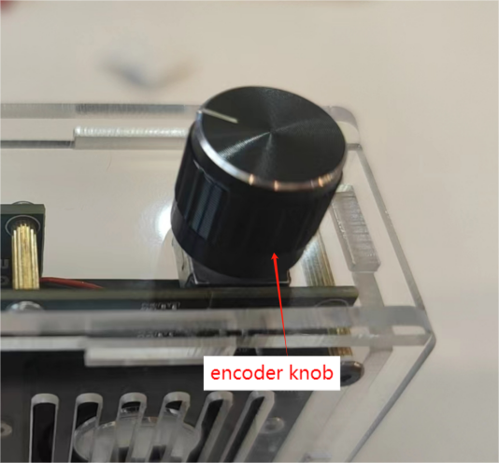
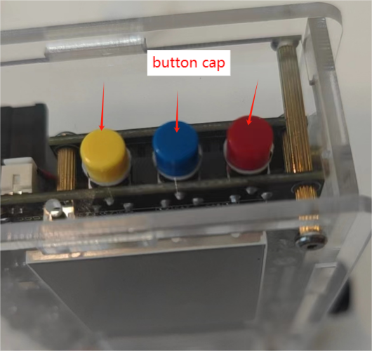

Now you finally complete the V5A Full Band Radio. Enjoy your journey with it!

Q&A:

Q: What should I do if long pressing the encoder(1.5s) does not turn on the power?

A: Press the RESET button once and try to power on again. If it still doesn't work, turn off the power (pull out the battery and reinstall) then try again.

