一、 Product Settings
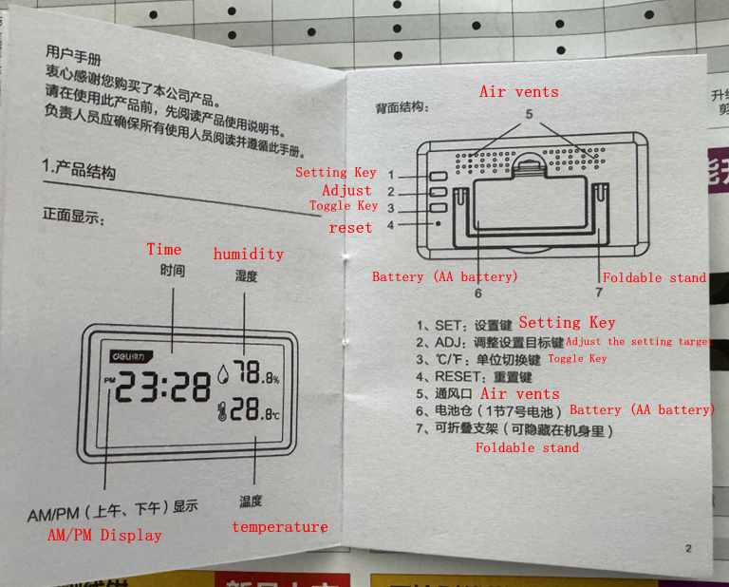
Product Use This product primarily displays time, temperature, and humidity. It can be used in living rooms, bedrooms, classrooms, offices, production workshops, etc. It is not recommended for outdoor use as it may lead to inaccurate display.

二、Product Features
Simple design, dimensions: 11x6x1.8cm, simple and compact design.
Simultaneous display of time, temperature, and humidity on the same screen.
4-inch LCD large screen display.
Accurate display: temperature display ±1.0℃, accuracy: ±1℃.

三、Instructions for Use

Button Functions SET button: Long press this button for about 3 seconds to enter time setting. ADJ button: Adjust the setting object during setting. 'C/℉' button: Switch temperature display units. RESET button: Restore factory settings.

Setting Instructions In normal display mode, the “.” between hours and minutes flashes once per second. Press the SET button for about 3 seconds to enter the setting interface, short press the “ADJ” button to adjust the setting items. Note: The setting order is: Minutes → Hours → 12/24 → Year → Month → Day → Exit. Use the ADJ button to adjust the minutes setting. When setting the time, long press the ADJ button to quickly adjust at approximately 8HZ.

四、Product Parameters
Product Size Approximately 11x6x1.8cm
Screen 4-inch LCD screen
Temperature Measurement Range Display range: -10℃~60℃,
Temperature Measurement Accuracy ±1℃ (0℃~40℃)
Temperature Resolution 0.1℃
Humidity Measurement Range 10%RH~99%RH
Humidity Measurement Accuracy ±5%RH (40%RH~70%RH), in other ranges max ±7%RH
Humidity Resolution 1%RH
12/24 Hour Display Yes
Date Reminder Yes
Battery Type 1.5V AAA battery
Product Weight Approximately 92 grams
Shell Material Plastic (ABS)
Product package includes:
main unit, 1.5V AAA battery, product line, manual, top rod

