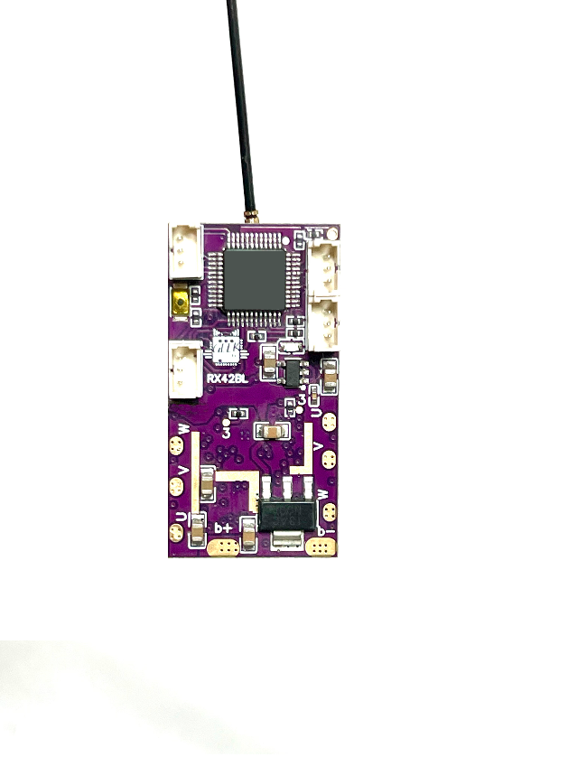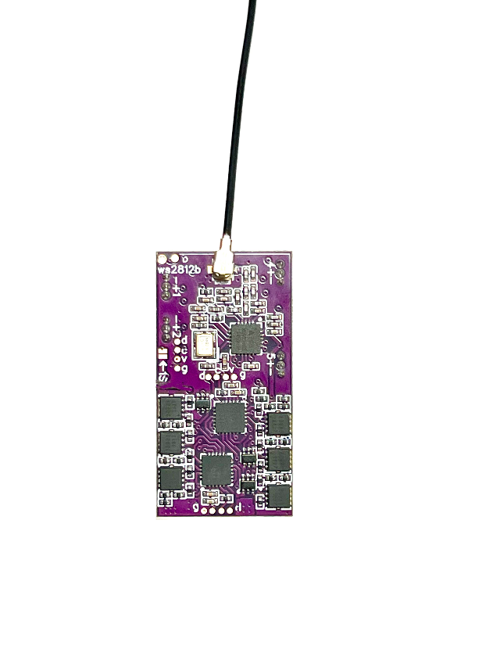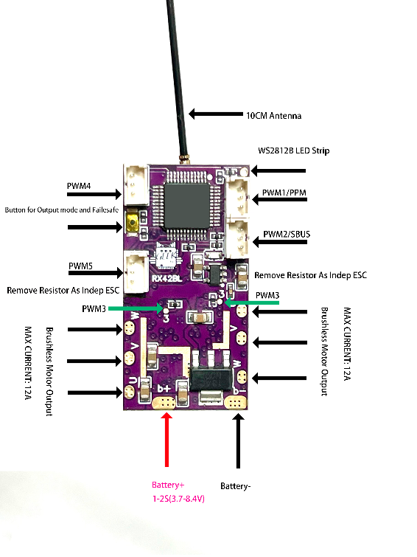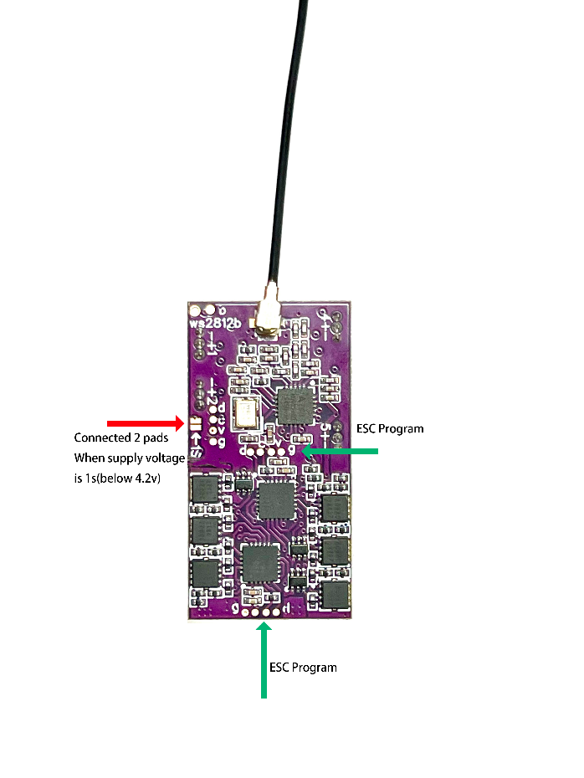​

​​​

# 1. How to bind with the remote control?

## 1.1 For Flysky, wfly:

1. Turn off the remote control, power on the receiver, wait 20 seconds, its indicator light will flash slowly and regularly

2. Turn on the remote control and boot into the binding mode. For Wfly, enter it from the menu. For Flysky, press the binding button and then press the power button to boot.

3. Wait for 20 seconds and the code will be automatically completed.

1.2 For Microzone

1. Turn off the remote control, power on the receiver, wait 20 seconds, its indicator light will flash slowly and regularly

2. When you observe that the flashing frequency is slow, turn on the MC remote control, the receiver flashes quickly, then stays on, and the code matching is completed.

3. The latest version has a button. You can press it to make it flash slowly and maintain the MC6C protocol.

NOTE: compatible with mc6cmc7/ mc10/mc8b/mc6cmini/mc7mini, mc6cmini needs to switch the radio frequency mode to the old protocol, mc7, mc7mini, mc8, mc10, etc. choose mc7rb receiver

# 2. How to switch to another remote control?

Turn off the old remote control, put it aside, then take out the new remote control, power on the receiver again, and then the coding process is exactly the same as in Section 1.

3．How to identify the current working mode?

After the binding is successful, turn off the rc transmitter, and observe how many flashes of the indicator light every 3 seconds, which is the mode number

# 4. How to change the working mode of the receiver?

1. Turn off the remote control, turn off the receiver, and power on the receiver again. Press and hold the button on the upper right corner of the receiver for 20 seconds.

​

2. Keep the button pressed (old version: short-circuit two solder joints) and observe the indicator light. At this time, the indicator will flash in a cycle every 3 seconds. The number of flashes every 3 seconds is the mode to be selected. , if it flashes twice every 3 seconds, it means that the current mode to be selected is 2. The flashing will repeat in a cycle. If the mode is missed, keep the short circuit state and wait another round.

3. When the flashing reaches the mode you want, such as 2 flashes every 3 seconds, cancel the short-circuit state. At this time, the receiver flashes several times quickly, save and restart, and the mode selection is completed.

Another Method for FLYSKY i6 i6x:

1. Enter the settings menu

2. Enter system settings (System)

3. Enter the receiver setup (Rx Setup)

4. Enter i-Bus setup

5. Select the channel, channels 1-7 correspond to modes 1-7

6. Long press cancel

7. Short press cancel again.

NOTE! The remote control does not save this selection, only the receiver saves the mode. Please see Section 3.

# 5. How many working modes are there? What is the difference between each working mode?

1. Mode 1, normal mode, this is the default factory mode. This mode has 5 pwm outputs, plus a wsled signal output, built-in ESC and channel 3 normal output, non-differential speed.

2. Mode 2, differential mode, this also has 5 pwm outputs, plus a wsled signal output, but the 3 and 4 channels are differential mixed control outputs, and the two built-in ESCs are also differential speed outputs.

3. Mode 3, SBUS+PPM mode, this only outputs ppm and sbus signals on channels 1 and 2 respectively, and other interfaces do not output signals.

# 1. 如何和遥控器对码？

**1.1富斯FLYSKY，天地飞:**

     一 关闭遥控器， 接收机上电，等20秒，它的指标灯会规则慢闪

    二 打开遥控器开机进入对码模式，天地飞是菜单里进入，富斯是按binding键，再按电源键开机。

    三 静待20秒，即可自动完成对码。

注意：使用富斯一代协议时，观察到接机器快闪一段时间，熄灯重启，这时其实已经完成对码，重启遥控器即可

**1.2 迈克MC6C/MC7/MC8B/MC6CMINI/MC7MINI:**

   一 关闭遥控器， 接收机上电，等20秒，它的指标灯会规则慢闪

   二 观察到闪的频率较慢时，打开MC遥控器，接收机快闪，然后常亮，对码完成

   三 最新版本带按钮的，可以按一下，让它一直较慢的闪，保持在MC6C的协议。

注意：mc6cmini需要切换射频模式为旧协议，mc7,mc7mini，mc8,mc10等选mc7rb接收机

# 2.如何切换对码另一个摇控器？

关掉旧的遥控器，放一边，然后拿出新的遥控器，接收机重新上电，然后和第1节的对码流程是完全一样的。

# 3. 如何判断接收正当前的工作模式？

   A： 对频完成后，关闭摇控机，接收指示灯进入闪烁模式， 每三秒闪几下表示模式几，如闪2下，表示模式2

# 4.如何切换或设置接收机的工作模式？

   以下操作需要在对码完成之后进行操作。

 1. 关闭遥控器，关闭接收机，接收机重新上电。20秒内按住接收机右上角的按钮。

    （旧版： 接收机然后使用一字螺丝批（或其它合适工具）短接右上角两焊点（见上封面两图右上角标注）保持短接两个焊点状态，打开接收机。）

   3. 一直保持按钮按下（旧版：短接两个焊点）状态，观察指示灯，这时指示会进入每3秒一个周期的闪烁，每3秒闪多少下，就是当前要选的模式几，如每3秒闪两下，表示当前的要选的模式是2. 闪烁会循环重复，错过了模式，保持短接的状态，再等一圈就好了。

   4.  当闪烁到达你想要的模式时，如每3秒闪2下时，取消短接状态，这时接收机快闪几下，保存，重启，模式选择完成。

  5.  最新版(2024)有按钮，开机20秒之内 ,使用按钮进行操作即可

## 方法二. (FLYSKY i6 i6x 等有菜单遥控器)

      1. 进入设置菜单

      2. 进入系统设置(System)

      3. 进入接收机设置(Rx Setup)

      4. 进入i-Bus setup

      5. 选择通道(channel), 通道1-7对应 模式1-7

      6. 长按cancel

      7.  再短按一下cancel.

     注意! 遥控不会保存这个选择的, 仅接收机保存模式。请看第3节。

# 5. 有多少个工作模式？每个工作模式有什么不同？

    1. 模式1， 正常模式，这个是默认出厂模式， 这个模式有5个pwm输出，加一个wsled的信号输出，内置电调和3通道正常输出，非差速。

    2. 模式2， 差速模式，这个也是5个pwm输出，加一个wsled的信号输出，但是3和4通是差速混控输出的，内置两个电调也是差速度输出。

    3.   模式3，SBUS+PPM模式，  这个仅在1和2通道分别输出ppm和sbus信号，其它接口不输出信号

# 6. WS2812B LED灯带每个灯的定义是怎么样的？

# ​​