SA6 mini频谱分析仪&信号发生器

4.4G Spectrum Analyzer & Signal Genertor

产品说明书
Product Manual

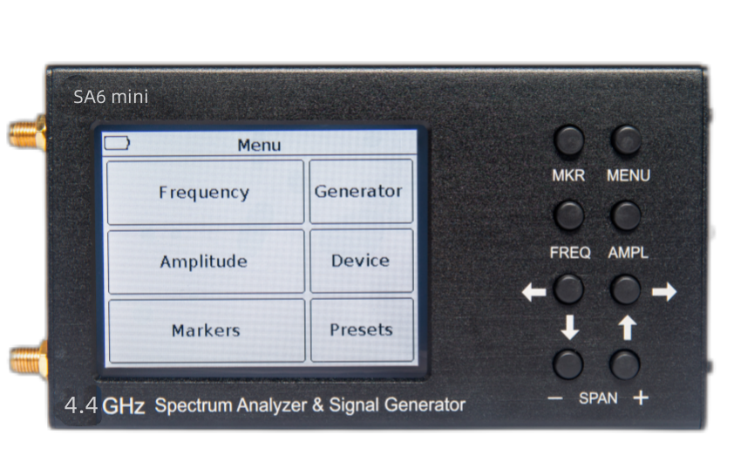

Product Manual

Packing
1. 4.4G Spectrum Analyzer & Signal Genertor x1
2. Connecting cable USB Type-C x1
3. SMA-kk female connector x1
4. Touch pen x1

Panel infomation
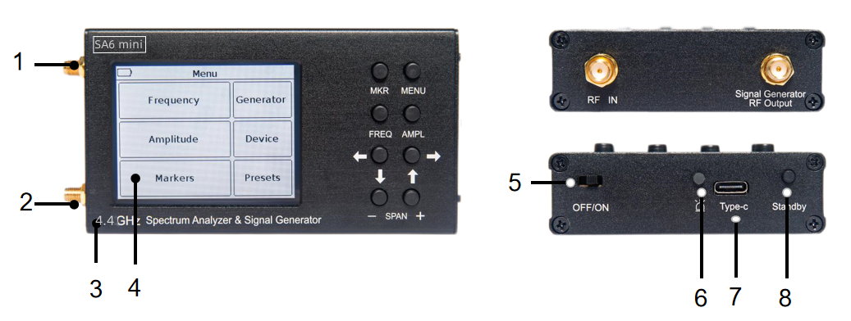

- The output of the signal generator TG OUT;
- Antenna input RF IN;
- Housing;
- Colour resistive screen of 3.2” ;
- OFF/ON;
- Battery charge indicator charge;
- Connector type C USB;
- Standby button on/off .

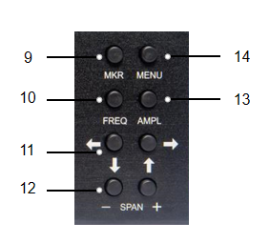
9.«MKR» setting markers. Long (more than 2 seconds) button holding opens the menu of markers and peak values of the analyzed signal.
10.«FREQ»-displays the frequency parameters on the screen. Long press (more than 2 seconds) to open the menu for setting the viewing frequency range.
11. Buttons to move the screen scale grid and change the frequency.
12.«SPAN»(overview frequency range) -buttons " -" and " + " change the frequency range of the analyzed signal.
13.«AMPL»-output amplitude parameters on the screen. Long (more than 2 seconds) holding the button opens the menu for setting the amplitude parameters.
14.«MENU»-the button opens the main menu of the device.

Specifications
Parameter name |  | Value
Displayed frequency range |  | 35-4400 MHz
Measured frequency range |  | 45-4400 MHz
Dynamic range | for 45-3000 MHz band | 75 dB
Dynamic range | for 3000-4400 MHz band | 70 dB
Maximum bandwidth |  | 4355 MHz
IF bandwidth (fixed) |  | 200 kHz
Sweep speed with a span of more than 100 MHz |  | 600 MHz/s
Sweep time of 100 MHz span |  | < 0.25 s
Detectable signal duration at 10 MHz scan span |  | 20 ms
Noise floor | in the band up to 3000 MHz | < -100 dBm
Noise floor | in the band 3000-4500 MHz | < -95 dBm
Noise floor | in the band 4500-6200 MHz | < -90 dBm
Input impedance |  | 50 Ohm
SWR in the operating frequency range |  | < 1,5
Internal attenuator |  | 0-30 dB
Error of attenuation | up to 10 dB | 2 dB
Error of attenuation | from 10 to 20 dB | 5 dB
Error of attenuation | from 20 to 30 dB | 8 dB
Frequency range of built-in tracking generator |  | 35-6200 MHz
Tracking generator output power |  | -15 .. -25 dBm
Accuracy of display of a signal within a dynamic range |  | 2 dB
Maximum input power | with 0 dB attenuator | + 10 dBm
Maximum input power | with attenuator > 20 dB | + 20 dBm
The measured maximum input signal |  | + 10 dBm
Maximum RF input DC voltage |  | 5V
Maximum supply current | when running on battery | 450 mA
Maximum supply current | when running on USB  (in charging mode) | 500 mA
Battery capacity |  | 3000 mAh
Continuous operation time from accumulator |  | 3 h
Battery charging time |  | ~4 h
Dimensions |  | 155×81×27 mm
Weight |  | 0.49kg

Notice：We are not responsible for the damage of the machine caused by privately upgrading the software version.

