**LCD solar controller instructions**

Please check out whether or not the product model is the same as the one on the packaging when open the pack.

Containing:

A set of host machine

A copy of manual

A pack of desiccant

**I. Instructions for model and specification**

Model: YCX-131

Input voltage: DC12V/24V, DC36V, DC48V,DC96V

Output voltage: DC12V/24V, DC36V, DC48V, DC5V/1.5A×2USB

Operating temperature: -25℃～55℃

**II. Description of product function**

The product is multi-functional LCD solar controller with clock display and seven operating modes that are charging mode, light control mode, light and time delay control mode, universal control mode, manual control mode, timing control mode and testing mode. Among them, test mode is only applicable to the factory test.

Charging control is applicable to any mode, as long as the charging condition is reached, it can charge immediately.

Discharge control varies as different control modes change, under the trouble-free condition, specific instructions as follows:

1. Charging mode: in any case, never discharge.
2. Light control mode: when the controller detects nights, it will delay ten minutes then start to discharge; when it detects daytime, it will delay ten minutes then stop discharging.
3. Light and time delay control mode: when the controller detects nights, it will delay ten minutes then start to discharge and count down, if the timer stops by zero, discharge will stop. The longest duration of delay is 23:59.
4. Universal control mode: under the trouble-free condition, it always keep discharging.
5. Manual control mode: it uses “▼” for discharging or not.
6. Timing control mode: it opens or closes the discharge regularly.
7. Test mode: it is the same as light and time delay control mode but only loses ten minutes of time delay.
8. The controller still discharges under low voltage protection. Touch-holding “▼” for 5 seconds, discharge continues to output. But discharge is only stopped by hand. Notice that this performance may damage the battery, be careful with it!

**III. Display and operation instructions**

**1. Display screen**

(1) Full screen

Normal and fault status display area

Mode control display area

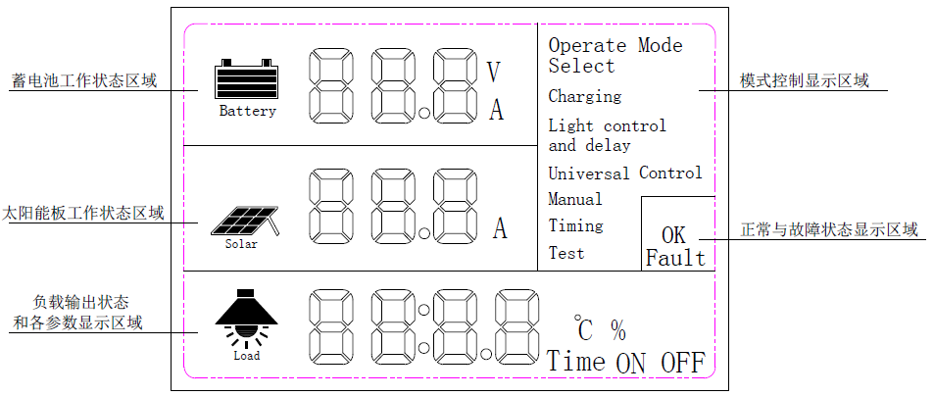

The operating status area of solar panel

Load output status and display areas of all parameters

Battery work status display area

(2) Battery work status display area instructions

Battery charging state and voltage indication. When the battery is charging, four rails will display dynamically if the four rails are in static state ,it is showing the current battery level.



The display of battery voltage and discharge current toggles at intervals of 5 seconds.



(3) The operating status area of solar panel

When the solar panel displays, it means charging status, when it doesn’t display, it means stopping charging.



It displays charge current.

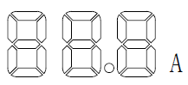

(4) Load output status and the parameters displaying area

When the battery discharges, the load icon light is on; when not discharge, the light is off.



When “℃” is displayed, four numerical values displayed is controller’s temperature; when “%” is displayed, four numerical values displayed is electric quantity of the battery; when “Time” is displayed, four numerical values displayed is 24-hour time. when “Time ON” is displayed, four numerical values displayed is the timing start time of timing control mode; when “Time OFF” is displayed, four numerical values is the timing stop time of timing control mode or light and time delay control mode.

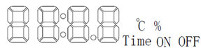

(5) Mode controlling display area

“Operate Mode Select” keeps on; it means that the area is the alternative area of controlling mode.

“Charging” keeps on, it means that the controller is in charging mode.

“Light Control” keeps on, it means that the controller is in light control mode.

“Light Control and delay” keeps on, it means that the controller is in light start and time delay stop control mode.

“Universal Control” keeps on, it means that the controller is in universal control mode.

“Manual” keeps on, it means that the controller is in manual control mode.

“Timing” keeps on, it means that the controller is in timing control mode.

“Test” keeps on, it means that the controller is in test mode.

(6) Normal and fault display area

“OK” keeps on, it means that the controller is in normal state.

“Fault” flickers, it means that the controller detects the abnormalities of battery’s voltage, discharge current or controller’s temperature. When the battery’s voltage is abnormal, “Fault” flickers, in the meantime, the value of voltage also flickers. When the discharge current is too large, “Fault” flickers, meanwhile, abnormal current value also flickers. When the controller’s temperature exceeds 75℃, “Fault” flickers, and the value of temperature also flickers.

**2. Operating instructions**

（1） “▲” Numerical values and mode adjustment.

“■” Setting/confirmation

“▼” Displacement and impulse start/stop

(2) Time setting

When charged, it immediately enter time setting state, load output and the first one(the first one to the left) of the four values in the parameters display area flicker, it means that this place is changeable, press “▲” to adjust, press “▼” for displacement adjustment. If time needs adjusting again, then long press “■” for 5 seconds to enter time setting state.

(3) Mode adjustment

Press “■”, the current control mode can flicker, then press “▲” to get the needed control mode, then press “■” again to confirm.

（4）Delay stop time adjustment of light control +delay stop control mode.

When “Light Control and delay” is chosen and confirmed, it will automatically pop up the delay stop time parameters, the operational approach is the same as time setting operation, load output and the display area of all parameters will show “Time OFF”, after adjusting, then press “■” to get back to the display mode. If delay stop time parameters needs modifying again, directly press two times of “■” to enter delay stop time parameters adjustment.

(5) The adjustment of start time and stop time of timing control mode

When “Timing” control mode is chosen and confirmed, it will automatically pop up time parameters start, the operational approach and time setting are the same, load output and the display area of all parameters will show “Time ON”. After adjusting start time and pressing “■”, it will automatically enter stop time parameters adjustment, load output and the display area of all parameters will show “Time OFF”, after finishing adjustment, press “■”to get back to display mode.

**IV. Protection parameters**

（1）Voltage protection instructions

When using 12V battery, if the battery’s voltage is below 10.5V, it will delay 6 seconds under low voltage protection, the value of voltage flickers, “Fault” flickers, discharge stops. When voltage gets back to 11.5V, it gets back to normal. When voltage is over 16.0V, the value of voltage flickers, “Fault” flickers, discharge stops. When voltage recovers back to 15.0V, it returns to normal.

When using 24V battery, if the battery’s voltage is below 21.0V, it will delay 6 seconds under low voltage protection, the value of voltage flickers, “Fault” flickers, discharge stops. When voltage gets back to 11.5V, it gets back to normal. When voltage is over 16.0V, the value of voltage flickers, “Fault” flickers, discharge stops. When voltage recovers back to 15.0V, it returns to normal.

When using 36V battery, if the battery’s voltage is below 31.5V, it will delay 6 seconds under low voltage protection, the value of voltage flickers, “Fault” flickers, discharge stops. When voltage gets back to 34.5V, it gets back to normal. When voltage is over 48.0V, the value of voltage flickers, “Fault” flickers, discharge stops. When voltage recovers back to 45.0V, it returns to normal.

When using 48V battery, if the battery’s voltage is below 42.0V, it will delay 6 seconds under low voltage protection, the value of voltage flickers, “Fault” flickers, discharge stops. When voltage gets back to 46.0V, it gets back to normal. When voltage is over 64.0V, the value of voltage flickers, “Fault” flickers, discharge stops. When voltage recovers back to 60.0V, it returns to normal.

**（2）Discharge current protection instructions**

When discharge current is above 150% of rated current, it starts protection immediately, the value of protection current flickers, “Fault” flickers, discharge stops.

Discharge current is around 110%~150% of rated current, it will delay ten seconds for protection, the value of protection current flickers, “Fault” flickers, discharge stops.

Discharge current is around 100%~110% of rated current, it will delay ten seconds for protection, the value of protection current flickers, “Fault” flickers, discharge stops.

**（3）Charging protection instructions**

When using 12V battery, if battery’s voltage is below 13.0V, it will start to charge, if the voltage is above 14.8V, it will stop charging.

When using 24V battery, if battery’s voltage is below 26.0V, it will start to charge, if the voltage is above 29.6V, it will stop charging.

When using 36V battery, if battery’s voltage is below 39.0V, it will start to charge, if the voltage is above 44.8V, it will stop charging.

When using 48V battery, if battery’s voltage is below 52.0V, it will start to charge, if the voltage is above 59.2V, it will stop charging.

Attention



1. Do not set the product on fire in case of the permanent damage of the product
2. Do not set the product on fire in case of the permanent damage of the product
3. Do not use this product in high temperature and wet environment
4. Do not dismantle this product in case of damage
5. Do not make the output a short circuit in case of danger