**User Manuals**

Thermal Imaging Multimeter

Quick Start User Manual

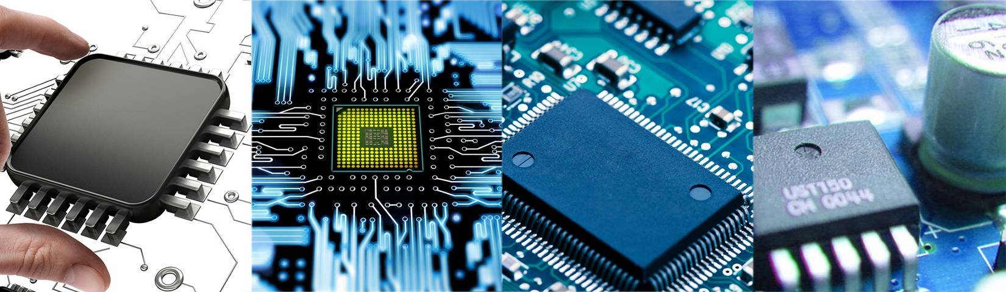

**Rev1.0**

Catalog

I. Safety instructions 3

II. Technical characteristics 4

III.Product Appearance Description 5

IV.thermal imaging operating instructions 7

V. Multimeter operating instructions 9

VI. System setup instructions 17

VII.the use of the upper computer 20

VIII. Technical specifications 21

Appendix: Emissivity of common objects 23

### I. Safety instructions

To prevent possible electric shock, fire or personal injury, and to ensure safe operation of this product:

* Please read all safety instructions before using the product.
* Do not modify this product and use it only for the intended purpose, as this may reduce the protection provided by the product.
* Replace the batteries when a low battery indication is displayed to prevent incorrect measurements.
* Do not use the product if it is working abnormally.
* Do not use if the product has been altered or has been damaged.
* For actual temperatures, see Emissivity information. Reflective objects can cause the measured temperature to be lower than the actual temperature. These objects can create a burn hazard.
* Do not place the battery and battery pack near sources of heat or fire. Do not expose to sunlight.
* Do not disassemble or squeeze the battery and battery pack. Batteries contain hazardous chemicals that may cause burns or explosions. If you come in contact with chemicals, clean with water or seek medical attention.
* If the product is not used for a long period of time, remove the batteries to prevent damage to the product from battery leakage.
* Keep the battery and battery pack clean and dry. Clean the connectors with a dry, clean cloth.
* If a battery leak occurs, repair the product before use.
* If the rechargeable battery becomes hot (>50 °C) while charging, disconnect the battery charger and move the product or battery to a cool, non-flammable location.
* Do not put metal objects into the connector.
* Have the product serviced by an approved technician.
* To avoid electric shock, always disconnect the meter pen before removing the battery, connecting USB, charging, removing the case, etc.

The symbols used on the thermal imaging camera or in this manual are listed in Table 1.

Table 1.

|  |  |  |  |
| --- | --- | --- | --- |
| Symbols | Description | Symbols | Description |
| 警告 | Warning, Danger | HOLD | Data Hold Prompt |
| 高电压 | Warning, dangerous voltage. Danger of electric shock | RANGE | Automatic range setting |
| AUTO | Auto Range Prompt | NCV | Non-contact AC voltage measurement |
| LIVE | Fireline LIVE recognition |  | Temperature measurement |
| AC/V | AC voltage measurement | AC/A | AC current measurement |
| DC/V | DC voltage measurement | DC/A | DC current measurement |
|  | Resistance measurement |  | Diode, PN junction forward voltage drop measurement |
|  | Circuit on/off measurement |  | Capacitance measurement |
| Hz % | Frequency and duty cycle measurements |  |  |

### II. Technical characteristics

1.Small size, light weight, easy to carry.

2.Thermal imaging images can be saved; images can be viewed locally.

3.Thermal imaging image with computer software can realize temperature reproduction function.

4、The screen adopts a 3.5-inch LCD large screen with a high resolution of 320 * 480.

5. The image mode has been upgraded to 15 color palettes: White Heat, Black Heat, Fusion 1, Rainbow, Fusion 2, Iron Red 1,Iron Red 2, Dark Brown, Color 1, Color 2, Ice Fire, Rain, Green Heat, Red Heat, Deep Blue.

6. Supports sound and light alarm function, and will sound an alarm when the set temperature is exceeded.

7. Supports up to 64GB TF memory card.

8. The multimeter measurement can achieve data waveform storage function; Combined with computer software, waveform reproduction function can be achieved.

9. A multimeter has functions such as DC voltage, AC voltage, DC current, AC current, resistance, diode, on-off, capacitance, temperature, NCV (contactless measurement), LIVE (neutral wire recognition), etc.

10. The multimeter shows a maximum reading of 19999.

11. Simulate pointer display.

12. Polarity display of multimeter: automatic.

13. Range of multimeter: automatic or manual.

14. The multimeter updates about 3 times per second.

15. Dual display of display screen data. Display frequency when measuring voltage, and display ambient temperature value when measuring other signals.

16. Support simulating USB flash drives for software upgrades.

17. There are 11 languages available, including Chinese, English, German, Russian, French, Spanish, Portuguese, Korean, Japanese, Italian, and Polish.

18. Powered by 18650 lithium battery, with a battery life of 8 hours, the battery is detachable and supports USB charging.

19. Automatic screen shutdown and automatic shutdown function.

### III.Product Appearance Description

#### 1. Front side of the instrument

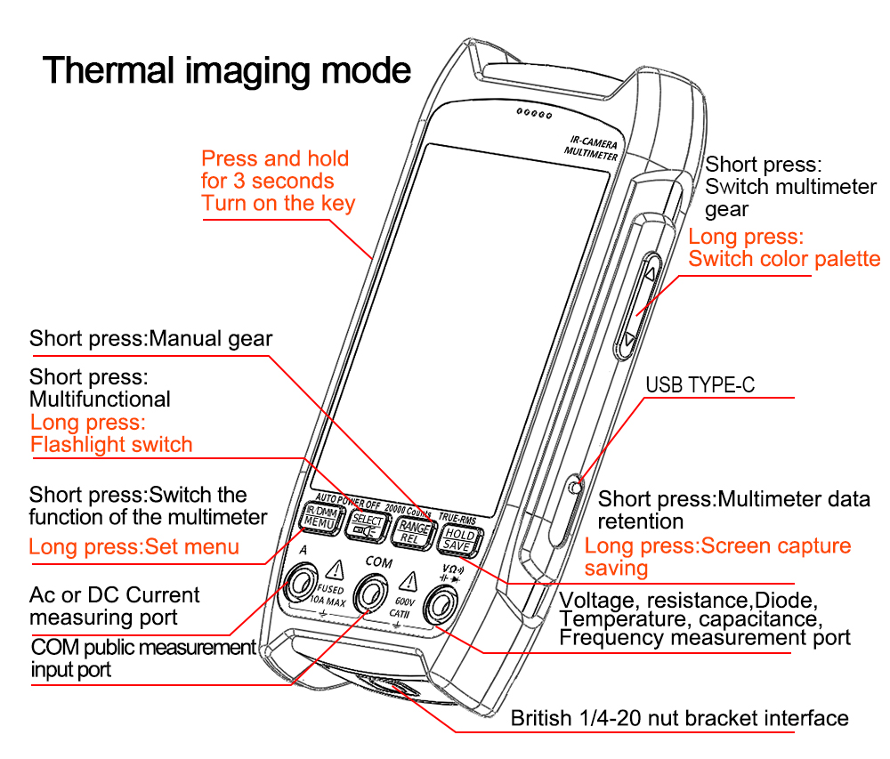

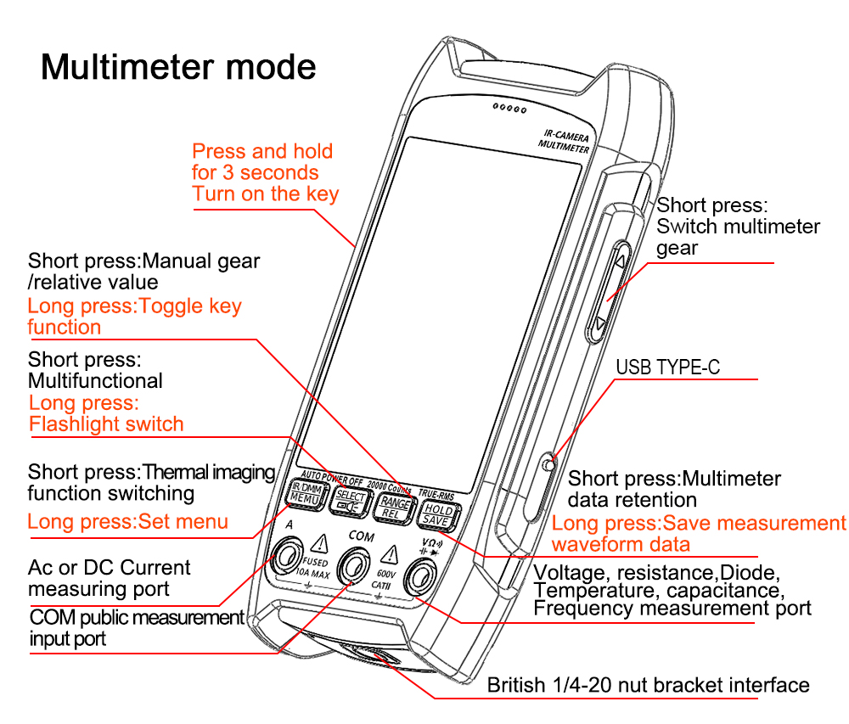

#### 2. Back of the instrument

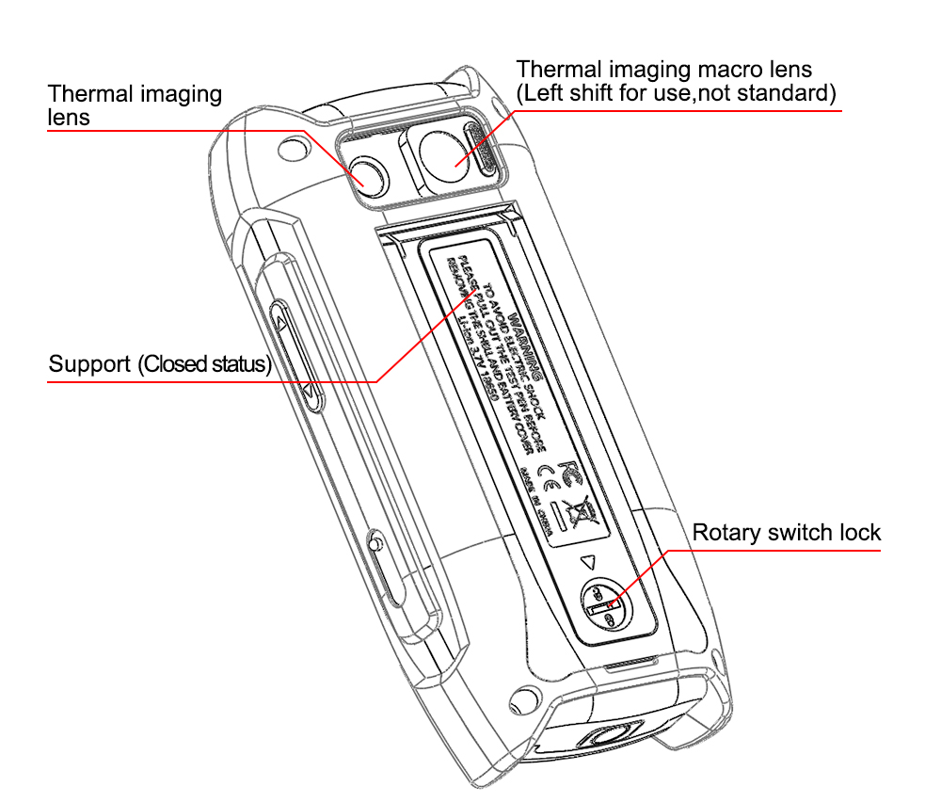

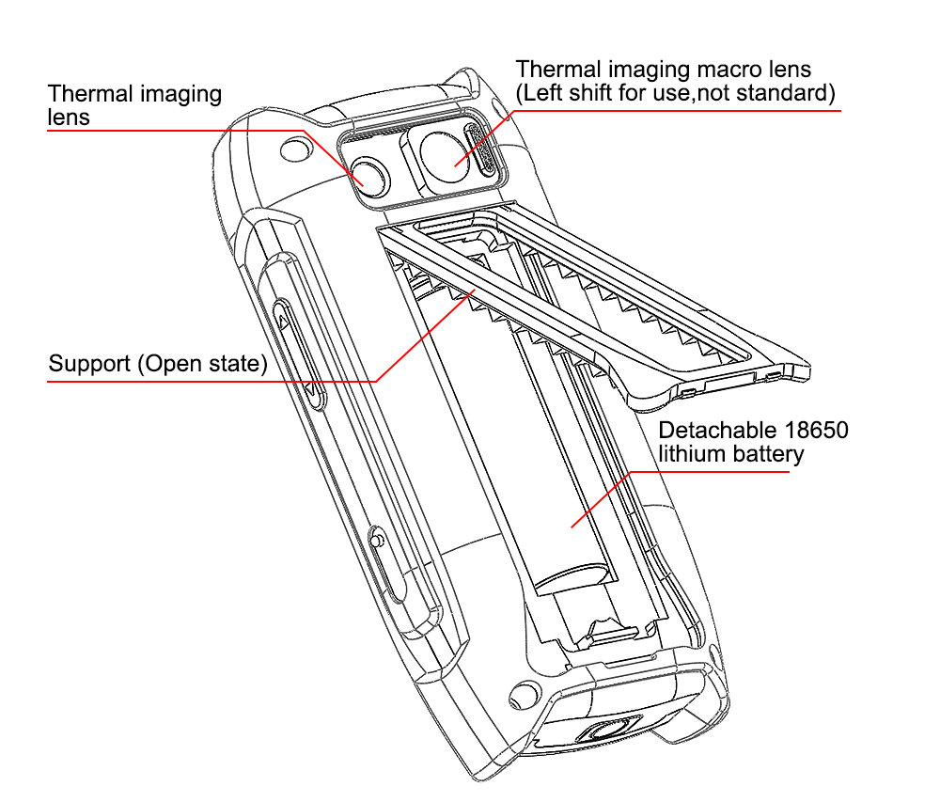

### IV.thermal imaging operating instructions

The thermal imaging interface has measurement functions such as center temperature, maximum temperature, minimum temperature, maximum and minimum temperature difference, and displays multimeter measurement data. The following figure shows the functional description of the thermal imaging interface.

 Warning:

The larger the temperature difference, the better the display effect.

During measurement, the interface may stutter and a "clicking" mechanical sound can be heard, which is a normal phenomenon. This is because thermal imaging is sensitive to changes in ambient temperature, and internal temperature changes can cause inaccurate temperature measurements and blurry images. Therefore, automatic calibration processing will be performed internally.

Inaccurate setting of the measurement gear may result in blurry images. It is possible to estimate the approximate temperature of the object being measured and set the temperature measurement gear accordingly.

If the temperature measurement is inaccurate, you can check if the emissivity is set correctly; When measuring metal objects, there is a significant difference in emissivity between smooth surfaces and oxidized surfaces.

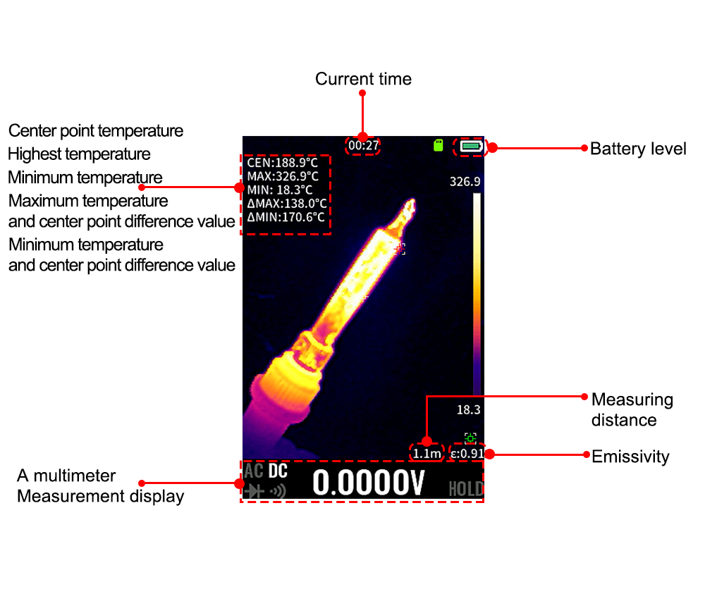

Figure 1

#### 1. Screen capture and save function

**Long press the function button** ,A screenshot save success prompt dialog box will appear in the center of the screen, indicating that the screenshot save is complete. To view screenshot files，Long press the function button  ，Enter the settings menu interface, select the "File" menu to view the saved content.

#### 2. Temperature measurement

By moving the crosshair at the center of the screen to the object being measured on a mobile device, the current temperature of the object can be measured;

Long press the function button ,Enter the settings menu interface and set relevant parameters such as "emissivity", "distance", "temperature range", "unit", etc.

#### 3. Emissivity adjustment

Long press the function button , Go to the settings menu ->select

the"emissivity" menu to change the emissivity, and choose different emissivity according to the material of the tested object;

You can select "Custom" and press the up and down arrow keys on the screen to customize the emissivity value. Long pressing the up and down arrow keys on the screen can speed up the adjustment.

#### 4. Temperature gear switching

Long press the function button  ,Go to the settings menu ->select the "Temperature Range" menu to change the temperature gear. The default gear is automatic, which can be switched according to the temperature range of the object being measured. The high temperature gear is suitable for measuring objects between 100 ℃ and 550 ℃, while the low temperature gear is suitable for measuring objects between -20 ℃ and 150 ℃.

In automatic mode, it is normal for the measurement object temperature to freeze for 2-3 seconds when switching from low temperature to high temperature or from high temperature to low temperature.

#### 5. Color board switching

#### In thermal imaging mode, long press the button on the right side of the device to switch between different color palettes. There are 15 color palettes: white hot, black hot, fusion 1, rainbow, fusion 2, iron red 1, iron red 2, dark brown, color 1, color 2, ice and fire, rain, green hot, red hot, and dark blue.

#### 6. Alarm settings

Long press the function button  Enter the settings menu ->select the "Alarm Settings" menu. After the "Enable" status is turned on, the "Light Alarm" and "Sound Alarm" states can be turned on. Select the "Rules" menu on this interface, press the corresponding up and down arrow keys on the screen to determine whether the alarm rule is "<less than" or ">greater than". Press the return button to exit the rule settings. Select the "Alarm Threshold" menu downwards and set the alarm temperature value. The corresponding up and down arrow keys on the screen can adjust the temperature value. Press the return option to exit the settings interface.

#### 7. Temperature unit

Long press the function button  Go to the settings menu ->select the "Units" menu, and press the confirm option continuously to switch temperature units. Temperature units include ℃, ℉, and K.

#### 8. Display parameters

Long press the function button  Enter the settings menu ->select the "Display Parameters" menu, enter the display settings interface, select one of the parameters, press the confirmation option "Disable", press the confirmation option "Enable" again, and press the corresponding up and down arrow keys on the screen to set other parameters. The setting method is the same.

#### 9. Measuring distance

Long press the function button  Enter the settings menu ->select the "Distance" menu, press the confirm option to set the measurement distance. The corresponding up and down arrow keys on the screen can change the value size. Return to the option to exit the settings interface. The measurement distance range is 0.3-10 meters.

### V. Multimeter operating instructions

The multimeter has data measurement functions such as DC voltage, AC voltage, DC current, AC current, resistance, diode, on-off, capacitance, temperature, NCV, LIVE, frequency, duty cycle, etc. It can switch between automatic and manual gear measurement (default automatic gear) and HOLD data saving function. It also has powerful data waveform recording function, and can achieve data waveform reproduction function with the help of upper computer software. The function setting for the multimeter interface screen to stay on for a long time. Voltage/current gear intelligent switching: When measuring voltage, the multimeter probe is connected to the current measurement port, and the instrument can automatically switch to the current measurement interface.（Note: To avoid electric shock, please remove the probe before connecting the USB device. The multimeter function will be disabled during charging）

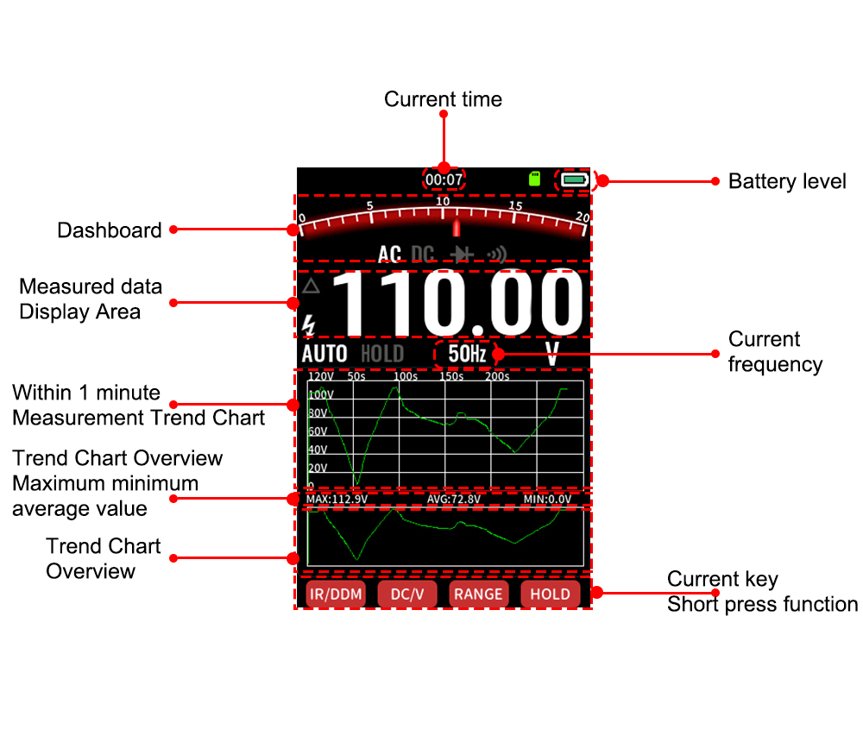

Figure 2 (Multimeter interface description)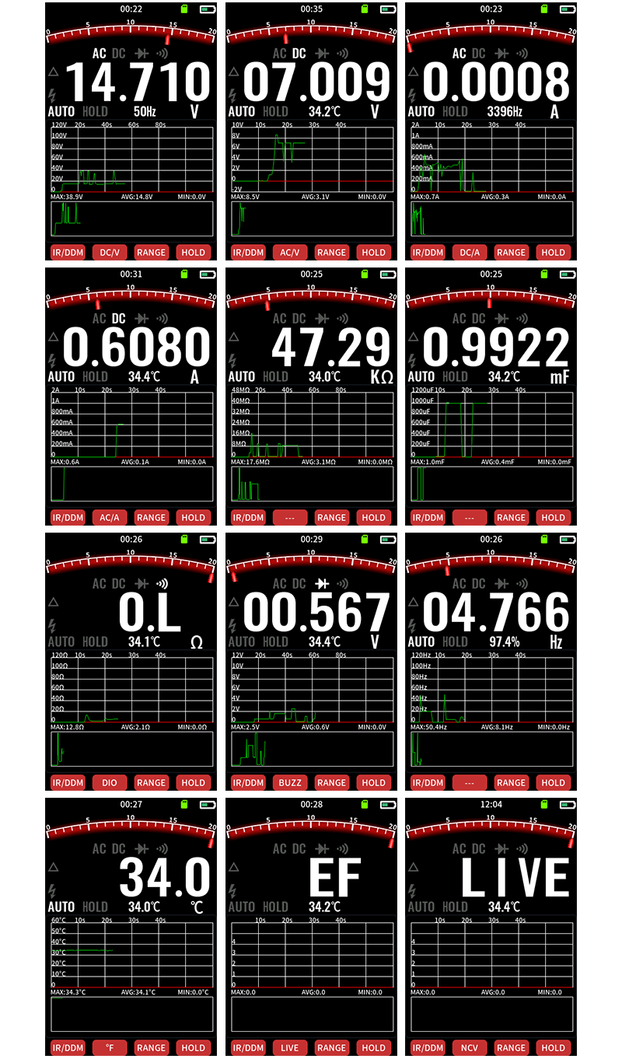

Figure 3

#### 1. Gear switching

According to the desired measurement method, short press the button on the right side of the device to switch the multimeter range, which is the multimeter high range switch; After selecting a certain gear, press this function button  to switch，It is a small gear switch, and the current measured gear icon and measurement unit will be displayed on the screen.

#### 2. AC/DC voltage measurement

Insert the red probe into the "V Ω" socket and the black probe into the "COM" socket;

When short pressing the button on the right side of the device switches to the DC voltage measurement interface, the measurement unit changes to "V", Short pressthis function button， Can switch back and forth between the DC voltage measurement interface and the AC voltage measurement interface;

Read the measurement results from the display interface. The secondary display shows the ambient temperature in DC voltage mode and the frequency in AC voltage mode.

 Warning:

Do not input voltage higher than AC 600V as there is a risk of damaging the instrument.

When measuring high voltage, special attention should be paid to avoiding electric shoc.

When the measured voltage is ≥ 30V safe voltage, the LCD of this instrument displays a high voltage warning prompt “”。

#### 3. AC/DC current measurement

Insert the red probe into the "A" socket and the black probe into the "COM" socket;

Short press the button on the right side of the device to switch to the current measurement interface, and the measurement unit will change to "A", Short press the function button  to switch back and forth between the DC current measurement interface and the AC current measurement interface;

Disconnect the circuit path to be tested. Connect the disconnect point with a test wire and then turn on the power.

Read the measurement results from the display interface. The secondary display shows the ambient temperature in DC current mode and the frequency in AC current mode.

Voltage/current gear intelligent switching function: When measuring voltage, insert the multimeter probe into the "A" socket, and the instrument can automatically switch to the current measurement interface.

 Warning:

To prevent damage to the circuit and possible current fuse burnout, please do not cross (parallel) the probe with the energized circuit when inserting the test wire into the current terminal, as this can cause a short circuit. The maximum current value measured by this instrument is 10A.

#### 4. Resistance measurement

Insert the red probe into the "V Ω" socket and the black probe into the "COM" socket;

Short press the button on the right side of the device to switch to the resistance measurement interface, and the measurement unit will change to "Ω";

Connect the probe in parallel to both ends of the measured resistor;

Read the measurement results from the display interface, and the secondary display shows the ambient temperature.

 Warning:

If the measured resistance is open or exceeds the maximum range of the instrument, the display will show "0L".

When measuring online resistance, all power sources in the tested circuit must be turned off and all capacitors must be discharged with residual charges before measurement. To ensure accurate measurement.

Do not input voltages higher than 30V DC or AC to avoid endangering personal safety.

#### 5. Capacitance measurement

Insert the red probe into the "V Ω" socket and the black probe into the "COM" socket;

Short press the button on the right side of the device to switch to the capacitance measurement interface, and the measurement unit will change to "nF";

Connect the probe in parallel to the two terminals of the measured capacitor;

Read the measurement results from the display interface, and the secondary display shows the ambient temperature.

 Warning:

If the measured capacitance is short circuited or exceeds the maximum range of the instrument, the display will show "OL".

For measurements of capacitors greater than 400uF, a certain reading stabilization time is required for accurate readings.

To ensure measurement accuracy, it is recommended to discharge all residual charges from the capacitor before inputting it into the instrument for measurement. For capacitors with high voltage, it is more important to avoid damaging the instrument and endangering personal safety.

#### 6. Continuity detection

Insert the red probe into the "V Ω" socket and the black probe into the "COM" socket;

Short press the button on the right side of the device to switch to the “”measurement interface, At this point, the measurement unit changes to "Ω", Short press the function button  , It can switch back and forth between the buzzer measurement interface and the diode measurement interface. Under the diode measurement interface, the measurement changes to "V";

When measuring the buzzer gear, connect the probes in parallel to both ends of the tested circuit load. If the resistance between the two terminals being tested is less than 30 Ω, it is considered that the circuit is conductive, and the buzzer sounds continuously. If the resistance is greater than 50 Ω, the buzzer does not sound, and the secondary display shows the ambient temperature when the buzzer is in gear;

 Warning:

When checking the continuity of online circuits, all power sources in the tested circuit must be turned off and all capacitors must be discharged with residual charges before measurement. Do not input voltages higher than 30V DC or AC to avoid endangering personal safety.

When switching to the “”measurement mode, Read the approximate forward PN junction voltage of the tested diode directly from the display interface. For silicon PN junctions, a normal value of about 500-800mV is generally confirmed, and the secondary display shows the ambient temperature.

 Warning:

If the tested diode is open or has reverse polarity, it will display "0L".

When measuring online diodes, all power sources in the tested circuit must be turned off and all capacitors must be discharged with residual charges before measurement.

Do not input voltages higher than 30V DC or AC to avoid endangering personal safety.

#### 7. Frequency and duty cycle measurement

Insert the red probe into the "V Ω" socket and the black probe into the "COM" socket;

Short press the button on the right side of the device to switch to the frequency measurement interface. At this point, the measurement unit changes to "Hz", and "0.0%" is displayed in front of the frequency unit as the duty cycle unit;

Connect the probes in parallel to both ends of the tested object and read the test results from the display interface. The main display shows the frequency and the auxiliary display shows the duty cycle.

 Warning:

Do not input voltages above 60V DC or 30V AC to avoid damaging instruments and endangering personal safety.

#### 8. Temperature measurement

1) Automatic detection of ambient temperature

The product is equipped with automatic environmental temperature detection (secondary display), and the accuracy is for reference only (please restart the device to refresh the current temperature when the product is in different environments).

2) When the HVAC water temperature detection is open circuit, it displays "current ambient temperature", and the secondary display shows the ambient temperature; By connecting the K-type temperature sensor, temperature measurement can be performed in Celsius ℃ or Fahrenheit ℉ (℉=℃ * 1.8+32).

Short press the function button  to switch back and forth between temperature units: ℉, ℃.

Thermocouples should be inserted into the "V Ω" socket with the positive+end and the "COM" socket with the negative - end

#### 9. NCV/LIVE

Short press the button on the right to switch to "NCV" mode without inserting the probe.

Non contact AC voltage sensing NCV: The NCV position on the upper end of the instrument is placed close to the measured conductor or socket for detection. When current is sensed, The measurement interface displays based on the sensing intensity "—" "——" "———" “————", Accompanied by buzzing sound, the secondary display shows the ambient temperature;

When there is no detection electric field on the product, the main display shows "EF" and the secondary display shows the ambient temperature.

 Warning:

NCV sensing endpoints should be used to approach the measured electric field, otherwise it will affect the measurement sensitivity.

When the measured electric field is above 100V AC voltage, attention should be paid to observing whether the conductor of the measured electric field is insulated to avoid harming personal safety.

Short press the function button on this interface  ，You can switch back and forth between the NCV measurement interface and the LIVE measurement interface.

Fireline LIVE identification measurement:

After switching to "LIVE" mode: Insert the red probe into the V terminal, touch the mains socket or bare wire, and distinguish between live and neutral wires

Product without detection display status: The main display shows "LIVE"

When detected as a zero line, the main display shows "LIVE" unchanged;

Sensing the "live wire" of the mains power, the main display shows the "OL" symbol and changes the sound according to the induction intensity, indicating the strength of the live wire voltage.

The secondary display shows the ambient temperature.

 Warning:

When measuring the LIVE function, to avoid interference from the COM input terminal's electric field on the accuracy of distinguishing between live and neutral wires, please remove the black probe from the COM terminal.

When encountering dense high voltage and strong electricity, the accuracy of the product's judgment of the "live line" may be unstable, and it should be judged by LCD display and combined with comparative sound frequency.

#### 10. Manual and automatic range switching

Under the interface of measuring voltage, current, resistance, capacitance, and frequency, Short press the function button  to enter the automatic range setting interface, The range can be manually set for more accurate measurement.

#### 11. Data retention function/waveform data saving

|  |  |  |
| --- | --- | --- |
|  |  |  |

Figure 4 Figure 5

In multimeter mode, Short press the function button  to keep the data on the multimeter; Long press the function button  ，Can save the current waveform data.

If it is necessary to delete the waveform data file, Long press the function button  , Enter the settings menu interface, select the "File" menu to delete saved content.

### VI. System setup instructions

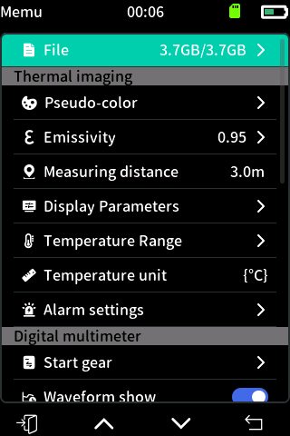

Figure 6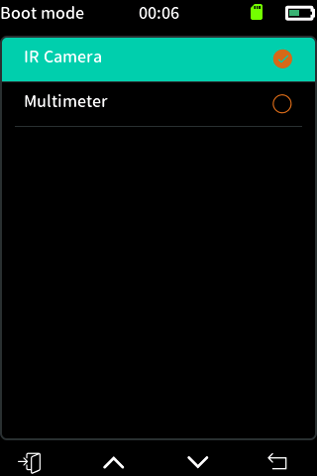

Figure 7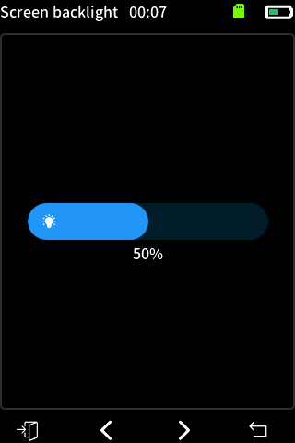

Figure 8

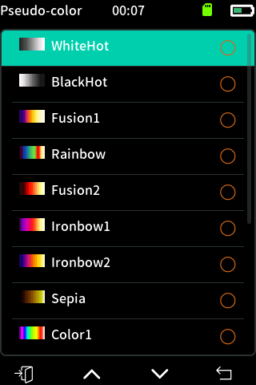

Figure 9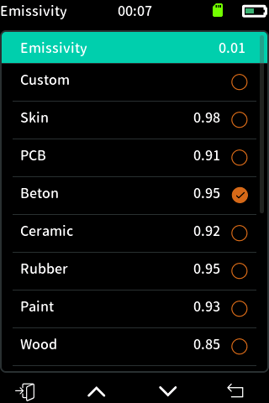

Figure 10

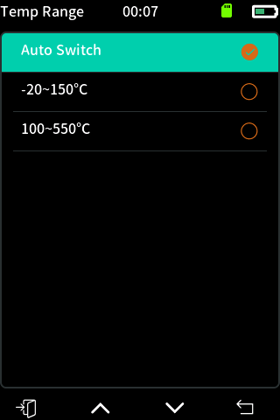

Figure 11

#### 1. System Setup

**Boot mode:** The power on default enters thermal imaging mode or multimeter mode.

#### 2. Backlight & Sound Settings

Reduce the backlight brightness and open the rest time can effectively extend the battery life.

The on/off gear buzzer in the multimeter is not affected by the sound off.

#### 3. Thermal imaging settings

**Color band:** You can modify the display relationship between thermal imaging temperature and color.

**Unit:** Modify the unit of the overall measurement temperature.

**Emissivity:** you can set the emissivity according to the measured object, you can click the bottom gear button to set it quickly.

**Temperature range:** It is recommended to set according to the actual measured temperature. When the automatic gear is selected, it is normal for there to be a 2-3 second lag when the temperature changes from low to high or from high to low. The high temperature range is suitable for temperatures between 100 ℃ and 550 ℃, while the low temperature range is suitable for temperatures between -20 ℃ and 150 ℃.

|  |  |  |
| --- | --- | --- |
|  |  |  |

Figure 12 Figure 13 Figure 14

|  |  |  |
| --- | --- | --- |
|  |  |  |

Figure 15 Figure 16 Figure 17

#### 4. Multimeter settings

**Boot mode:** Set the default gear when the multimeter is first entered at power on.

#### 5. Storage settings

You can preview saved thermal imaging screenshots, select the thumbnail to open its corresponding image, and delete the image after opening it; In the system menu state, go down to the "Format Storage" menu and click to format the storage.

#### 6. USB mode

Enter this USB mode can connect the device's USB to the computer USB to view the files in the device; if you exit this mode USB will be disconnected (Note: To avoid electric shock, please remove the meter pen before connecting the USB to other devices).

#### 7. Constant brightness setting on the multimeter interface

Enter the system settings interface, go down to the "Multimeter Screen Always On" menu, press the confirm option to turn on the multimeter interface constant on function, and press again to turn off the multimeter interface constant on function.

#### 8. Intelligent switching of voltage/current gear

When measuring voltage, insert the multimeter probe into the "A" socket, and the instrument will automatically switch to the current measurement interface, allowing for direct current measurement.

### VII.the use of the upper computer

Thermal imaging image temperature reproduction and multimeter data waveform reproduction functions can be realized using the upper computer.

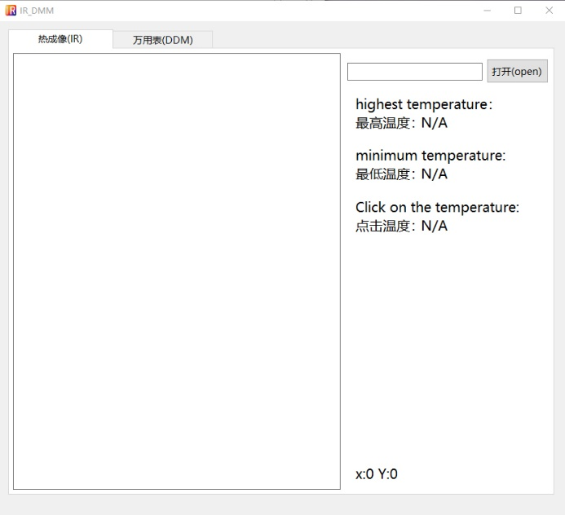

Figure 18

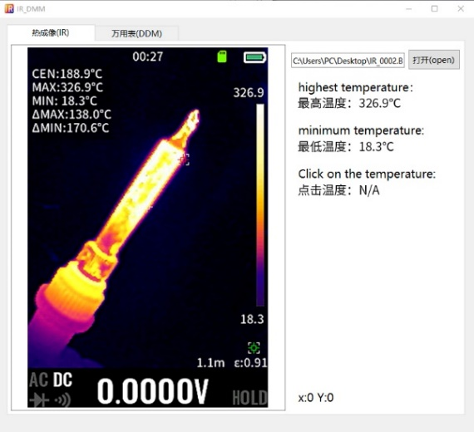 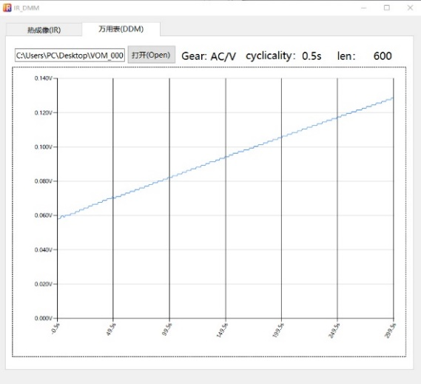

Figure 19 Figure 20

1. Thermal imaging temperature reproduction:

First open the upper computer as in Figure 18, select the Thermal Imaging tab, click the Open button to select the thermal imaging screenshot image as inFigure 19, use the left mouse button in the thermal imaging image area to get the temperature value of the currently clicked area.

2. Multimeter data waveform reproduction:

First open the upper computer as Figure 18, select the multimeter tab, click the Open button to select the multimeter waveform data file as Figure 20, move the mouse to the waveform graph area, and fluctuate the mouse wheel to zoom in and out of the waveform.

### VIII. Technical specifications

|  |  |  |  |
| --- | --- | --- | --- |
| **Thermal imaging parameters** | | | |
| Sensor | | Vanadium oxide (VOx) | |
| Image capture frequency | | 25Hz | |
| Thermal imaging pixels | | 256x192 | |
| Display image resolution | | 427 x 320 | |
| Field of View (FOV) | | 50.0°(H) × 37.2°(V) | |
| Emissivity | | 0.1 – 0.99 adjustable,(0.95 by default) | |
| Temperature range | | -20℃ ~ +550℃ | |
| Gain mode | | Auto Gain | |
| Color palette | | White Heat, Black Heat, Fusion 1, Rainbow, Fusion 2, Iron Red 1, Iron Red 2, Dark Brown, Color 1, Color 2, Ice Fire, Rain, Green Heat, Red Heat, Deep Blue | |
| Accuracy | | ±2℃or±2% | |
| Measurement resolution | | 0.1℃/0.1℉ | |
| **Multimeter parameters** | | | |
| DC maximum input voltage | | 1000V | |
| AC maximum input voltage | | 750V | |
| Maximum current measurement | | 10A | |
| The maximum resistance | | 99.99MΩ | |
| The maximum capacitance | | 199.99mF | |
| Duty cycle test range | | 0.1% ~ 99.9% | |
| Diode test range | | 0V ~ 3V | |
| Continuity test | | 199.99Ω | |
| Display word count | | 19999 counts, Updates 3/sec | |
| **Accuracy** | | | |
| Function | Range | Resolution | Accuracy |
| AC Volts | 1.9999V  19.999V  199.99V  999.9V | 0.0001V  0.001V  0.01V  0.1V | 1.0% +3 |
| DC Volts | 1.9999V  19.999V  199.99V  999.9V | 0.0001V  0.001V  0.01V  0.1V | 1.0% +3 |
| AC current | 1.9999A  9.999A | 0.0001A  0.001A | 1.0% +3 |
| DC current | 1.9999A  9.999A | 0.0001A  0.001A | 1.0% +3 |
| Resistance | 199.99Ω  1.9999KΩ  19.999KΩ  199.99KΩ  1999.9KΩ  19.999MΩ | 0.01 Ω  0.1Ω  0.001 kΩ  0.01 kΩ  0.1 kΩ  0.001 MΩ | 0.5% + 3 |
| Diode Test | 3.000V | 0.001V | 10% |
| Capacitance | 19.999nF  199.99nF  1999.9nF  19.999uF  199.99uF  1999.9uF | 0.001nF  0.01nF  0.1nF  0.001uF  0.01uF  0.1uF | 2% +5 |
| 19.999mF  199.99mF | 0.001mF  0.01mF | 5% +5 |
| **Other parameters of the equipment** | | | |
| Display type | | 3.5-inch 320 * 480 resolution | |
| USB interface | | Type-C USB | |
| Maximum capacity of TF card | | 64G | |
| lmage storage format | | BMP | |
| Battery Type | | Detachable 18650 Lithium-ion battery | |
| Storage temperature | | -20～60℃（-4～140℉） | |
| Operating temperature | | 0～50℃（32～122℉） | |
| Operating Humidity | | ＜85%RH （ non-condensing ） | |
| Size | | 134 mm * 64mm * 28 mm | |
| Weight | | Host weight: 198g (including battery), packaging weight: 390g | |

### Appendix: Emissivity of common objects

Infrared thermometer temperature measurement when a variety of materials emissivity table

Emissivity(emissivity / emittance)The ratio of the radiation capacity of the object to the radiation capacity of the black body at the same temperature is called the emissivity or blackness of the object, also known as the radiation rate.

For most infrared thermometers, all that needs to be set is the rated emissivity of the material being measured, which is usually preset to 0.95, which is sufficient for measuring organic materials or painted surfaces.

|  |  |  |  |
| --- | --- | --- | --- |
| Material & condition | Temperature range (℃) | Emissivity (near 1 micron) | Emissivity (8 to 14 microns) |
| Steel：polished unoxidized | 100~1200 | 0.05～0.1 | 0.05 |
| Steel：polished lightly oxidized | 100~1200 | 0.45 | 0.35 |
| Steel：roughing unoxidized | 100~1200 | 0.25～0.35 | 0.2～0.25 |
| Steel：slight oxidation in rough machining | 100~1200 | 0.5～0.6 | 0.5 |
| Steel：severe oxidation | 100~1200 | 0.8～0.95 | 0.7～0.95 |
| Steel：liquid | 100~1200 | 0.35～0.45 | 0.3～0.4 |
| Cast iron：polished unoxidized | 100~1200 | 0.3 | 0.2 |
| Cast iron：polished lightly oxidized | 100~1200 | 0.5 | 0.5 |
| Cast iron：severe oxidation | 100~1200 | 0.8～0.95 | 0.8～0.95 |
| Cast iron：liquid | 100~1200 | 0.35～0.4 | 0.2～0.35 |
| Stainless steel: smooth surface | Room temperature ~800 | 0.2～0.25 | 0.1～0.25 |
| Stainless steel: oxidation by 800 ℃ or more | Room temperature ~ 800 | 0.85 | 0.85 |
| Copper: polished unoxidized | Room temperature～260 | 0.06 | 0.04~0.05 |
| Copper: severely oxidized | 100~1000 | 0.8 | 0.8 |
| Gold and gold plating: polished unoxidized | 100~500 | 0.1~0.2 | 0.05~0.1 |
| Gold and gold plating: lightly oxidized | 100 ~ 500 | 0.4 ~ 0.5 | 0.2 ~ 0.3 |
| Gold and gold plating: liquid | 100～500 | 0.22 | 0.22 |
| Lead: polished unoxidized | 50~ 300 | 0.3 | 0.05 |
| Lead: polished slightly oxidized | 50 ~300 | 0.4 | 0.2 |
| Lead: polished severely oxidized | 50 ~ 300 | 0.6 ~ 0.7 | 0.6 ~ 0.65 |
| Brass: polished unoxidized | 20 ~400 | 0.2 | 0.03 |
| Brass: polished slightly oxidized | 20 ~ 400 | 0.4 | 0.2 |
| Brass: polished severely oxidized | 20～400 | 0.7 | 0.6 |
| Brass: roughing unoxidized | 20～400 | 0.4 | 0.2 |
| Brass: roughing slightly oxidized | 20～400 | 0.6 | 0.4 |
| Asbestos | 0～400 | 0.8～0.9 | 0.9～0.95 |
| Asphalt | 0～200 | 0.85～0.9 | 0.8～0.85 |
| Carbon | 0～1500 | 0.8～0.85 | 0.85～0.9 |
| Graphite | 0～1500 | 0.8 | 0.75～0.85 |
| Cement and concrete | 0～100 | 0.6～0.7 | 0.95 |
| Paper and cardboard | 0～100 |  | 0.8～0.95 |
| Paint and wax | 0～100 |  | 0.9～0.95 |
| Rubber hard, black | 0～100 | 0.9～0.95 |  |
| Rubber soft, gray | 0.8～0.85 |  |  |
| Wood | 0～100 |  | 0.8～0.9 |
| Ceramic | 0～100 | 0.3～0.5 | 0.85～0.95 |
| Water (more than 50mm deep) | 0～100 |  | 0.95 |
| Snow | -10 |  | 0.85 |
| Ice | -10 |  | 0.98 |
| Wall clay | 0 ~ 100 |  | 0.9 |
| Human skin | 32 |  | 0.98 |
| Soil:dry | 20 |  | 0.92 |
| Soil:watery | 20 |  | 0.95 |
| Oil film:0.002” thick | 20 |  | 0.46 |
| Gypsum | 0～100 |  | 0.8～0.95 |
| Common red brick | 20 | 0.8 | 0.93 |
| Refractory red bricks | 20 | 0.8 | 0.95 |
| White refractory bricks | 100 | 0.3 | 0.9 |
| Silica bricks | 1000 | 0.5~0.6 | 0.75~0.85 |
| Limestone | 0～100 | 0.4～0.6 | 0.95～0.98 |