**750V Excellent Positive V Antenna**

**750V Antenna Installation and Debugging Instructions**

**750V Antenna Installation Instructions**

1. **drawing:**

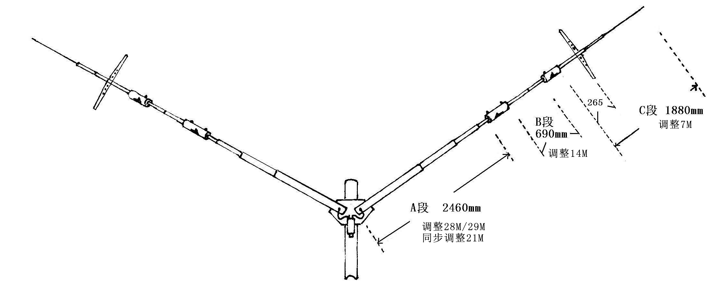

1. **Schematic diagram of assembly of each component:**

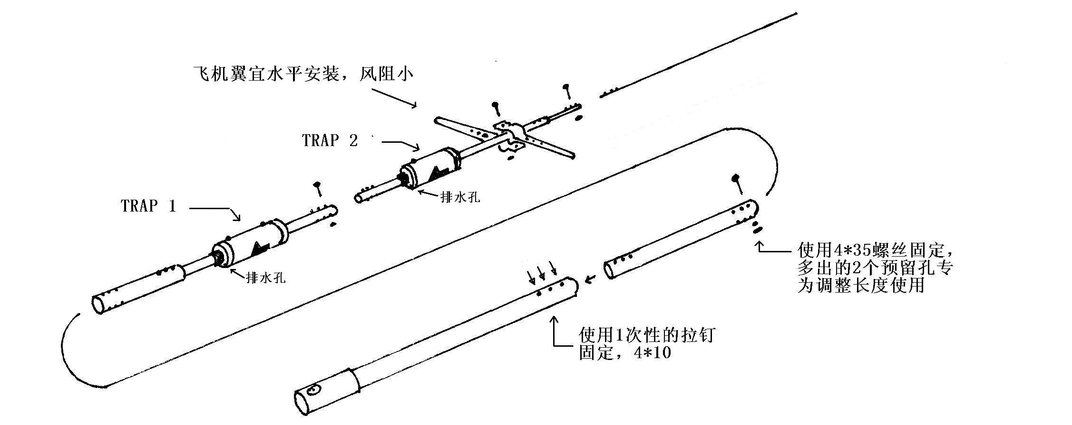

Installation order: First, fix the main oscillator large aluminum tube and extension tube with 3 disposable rivets, then connect TRAP 1 with 1 screw, then connect TRAP 2 with 1 screw, then connect the tail pipe, and finally install the aircraft wing. The oscillator is assembled. When installing, it is advisable to use 3 pairs of 3 holes according to the standard hole position. If the length needs to be adjusted, you only need to stagger the hole position to have an adjustment range of 4 cm up and down. It should be noted that **the drainage hole of TRAP must be downward** . The aircraft wing can work normally when installed horizontally or vertically. It is recommended to install it horizontally, which has low wind resistance and beautiful appearance!

**3. Schematic diagram of mounting plate fixation:**

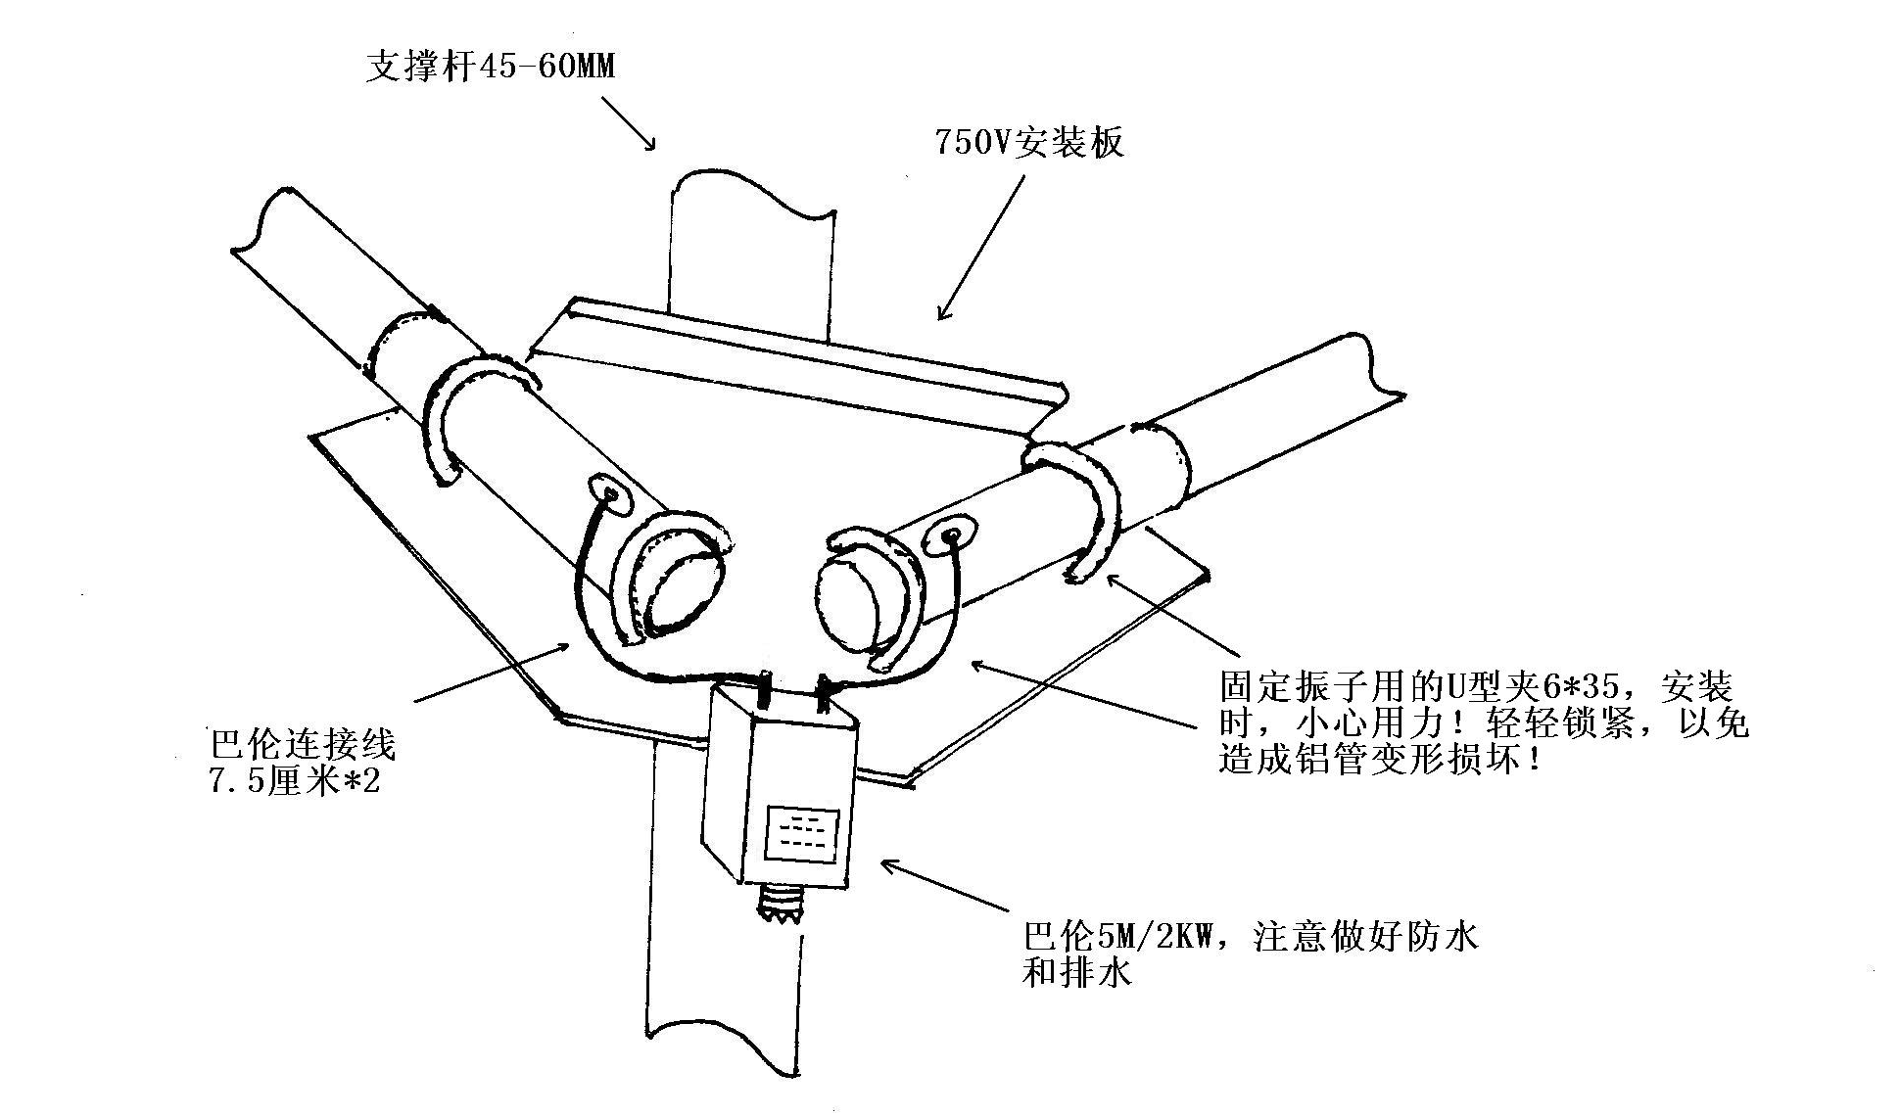

**4. 50MHZ component installation diagram:**

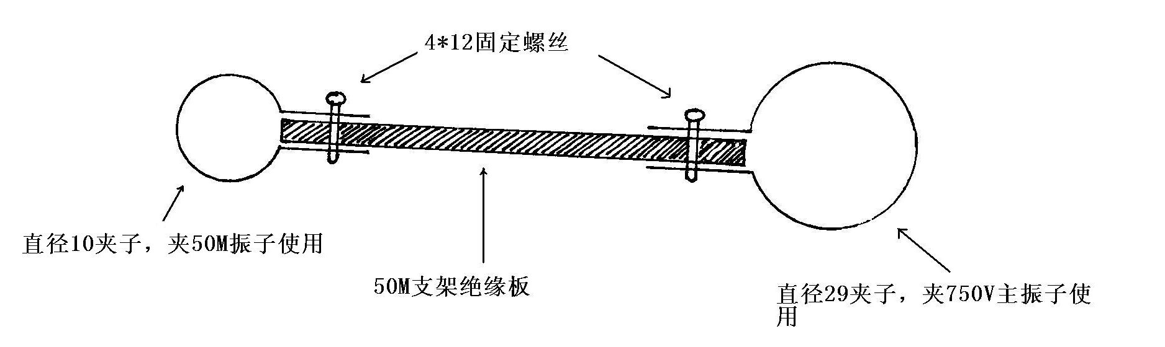

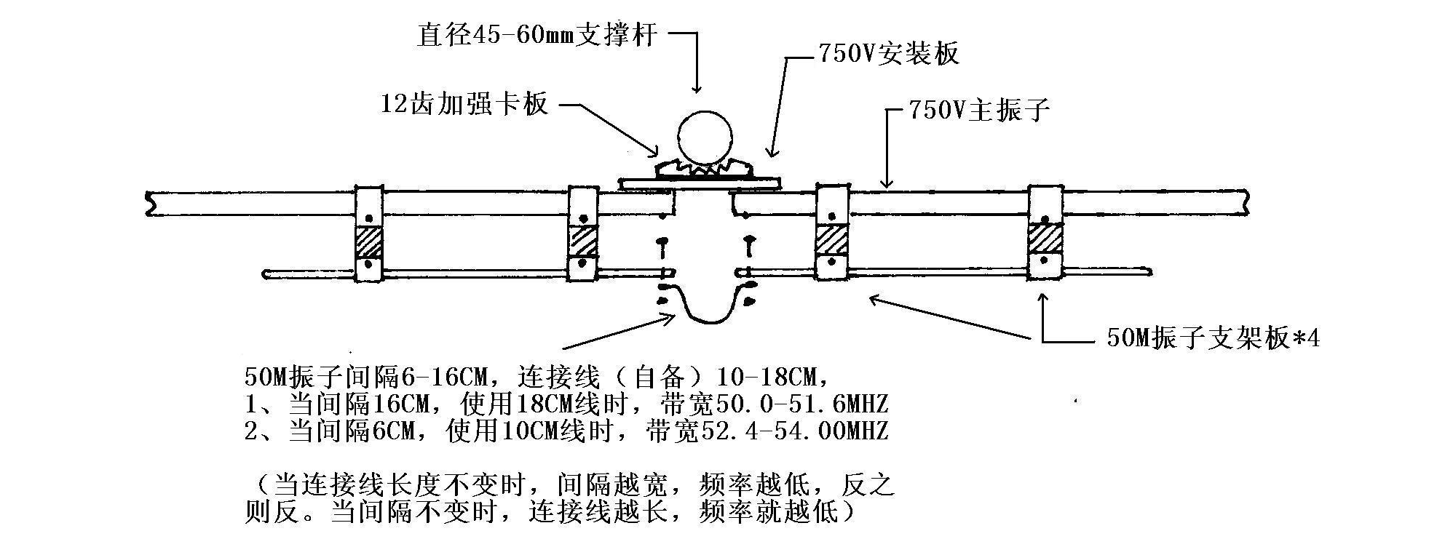

**5. Antenna SWR diagram:** (The data will vary due to different altitudes, environments, feeders, and measuring instruments. You can use it with confidence if the SWR value is less than 2.0!)

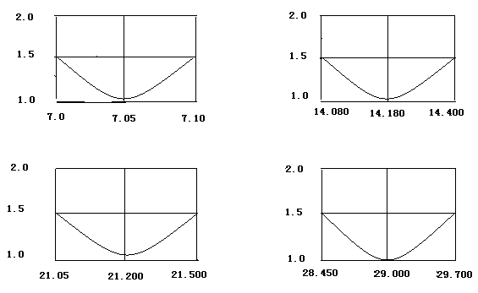

1. **Basic parameters:**
2. Working frequency: 7M, 14M, 21M, 28M, 50MHZ.
3. Standing wave: 1.5:1
4. Power handling: 2KW/PEP, (continuous power SSB=1300W, CW=500W).
5. Wind resistance: less than level 11.
6. Weight: 5.5 kg
7. Size: 5.65m*2 sides
8. Support rod: It is recommended to use a metal pipe with a diameter of 45-60 mm, and the recommended installation height is 3-12 meters

**7. Installation and debugging methods** :

The factory-designed bandwidth of the 750V antenna already covers amateur frequencies very well. Just install it according to the factory standard hole positions of the antenna (3 holes aligned with 3 holes). It will work well without any adjustments.

The change of antenna standing wave will be affected by the height, feeder, environment, and measuring instrument. After installation and testing the data, you can make the following adjustments to the antenna according to your preferences:

1. 28M/29M adjustment, the total length of antenna A section can be changed to achieve the upward and downward shift of 28M/29M frequency. The length of A section can be changed between 2400-2480 mm. The shorter the vibrator, the higher the operating frequency (biased towards 29.6M), and vice versa, the frequency will shift to the lower section of 28. (The factory design center frequency is 29.000, which has taken into account 28/29M. Please do not pursue the perfection of 29.6 standing wave unilaterally. Just install it according to the factory standard hole position of the antenna, 3 holes to 3 holes, no adjustment is required)

2. 21M adjustment is to achieve 21M frequency offset by adjusting 29M. (Center frequency 21.200)

3. 14M adjustment: by changing the length of section B by 680mm, you can adjust the 14M standing wave. If it is shortened, the operating frequency will be biased towards the high section of 14.270. Otherwise, the frequency will shift to the lower section of 14. (The factory designed center frequency is at 14.180, which has taken into account the entire 14M section. Please do not pursue the perfection of the 14.270 standing wave unilaterally. Just install it according to the factory standard hole position of the antenna, 3 holes to 3 holes, no adjustment is required).

4. 7M adjustment is achieved by changing the total length of the C section (tail section) to 1880 mm. If it is shortened, the operating frequency will be biased towards 7.080. Otherwise, the frequency will shift to the lower section of 7.020 (the factory design center frequency is 7.050, which has taken into account the entire 7M section. According to the factory standard hole position of the antenna, 3 holes are matched with 3 holes). Moving the position of the aircraft wing can also change the 7M standing wave.

5. The debugging sequence is from 29M------21M-------14M-------7MHZ. The 50M adjustment does not affect other bands.

6. If you need a larger range of adjustment offset, please contact 135 5368 8148, BG7PNV, thank you!

**8. Tips:**

* 1. Pay attention to the drainage of the balun and do not block the drainage holes below.
  2. To prevent rust on the U-clamp screws, you can apply butter to the threaded part of the screws to prevent rust.
  3. Pay attention to the impact of the environment on the antenna: height, direction, being too close to large or long metal objects, steel cables, solar water heaters, pointed-roof houses, etc., will have a greater impact on the 7M. The antenna can be protected from the impact by changing the height, rotating the angle, and staying away from metal objects.
  4. Important reminder: Using poor feeder (quality) will have a serious impact on the antenna, causing the standing wave in a certain band or even all bands to be unsatisfactory, and the frequency point to be seriously shifted. Conventional adjustment methods cannot take into account good adjustments between several bands. It is recommended to use the standard feeder of Tianjin 609 Factory.

**IX. List of Attachments** :

1. Balun: HF5M/2KW 1 (including 2 7.5 cm leads)

2. 1 mounting plate,

3. 2 pieces of 12-tooth reinforced pallet

4. U-shaped clip: 2 pieces of 8*60, 4 pieces of 6*35

5. Aircraft wings: 4 pieces (with 4 4*10 screws)

6. Pull nails: 6

7. Instructions: 1 copy

8. 50M vibrator and 50M bracket plate: 1.296m vibrator*2 (with screws), bracket plate*4 sets (including 8 4*12 screws)

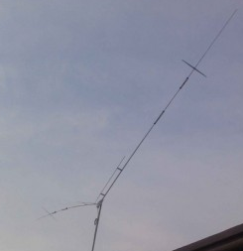 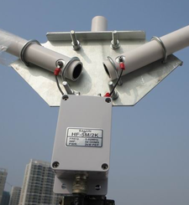

Work hard! Just to thank you for your support and trust!