**LCR bridge brief description**

1. **button**
   1. The power button is located at the top right side of the motherboard. Press it to turn on the machine when it is off. Press it to turn off the machine when it is on, and PowerOff will be displayed . After version 2.41, press the level button and then click the power button to temporarily cancel the automatic shutdown function.
   2. The "Frequency" button modifies the signal frequency. The default setting is 1kHz when the power is turned on. Press the button to cycle through 100Hz/1kHz/10kHz/100kHz/DCR.
   3. Press the "Level" L key to modify the signal level. The default value is 0.6V when the power is on. Press the key to adjust 0.6V/1V/0.2V in a cycle.
   4. clears the base value of stray capacitance between lines in the open circuit state . This function is more useful when measuring small capacitance.
   5. clear the line resistance in the short circuit state . When measuring small resistance, try to use a four-wire Kelvin clip. The contact resistance of the two-wire test lead is unstable, which will cause a relatively large error in the measurement. When measuring milliohm resistance , after switching the level, you need to short-circuit again and press this key to clear to reduce the error caused by the chip gain switching.
   6. The "Display" key can manually select the display parameter Ind/Cap/Res type; the main parameters of the device under test are automatically displayed according to the measured parameters by default when the power is turned on. Press this key to fix the display of inductance/capacitance/resistance parameters. Press and hold the display key for more than 3 seconds to cycle through the display direction. Press and hold once to rotate the display 90 degrees clockwise.
2. **Measuring range**

|  |  |  |
| --- | --- | --- |
|  | Measurement | Resolution |
| resistance | 10mΩ - 20MΩ | 0.1mΩ |
| capacitance | 1pf - 50mF | 0.1pf |
| inductance | 1uh - 2000H | 0.1uh |

1. **show**

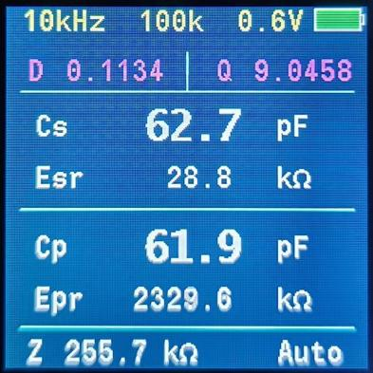

**(The displayed pictures are not updated in time, for reference only, and subject to minor adjustments)**

* 1. The first line shows the current signal frequency, current range resistance, current level and battery status;
  2. The second line shows the D/Q value;
  3. the capacitance/inductance /resistance in series mode respectively ;
  4. The fourth row shows Esr , the equivalent series resistance in series mode;
  5. The fifth line shows Cp/ Lp /Rp, which respectively represent the capacitance/inductance /resistance in parallel mode; the short-circuit calibration line resistance is displayed in DCR state;
  6. The sixth line shows Epr , the equivalent parallel resistance in parallel mode; in DCR state, it shows the resistance of the short-circuit calibration line ;
  7. The seventh line shows the impedance value Z; The last line shows the current display type, LCR is automatic display, in most cases the automatic display can accurately display the corresponding attributes; Ind is inductance, Cap is capacitance, Res is resistance; when measuring some special devices, it may be necessary to display certain attributes in a fixed manner; short press the "Display" button to cycle through the display;

1. **other**
   1. When measuring capacitance, please be sure to discharge the capacitor before measuring, otherwise it is very easy to damage the op amp. Functional tests have been carried out before delivery. If damaged, it can be repaired with the buyer bearing the round-trip shipping costs and the cost of damaged components.
   2. Do not measure when the circuit board is powered, as this may cause damage to the LCR bridge or the device under test. The seller will not be responsible for any losses caused by this.
   3. The device will automatically shut down when the voltage is lower than 3.6V.
   4. After powering on, it will automatically shut down if no button is pressed for 5 minutes.
   5. The charging status light is red, and the fully charged light is green .
   6. The USB interface hardware design can communicate and print, using a virtual serial port, and the corresponding driver needs to be installed. This function has not yet been added, and the protocol can be customized according to needs.
   7. In order to enable a quick response, the algorithm does not perform excessive averaging on the measured data. When measuring mΩ resistance, there will be some fluctuations after the decimal point.

**Bridge use precautions**

1. Before measuring capacitance, it must be discharged . There is a protection tube on the circuit board, but the protection ability is also weak for capacitors with higher capacity or voltage.
2. When measuring inductance of several uH , you can use high frequency (10kHz, 100kHz) for measurement, which will give more accurate measurement value.
3. Electrolytic capacitors are usually measured at 100Hz, and capacitors below 1uF can be measured at 1kHz.
4. It is normal for capacitors of different materials to have very different D values with the same capacity. The D value of electrolytic capacitors is generally larger (less than 0.2 is normal) , and the D value of film capacitors is generally smaller (less than 0.02 is normal) .
5. the quality of capacitors , it is only meaningful to compare capacitors with the same specifications (same capacity & same withstand voltage).
6. For the same material, under normal circumstances, with the same withstand voltage value, the larger the capacity, the smaller the ESR; for the same capacity, the higher the withstand voltage value, the smaller the ESR;
7. The ESR parameter has practical significance for large-capacity filter capacitors. In the filter circuit, ESR directly affects the filter effect. The smaller the ESR, the smaller the voltage ripple caused under the same load condition, and the better the filter effect.
8. Generally speaking, when the complex impedance Z is lower than 100Ω, the series model measurement parameters are more accurate; when it is greater than 10kΩ, the parallel model is more accurate; and any value in between is acceptable.
9. The accuracy of the bridge is much higher than 0.3% between 1Ω and 10kΩ. If you have a high-level meter, you can compare the DCR accuracy.
10. When measuring offline , try to use 0.6V or 1V level to measure, which will drive a larger current and provide more accurate measurement.
11. When measuring in circuit , make sure to turn off the power first and discharge the capacitor before measuring. When measuring in circuit, try to use 0.2V level to test to reduce the measurement error introduced by the transistor circuit.

**DIY clamps and precautions**

1. The charging port is a Type-C port, which allows for convenient charging using a mobile phone charger.
2. The recommended battery specification is 603450, which can be conveniently placed between the bottom case and the circuit board without affecting the appearance. The capacity is about 1200mAh; the startup current of the circuit board is about 90mA, and the 1200mAh battery is discharged to 3.6V to shut down, which is about 60%~80% discharged, and the usage time is about 8-10 hours.
3. Regarding automatic shutdown, it will automatically shut down in 5 minutes without any key operation; any key operation will restart the 5-minute countdown.
4. The acrylic shell has a film with some scratches (caused during the production process). You can tear it off if you mind. After tearing it off, the transparency is greatly improved, but it is easy to get scratched.
5. For Kelvin clip wiring , it is best to use hot melt adhesive and heat shrink tubing to fix the connection between the wire and the clip, which is more secure and less likely to cause wire breakage. The two wires in the middle of the audio cable can be soldered to the two copper plates of the Kelvin clip respectively. Avoid soldering two wires to the same copper plate at the same time, because this will lose the meaning of four-wire measurement and introduce wire errors. The outermost copper mesh of the audio cable is connected to the GND on the board and used as a shielding layer. Just make sure that the shielding layer is not connected to the two wires in the middle .
6. The test leads are connected as shown in the upper figure below. The two middle wires of the audio cable are connected to the metal head of the test lead. The outer copper mesh is used as a shielding layer and should not come into contact with the two middle wires.

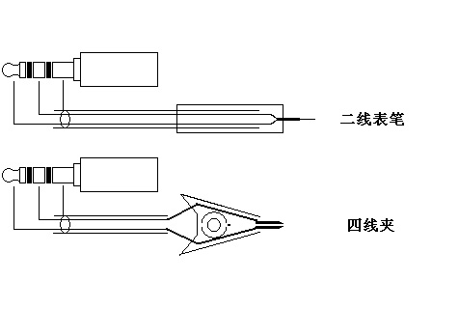

If a fault occurs, such as all displayed parameters are 0 or the measured values are obviously abnormal, please check whether the wiring is wrong or the audio plug is not fully inserted. After unplugging the test lead, the power-on display should be around 1pf, which is the distributed capacitance on the circuit board. When measuring small capacitance, you can press the open circuit to clear the bottom number and then measure. When measuring large capacitance, you can ignore this bottom number.

1. If you are measuring a lot of small capacitance values (1pf-100pf), it is better to add a set of simple tweezers. The measurement is stable, the wire error is small, and the reliability is high.