LM320C Digital Angle Meter

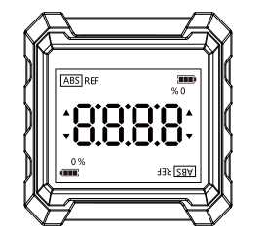

User Manual

PREFACE

Thank you for purchasing the Digital Angle Meter. In order to use this product safely and correctly, please read this manual thoroughly.

After reading this manual, it is recommended to keep the manual at an easily accessible place, preferably close to the device, for future reference.

LIMITED WARRANTY AND LIABILITY

Uni-Trend guarantees that the product is free from any defect in material and workmanship within one year from the purchase date. This warranty does not apply to damages caused by accident, negligence, misuse, modification, contamination and improper handling. The dealer shall not be entitled to give any other warranty on behalf of Uni-Trend. If you need warranty service within the warranty period, please contact authorized service center or send the product back with problem description.

This warranty is the only compensation you can obtain. Uni-Trend will not be responsible for any special, indirect, incidental or subsequent damage or loss caused by any reason or speculation. As some areas or countries do not allow limitations on implied warranties and incidental or subsequent damage, the above limitation of liability and stipulation may not apply to you.

Product Overview
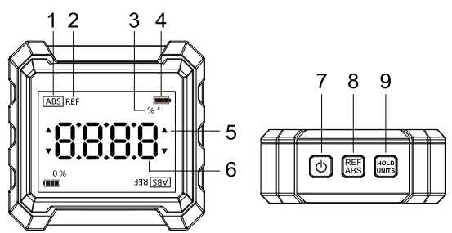

1 | Absolute value display
2 | Relative value display
3 | (%,°) Unit display
4 | Battery state
5 | Angle direction display
6 | Measured data display
7 | POWER
8 | Absolute value/Relative value switch
9 | Data hold/Unit switch

Technical Specification
Model | LM320C
Measurement Range | 4*90°
Resolution | ±0.05°
Angle Accuracy | ±0.2°
Repeatability | ±0.2°
Unit | %,°
Magnetic Base | Three-sided magnetic
Relative/Absolute Angle Measurement | √
Angle Hold | √
Screen Flip | √
Auto Power Off | No operations in 3min
Machine Material | PC+15%GF
Power Supply | 2 x AAA 1.5V dry battery
Working Temperature | 0°C - +40°C
Relative Humidity | 40%-80%RH
Battery Life | ＞24 hours, continuous work
Size | 62*62*25mm
Weight | About 88g

Operations:
Power On: In power-off state, short press  button to power on.
Power Off: In power-on state, long press button for 3-5 seconds to power off.

Functions:
- Absolute Angle Measurement (ABS)
Press button to power on and it defaults to absolute measurement (regardless of battery changes). It displays the angle between the measured surface and the horizontal.
As the angle between the device's working surface and the level changes, the angle value also changes, as shown in Figures 1 and 2.

- Relative Angle Measurement (REF):
Place the device on the worktop with its power-on state. Short press  button to enter relative mode (set the current value to 0), and short press it again to exit this mode, as shown in Figure 3 and 4.
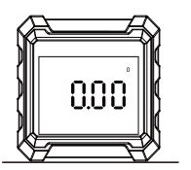Figure 1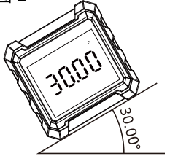Figure 2
Absolute Angle Measurement (ABS)

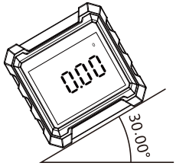Figure 3 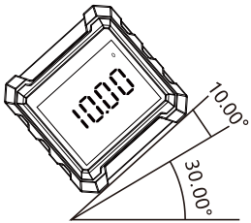Figure 4
Relative Angle Measurement (REF)

- Display Lock

Short press  button, the displayed value will not be changed, regardless of the device's inclination angle. Short press it again to restore measurement.
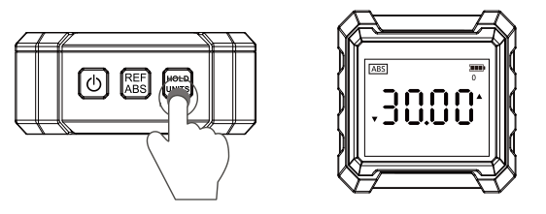

- Percentage/Angle Unit Switch

Long press button to display the percentage, and long press it again to back to the angle mode.

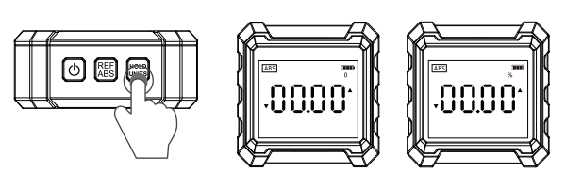
Angle Display Percentage Display

Cautions
- Do not use organic solvents to clean the device. Keep it away from water and corrosive substances.
- Do not damage the working surface of the device. Use a soft cloth to remove dirt to ensure its measurement accuracy.
- The device will be auto power off to save power if no operations in 3 minutes. Replace a new 1.5V AAA battery in time when the low battery icon displays.
- If the device is not used for a long time, take the battery out to avoid battery leakage.

Accessories
LM320C Angle Meter | 1 | Gift Box | 1​
AAA 1.5V Dry Battery | 2 | Blister Tray | 1​
User Manual | 1

The manual is subject to change without prior notice!

Due to different batches, the materials and details of actual products may be slightly different from the graphic information, please refer to the actual product received. Experimental data provided in the page is from internal laboratory of UNI-T, but it should not be a reference for customer to place orders. Any questions, please contact the customer service, thanks!

