FlyingRC F4WSE MK1.5
Description:
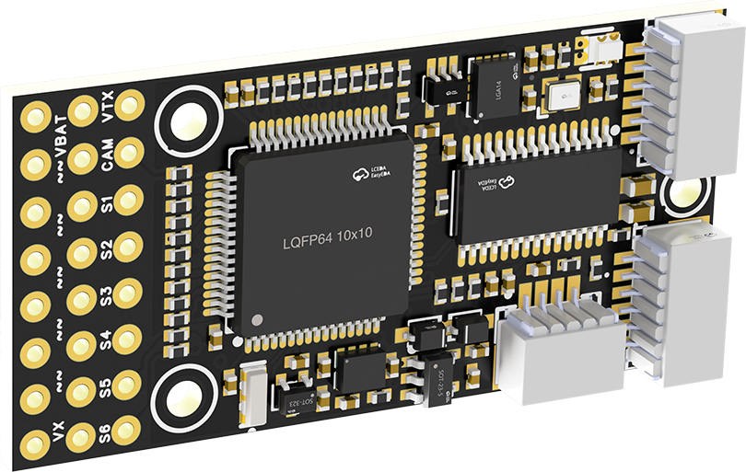
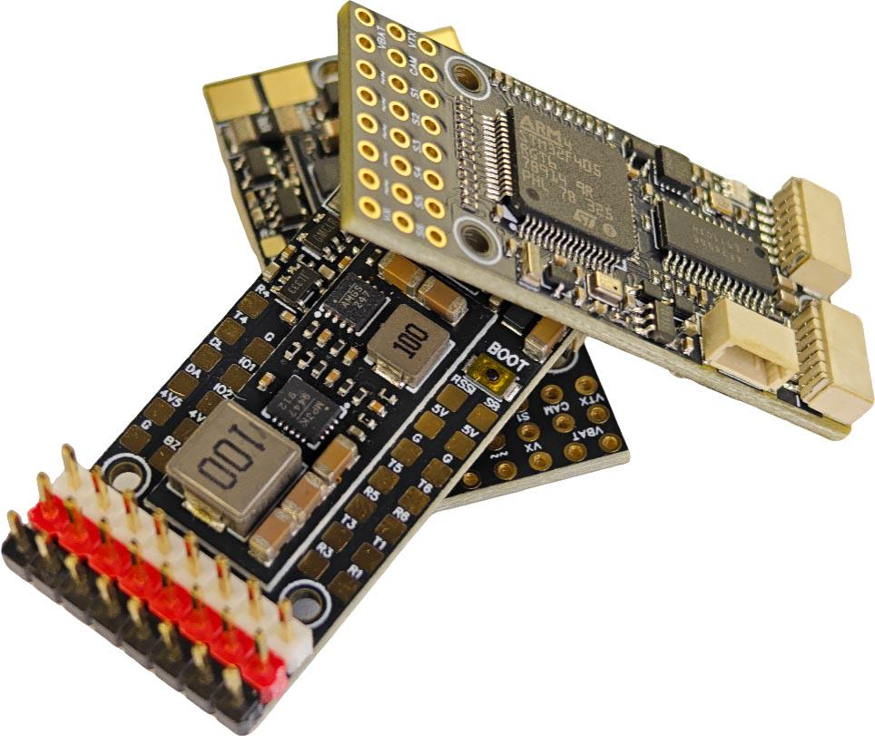
- MCU: STM32F405RGT6, Gyro/Accel: ICM-42688-P, Baro: SPL06-001，
- Analog/HD OSD, 5xUARTs, 1xSBUS, 12PWMs (6 + 6), 1I2C, 1ADC (RSSI), 2xPinIOs
- Blackbox: external TF card module, maximum available 4GB, max supported 32GB
- Current Sensor: 40A/80A Continuous./Instant(<3s)
- 7~28V DC IN（2~6S LiPo）
- Dual BEC, MP9943+MP9447, 5V2A (For devices)& 5V4A (For servos)
- Dimension & Weight: 20mm*40mm*9mm, 9g
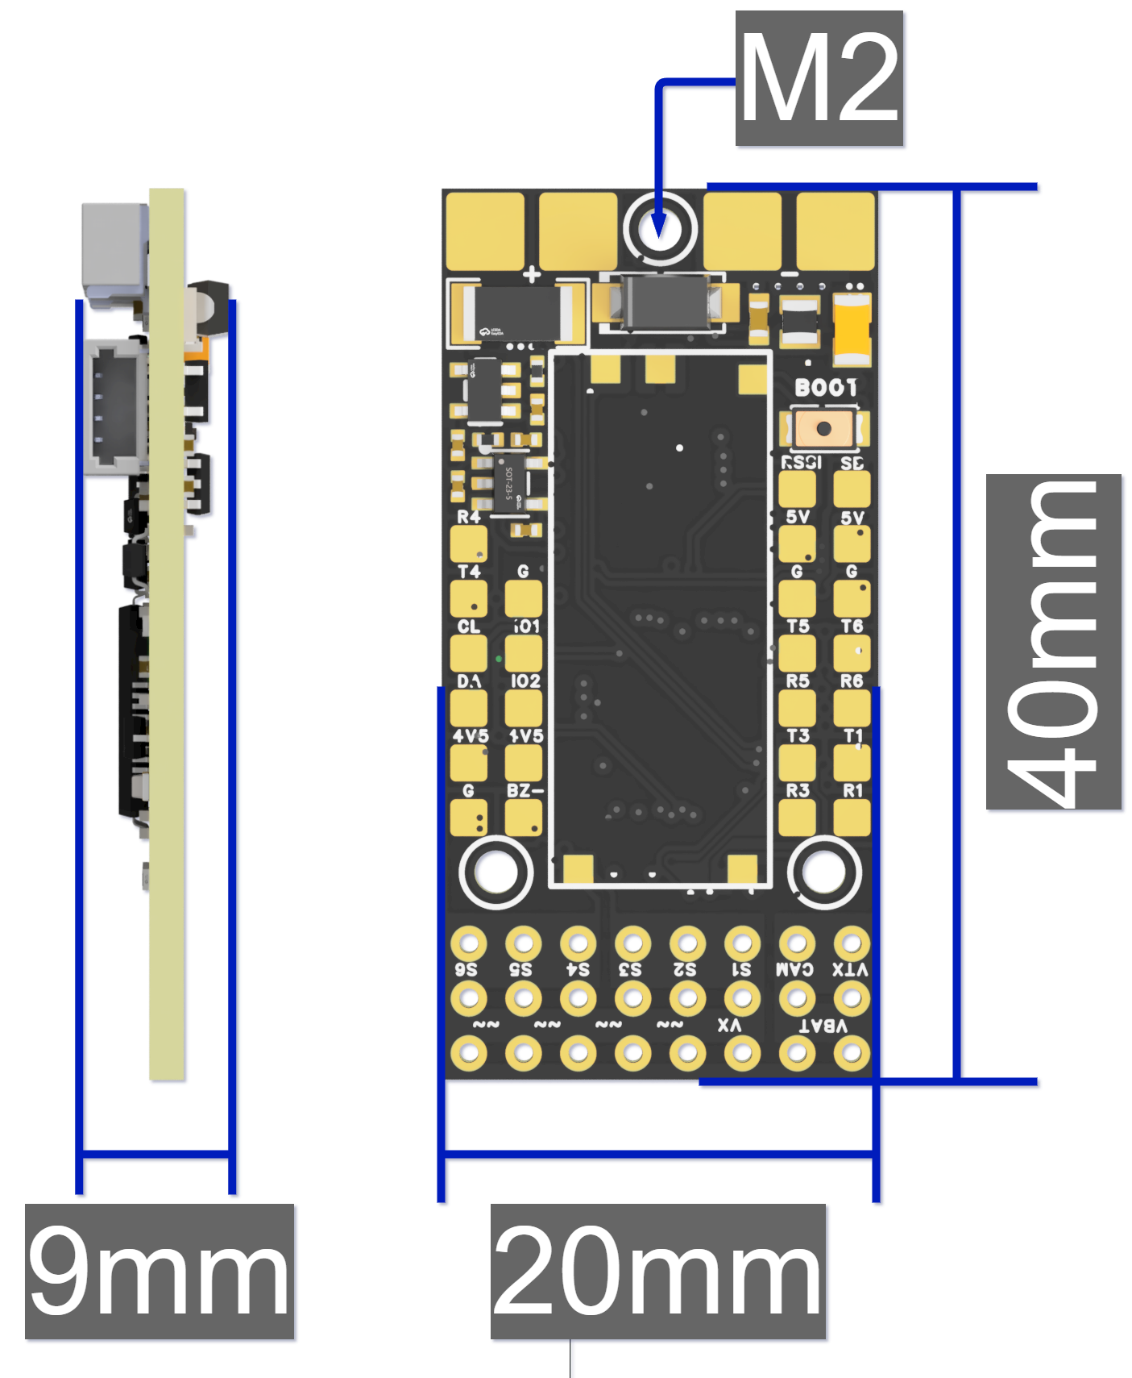
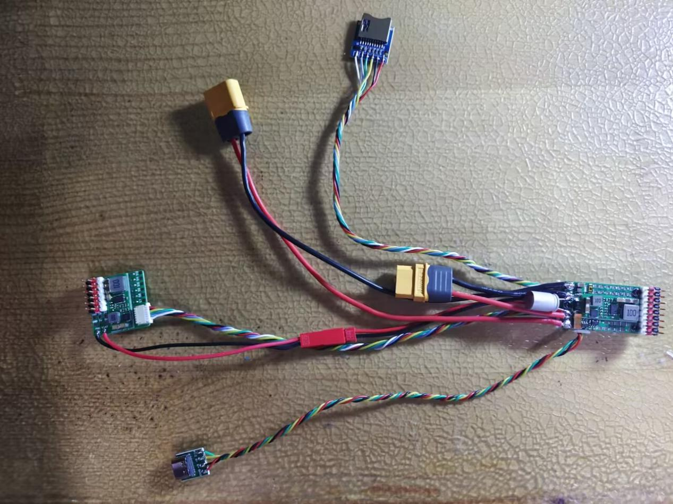
Advanced Version (some wires are not included in the package)
Features:
- Small in size, suitable for small FPV drones or modified hand-launched aircraft, can also be connected to expansion boards, totaling 12 PWM channels, suitable for use in large drones as well.
- Using high-precision gyroscopes and barometers, the stability of the flight controller is significantly improved.
- The flight controller has the strongest BEC current output capability comparing with other flight controllers of the same size.
- External USB connector, external TF card module, allowing more flexible installation in small sized planes.

LAYOUT:
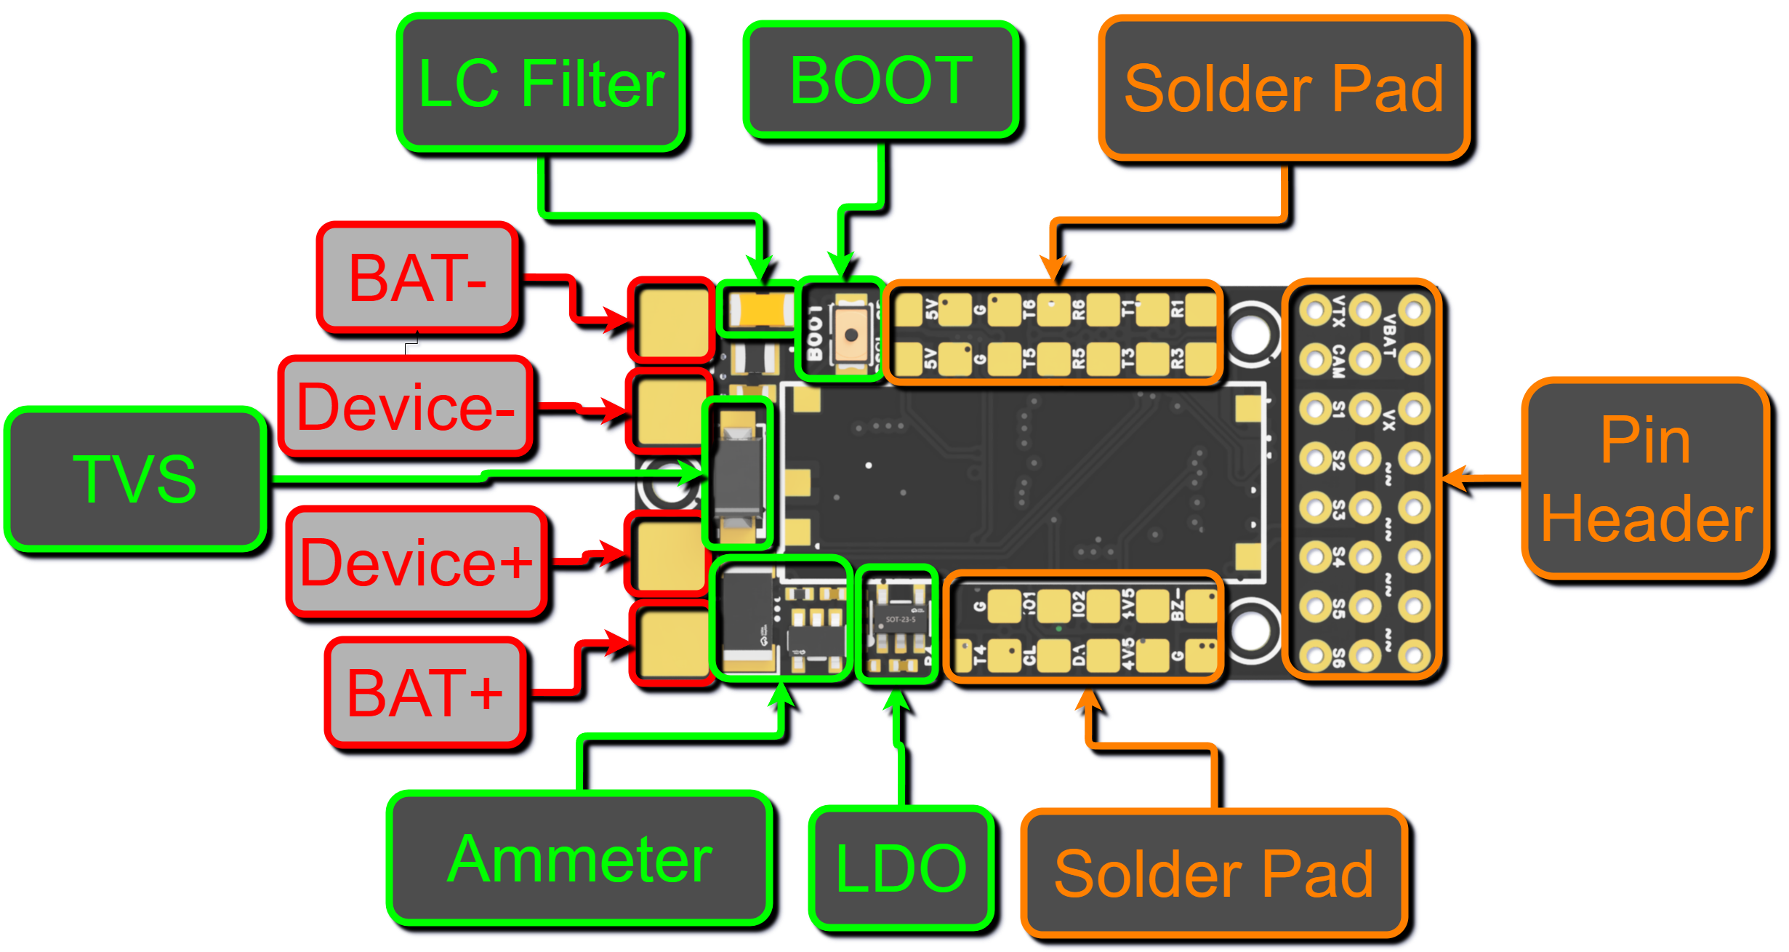
3D Diagram - Top
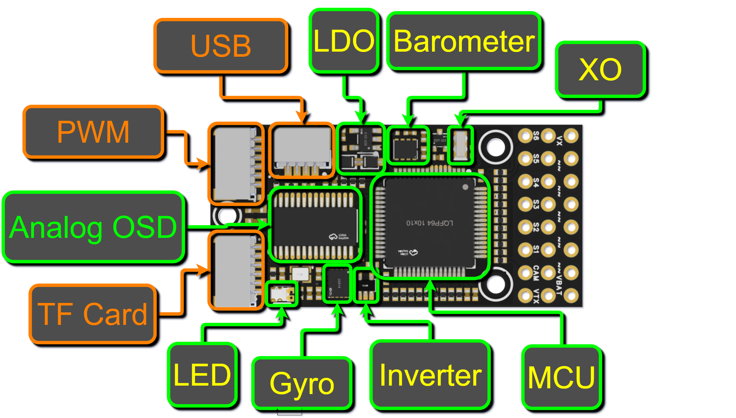
3D Diagram - Bottom

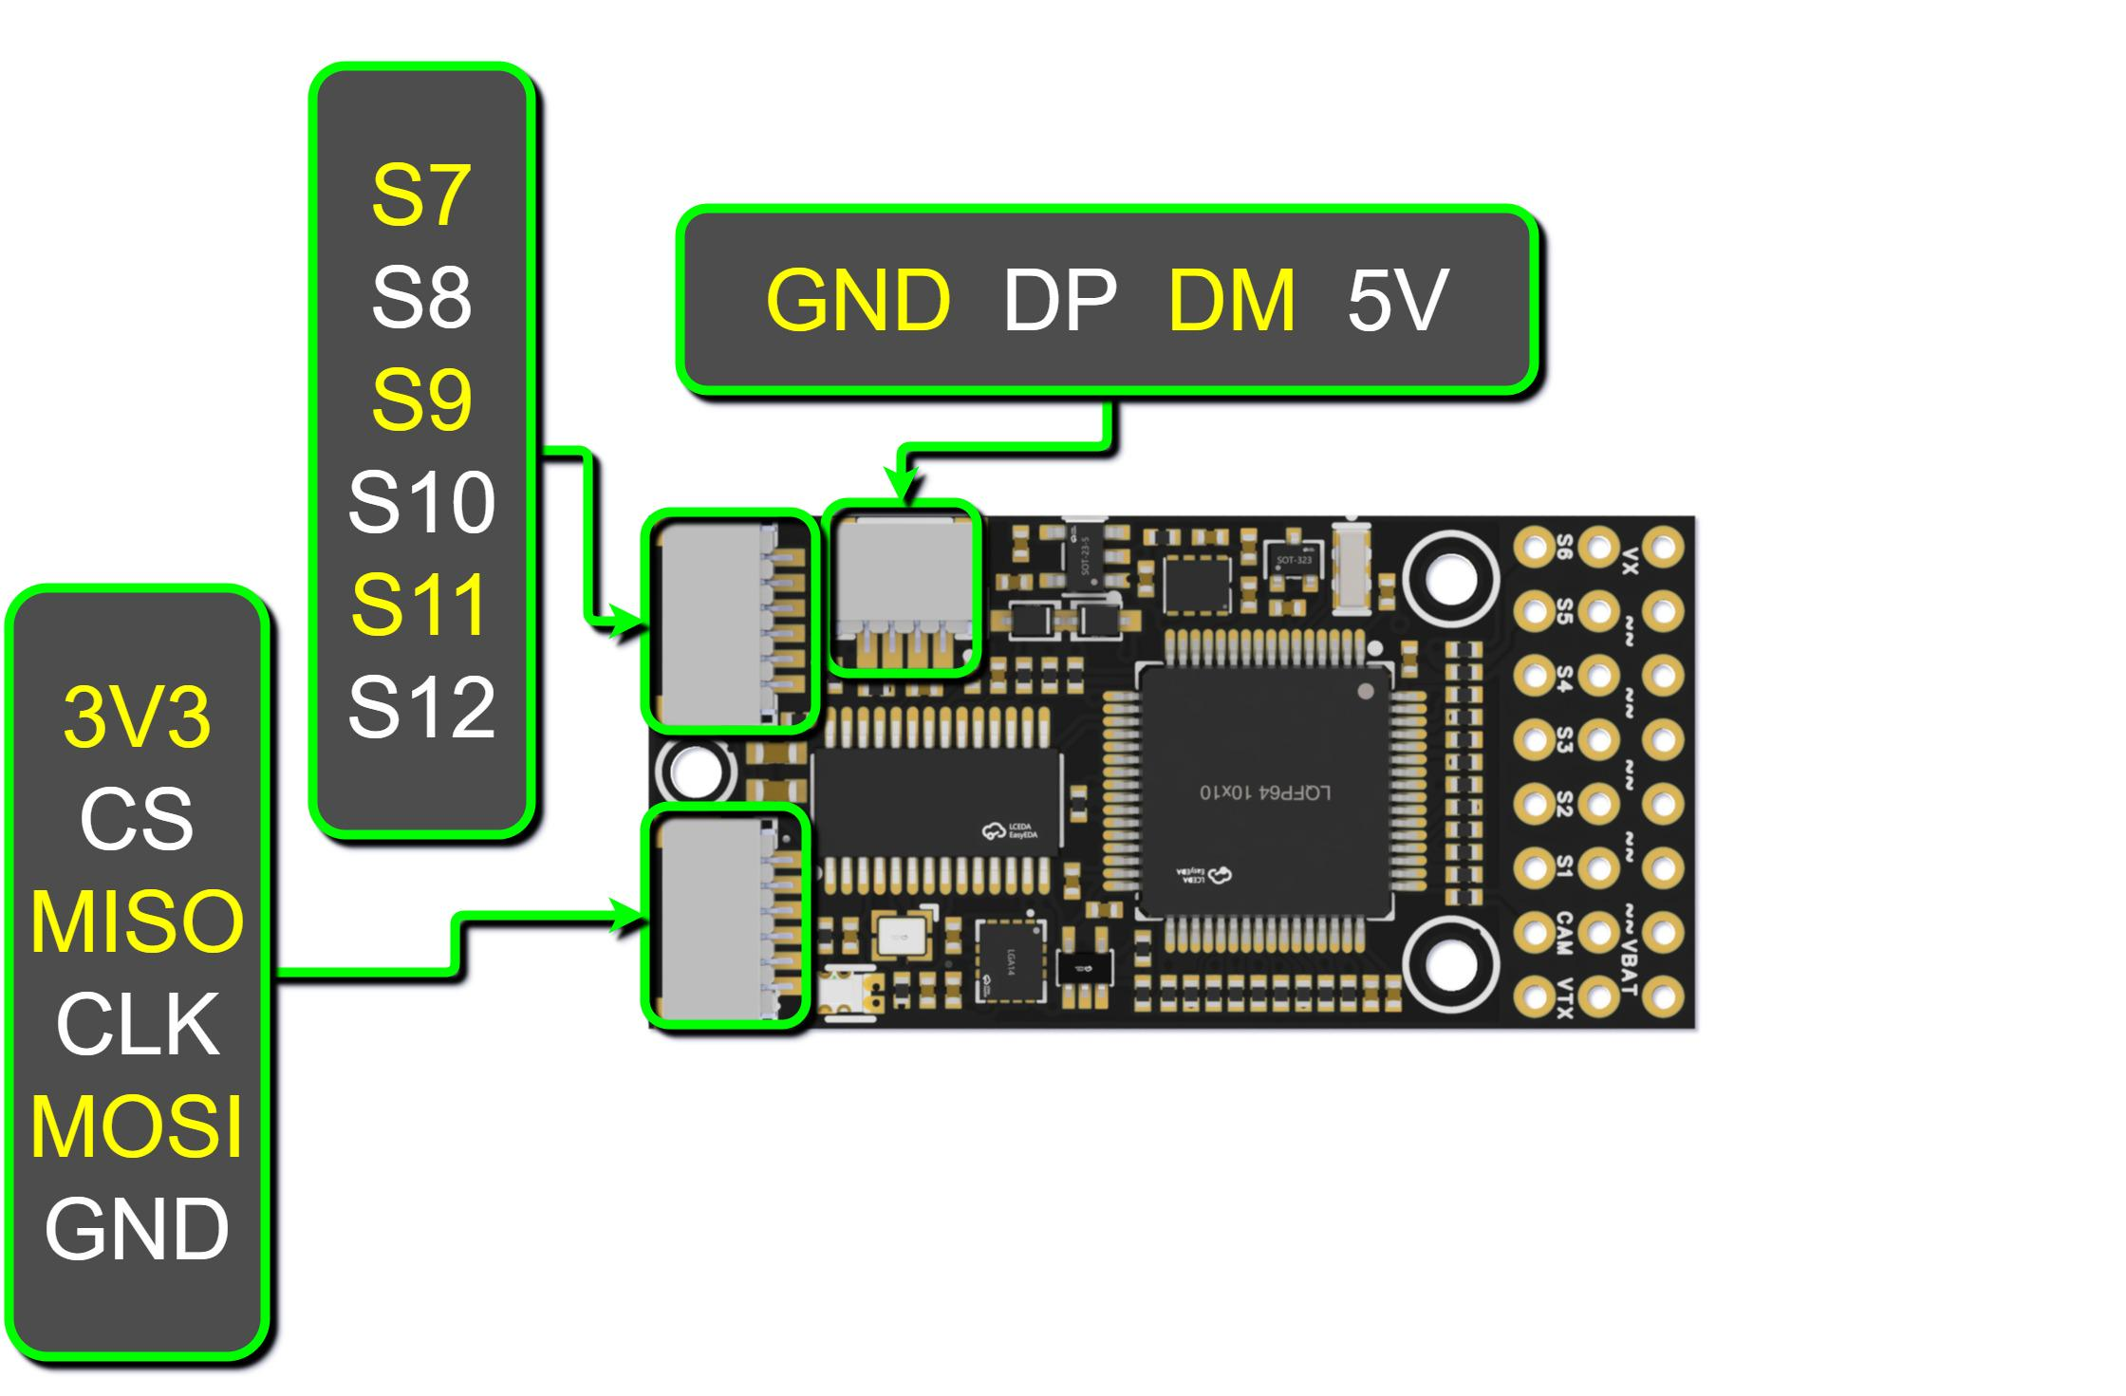
Connector Function Diagram

Preparation before using：
  - Preparation of Tools and Materials:
soldering iron or soldering station (T12 series or 936 series recommended),
solder wire (recommended 63Sn37Pb), wire (28-30AWG wire recommended for signal wires, 14-18AWG recommended for power wires),
35V 470uF capacitor (can be parallel soldered on the power input pad, optional),
10V 2A buck module (optional, required for DJI HD video transmission system, Caddx HD video transmission system, and some analog cameras and video transmission systems with poor filtering).

  - Solder the external boards to the included connecting wires:
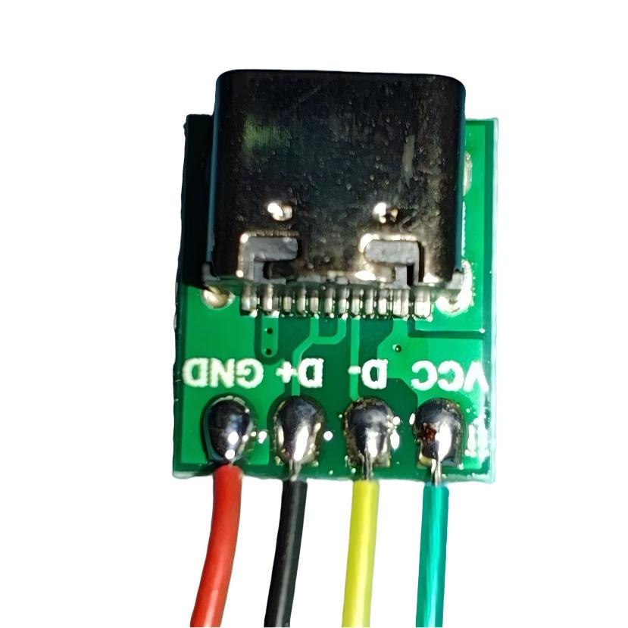
Soldering order of wire to USB board

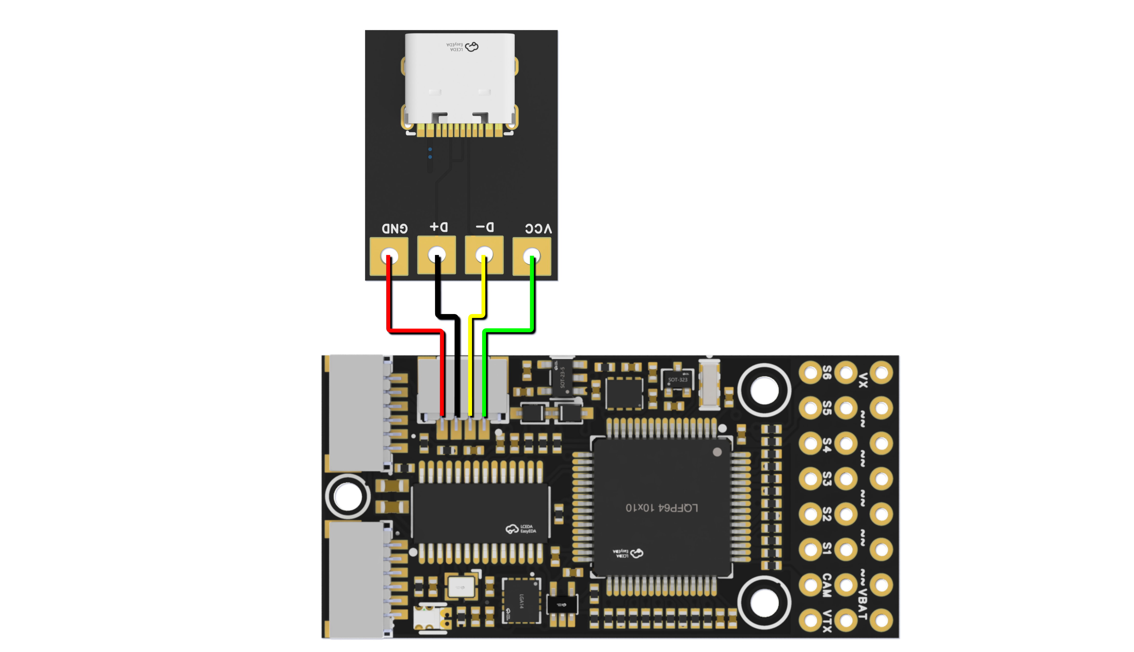
Wiring diagram for connection to USB small board
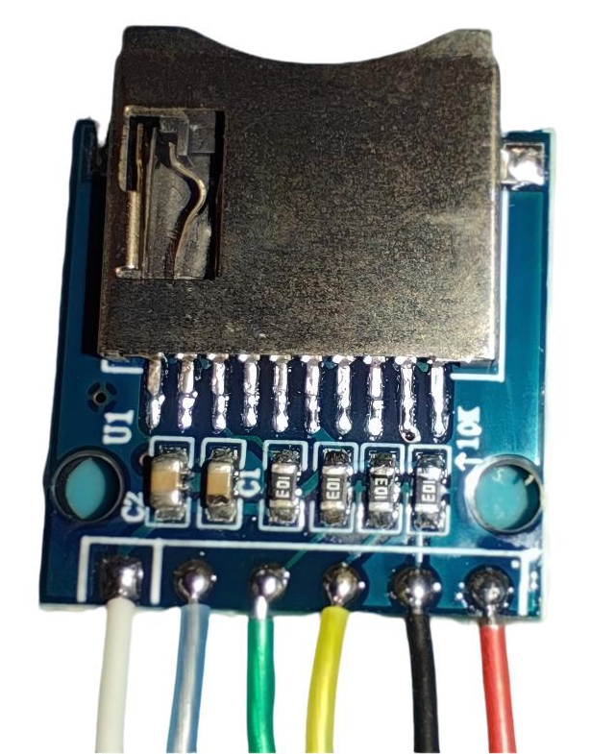
Soldering order of wire to External TF Card module

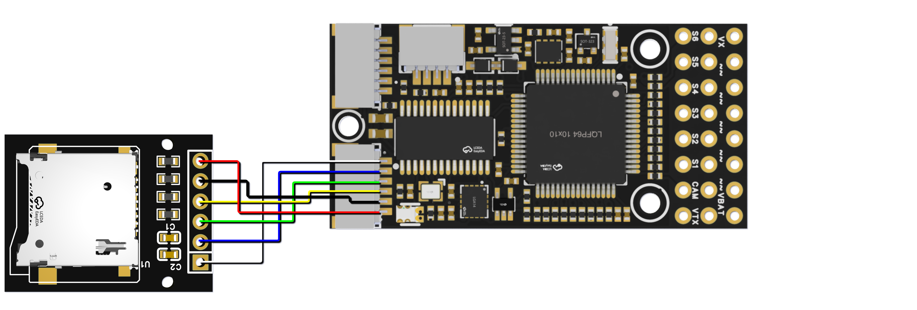
Wiring diagram for connection to TF small board

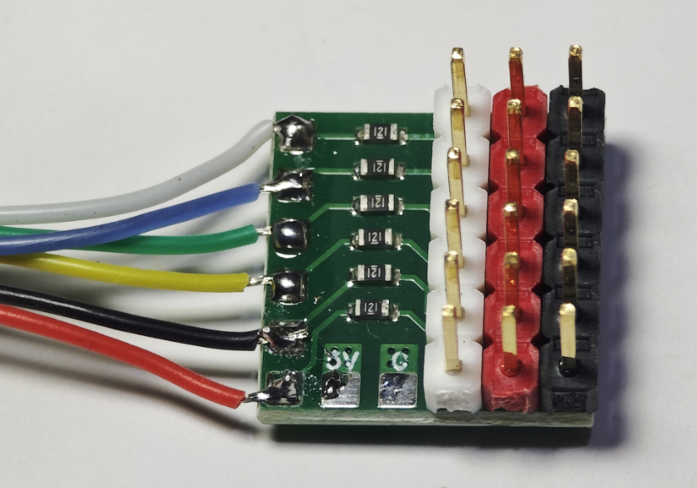
Wiring diagram for soldering expansion board pins to connecting wires

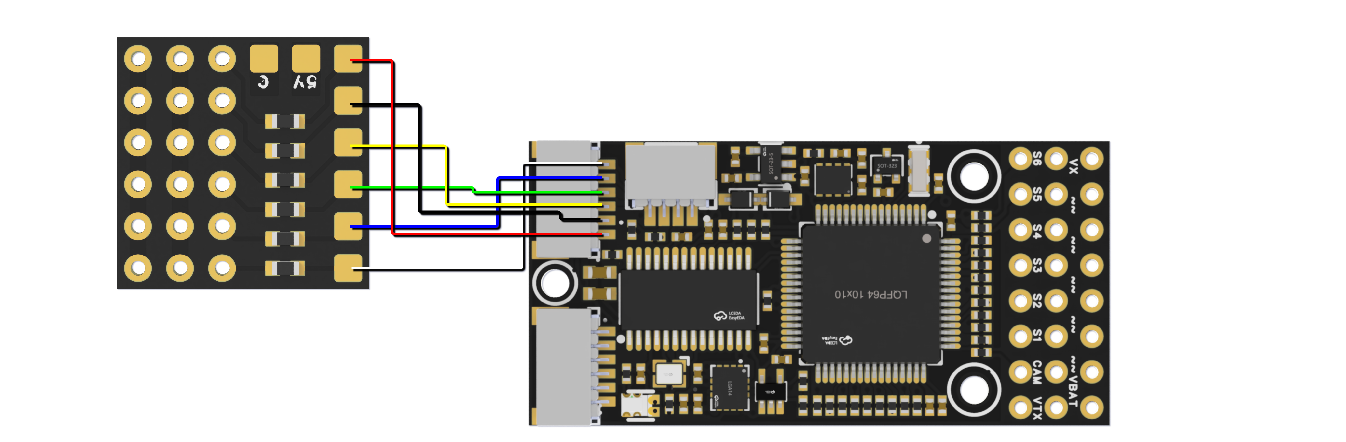
Soldering order of wire to External PWM expension board

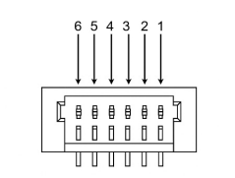
Interface sequence diagram

Pin Definition of PWM Expansion Interface
Pin Number | Pin Name | Pin Definition
1 | S12 | PWM_CH12 ESC/Servo
2 | S11 | PWM_CH11 ESC/Servo
3 | S10 | PWM_CH10 ESC/Servo
4 | S9 | PWM_CH9 ESC/Servo
5 | S8 | PWM_CH8 ESC/Servo
6 | S7 | PWM_CH7 ESC/Servo
Soldering wire sequence of flight controller and servo expansion board

  - Firmware
Recommend using ArduPlane & INAV for fixed-wing aircrafts, the default firmware for shipping is Arduplane.

Newest (up till 01/10/2024) Firmware Download:
ArduPlane
ArduCopter
INAV
BF(Betaflight)

Ardupilot Wiring：
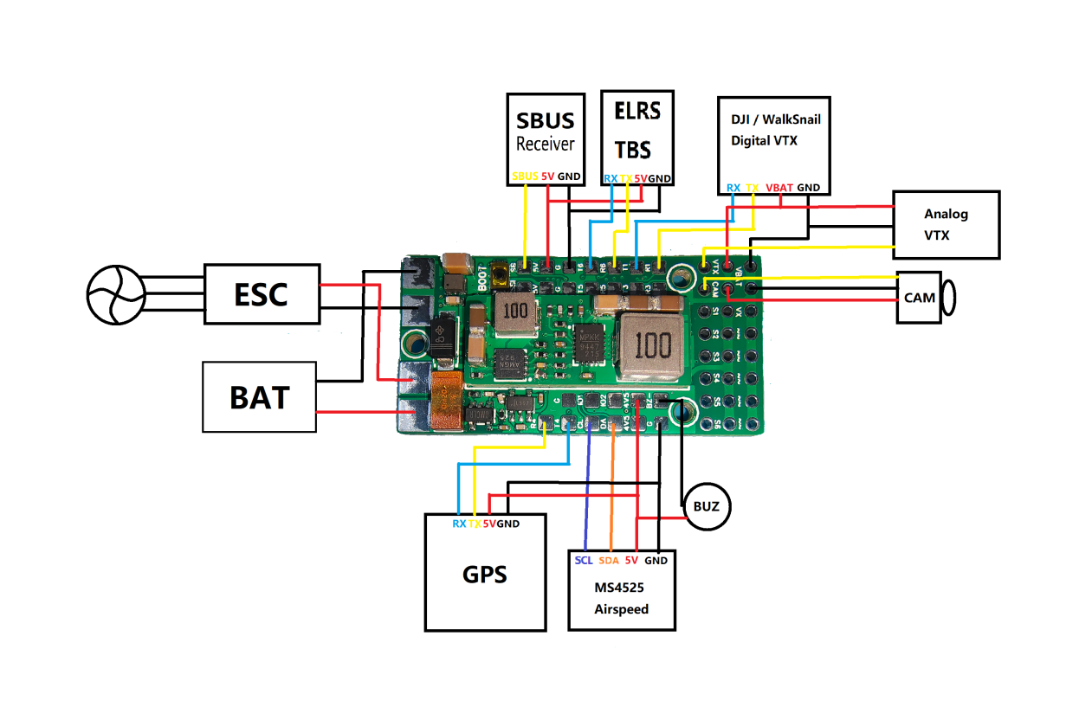
Wiring Diagram

  - ELRS Receiver
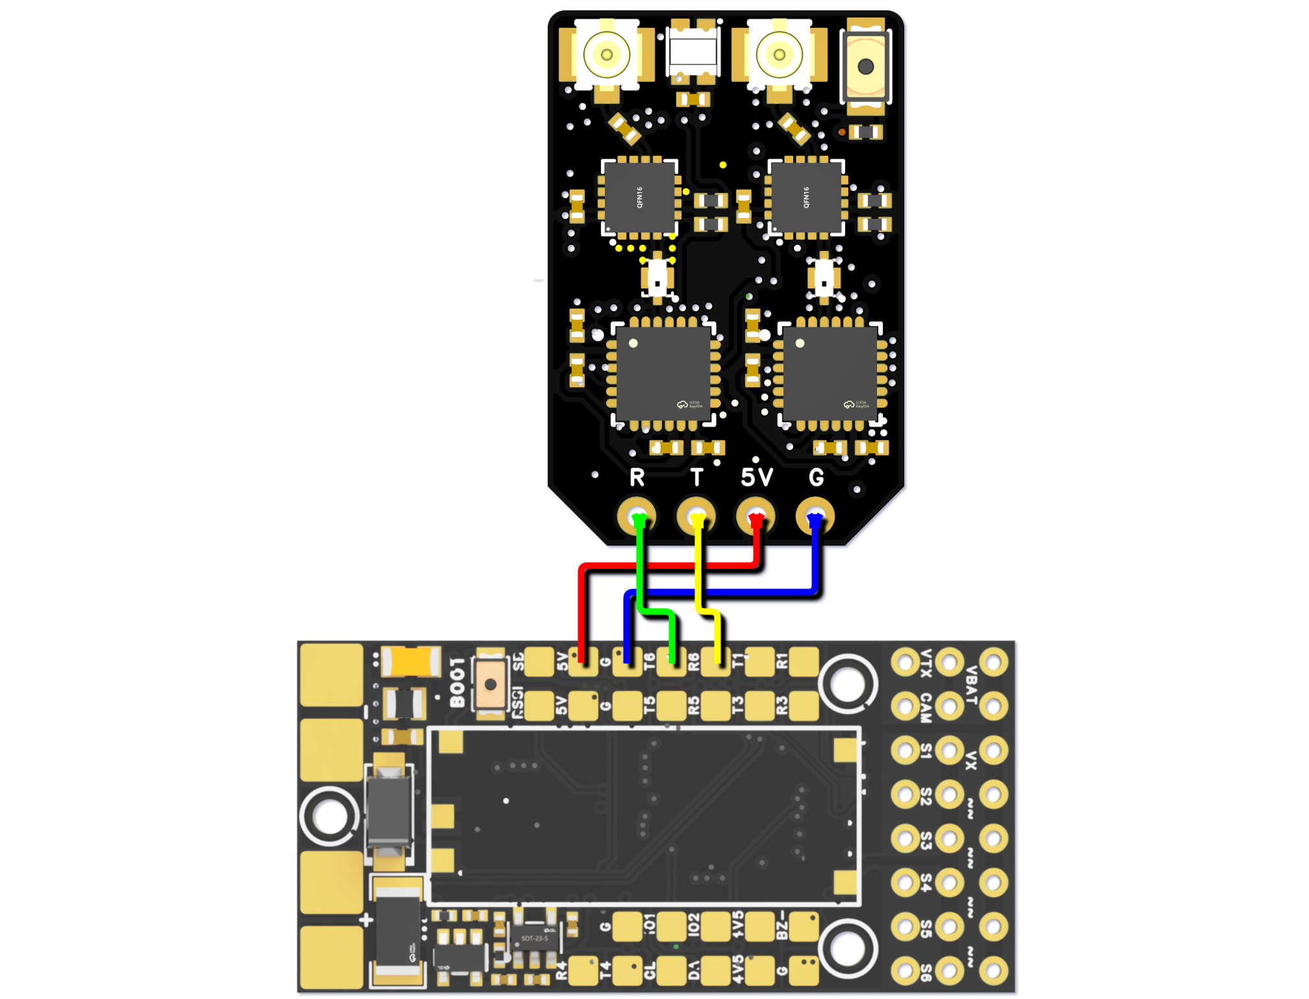
Wiring diagram for connection to flyingRC ELRS Receiver

  - SBUS
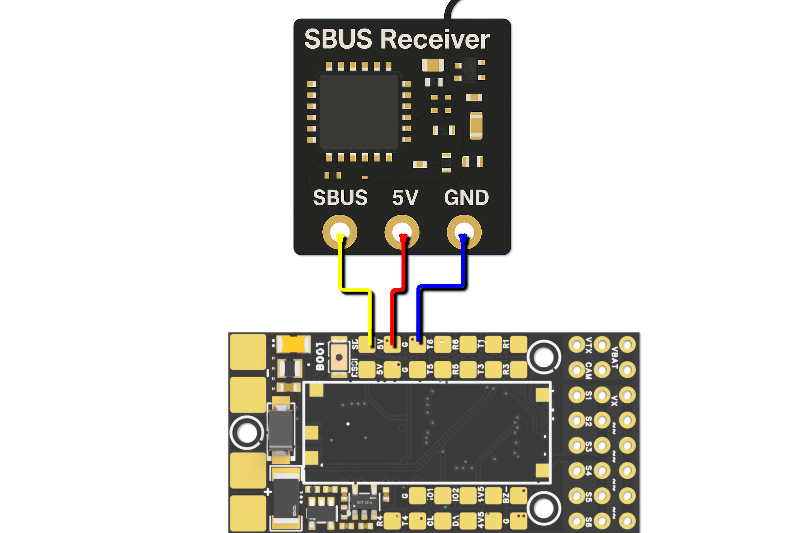
Wiring diagram for connection to SBUS
  - GPS
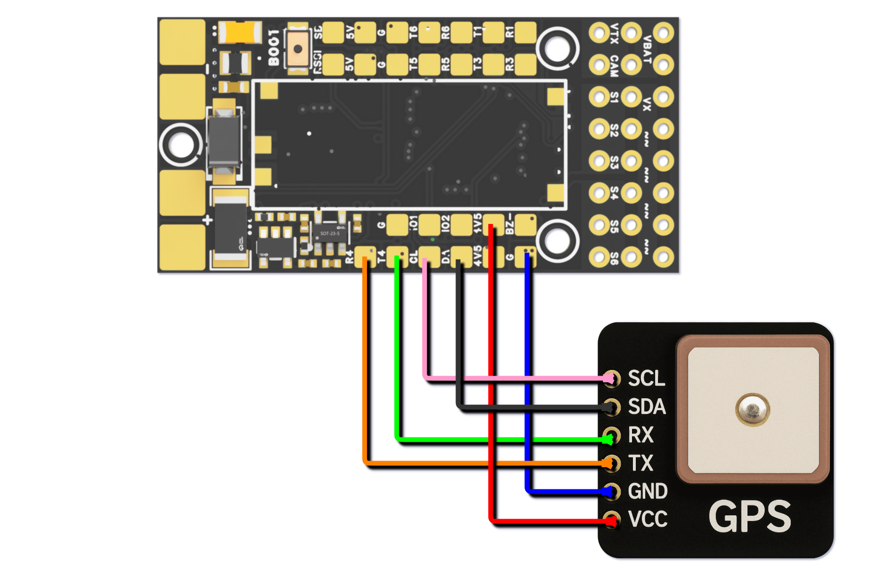
Wiring diagram for connection to flyingRC GPS

  - Analog Camera and Video Transmitter
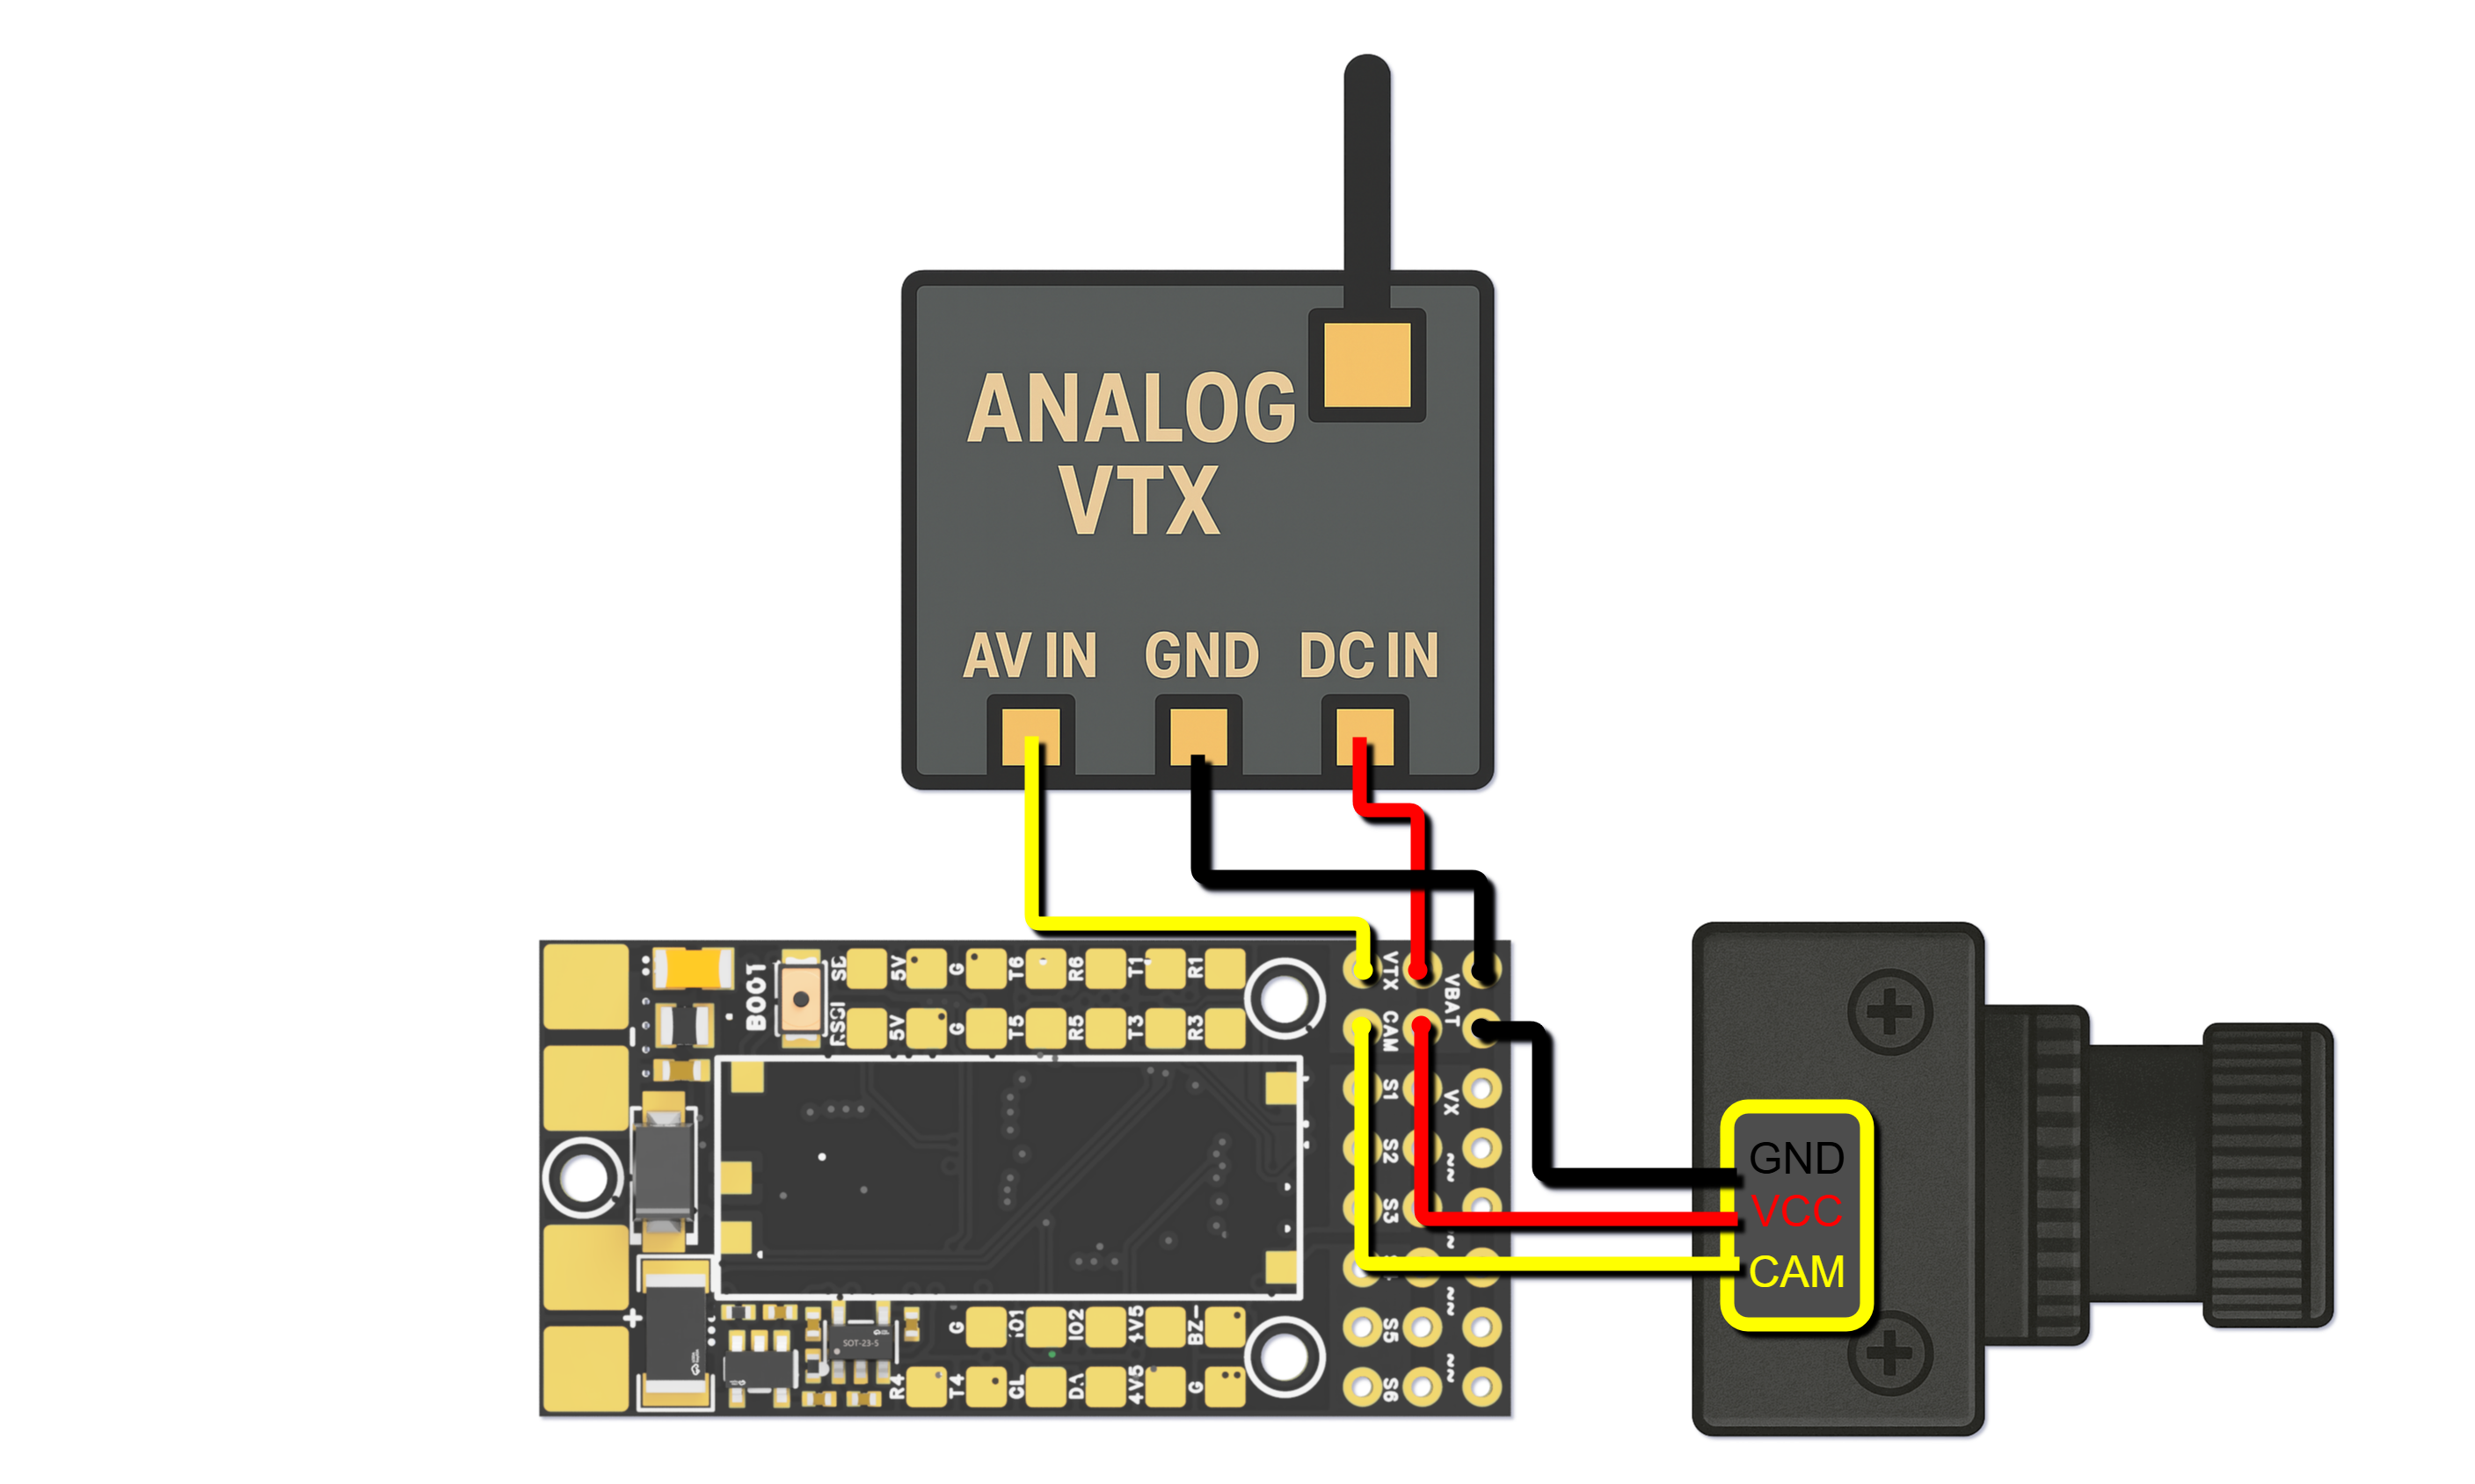
Wiring diagram for connection to Analog Camera and Video Transmitter

  - SBUS-Enabled Digital Video Transmitter

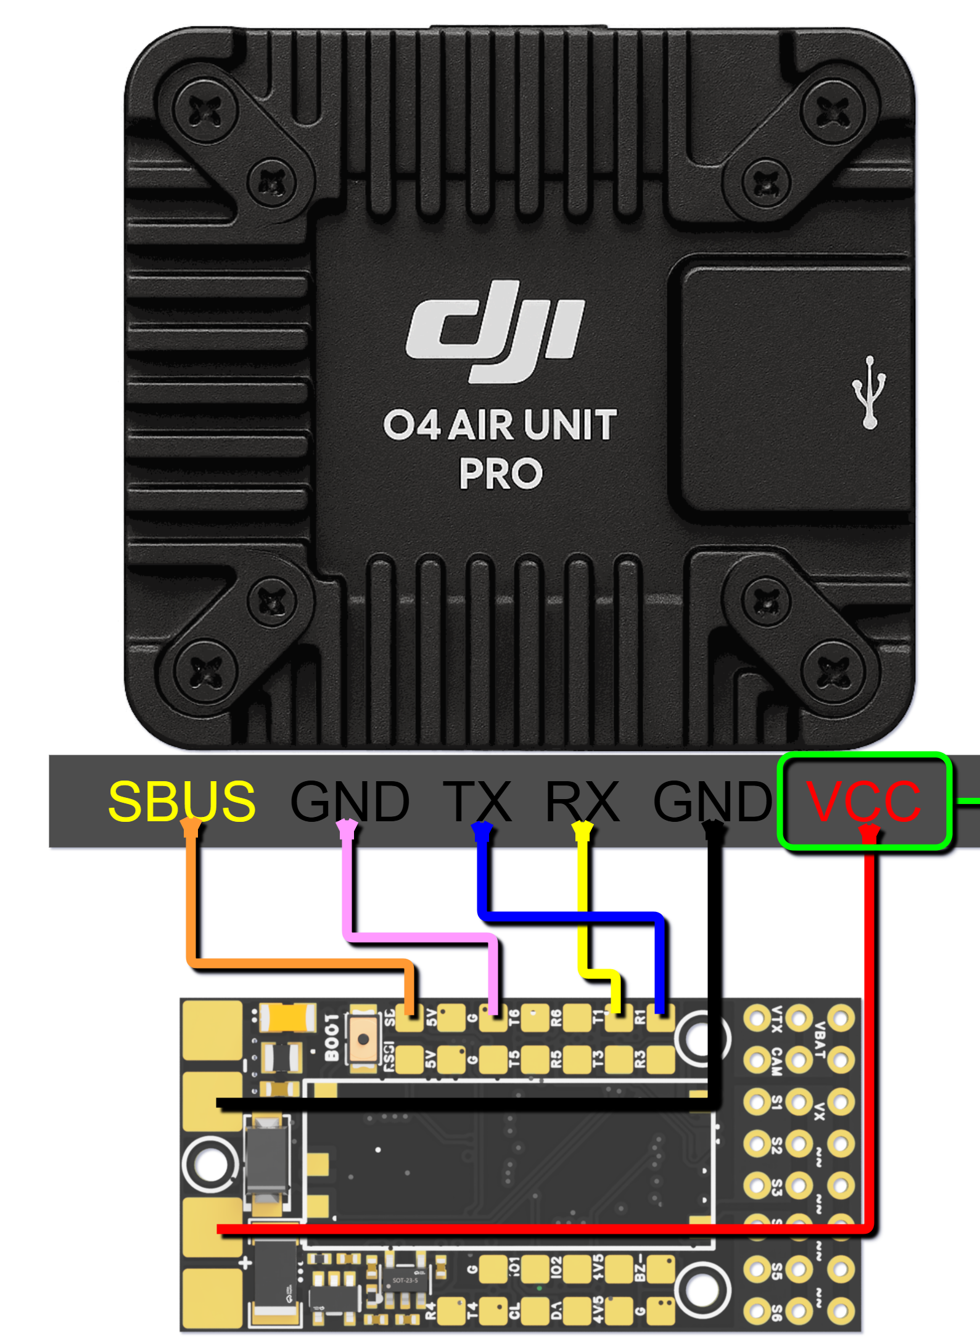
Wiring diagram for connection to SBUS-Enabled digital Video Transmitter

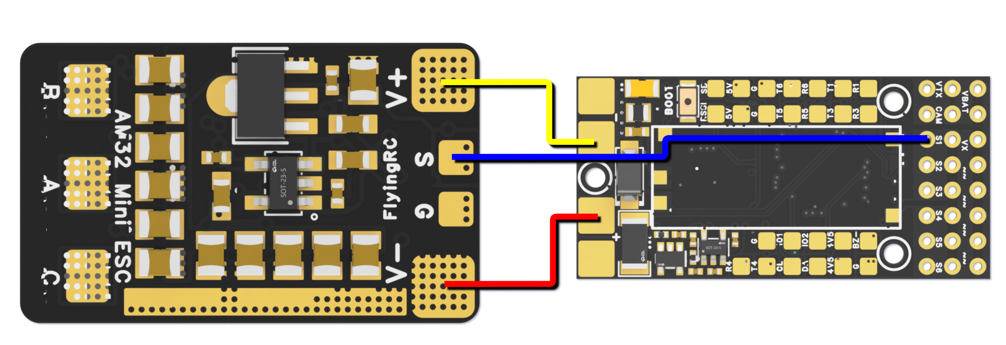
  - ESC

Wiring Diagram for Connection to FlyingRC AM32 Mini 40A ESC

All soldering pads on the flight controller have silk print beside them indicating the function of the pad. E.g, T4 stands for UART4 TX and R1 stands for UART1 RX

Please take note that the serial number and the UART number does NOT correspond to each other in Ardupilot Firmware.

Also, please take note that after soldering your devices to the flight controller, remember to modify the corresponding function of the serial. E.g, in the wiring diagram above, the GPS id connected to R4, T4, which corresponds to serial4, please set the serial4_function to GPS and check if the function of other serials is being set to GPS as Default, if there is, please ensure that serial4_function is the only serial that is being set to GPS, OR the GPS might NOT work.
  - PWM Output Functions
PWM Group |  | PWM Channels | GPIO | Timer | DMA/DShot
Group1 | PWM 5V tolerant I/O | S1 | PWM1 GPIO50 | TIM8_CH4 | DMA/DShot
Group1 | PWM 5V tolerant I/O | S2 | PWM2 GPIO51 | TIM8_CH3 | DMA/DShot
Group2 | PWM 5V tolerant I/O | S3 | PWM3 GPIO52 | TIM1_CH3N | DMA/DShot
Group2 | PWM 5V tolerant I/O | S4 | PWM4 GPIO53 | TIM1_CH1 | DMA/DShot
Goup3 | PWM 5V tolerant I/O | S5 | PWM5 GPIO54 | TIM2_CH4 | DMA/DShot
Goup3 | PWM 5V tolerant I/O | S6 | PWM6 GPIO55 | TIM2_CH3 | DMA/DShot
Goup3 | PWM 5V tolerant I/O | S7 | PWM7 GPIO56 | TIM2_CH2 | DMA/DShot
Goup3 | PWM 5V tolerant I/O | S8 | PWM8 GPIO57 | TIM2_CH1 | DMA/DShot
Goup4 | PWM 5V tolerant I/O | S9 | PWM9 GPIO58 | TIM12_CH1 | NO DMA
Goup5 | PWM 5V tolerant I/O | S10 | PWM10 GPIO59 | TIM13_CH1 | NO DMA
Goup6 | PWM 5V tolerant I/O | S11 | PWM11 GPIO60 | TIM4_CH1 | NO DMA
Goup7 | PWM 5V tolerant I/O | LED pad | PWM12 GPIO61 | TIM3_CH4 | DMA/DShot
Goup7 | PWM 5V tolerant I/O | LED pad | SERVO12_FUNCTION 120, NTF_LED_TYPES neopixel |  | DMA/DShot
Mixing Dshot and normal PWM operation for outputs is restricted into groups, ie, enabling Dshot for an output in a group requires that ALL outputs in that group be configured and used as Dshot, rather than PWM outputs.
If servo and motor are mixed in same group, make sure this group run lowest PWM frequency according to the servo specification. ie. Servo supports Max. 50Hz, ESC must run at 50Hz in this group.

LED pad is the S12 port on external PWM expansion board, can connect to WS2812 LEDs to show the state of the flight controller.
PWM channels under the same Timer Group can NOT be used simultaneously for ESCs using Dshot and Servos using 50Hz PWM.
S9-S11 does not have DMA, therefore could not be used for Dshot Protocol

  - UARTs & Serials
 | PCB | UART | Protocol | Config | SERIAL_X
UART 5V tolerant I/O | USB | USB |  | console | SERIAL0
UART 5V tolerant I/O | TX1 RX1 | USART1 | with DMA | telem1 | SERIAL1
UART 5V tolerant I/O | TX3 RX3 | USART3 | NO DMA | telem2 | SERIAL2
UART 5V tolerant I/O | TX5 RX5 | UART5 | NO DMA | GPS1 | SERIAL3
UART 5V tolerant I/O | TX4 RX4 | UART4 | NO DMA | USER | SERIAL4
UART 5V tolerant I/O | TX6 RX6 | USART6 | TX6 with DMA | USER | SERIAL5
UART 5V tolerant I/O | SBUS | USART2 | with DMA | RC input/Receiver | SERIAL6
UART 5V tolerant I/O | SBUS |  |  | BRD_ALT_CONFIG 0 Default | SERIAL6
UART 5V tolerant I/O | SBUS | Sbs pad | SBUS | BRD_ALT_CONFIG 0 Default | SERIAL6

UARTs & Serials diagram
USART2 only has SBUS pad, RX2 and TX2 is not usable.
For devices with high data rate, such as CRSF receiver, HD OSD, it is recommended to connect these devices to ports with DMA function, such as USART1(Serial1)

  - I2C
I2C |  | Config | Parameterl | Value
I2C1 | 5V tolerant I/O | Compass | COMPASS_AUTODEC | 1
I2C1 | 5V tolerant I/O | onboard Baro SPL06 - 001 | Address | 0x76
I2C1 | 5V tolerant I/O | Digital Airspeed I2C | ARSPD_BUS | 1
I2C1 | 5V tolerant I/O | MS4525 | ARSPD_TYPE | 1
I2C1 | 5V tolerant I/O | DLVLR - L10D | ARSPD_TYPE | 9

The Internal Baro is at 0x76, therefore, can NOT connect to external devices that are also on 0x76

  - ADC Analog Input
RSSI Pad | 0 - 3.3V | RSSI ADC | RSSI_ANA_PIN | 8
RSSI Pad | 0 - 3.3V | Analog RSSI | RSSI_TYPE | 2

Could also be used for connecting to extral current sensor.

Common parameter settings for Ardupilot:
LOG_BACKEND_TYPE = 1, Enable balckbox function
BATT_VOLT_PIN 14
BATT_VOLT_MULT 21.0
BATT_CURR_PIN 15
BATT_AMP_PERVLT 39.2

Common parameter settings for INAV:
Voltage scale 2100
Current scale 255

Introduction to Other FlyingRC Products
- FiyingRC F4WSE MK1.5 - F405 MCU
Fixed-Wing Flight Controller
-- Legendary product with distinctive styling and glowing reviews

Instruction Manual: https://kdocs.cn/l/cpyd8MTS56DD

- FlyingRC H7Wlite MK1 H743 MCU  Fixed-Wing Flight Controller  -- Flagship-level performance, fully expandable, with Triple high-capacity BECs  Instruction Manual: https://kdocs.cn/l/cpYaBiFKh8U1 | 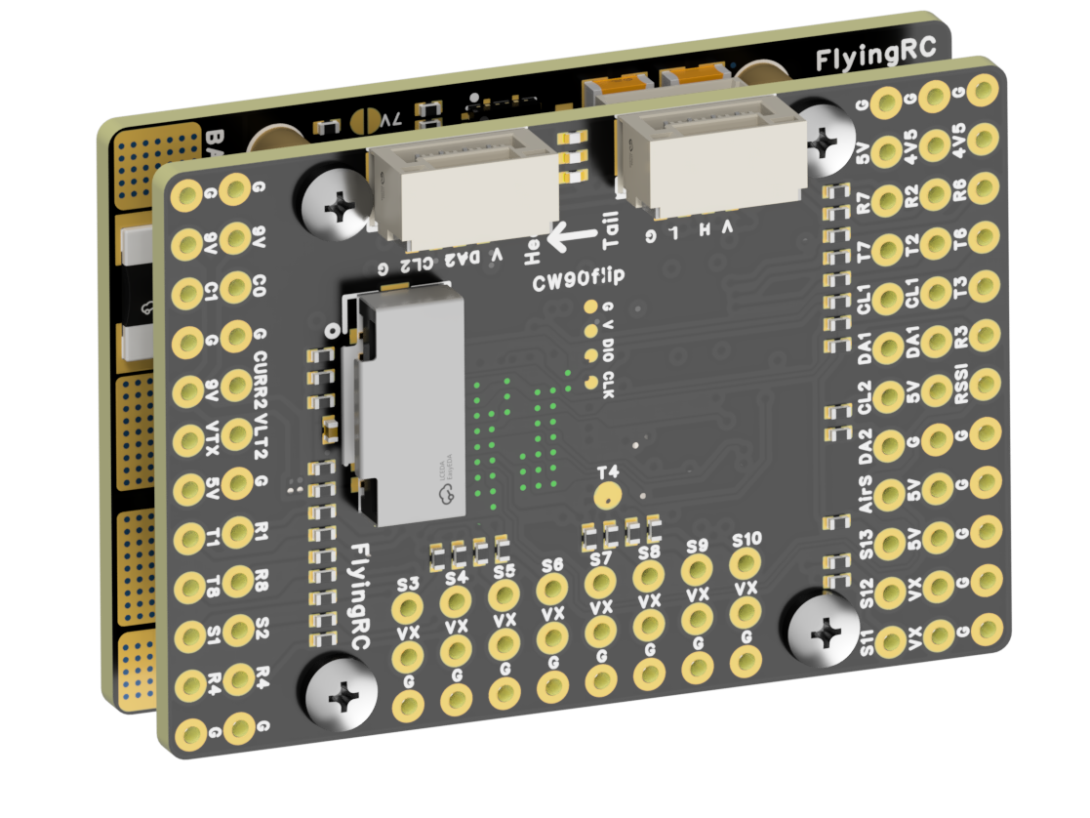

- FlyingRC F4Wing Mini MK1 F405 MCU  Fixed-Wing Flight Controller  -- 2025 standout release: ultra-streamlined, smallest footprint, excellent value  Instruction Manual：https://kdocs.cn/l/cdUIdmpSpW7J | 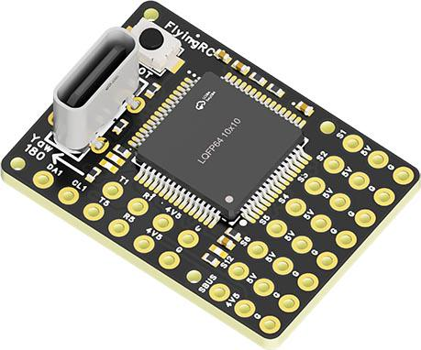

- FlyingRC AM32 ESC V2.5 75A  -- Infineon DirectFET™ packaging MOSFETs, premium components, superior heat dissipation  Instruction Manual: https://kdocs.cn/l/cv6hUy67IdTJ | 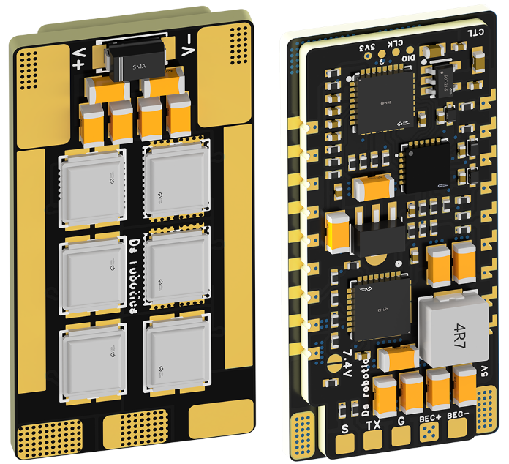

- FlyingRC AM32 Mini ESC 40A V1.0 40A  -- Ultra-mini footprint designed for micro frames, high over-current capability, and stable performance  Instruction Manual: https://kdocs.cn/l/cqdLSysEyWFh | 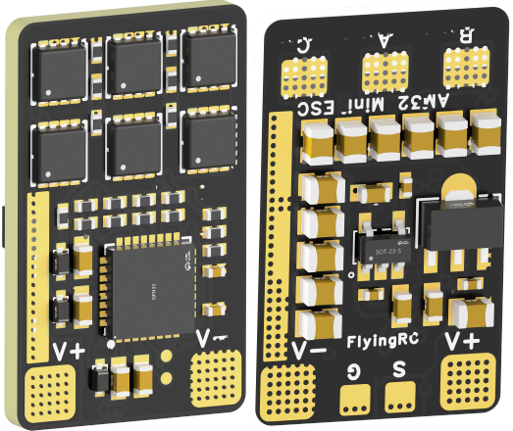

- FlyingRC 10A 12S 400A FPV Drone Power Distribution Board  -- Industry favorite—pro-grade build at a competitive price  Instruction Manual: https://kdocs.cn/l/coel7OgrlCBP | 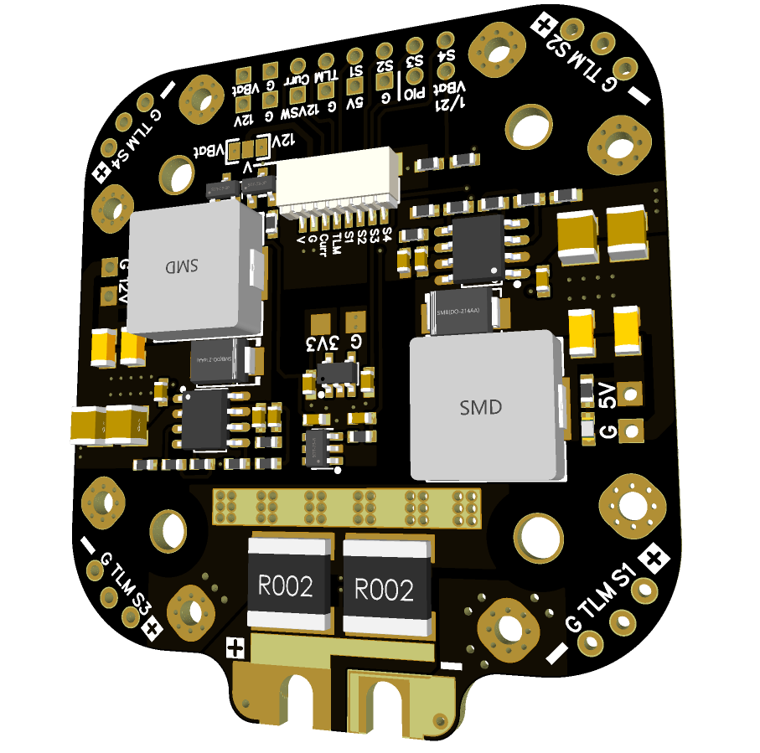

- FlyingRC H7D MK1 H743 Dual-Gyro FPV Drone Flight Controller  -- High-performance onboard MCU, precise and stable flight control, rich I/O  Instruction Manual: https://kdocs.cn/l/cqMh1I0RwAoD | 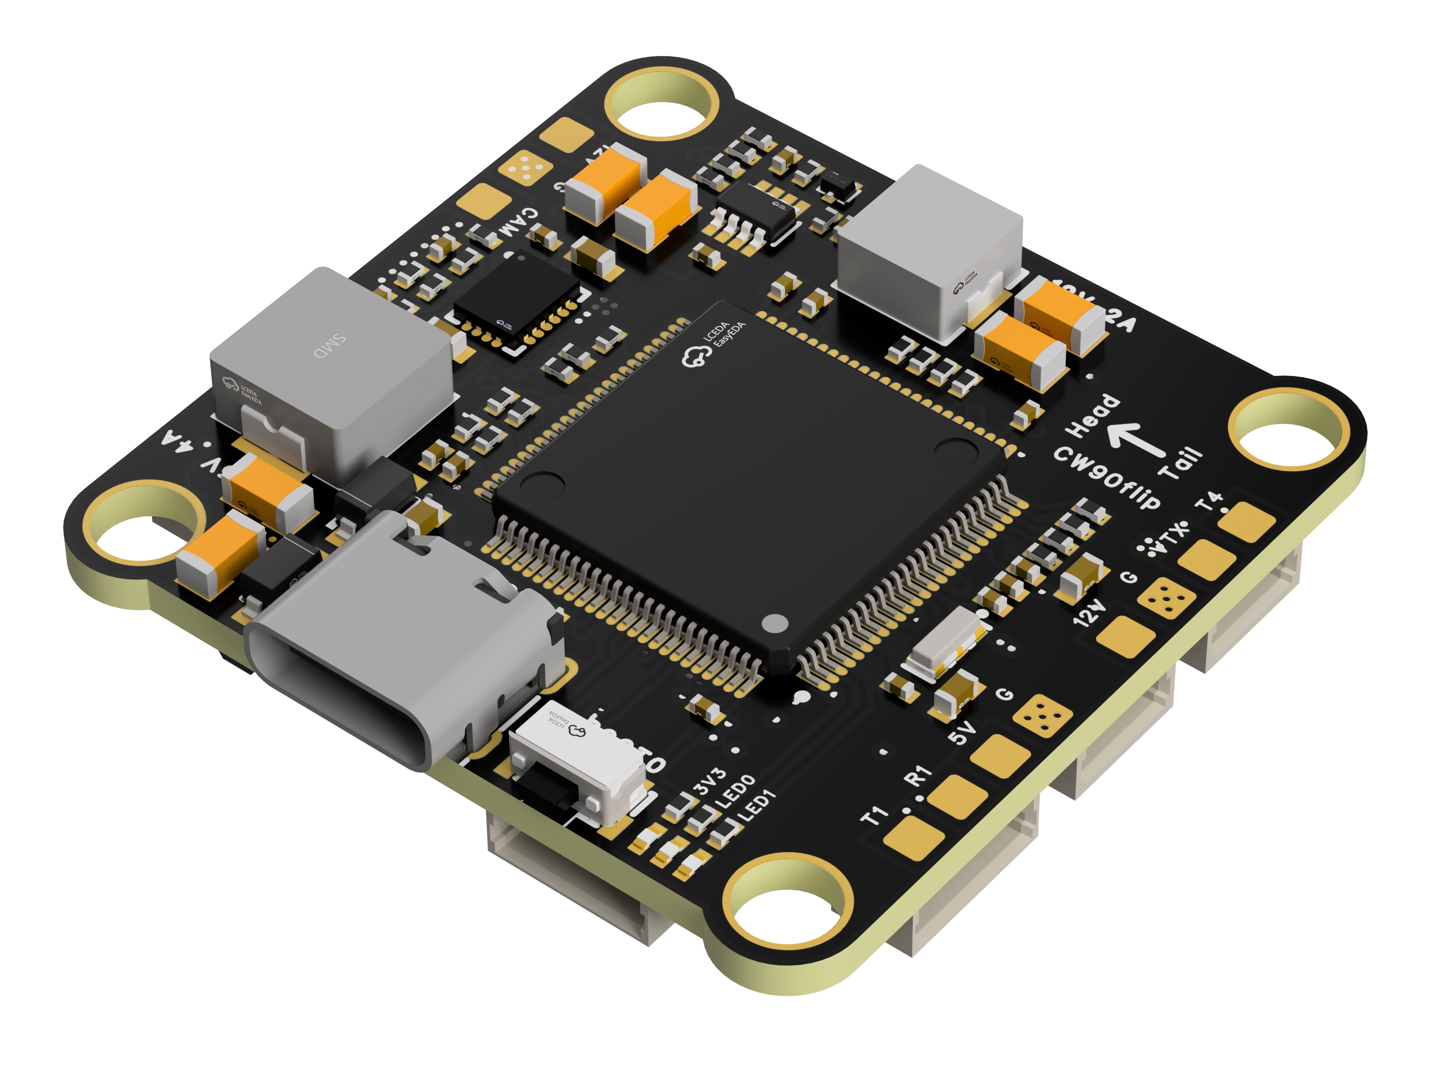

- FlyingRC F420 MK1 F405 20\30.5 FPV Drone Flight Controller  -- Dual mounting holes and all-socket assembly zero-solder setup, Betaflight-standard pin-out  Instruction Manual: https://kdocs.cn/l/ctGeLiN9ZYKj | 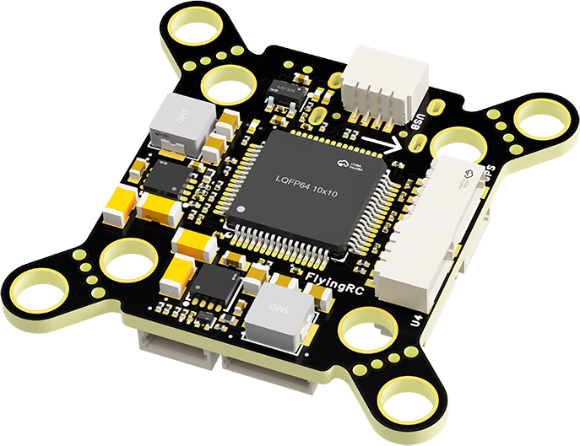

- FlyingRC 4IN1 75A ESC V3.2 4-in-1 FPV Drone Infineon DirectFET™ MOSFETs ESC  -- Infineon DirectFET™ packaging MOSFETs, top-tier heat dissipation and high current capability—premium choice for high-end builds  Instruction Manual: https://kdocs.cn/l/ceLilc8Gaa21 | 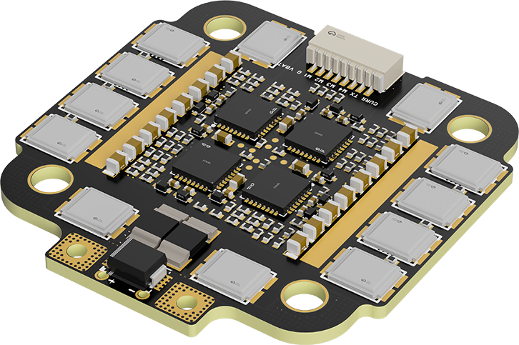

FlyingRC Flight Controller Tower Kit, H743 FPV Drone Flight Controller + 4-in-1 FPV Drone 75A Infineon DirectFET™ MOSFETs ESC  --Pro pilots’ top choice—flagship-grade components and manufacturing process, fair pricing  Instruction Manual:  Flight Controller https://kdocs.cn/l/cqMh1I0RwAoD  ESC https://kdocs.cn/l/ceLilc8Gaa21 | 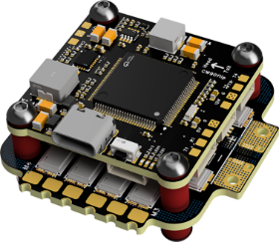

- FlyingRC ELRS 10A  -- True-diversity reception with temperature compensation and robust signal pickup  Instruction Manual: https://kdocs.cn/l/cbvlOlShmsPS | 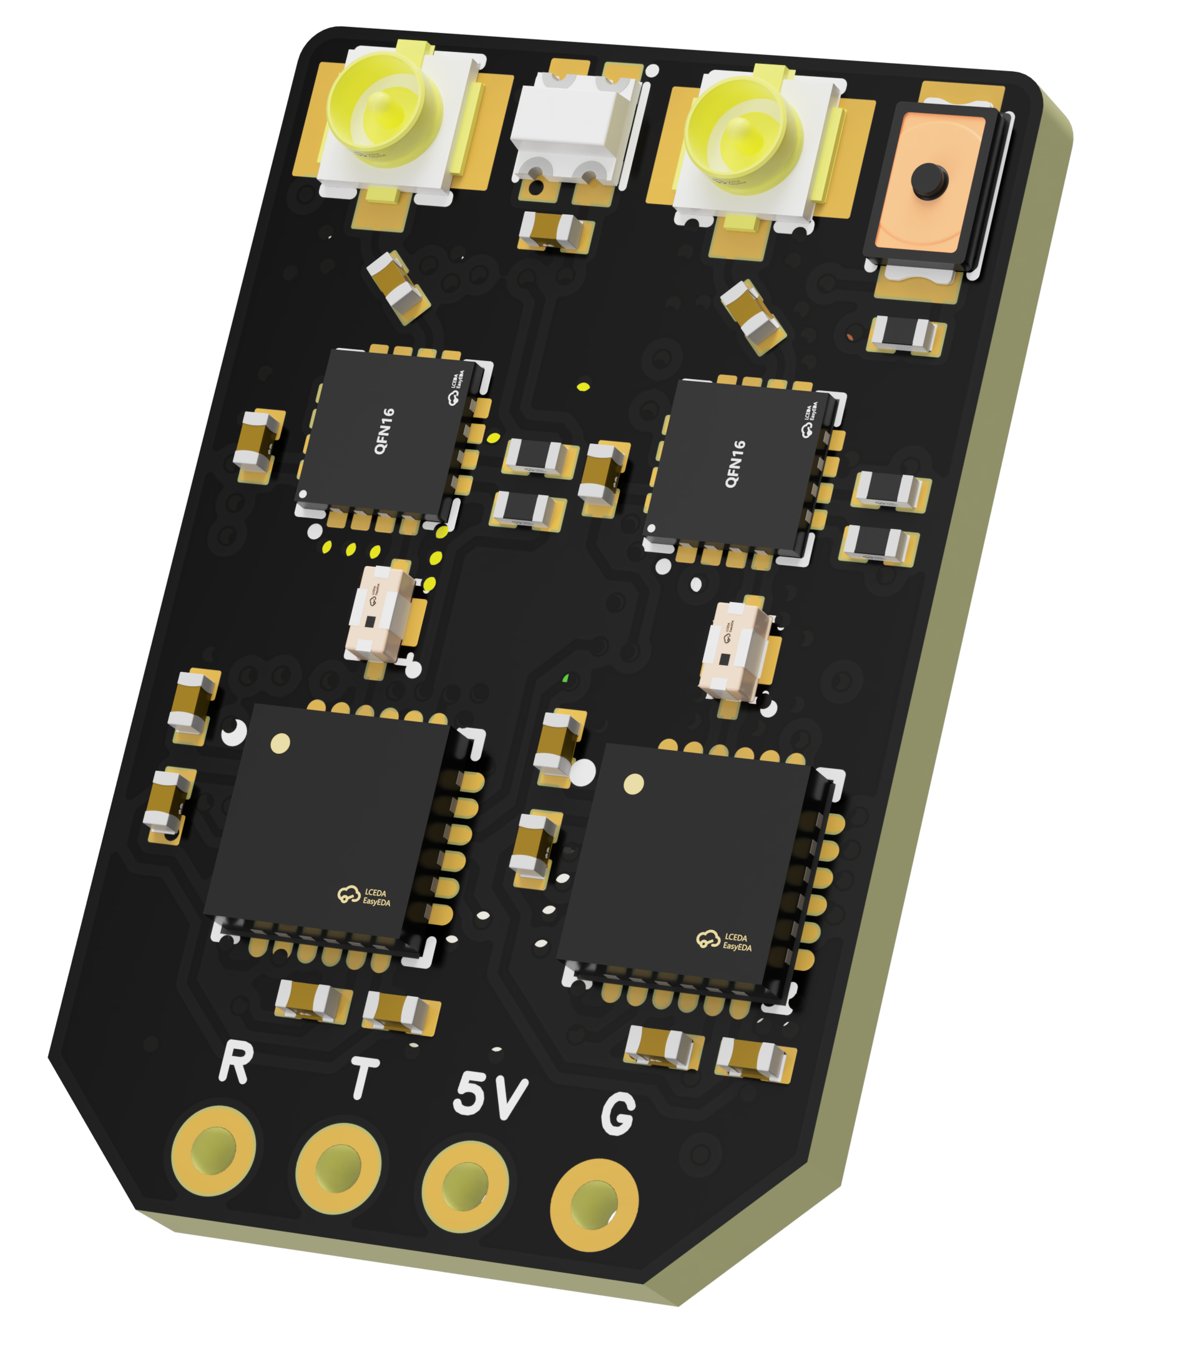

- FlyingRC 10A 12S BEC 10A  --Wide-voltage support, high-power delivery in a compact package—selectable voltages, 10 A continuous output  Instruction Manual: https://kdocs.cn/l/clssNCKgNhLV | 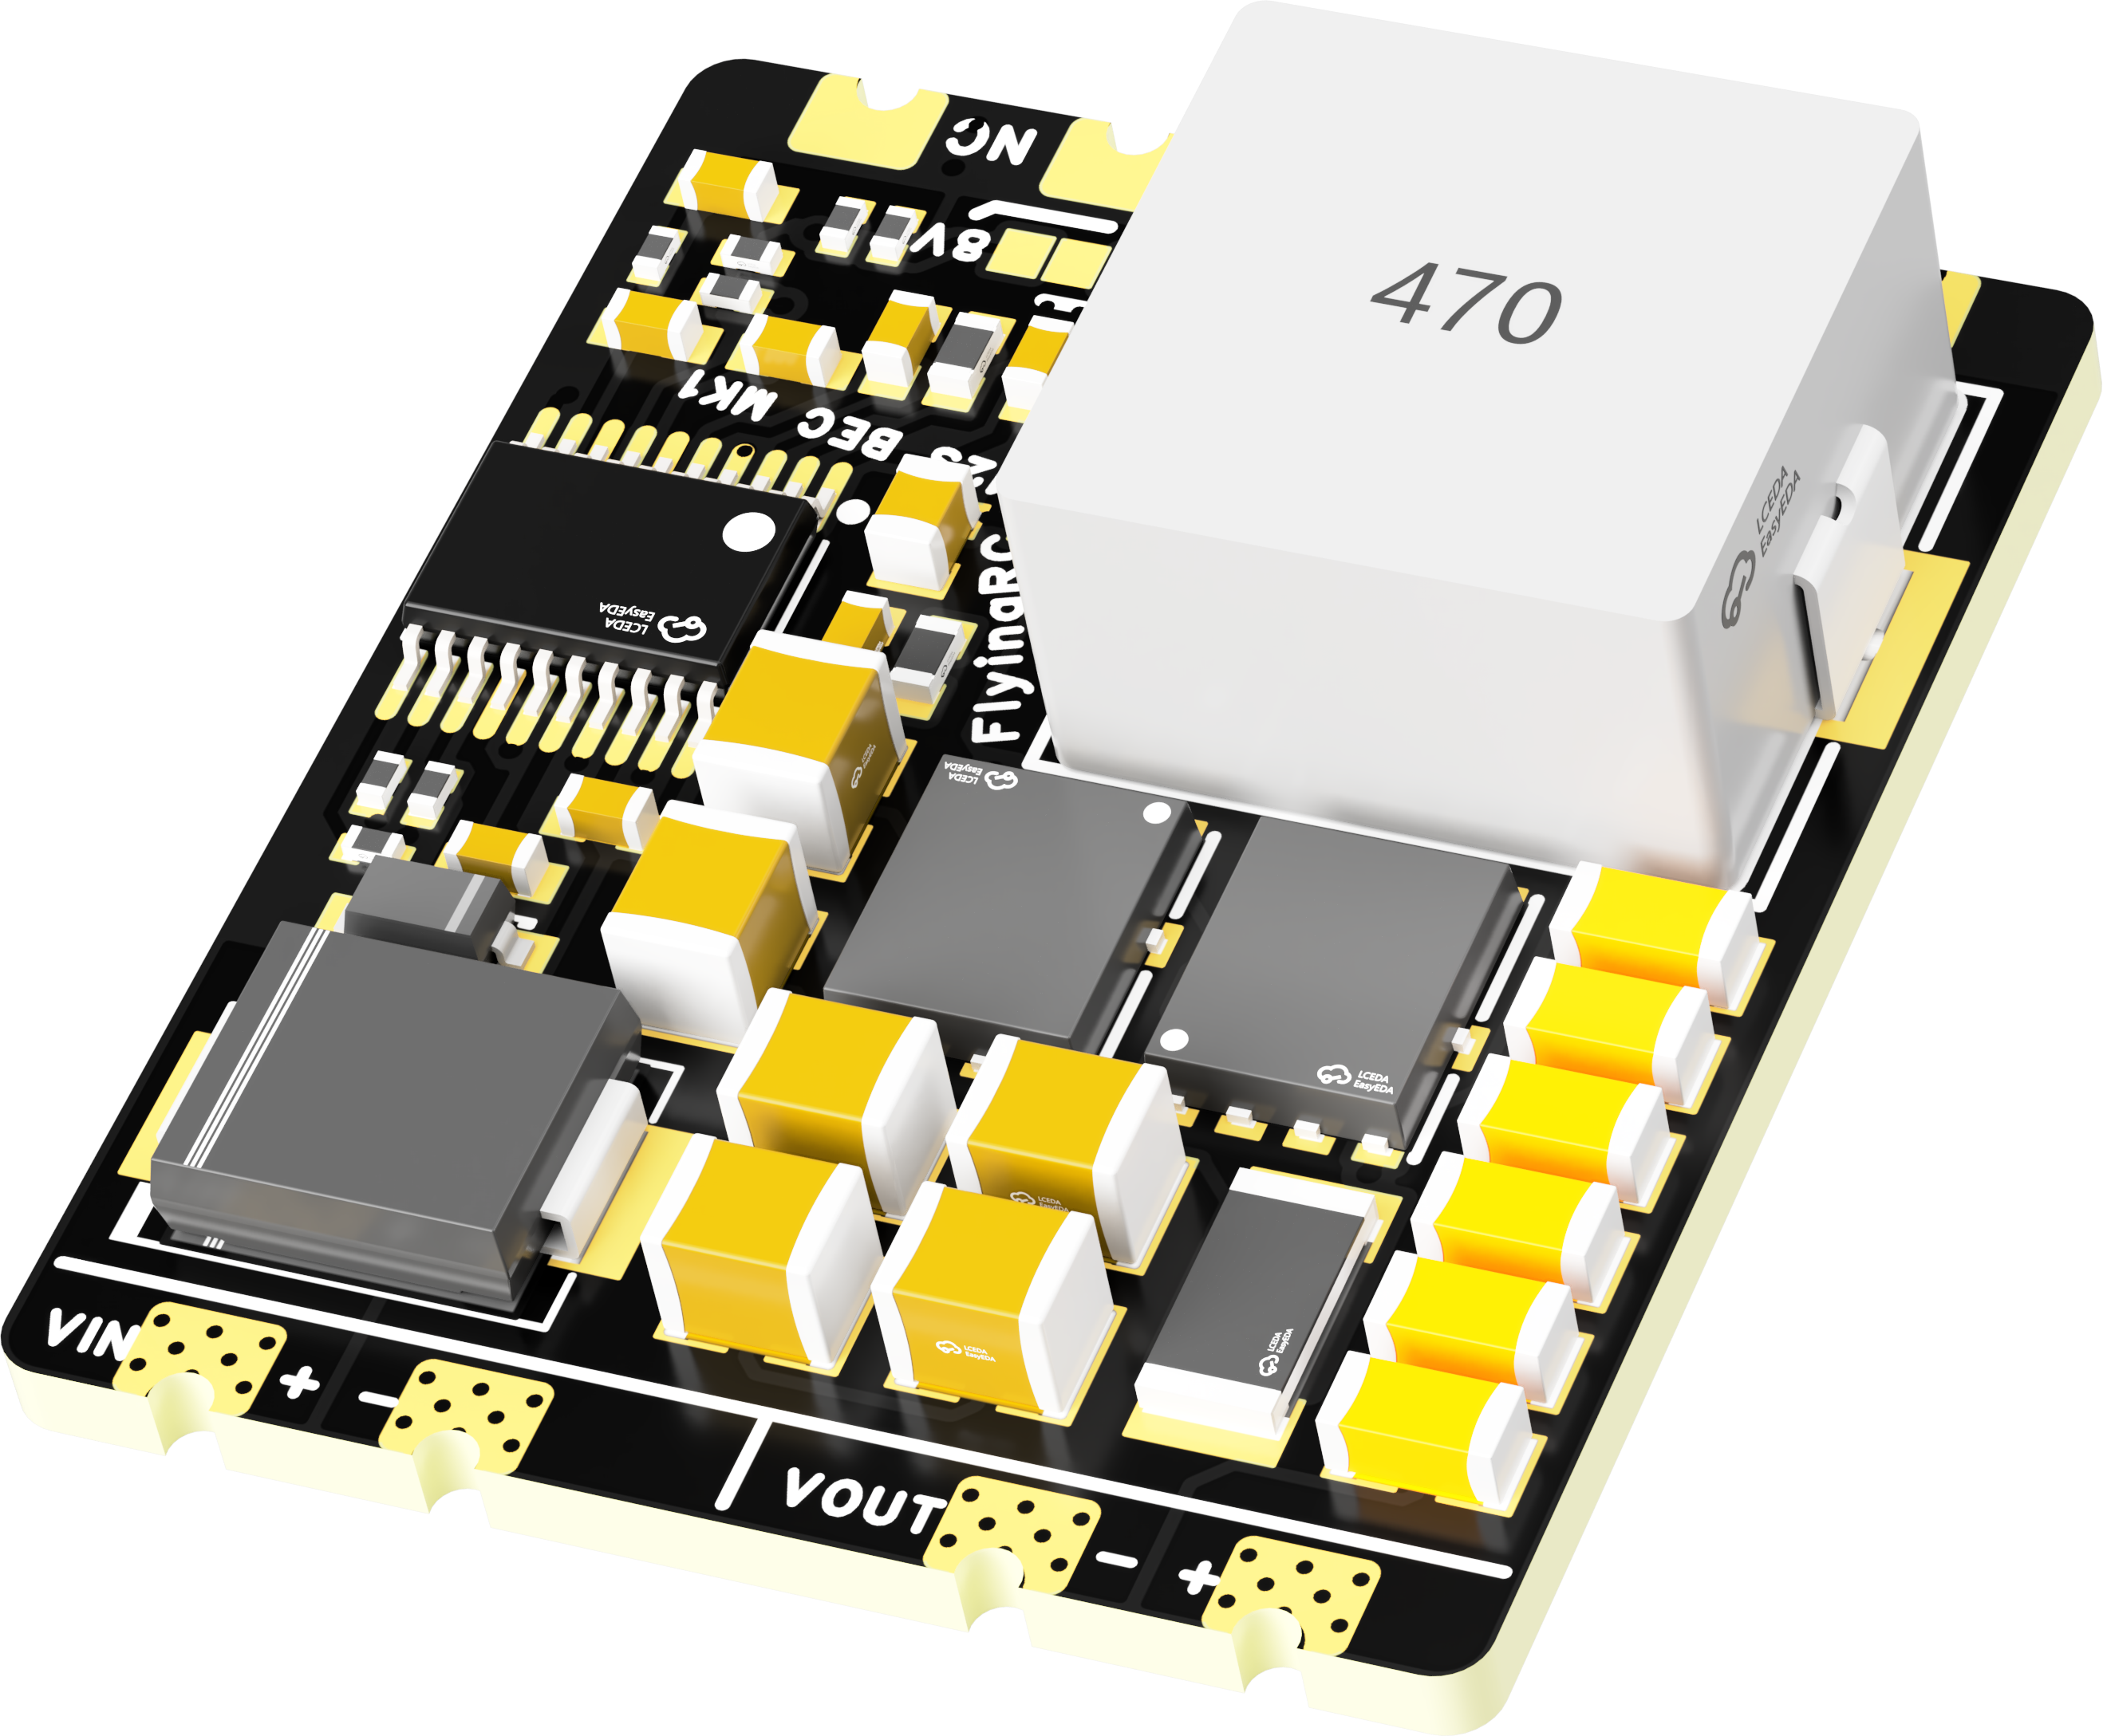

FlyingRC 5A BEC  -- Ultra-compact size, user-selectable output voltages with 5 Amps continuous output  Instruction Manual: https://kdocs.cn/l/cb9VdNywqCKA | 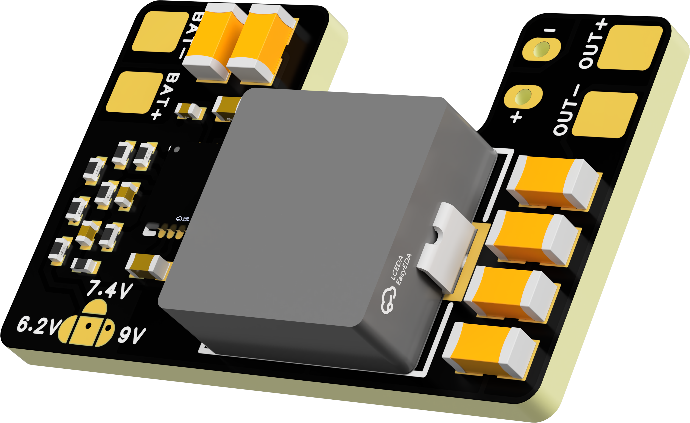

FlyingRC AM32 ESC Programmer  Supports BL, BL32, AM32 ESCs  Instruction Manual：https://kdocs.cn/l/cogBSEBe67mE | 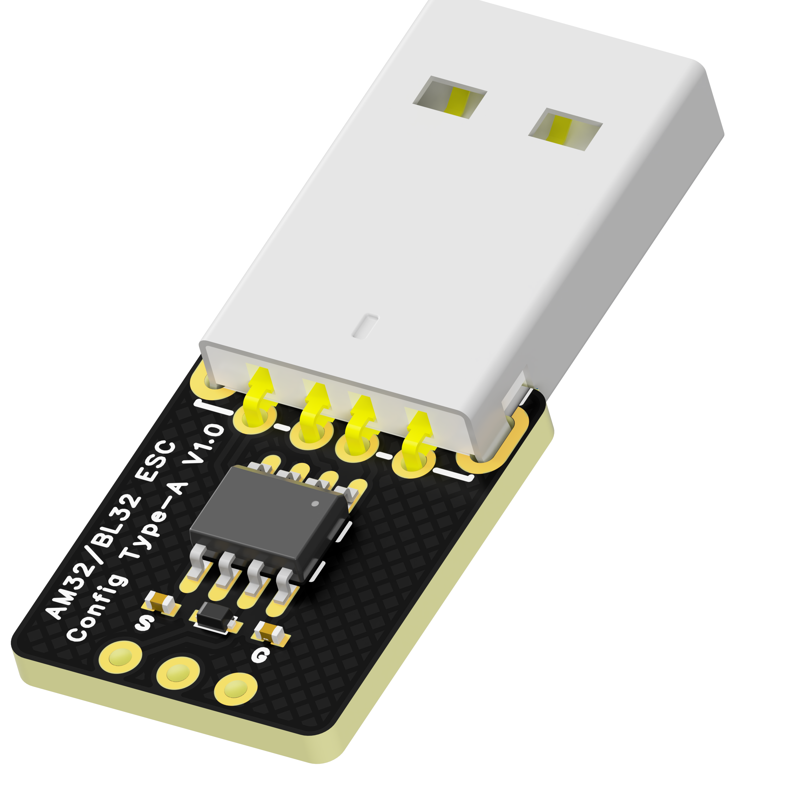

FlyingRC Digital Airspeed Sensor without Pitot Tube  Instruction Manual：https://kdocs.cn/l/clPvEEEcJgCC | 