Portable LCD Digital Microscope
(G600)
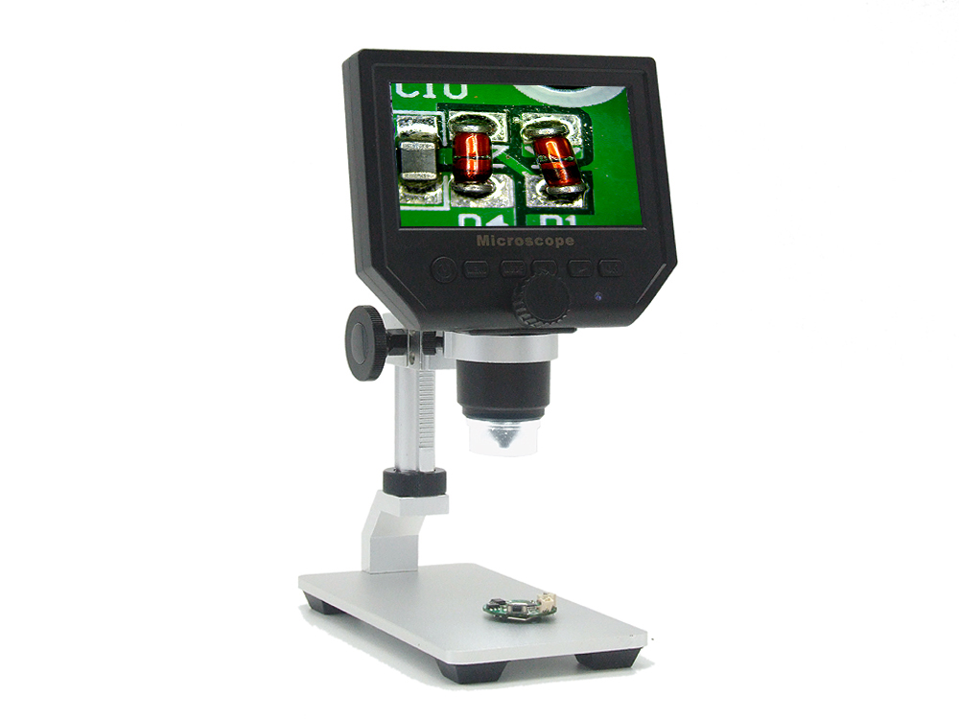

Main parameters:
1: Pixel: HD 3 .6MP CCD
2: Display: 4.3 inches HD LCD display.
4: Magnification: 1-600X continuous magnification system.
5: Object distance: 15mm-- infinity
6: With built-in lithium battery, Continuous working for 6 hours .
7: Languages: English, Spanish, Russian, Korean, Japanese, Thai, Hebrew, Portuguese, German, French, Italy, Turkey, Czech, Poland, Traditional Chinese, simplified Chinese.
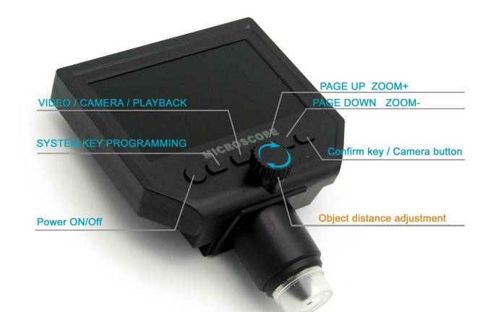

The High-capacity lithium battery needs about 4 hours to be full charged.When it ‘s charging,the display will show ,when it’s full charged, the display will show 

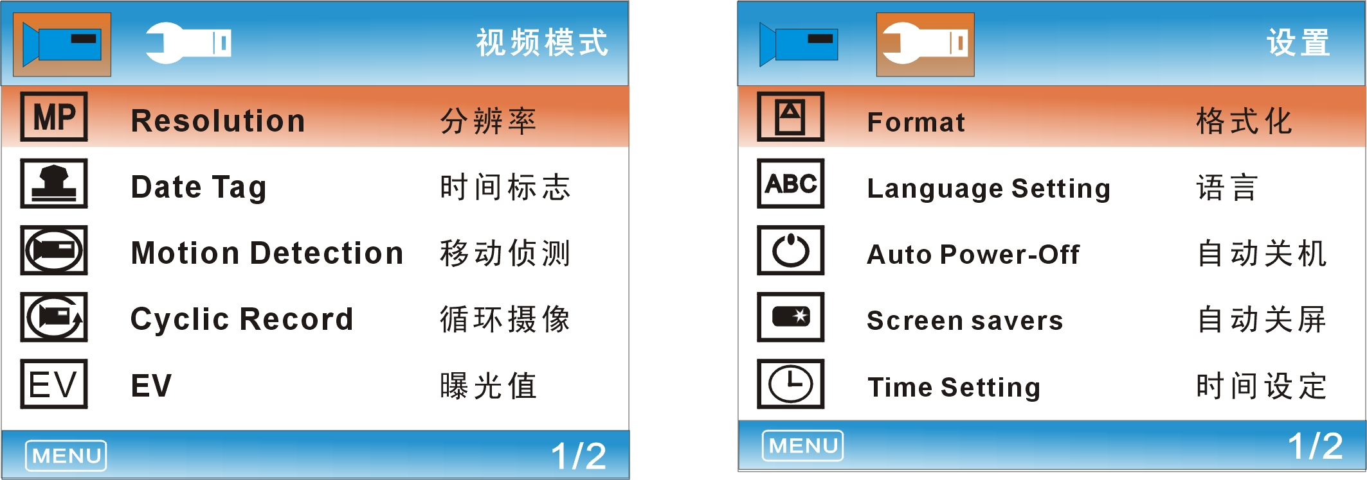

: Power On/Off
Press it once to turn on,press once again to turn off.
：Function setting key:
1. Resolution: 1080P, 720P, VGA
2. Date Tag: Displayed /Not displayed
3. Motion Detection: ON/OFF (When it’s on it will start to record a video automatically , as soon as detecting something’s moving .)
4. Cyclic Record : off /3 minutes /5 minutes /10 minutes.
In the memory card is full, it will delete the first video and save the new video automatically.
5. Exposure value: +2.0 (0) -2.0
6. Format: Yse / NO
7. Language: 16 kinds of languages
8. Automatic shutdown: off, 1 minutes, 3 minutes,
9. Automatic turn off the LCD : off, 1,3,5 minutes
10. Factory Reset:Yes / No
11. Light source’s frequency: 50HZ, 60HZ
12. Time setting: year, month, day, hours, minutes, seconds
13. Image rotating on / off
14. Light: on / off
15. Software version: V1.10

Mode button:
1．Recording Video mode:
2．Taking Photos mode: (5M, 2M, 1.3M, VGA) press “OK” button for taking photos
3．Playback mode: delete, lock / unlock

Left button, right button, OK button (photo / video, open key)
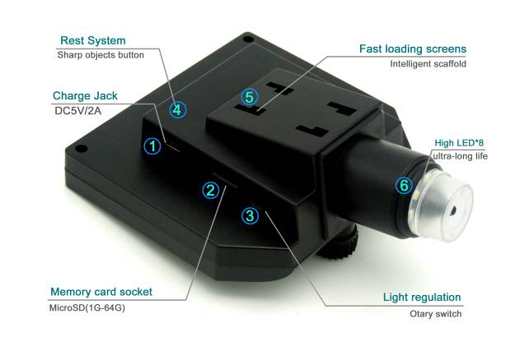
1: Power DC interface (5P MINI).
2: Memory card’s socket (Micro SD), supporting 1-64GB.
3: Brightness Adjust button
4: REST button, restore the system.(If the machine can not work, please press the button with sharp objects to restart it.)
5: Fast loading 4 holes’ bayonet, push the bracket’s 4 claws into the bayonet,hearing ”ka” once,it says the assemble is finished .
6: High brightness 8 LEDs, available for up to 100 thousand hours.
Intelligent universal support
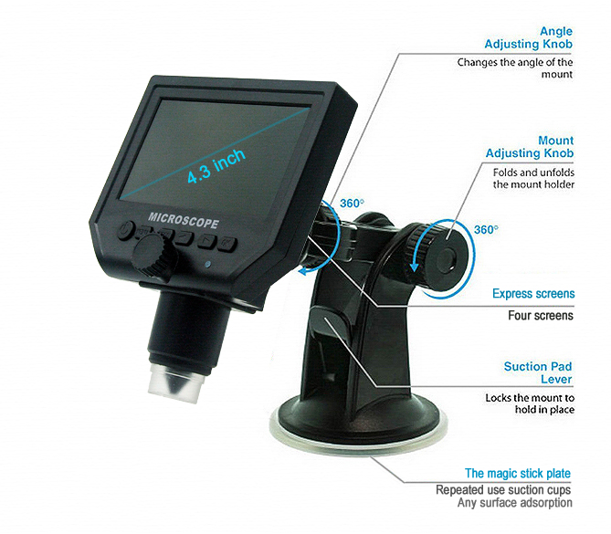
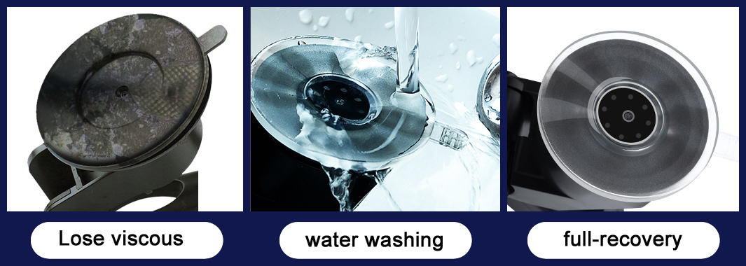
The intelligent universal support is super light and powerful, can be adsorbed on the surface of glass/ceramic/marble/plastic board and others.
The silicone sucker will not leave marks on any surface.after long-term using, it can be cleaned by water when there’s dust on the surface.

The closest distance of microscope and the goal is 15mm, the magnifying time is the maximum , the magnifying time will be smaller as the distance increasing .
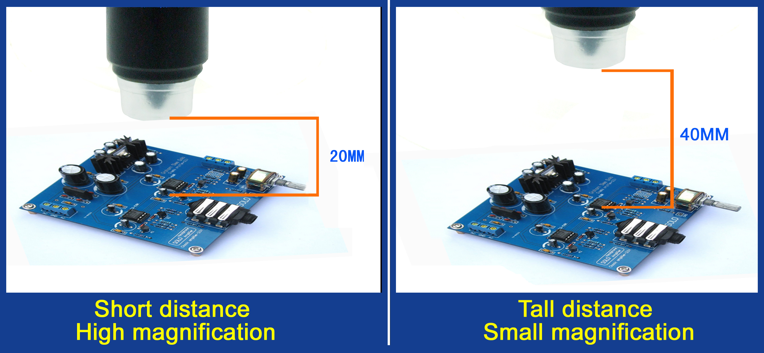

Accessories icon:
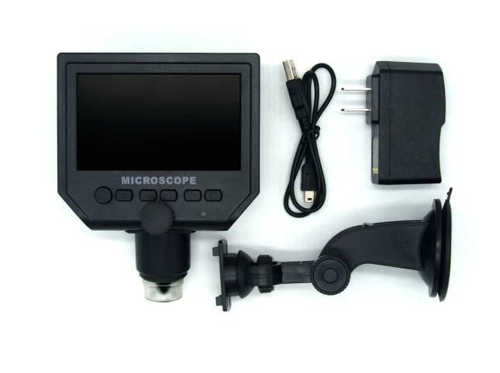
Microscope, power supply, data line, multi functional support, user’s manual.

