Amazfit Neo User Manual

Contents
Operating instructions and function navigation 2
Key operations 2
Wearing and charging the watch 3
Using the watch 4
Pairing and unpairing the watch 4
Functional pages 5
Workout screen 8
Find my phone 10
Factory reset 11

Operating instructions and function navigation
The Amazfit Neo is equipped with an STN screen and four physical keys.

Key operations
Key name: SELECT
Key function: confirm or select
1. Pairing page: confirm
2. Factory Reset page: confirm
3. Function of the key on a specific page:
Stopwatch page: start, pause, or continue
Workout secondary screen: pause or continue
Single heart rate measurement: Begin measurement.
DND mode: switch and confirm
4. Power-on/off: Press and hold the SELECT key for 2s.

Key name: BACK
Key function: return or exit
1. Non watch face page: Press to return to the previous page.
2. Function of the key on a specific page:
Workout secondary screen: On the workout pause page, press the BACK key to exit the workout.
3. Press and hold the BACK key for 2s to enable or disable the backlight function.

Name of the key: UP
Function of the key: page up
1. Page up: Press the UP key to switch between different functional pages.
2. Stopwatch page:
a. Count function
b. After the stopwatch is paused, press the UP key to check the counting records.

Key name: DOWN
Key function: page down
1. Page down: Press the DOWN key to switch between different functional pages.
2. Stopwatch page: When the stopwatch is paused, press this key to check the counting records.

Key combinations: Press and hold a key combination for 2s.
1. Reboot: SELECT + UP
2. Factory Reset: BACK + DOWN
3. Regulation: SELECT + DOWN
- Find your phone: BACK + UP

Wearing and charging the watch
Daily wear: It is recommended that you wear the watch at a distance of two fingers away from the wrist with moderate tightness to ensure that the optical heart rate monitor properly measures heart rate.
Wearing during workouts: During workouts, it is recommended that you wear the watch comfortably and ensure a tight fit that does not slip. If the watch is too tight or too loose, the monitored workout data may be inaccurate.
Charging
1. Plug the watch charger into a device that supports USB power delivery, such as a socket, PC, or power bank.
2. Mount the watch onto the charging base. Ensure that the direction and position of the watch are correct, and that the metal contacts at the back of the watch are in close contact with the charging base.
3. When the watch is placed properly, a charging status icon is displayed on the screen.
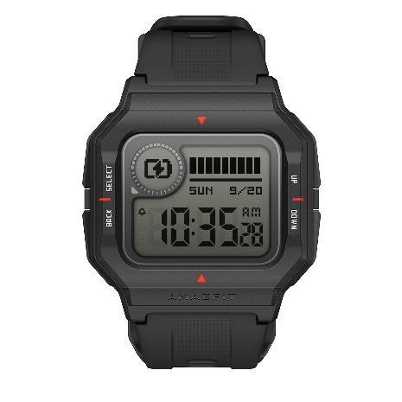

Using the watch
Before using the Amazfit Neo, download the Zepp app on your mobile phone. You can enjoy all functions of the watch and save data generated by the watch to your personal cloud account only after you pair your phone with the watch through the Zepp app.

Pairing and unpairing the watch
1. Scan the QR code on the user manual to download the Zepp app, register an account, and log in to the account.
2. Open the app, and choose Profile > My devices > Watch > Watch without a QR code to start searching for nearby devices.
3. When the app finds the watch, follow the prompts on the watch to complete the pairing process.
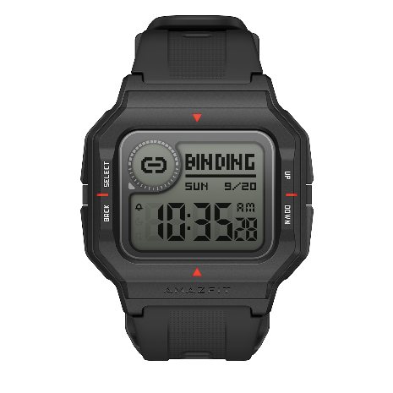

4. After pairing, the watch will need to be upgraded regularly. To upgrade your watch, enable your mobile network and Bluetooth, and place your watch and phone together to ensure the watch is successfully upgraded.
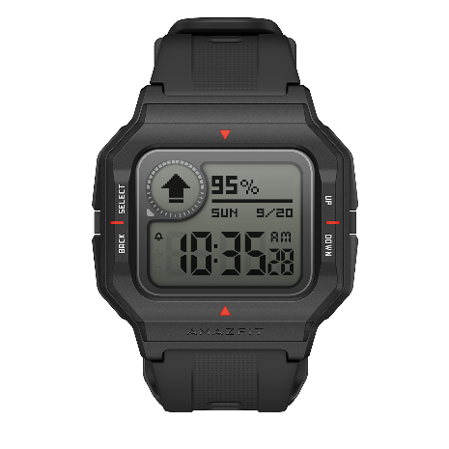
5. After the watch is paired and upgraded, you can start using the watch. In addition, you can perform operations or configure watch functions in the app.
6. If you need to unpair the watch from your phone, start the app, and tap Unpair on the device page.

Functional pages
Press the UP or DOWN key to switch between different functional pages.
Step count: Displays the current number of steps.
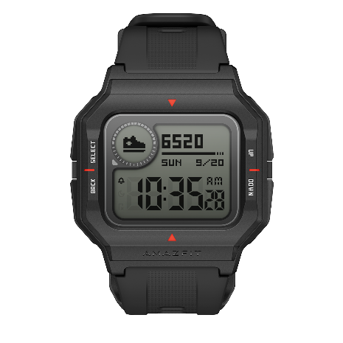

Distance: Displays the current distance.
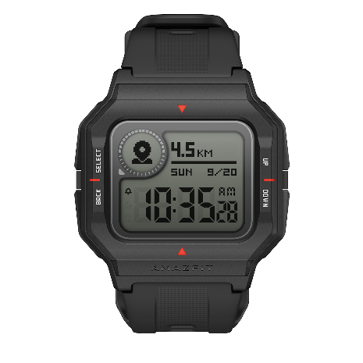

Consumption: Displays the current number of calories consumed.
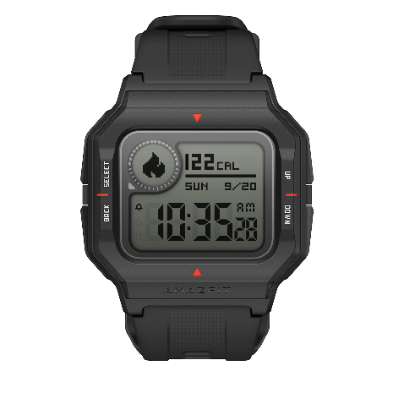
Weather: Displays today's weather data. If the weather data cannot be displayed, connect the watch to the app on your phone, and update the weather data.
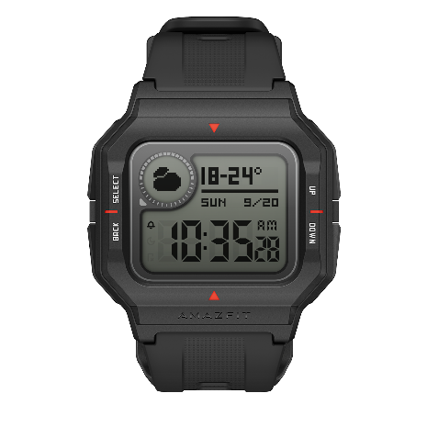

DND:
ON: The DND mode is enabled, and the watch can no longer receive notifications pushed by your phone.
OFF: The DND mode is disabled, and the watch can once again receive notifications from your phone.
SMART: The smart DND function is enabled. When the watch detects that you are asleep, the DND mode is automatically enabled.
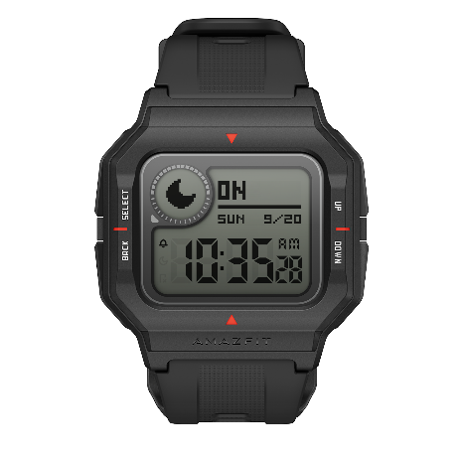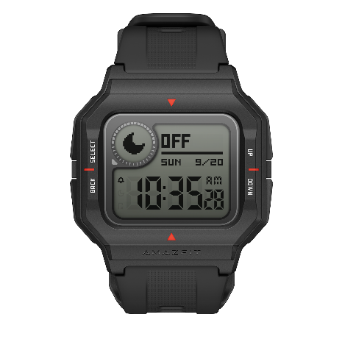
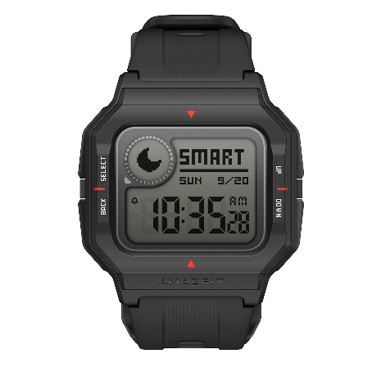

Stopwatch: The result is accurate to hundredths of a second.
- Start: Press the SELECT key to start timing.
- Count: During the timing process, you can press the UP key to log the times. Up to 9 times can be logged.
- Pause: During the timing process, you can press the SELECT key to pause the stopwatch.
- Reset: When the stopwatch is paused, you can press the BACK key to reset the stopwatch, that is, to return to the stopwatch home page.
- Stopwatch record: When the stopwatch is paused, you can press the UP or DOWN key to view the records.
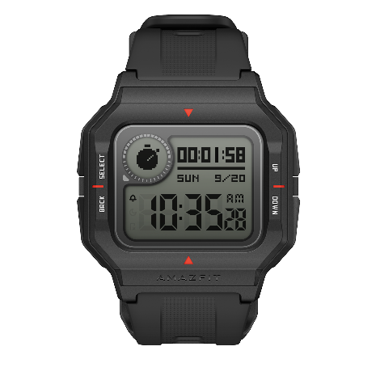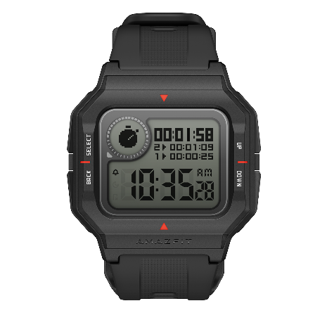

Clock: You can set the alarm clock in the app, and the watch will display the next alarm time.
Close: When the alarm clock sounds on the watch, you can press any key to disable the alarm.
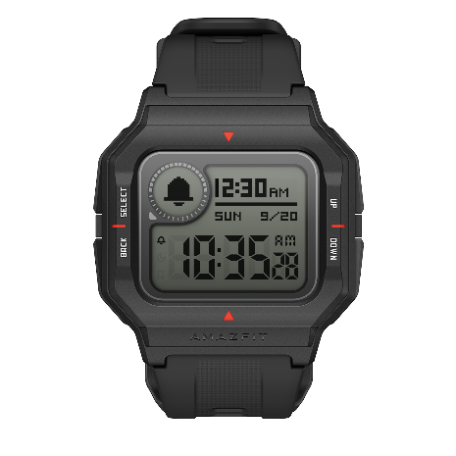

PAI: The accumulated value is displayed. The PAI value is generated when all-day heart rate detection is enabled.
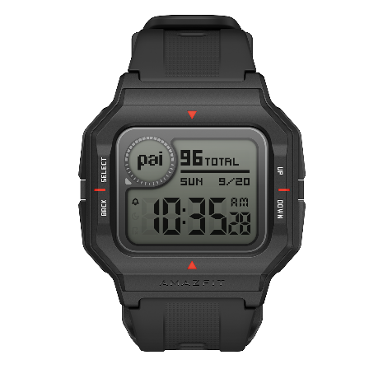

Heart Rate:
1. Go to the heart rate page. The watch automatically measures your heart rate. During the measurement process, properly wear the watch and keep the back of the watch close to your skin until the watch can measure a stable heart rate.
2. To start a single heart rate measurement, press the SELECT key.
3. To enable all-day heart rate detection, open the app, choose Profile > Amazfit Neo > Heart rate detection, and select Automatic heart rate detection.
Note: When automatic heart rate detection is enabled, the watch will measure your heart rate at the scheduled time. When you visit the heart rate page again, the latest heart rate measurement results are displayed.
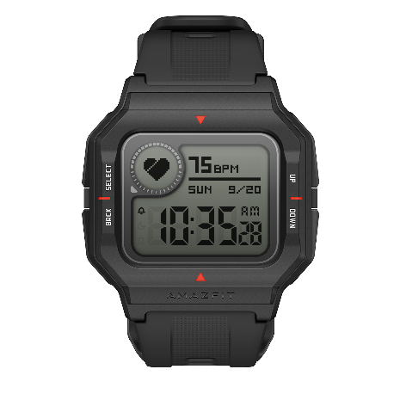

Workout secondary screen
When the watch is connected with your phone, the workout data is automatically displayed on the watch if you start a certain workout on the workout page of the app.
During a workout, you can use the keys as follows:
1. Pause/Continue: Press the SELECT key.
2. End (Back): On the Pause page, press the BACK key.
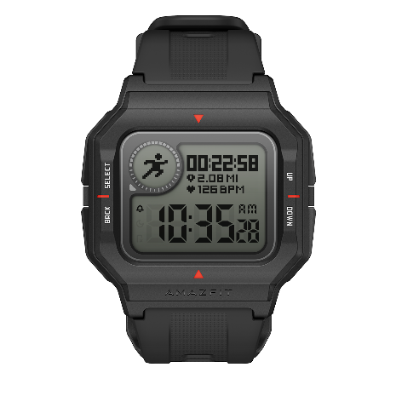

Notifications
Enable the notifications function
To use the notifications function, you need to enable the app notifications function in the app, and keep the watch connected with your phone. You can also enable the SMS and incoming call notifications.
1. If your phone uses the iOS system, pair the watch with your phone through Bluetooth.
2. If your phone uses the Android system, keep the app running in the background, or add the app to the auto-run whitelist to ensure that notifications can be sent to the watch through your phone.
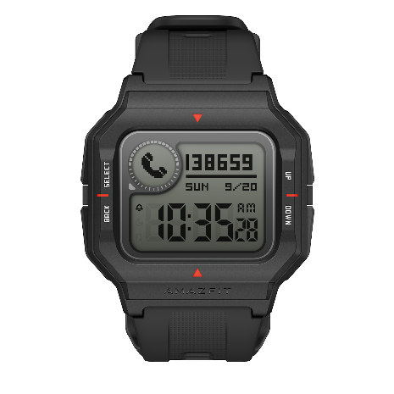

View notifications
1. When there is an incoming notification, the watch buzzes and displays the notification information.
2. You can press any key to exit the notifications page.
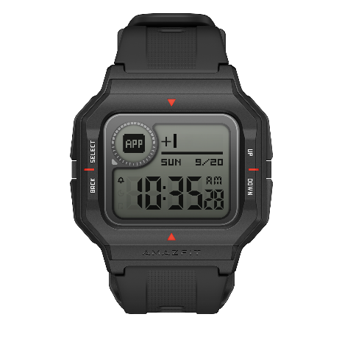

Workout reminder
During a workout, the watch generates a notification every kilometer/mile.
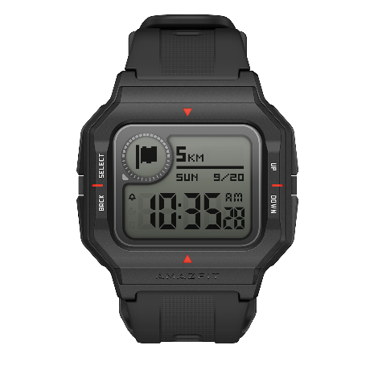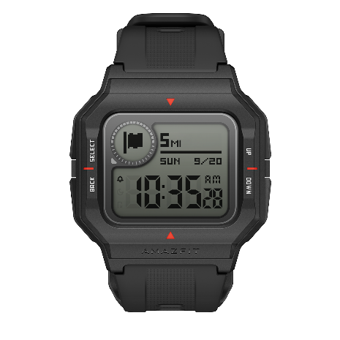

Find my phone
Amazfit Neo allows you to find your phone through Bluetooth. You can press the BACK and UP keys on your watch to enable this function.
1. To use this function, ensure that the app is running and the watch is connected with the phone. If the app is not running or the watch is not connected with the phone, the function cannot be used.
2. Go to the Find my phone page. The watch will automatically find the phone. If the phone is not found within 60s, the watch displays a failure message and requests to try again.
3. If the phone is successfully found, the phone will ring. You can press any key to stop the phone from ringing.
Note: If you would like to be able to use the find my phone function at any time, add the app to the auto-run whitelist to keep the app running in the background. Otherwise, the find my phone function will be unavailable because the watch is disconnected from your phone.
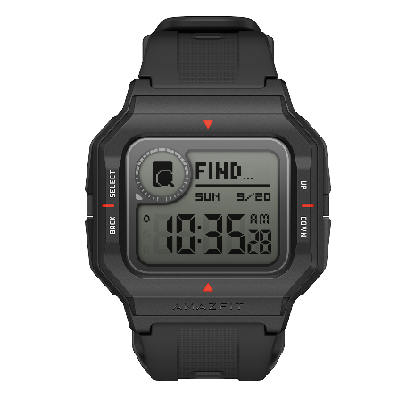

Factory reset
This function restores the watch's factory settings.
On the factory reset page, you can use keys as follows:
1. Restore factory settings: Press and hold the BACK + DOWN keys.
2. Confirm: Press the SELECT key.
3. Cancel (Return to the original watch face): Press the BACK key.
