Product introduction​

1. Please read the product instructions carefully, choose the type according to the function and power you need, and avoid the damage caused by wrong wiring.

2. This frequency converter can not drive other load types except inductive load such as motor . Please pay special attention to it when purchasing.

3. The overload capacity of 220V to 380V frequency converter is small. Please choose at least one higher power level. When the load is very large (such as gear pump hydraulic pump) or there is a blocking condition, please choose carefully.

4. If you don't know how to choose the type, you can also contact us to give you some suggestions.

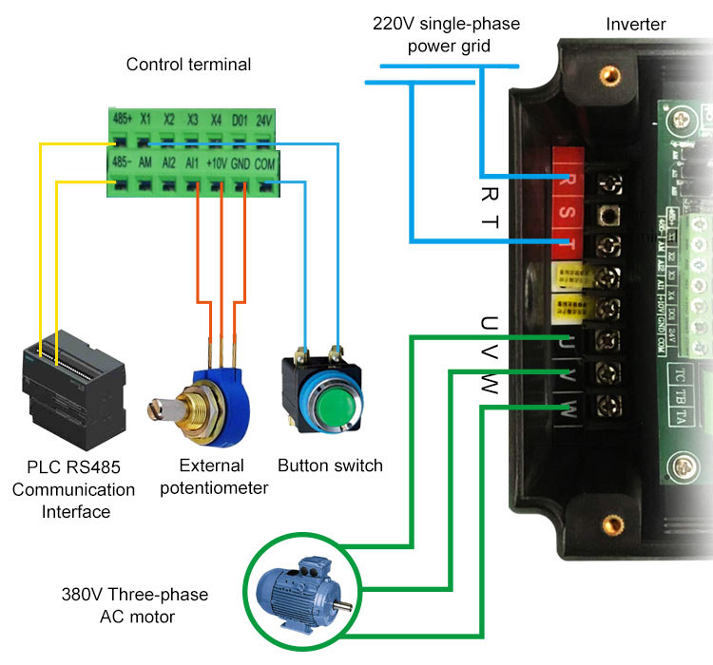

● Input and output characteristics
Input voltage range: 220V±15%
Input frequency range: 47~63Hz
Output voltage range: 0~rated input voltage
Output frequency range: 0~650Hz

● Peripheral interface features
Programmable digital input: 4 inputs
Programmable analog input: AI1: 0~10V input, AI2: 0~+5V or panel potentiometer input
Open collector output: 1 output
Relay output: 1 output
Analog output: 1 output, optional 4~20mA or 0~10V

● Technical performance characteristics
Control: PG-free vector control, V/F control
Starting torque: without PG vector control: 0.5Hz / 150% (SVC)
Speed ratio: no PG vector control: 1: 100
Speed control accuracy: PG vector control: ± 0.5% of the maximum speed
Carrier frequency: 0.5k ~ 15.0kHz

● Features
Frequency setting mode: digital setting, analog setting, serial communication setting, multi-speed, PID setting.
PID control function
Multi-speed control function: 8-speed control
Swing frequency control function
Instantaneous power outage without stopping function
REV / JOG key function: user-defined multi-function shortcut keys
Automatic voltage adjustment function: When the grid voltage changes, the output voltage can be automatically maintained constant
Provide up to 25 kinds of fault protection: over-current, over voltage, under voltage, over temperature, phase loss, overload and other protection.

