Product introduction

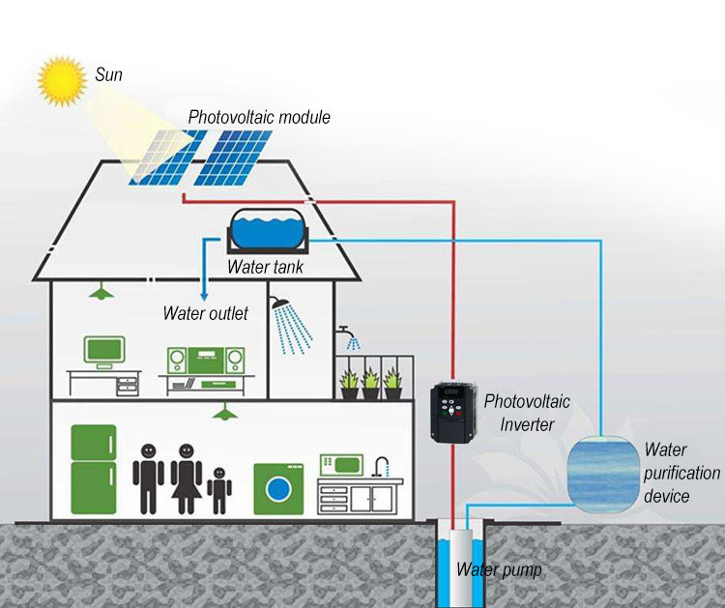
• Built-in MPPT controller：
MPPT: full name "Maximum Power Point Tracking". It can detect the generation voltage of solar panels in real time, and track the maximum voltage and current value (VI), so that the system can output the driving load with the maximum power and apply it to solar photovoltaic system to coordinate the work between solar panels and loads. It's the brain of photovoltaic systems.

• Supporting Wide Voltage Input;
A, 220V photovoltaic converter corresponding input voltage below 200V will jump low-voltage alarm shutdown, 400V above automatically suppress voltage rise, avoid overlooking overvoltage shutdown;
B, 380V photovoltaic converter corresponding input voltage below 400V will jump low-voltage alarm shutdown, 700V above automatically suppress voltage rise, avoid overlooking overvoltage shutdown.

• Support unattended automatic start and stop.
In the morning, when the illumination intensity rises to a certain extent, the input voltage reaches about 400 V (220 V photovoltaic converter reaches about 200 V), and the photovoltaic converter automatically starts driving load operation without manual operation.
In the evening, when the illumination intensity decreases to a certain extent, the input voltage drops to about 400 V (220 V photovoltaic converter reaches about 200 V), and the photovoltaic converter automatically stops driving the load without manual operation.

• Our products can provide motor protection function.
Such as Short-circuit, phase-absence, over-current, over-voltage, under-voltage, over-heat, over-load protection, etc.

● Input and output characteristics
220V type (D1T)
Input voltage range: DC 200V-400V(best for 300V-320V) or single phase 220V±15% 50/60Hz
Output voltage range: AC Three phase 0-220V 0-650Hz
380V type (D3T)
Input voltage range: DC 400V-700V(best for 530V-550V) or three phase 380V±15% 50/60Hz
Output voltage range: AC Three phase 0-380V 0-650Hz

● Peripheral interface features
Programmable digital input: 4 inputs
Programmable analog input: AI1: 0 ~ 10V input, AI2: 0 ~ + 5V or panel potentiometer input
Open collector output: 1 output
Relay output: 1 output
Analog output: 1 output, optional 4 ~ 20mA or 0 ~ 10V

● Technical performance characteristics
Control: PG-free vector control, V / F control
Overload capacity: 150% rated current 60s; 180% rated current 10s
Starting torque: without PG vector control: 0.5Hz / 150% (SVC)
Speed ratio: no PG vector control: 1: 100
Speed control accuracy: PG vector control: ± 0.5% of the maximum speed
Carrier frequency: 0.5k ~ 15.0kHz

● Features
Frequency setting mode: digital setting, analog setting, serial communication setting, multi-speed, PID setting.
PID control function
Multi-speed control function: 8-speed control
Swing frequency control function
Instantaneous power outage without stopping function
REV / JOG key function: user-defined multi-function shortcut keys
Automatic voltage adjustment function: When the grid voltage changes, the output voltage can be automatically maintained constant
Provide up to 25 kinds of fault protection: over-current, over voltage, under voltage, over temperature, phase loss, overload and other protection。
.
